2.Disparity map

2.1 Depth perception via triangulation

After image rectification, the corresponding points are constrained on the same

image scanline.

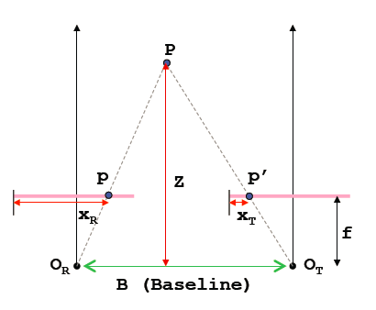

By considering the similar triangles $PO_{R}O_{T}$ and $Ppp^{'}$, we have

$$\frac{b}{Z}=\frac{\left(b+x_{T}\right)-x_{R}}{Z-f}$$

Which is

$$Z=\frac{b∙f}{x_{R}-x_{T}}=\frac{b∙f}{d}$$

In which d is disparity, the difference between the x coordinate of two corresponding points. The disparity is higher for points closer to the camera.

2.2 Semi-globel block matching(SGBM)

In order to create disparity map, we have to find correspondence for each pixel in the image, after research, this documentation takes the method of semi-globel block matching for dense reconstruction.

Compared with other method, this method additionally use a smoothness constraint that penalizes discontinuities. This is typically formulated in a cost function with three parts

$$E\left(D\right)=\sum_{P}{(C\left(p,D_{p}\right)+\sum_{q∈N_{p}}{P_{1}\left[D_{p-}D_{q}=1\right]}+ \sum_{q∈N_{p}}{P_{2}\left[D_{p-}D_{q}>1\right]})}$$

The first part is the sum of all pixel matching costs for the disparities of D. the second part penalizes all pixels q in the neighborhood $N_{p}$ for p, for which the disparity changes a little bit. The third part adds a larger penalty for all larger disparity changes. The problem then becomes the minimization of energy $E(D)$, which is NP complete. This can be solved by aggregating matching costs in 1D from all directions equally (considering the time cost, our realization uses only 8 directions, which is illustrated in figure ). The aggregated cost $S(p,d)$ is calculated by summing up the costs of the 8 directions or paths.

$$S\left(p,d\right)=\sum_{r}{L_{r}(p,d)}$$

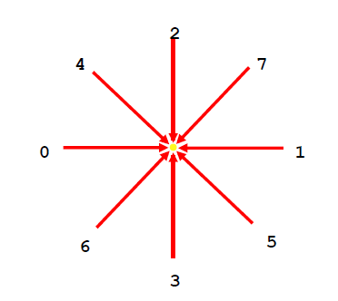

Then the disparity d for each pixel p is selected such that the cost is minimized.

* 1. Results and discussion

As is shown in the figure, the result of the background (i.e. the wall) is disappointed, which is caused by the low texture of the wall. Therefore, the background is segmented in order to get a better result. This will be introduced in the last chapter in details.

3. Depth image based rendering (Zinger)

With the depth information, this documentation creates the intermediate view with the help of DIBR technique (Depth image based rendering), which is a classical virtual view synthesis technique. Our realization relies on paper [Zinger], which reduced the holes and removed the most of the contour artifacts of the reconstructed image.

3.1 Rendering model

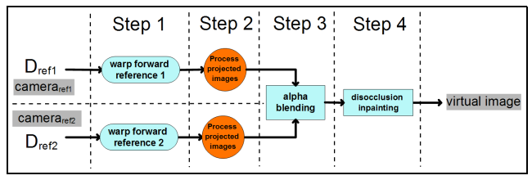

From paper 7

The standard process of rendering is to warp the depth map of reference image and then calculate the world coordinate of pixels in images, and re-projected onto the virtual viewpoint. The target position of virtual viewpoint can be found with rotation (R) and translation(T) parameter and blending the re-projected image pair with weighted parameter(p) can find the target virtual image. However, in our project, we skip the 3D wrap step and find the target virtual image with the help of one depth map and one reference image.

3.2 Pre-processing

3.2.1 Filling gaps and holes

Since in the new view point, the previously invisible scene points can not be rendered, gaps and holes occur. Which is also caused by the discontinuity of the disparity map.

3.2.2 Removing contour artifacts

3.3 result and discussion

4. Improvement

4.1 time cost

In order to accelerate the program, we down sample the image to a smaller size, after processing, the image is interpolated to the original size.

4.2 quality

Following the chapter 2, we discussed in details the segmentation, we segmented the wall out of the original image and ……………

4.3 Graphic interface--GUI

In order to better manipulate our program, we create an interface, which is shown in figure …………………..