Python 3 Object-Oriented Programming

Chap 1. Object-oriented Design

An object is a collection of data and associated behaviors.

Analysis, design, and programming are all stages of software development.

Object-oriented analysis (OOA) - is all about what needs to be done.
Object-oriented design (OOD) - is all about how things should be done.
Object-oriented programming (OOP)

No matter how hard we try to separate these stages, we'll always find things that need further analysis while we're designing. When we're programming, we find features that need clarification in the design.

Classes describe objects.

Unified Modeling Language(UML)
class diagram(类图)
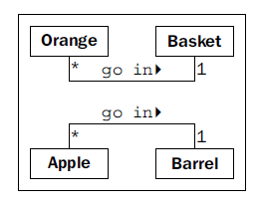

Association is the most basic way for two classes to be related.

An object instance is a specific object with its own set of data and behaviors;

Data typically represents the individual characteristics of a certain object.
Attributes are frequently referred to as members or properties, attributes are settable, while properties are read-only.

Behaviors are actions that can occur on an object. The behaviors that can be performed on a specific class of objects are called methods.

Object-oriented analysis and design is all about figuring out what those objects are and how they should interact.

The interface is the collection of attributes and methods that other objects can use to interact with that object. They do not need, and are often not allowed, to access the internal workings of the object

This process of hiding the implementation, or functional details, of an object is
suitably called information hiding. It is also sometimes referred to as encapsulation.

Abstraction means dealing with the level of detail that is most appropriate to a given task. Abstraction is the process of encapsulating information with separate public and private interfaces.

Two basic object-oriented principles known as composition and inheritance

Composition(组合) is the act of collecting several objects together to create a new one.

Object diagram, also called an instance diagram.
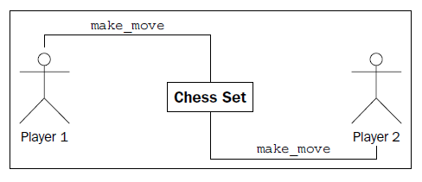

Aggregation is almost exactly like composition. The difference is that aggregate
objects can exist independently.

In object-oriented programming, one class can inherit attributes and methods from another class.

Object-oriented design can also feature such multiple inheritance, which allows a subclass to inherit functionality from multiple parent classes.

Polymorphism(多态) is the ability to treat a class differently depending on which subclass is implemented.(duck typing)

Sequence diagram explaining how the various objects are communicating:
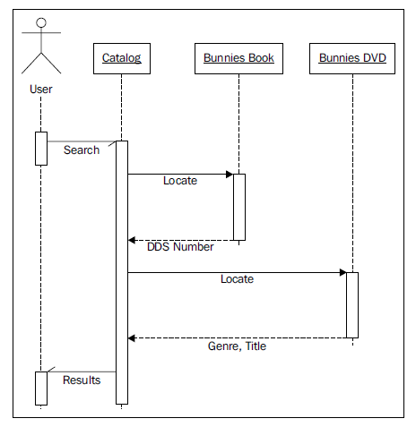
Sequence diagrams describe specific sequences of messages passed between objects.

Chap 2. Objects in Python

