Image Recognition Application

Student: Ran Wei, Tingyuan Cui

GitHub Link:

[https://github.com/weirande2009/FinalProject](https://github.com/weirande2009/FinalProjectWorker)

<https://github.com/weirande2009/FinalProjectWorker>

Name of GENI slice: RanWeiFinalProject

Public routable IP address of GENI node:

# Introduction / Problem Statement

In this project, we successfully implemented an image-recognition service which contains a web interface where users are able to upload their images from local to server.

Once the server receives the image, it would assign an image recognition task to an idle worker, which runs the image processing program. After the worker completes the image recognition, it returns the recognition result to the server, and then the server returns the result back to the browser.

About implementation part, we used socket programing in Python to build communications between client, server and workers, and used Django as the web framework.

We also used OpenCV to process and recognize the images. We have multiple nodes for workers and one node for server (server and workers are separated)

About analysis part, we […]

After this project, we learned:

1. How to use socket programing properly
2. How to design the workers scheduling strategy (load balancing)
3. Multi-thread programing
4. Web crawler
5. Locks
6. Basic use of Django
7. CSS & HTML programing

# Experimental Methodology

Architecture diagram:

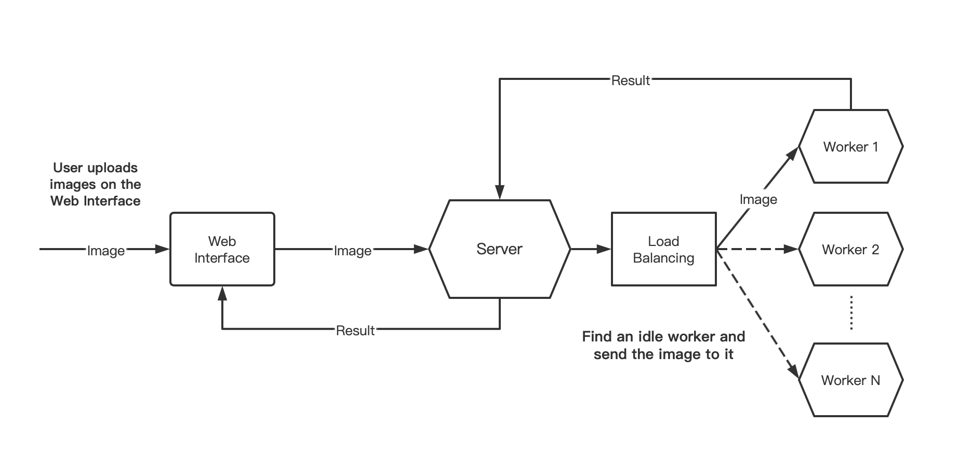

## Program execution

Step 1:

User uploads a local image document through the web interface.

Step 2:

Server receives HTTP POST request from the web interface and retrieve the image.

Step 3:

Server finds an ideal worker based on load balancing design and send the image to it.

Step 4:

Worker receives the image and starts the image processing program (Open CV)

Step 5:

Worker gets the processing result and give it to server.

Step 6:

Server receive the result from the worker and return it to the web interface.

Maximum number of requests our system can handle: […]

# Results

# Usage Instructions

# Analysis

# Conclusion

# Division of Labor

Ran Wei:

Tingyuan Cui: