**MicroVecmini V5 Installation and questions**

**1.MicroVecmini V5 Installatino**

Step1：Click on the “MicroVecmini.exe”，figure1.1:

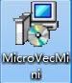

Figure1.1: MicroVecMini.exe

Step2：Please select an installation position, then click “Next”, figure1.2:

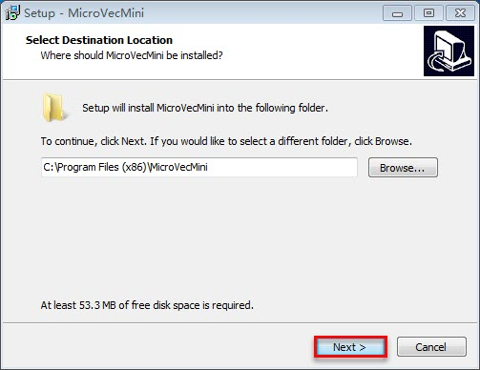

Figure 1.2

Step3：Figure1.3，select “Create a desktop shortcut” ,then click “Next”：

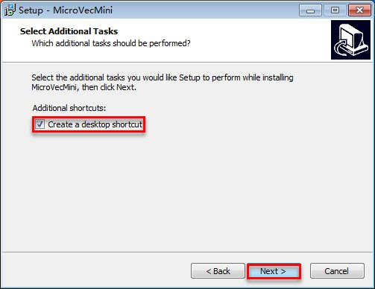

Figure 1.3

Step4：Figure1.4，click “Install”：

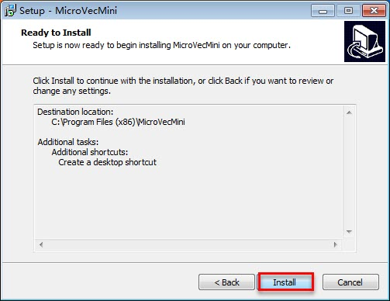

Figure 1.4

Step5：Figure 1.5，Installing，can`t click “Cancel”：

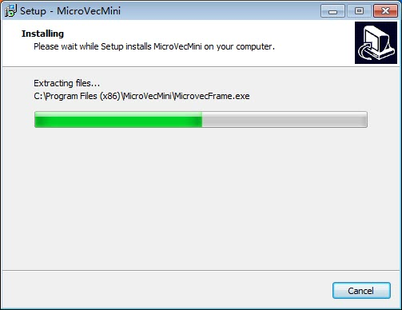

Figure 1.5

Step6：Figure 1.6，click “Finish”，install Successfully. Figure1.7, the tip is not equipped with MVS software:

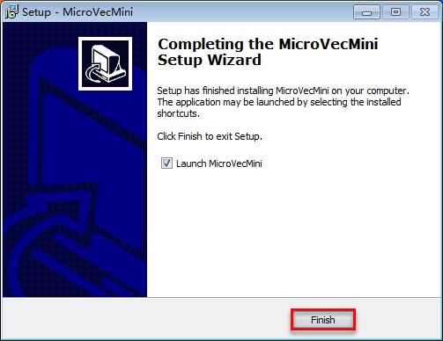

Figure 1.6

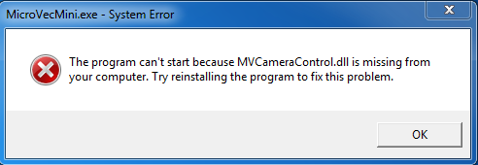

Figure 1.7

Step7：please click on “MicroVecFrame.exe”(C:\Program Files (x86)\MicroVecMini), Figure 1.8:

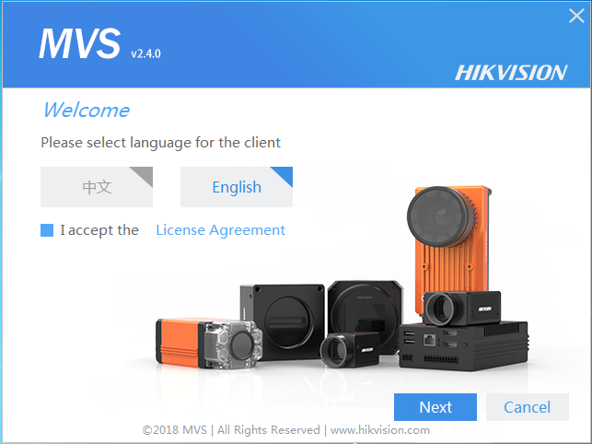

Figure 1.8

Step8：Figure 1.9，click “Next”：

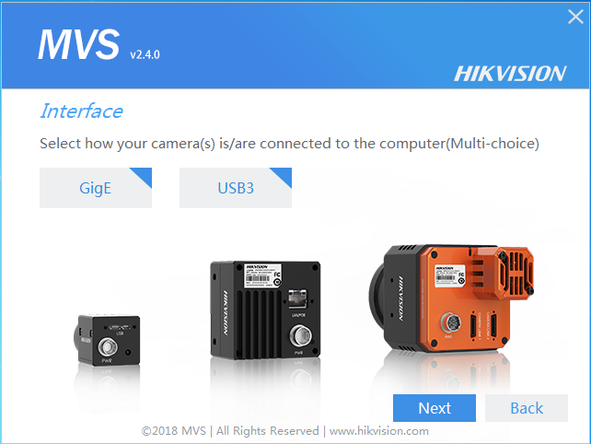

Figure 1.9

Step9：Figure 1.10，please select an installation position and click “Install”，Installing…., Figure 1.11、1.12， click “Finish”：

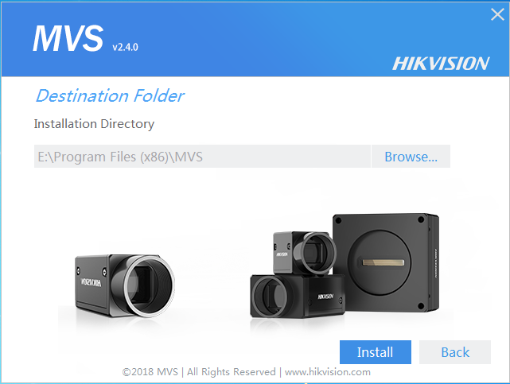

Figure 1.10

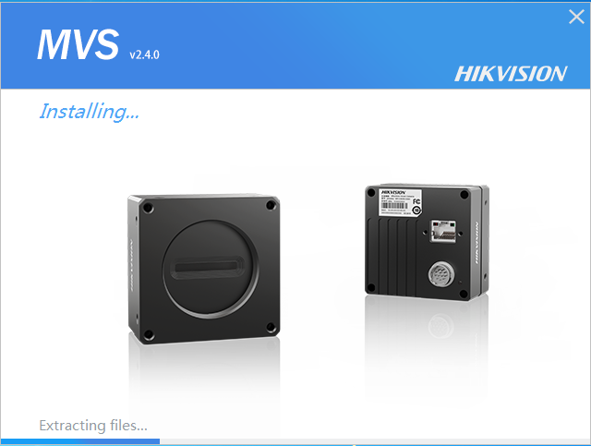

Figure 1.11

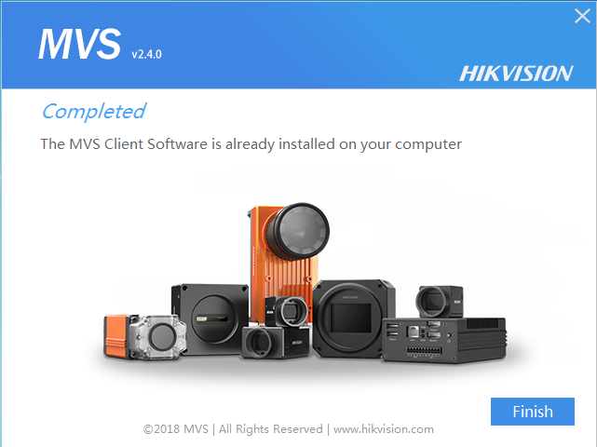

Figure 1.12

Step10：Install successfully，click the MicroVecmini shortcut and open the software，Figure 1.13

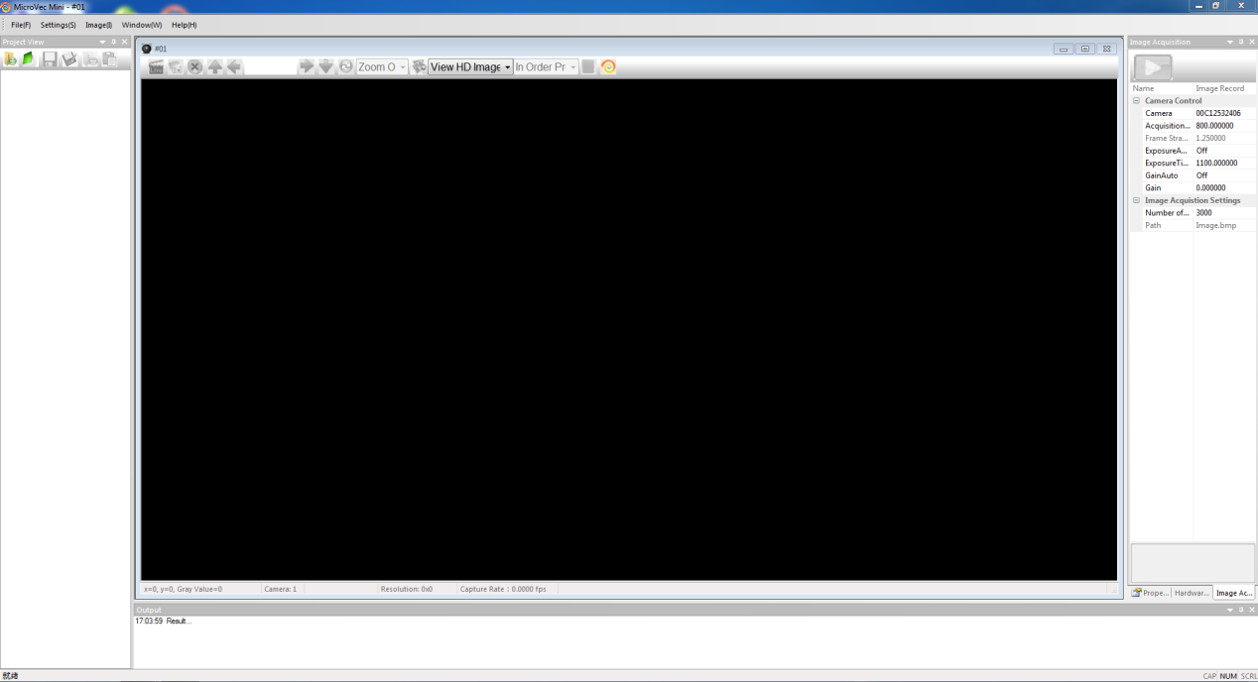

Figure 1.13

**2. Questions**

Question 1: software install successfully, but you can`t open the MircoVecmini, Figure1.14.

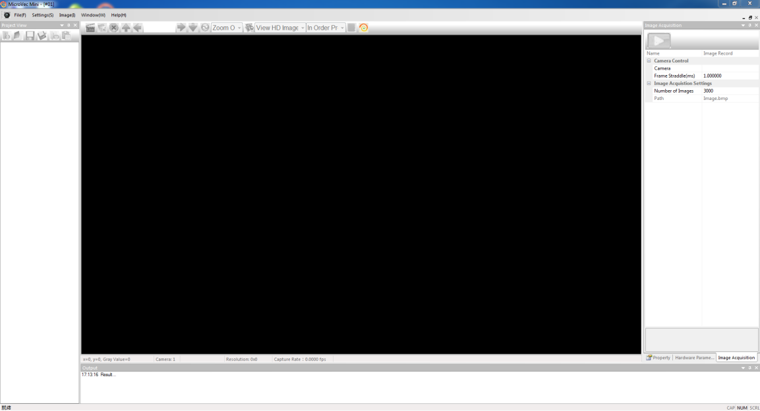

Figure1.14

Solution: delete the “msvcr120.dll”(C:\Program Files (x86)\MVS\Applications\Win64), and install the “Microsoft Common Runtime Collection 64-bit”.

Question 2: software install successfully, but Software Interface has some Chinese character.

Solution: please delete Windows Registrations related to MicroVecmin: open the Windows Registrations and delete the PIV4 file(HKEY_CURRENT_USER\software\Local application generated by the application wizard\PIV4).