Assessment Cover
Module’s Information
Module | DCS2102 – Rapid Application Development
Lecturer | Dr. Siti Syakirah Sazali (sitisyakirah.sazali@newinti.edu.my)
Coursework Type | Lab Report (20%)
Handout Date | Week 10
Due Date | Week 12
Student’s Declaration
I declare that:
I understand what is meant by plagiarism.
This assignment is all my/our own work, and I/we have acknowledged any use of the published or unpublished works of other people.
I hold a copy of this assignment which I can produce if the original is lost or damaged.
Plagiarism, which includes using someone else's work or AI-generated content without proper acknowledgement, is strictly prohibited.
In cases of plagiarism or unauthorized AI use, penalties will be imposed based on severity of marks up to 70% of the assignment's total marks.
The severity of each case will be determined by the instructor based on the extent of the violation.
Student Details
Name: | Kho Wei Seong
Student ID: | J24041882
Section: | Y1
Session: | DITN DCS2102
Submission Date: | 10/11/2025
Signature: | KHO

Learning Outcomes Assessed
CLO2 | Display programming skills in web and mobile hybrid application development using HTML, CSS, JavaScript, and PHP programming language. [P3, PLO3]
Assessment Criteria |  | Total Marks | Marks Given
Rubrics |  | 100
Lecturer’s Comment

Table of Contents
Table of Contents 2
1.0 Introduction 3
2.0 Objectives 4
3.0 Website Overview 5
3.1 Main Concept and Theme 5
3.2 Website Pages 5
3.3 Navigation System 8
4.0 Implementation Details 10
4.1 HTML Structure 10
4.2 CSS Styling 11
4.3 Bootstrap Integration 12
4.4 JavaScript Functionality 13
5.0 Design and Usability 14
5.1 Design Inspiration, Colour Palette, and Typography 14
5.2 Responsive Design Across Devices 14
5.3 Accessibility Features 14
6.0 Code Quality 15
6.1 Clean and Readable Code 15
6.2 Comments and Naming Conventions 15
6.3 Project File Organization 15
7.0 WEBSITE SCREENSHOTS 16
7.1 Home Page 16
7.2 About Page 17
7.3 Experiences Page 19
7.4 Achievements Page 20
7.5 Project Page 21
7.6 Skills Page 22
7.7 Contact Page 24
8.0 CHALLENGES AND SOLUTIONS 25
9.0 CONCLUSION AND REFLECTION 27
10.0 REFERENCES 28

Introduction
This personal portfolio website showcases my skills, experiences, achievements, and projects in web development and technology. It serves as a central hub for my professional profile, highlighting my technical abilities, work history, and creative projects.

The site includes multiple sections: an About page with background and interests, an Experience page detailing professional roles and responsibilities, an Achievements page listing accomplishments and recognitions, a Projects page presenting technical work, a Skills page covering programming languages and tools, and a Contact page for communication.

The design emphasizes a responsive, mobile-first approach to ensure a consistent experience across devices. Interactive elements and smooth navigation improve usability and engagement. This portfolio demonstrates proficiency in modern web development practices, including semantic HTML, responsive CSS, Bootstrap components, and JavaScript interactivity. It reflects my commitment to creating clean, accessible, and user-friendly digital experiences.

2.0 Objectives
This project was developed as part of an assignment focused on understanding and applying core web technologies. The main objectives were to:
- HTML (Hypertext Markup Language): Structure content semantically to create a well-organized, accessible foundation. This involved using appropriate tags (headings, paragraphs, lists, links, images), organizing content into logical sections, and ensuring proper document structure. Semantic HTML improves accessibility, SEO, and maintainability, and helps screen readers and search engines understand the content.
- CSS (Cascading Style Sheets): Style and design responsive layouts that work across devices and screen sizes. This included custom styling, colour schemes, typography, spacing, animations, and transitions. CSS was used to create a cohesive visual identity, implement responsive breakpoints, and ensure consistent presentation across browsers and devices.
- Bootstrap: Use Bootstrap’s responsive grid and components to build a mobile-first, consistent design. This involved leveraging Bootstrap’s utility classes, grid system, navigation components, buttons, cards, and responsive utilities. Bootstrap accelerated development, ensured cross-browser compatibility, and provided a solid foundation for responsive design, reducing the need for custom CSS.
- JavaScript: Add interactivity, dynamic content, and improved user experience through client-side scripting and event handling. This included implementing interactive features such as mobile menu toggles, dynamic content updates, form validation, smooth scrolling, and other user interactions. JavaScript enhanced the site’s functionality and responsiveness, making it more engaging and user-friendly.
Through this project, I gained hands-on experience combining these technologies to build a functional, responsive, and interactive web application that demonstrates both technical skills and design principles. The assignment provided practical experience in planning, designing, developing, and testing a complete web application from start to finish, reinforcing the importance of clean code, responsive design, and user-centered development practices.

3.0 Website Overview

3.1 Main Concept and Theme
This is a personal portfolio website that presents my professional profile, technical skills, work experience, achievements, and projects. The theme is professional and modern, with a clean layout that highlights my background in web development and information technology. The design emphasizes responsiveness, interactivity, and clear presentation of information.

3.2 Website Pages
The website consists of seven main pages:
- Home Page (index.html)
- Landing page with a hero section introducing the site owner
- Includes a greeting, professional photo, tagline, and call-to-action buttons
- Provides quick access to "Learn More About Me" and "Get In Touch" sections
- Sets the tone for the portfolio

- About Page (about.html)
- Personal information and bio
- Hobbies and interests (cooking, photography)
- Education timeline (secondary school, certificate, current diploma)
- Personal projects gallery with embedded videos and project links
- Resume download section with PDF link

- Experience Page (experience.html)
- Work experience timeline
- Details of part-time positions at C K HOME AUTOMATION SDN BHD and Bumi Maju Engineering
- Promoter roles with various companies
- Responsibilities and achievements for each position

- Achievements Page (achievements.html)
- Awards and achievements section (currently placeholder for future accomplishments)
- Co-curricular activities including:
- School Prefect role
- Mechanical Society positions (Treasurer, President, Arduino Instructor)
- Orientation Camp Head of Logistics
- Current Capstone Project leadership role

- Projects Page (projects.html)
- Portfolio of completed projects
- Featured projects include:
- NS Pickle Ball Booking System (Figma prototype)
- INTI JOMMAKAN Order System (Figma prototype)
- Activities Booking System (Final Year Project with live demo)
- Each project includes descriptions, technologies used, and links to live demos

- Skills Page (celebrities.html)
- Technical skills showcase with icons and descriptions
- Skills include: C++, HTML, JavaScript, Arduino, Figma, Python, ServiceNow, PHP, XAMPP, Photoshop, and GitHub
- Strengths and weaknesses section highlighting personal attributes and areas for improvement
- Interactive horizontal scrolling interface for skill cards

- Contact Page (contact.html)
- Contact form with fields for name, email, phone, and message
- Contact information display (phone, email, location)
- Social media links (LinkedIn, Facebook, WhatsApp)
- Form submission handling with user feedback

3.3 Navigation System
The website uses a consistent navigation system across all pages: Desktop Navigation:
- Fixed left sidebar navigation menu
- Menu title: "Personal Profile"
- Seven navigation links: Home, About, Experience, Achievements, Projects, Skills, and Contact
- Active page is highlighted
- Always visible for quick access
Mobile Navigation:
- Hamburger menu button (☰) in the top-left corner
- Sidebar is hidden by default on mobile devices (screens ≤ 768px)
- Toggle button shows/hides the navigation menu
- Menu closes when clicking outside the sidebar
- Button icon changes from ☰ to ✕ when menu is open
Navigation Features:
- All pages share the same navigation structure
- Smooth transitions between pages
- Top info bar with welcome message on all pages
- Footer with creator credit on all pages
- Responsive design that adapts to different screen sizes

User Flow: Users can navigate by:
- Clicking navigation links in the sidebar
- Using call-to-action buttons on the Home page
- Directly accessing any page via URL
- Using the mobile menu toggle on smaller screens
The navigation is designed to be intuitive and accessible, allowing users to move between sections and find information quickly.

4.0 Implementation Details

4.1 HTML Structure
The website uses semantic HTML elements to organize content. The navigation is implemented using a <nav> element that contains a fixed left sidebar navigation menu. The main content area is wrapped in a <main> element, and major sections like the hero section, about section, experience section, achievements section, projects section, skills section, and contact section are all structured using <section> elements. The footer is implemented using a <footer> element that displays the creator credit, and the contact page includes a <form> element for user input. The navigation menu structure uses semantic list elements with <ul> and <li> tags, and each navigation item contains an anchor tag <a> that links to different pages.
The navigation menu is a fixed left sidebar that displays the title "Personal Profile" and contains seven navigation links connecting to Home, About, Experience, Achievements, Projects, Skills, and Contact pages. The active page is highlighted using an active class that changes the styling of the current page link. All pages are connected through relative path links in the anchor tags, allowing seamless navigation between different sections of the website. On mobile devices, a hamburger toggle button is implemented to show and hide the sidebar navigation menu, providing a better user experience on smaller screens.
The page structure is consistent across all HTML files, with each page following the same layout pattern. Every page includes a top info bar that displays a welcome message, followed by the main container that houses both the sidebar navigation and the main content area. The footer is positioned at the bottom of each page, creating a cohesive design throughout the entire website.

4.2 CSS Styling
Styling is in a single external file, CSS/index.css, linked in all HTML files.The colour scheme uses dark gradients (#2d2d2d, #1a1a1a, #4a4a4a) with an animated background. Content areas use light backgrounds with glass morphism. Text uses dark greys for contrast.
Fonts use system fonts (no external imports). Sizes range from 0.8rem to 3rem, with weights 400, 500, 600, and 700.Layout uses Flexbox and CSS Grid. Flexbox is used for the main container, hero section, navigation, buttons, and the skills scrolling container. CSS Grid is used for projects, achievements, strengths/weaknesses, and other grids, with responsive column counts.
Animations include gradientShift for the background, fadeInUp/fadeInLeft/fadeInRight for entrances, shimmer for text effects, and float for floating elements. Transitions are applied to navigation links, buttons, cards, images, and form inputs.Special effects include glass morphism with backdrop-filter: blur(10px), gradient borders, hover overlays, and smooth scrolling.

4.3 Bootstrap Integration
The website integrates Bootstrap version 5.3.2 through CDN links, including both the
CSS and JavaScript bundles. The Bootstrap CSS file is linked from https://cdn.jsdelivr.net/npm/bootstrap@5.3.2/dist/css/bootstrap.min.css and the JavaScript bundle is included from https://cdn.jsdelivr.net/npm/bootstrap@5.3.2/dist/js/bootstrap.bundle.min.js.
While Bootstrap's grid system is available, the website primarily uses custom layout techniques with Flexbox and CSS Grid, though some Bootstrap utility classes are utilized for spacing and responsive utilities. The Bootstrap JavaScript bundle is included to provide potential component functionality if needed in the future.
The responsive design is primarily achieved through custom media queries rather than relying solely on Bootstrap's grid system. The website defines custom breakpoints at 768px for mobile devices, 480px for small mobile devices, and 360px for very small devices, allowing for precise control over how the layout adapts to different screen sizes. On mobile devices, the sidebar is positioned as fixed and hidden by default, the main content takes full width, navigation is controlled through a hamburger menu toggle, grid layouts switch to one or two columns, typography uses reduced font sizes, images are sized responsively, forms stack vertically, and buttons expand to full width.
Bootstrap's role in the website is to provide base styles and normalization that ensure cross-browser compatibility, serve as a foundation for responsive utilities, and offer a consistent starting point for styling. However, the majority of the visual design and layout is achieved through custom CSS, giving the website a unique appearance while benefiting from Bootstrap's reliability and browser compatibility features.

4.4 JavaScript Functionality
JavaScript is inline in each HTML file, using vanilla JavaScript with an event-driven approach. Scripts are wrapped in DOMContentLoaded to ensure the DOM is ready.
The mobile menu toggle hides the sidebar by default on screens ≤768px. A hamburger button toggles the menu and changes the icon. Clicking outside closes the menu. Uses getElementById(), querySelector(), and classList.toggle().
The skills gallery scroll enables horizontal scrolling with left/right buttons. It uses smooth scrolling and updates button visibility based on scroll position. Uses scrollBy() and style manipulation.
The projects gallery scroll works similarly, scrolling the project gallery horizontally.
The contact form prevents default submission and shows an alert. Uses preventDefault().
JavaScript uses DOMContentLoaded, click, scroll, and submit events. It interacts with HTML via getElementById(), querySelector(), classList methods, addEventListener(), scrollBy(), and preventDefault().
JavaScript enhances the site with smooth scrolling, dynamic button states, responsive menu behaviour, form feedback, and interactive scroll controls. Code is placed before the closing </body> tag, wrapped in DOMContentLoaded listeners, and follows a consistent pattern across pages.

5.0 Design and Usability

5.1 Design Inspiration, Colour Palette, and Typography
The design uses a modern, professional portfolio style with a dark gradient theme. The colour palette centers on dark greys (#2d2d2d, #1a1a1a, #4a4a4a). The background uses an animated gradient with a subtle geometric pattern. Content areas use light backgrounds with glassmorphism for depth. Text uses dark greys on light backgrounds for readability. Typography uses system fonts for fast loading. Font sizes range from 0.8rem to 3rem, with weights 400, 500, 600, and 700. Line heights are 1.5–1.9 for comfortable reading.

5.2 Responsive Design Across Devices
The site is responsive and adapts to different screen sizes using custom media queries. On desktop (over 768px), the sidebar is visible, grids use multiple columns, and font sizes are larger.On mobile (768px and below), the sidebar is hidden by default and accessed via a hamburger menu, grids switch to 1–2 columns, font sizes are reduced, buttons are full width, and forms stack vertically. On small mobile (480px and below), layouts use single columns and spacing is more compact. The layout uses Flexbox and CSS Grid with auto-fit and minmax() to adjust columns based on available space. Images are responsive and scale with their containers.

5.3 Accessibility Features
All images include descriptive alt attributes, such as "Professional Photo" for the hero image and technology names for skill icons. ARIA labels are used for interactive elements. The mobile menu toggle has aria-label="Toggle Menu", scroll buttons have labels like "Scroll left" and "Scroll right", and social media links have descriptive labels.Form accessibility is ensured with proper labels. All form inputs have associated <label> elements linked to their inputs, and required fields are marked with the required attribute. colour contrast is maintained with dark text on light backgrounds and high contrast between text and backgrounds. Readable fonts are used throughout. System fonts are chosen for clarity, font sizes are appropriate (minimum 0.8rem), and line heights of 1.5–1.9 provide comfortable reading. Additional accessibility features include semantic HTML elements for better screen reader support, external links using rel="noopener no referrer" for security, smooth scrolling for better navigation, and keyboard navigation support through proper focus states. These features help ensure the website is accessible to users with different needs and assistive technologies.

6.0 Code Quality

6.1 Clean and Readable Code
The code is organized for readability. HTML uses consistent indentation and clear structure. CSS is grouped by sections. JavaScript is straightforward with clear logic. Formatting is consistent across files.

6.2 Comments and Naming Conventions
Comments: HTML comments mark major sections, such as <!-- Mobile Menu Toggle Button --> and <!-- Main Content Area -->. CSS comments describe sections, such as /* Hero Section Styles */ and /* Mobile Responsive Styles */. JavaScript comments explain functionality, such as // Mobile Menu Toggle and // Close menu when clicking outside on mobile. These comments clarify complex code and explain design decisions. Naming Conventions: CSS classes use kebab-case, such as mobile-menu-toggle, hero-section, and nav-link. IDs use camelCase, such as mobileMenuToggle and projectGallery. File names use lowercase with hyphens, such as index.html and about.html. Names are descriptive and indicate purpose, such as resume-download-btn and experience-timeline.

6.3 Project File Organization
The project is organized into clear folders. HTML files are in the root directory, including index.html, about.html, experience.html, achievements.html, projects.html, celebrities.html, and contact.html. The CSS folder contains a single stylesheet file index.css with all styling code. The images folder contains all image files including photos, project screenshots, and skill icons. The JavaScript folder contains external libraries like jQuery and Swiper, while the main JavaScript code is written inline in the HTML files for simplicity. This structure keeps files organized, makes assets easy to locate, and supports future maintenance and updates.

7.0 WEBSITE SCREENSHOTS

7.1 Home Page
Desktop View
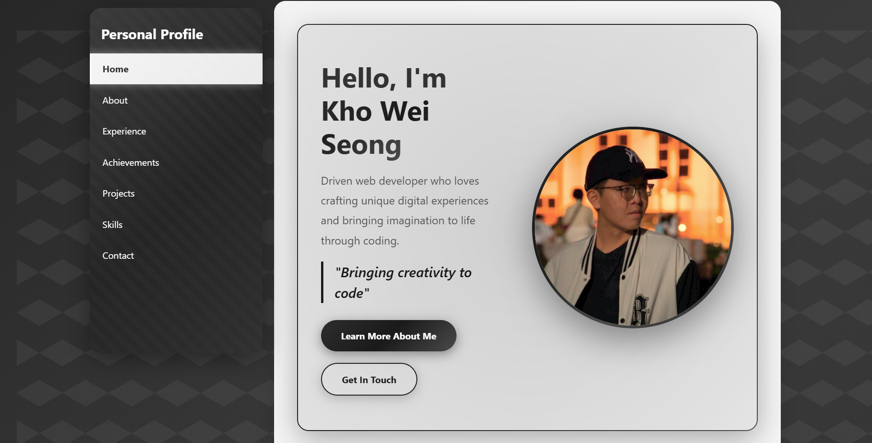
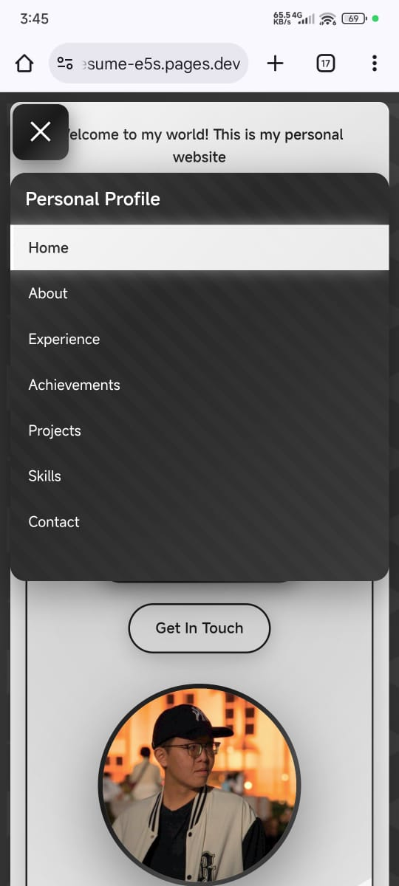
Mobile View
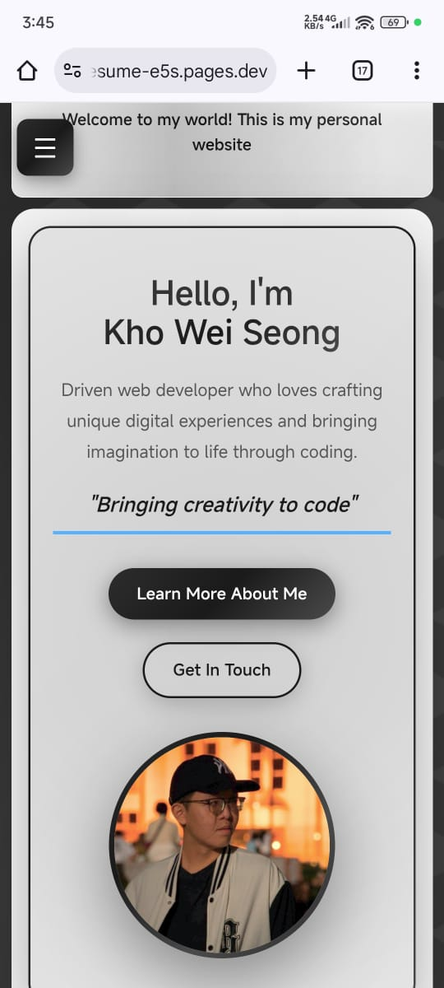

7.2 About Page
Desktop View
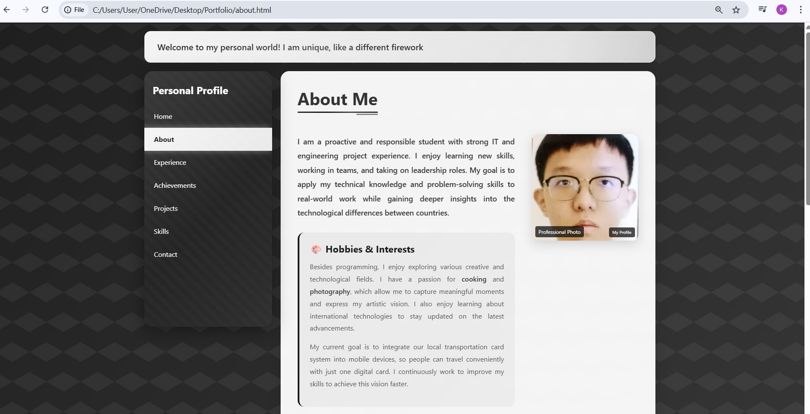
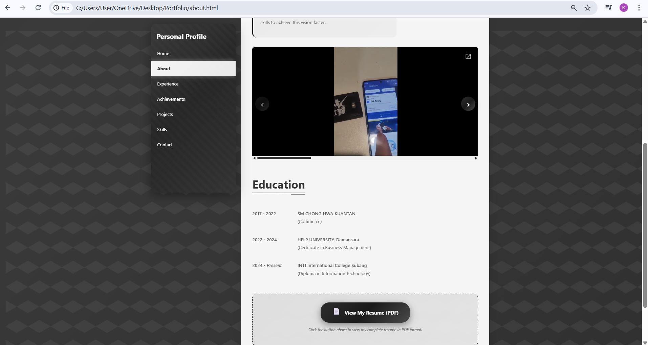

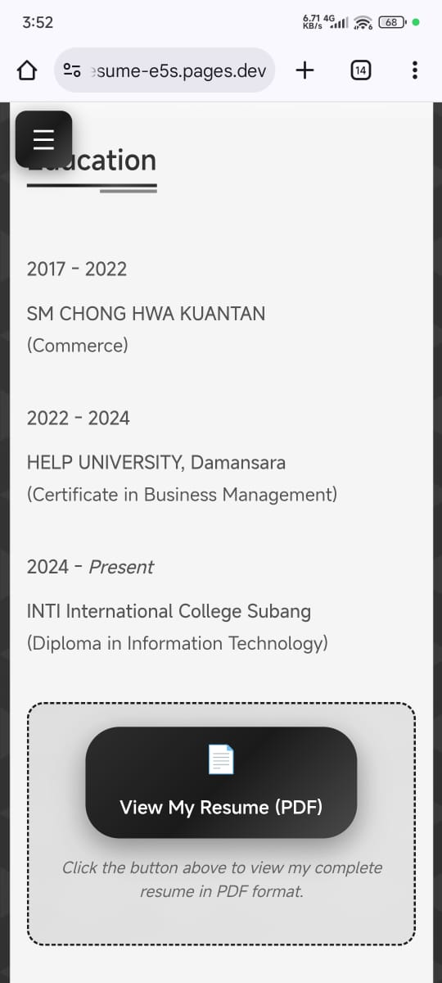
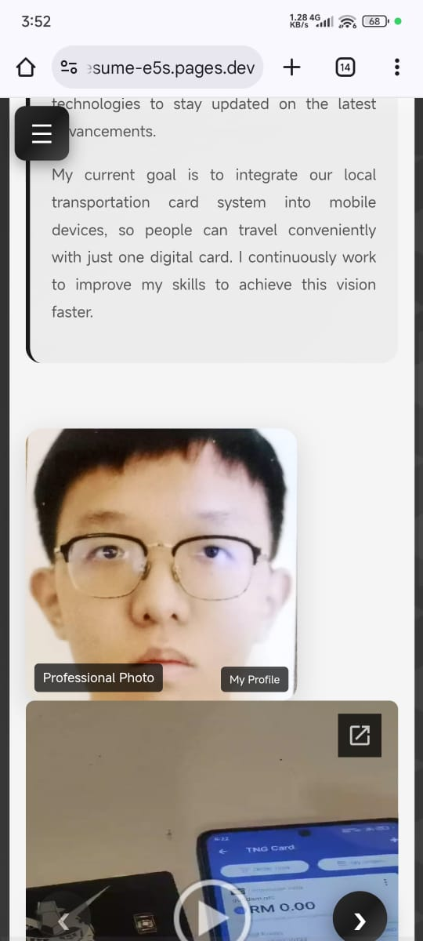
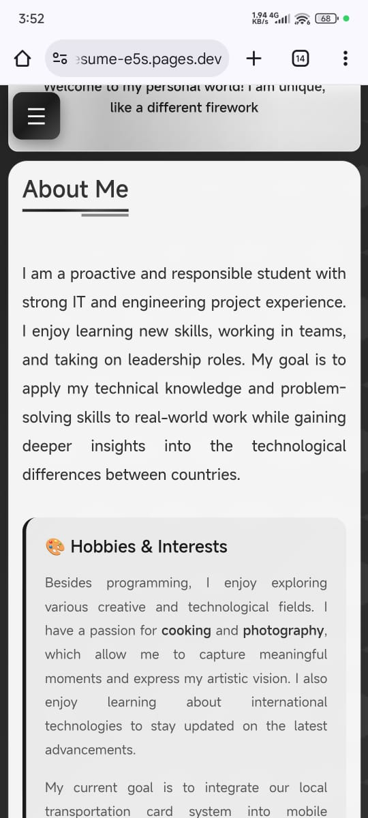
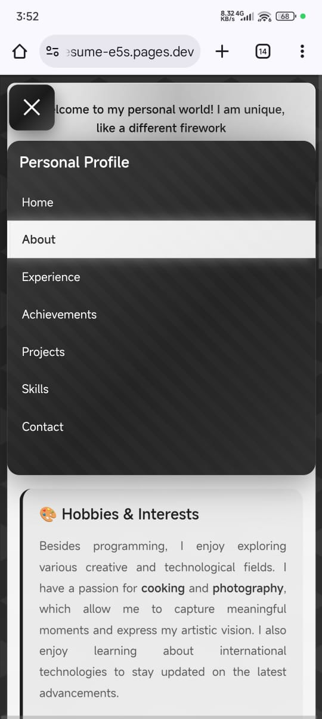
Mobile View

7.3 Experiences Page
Desktop View
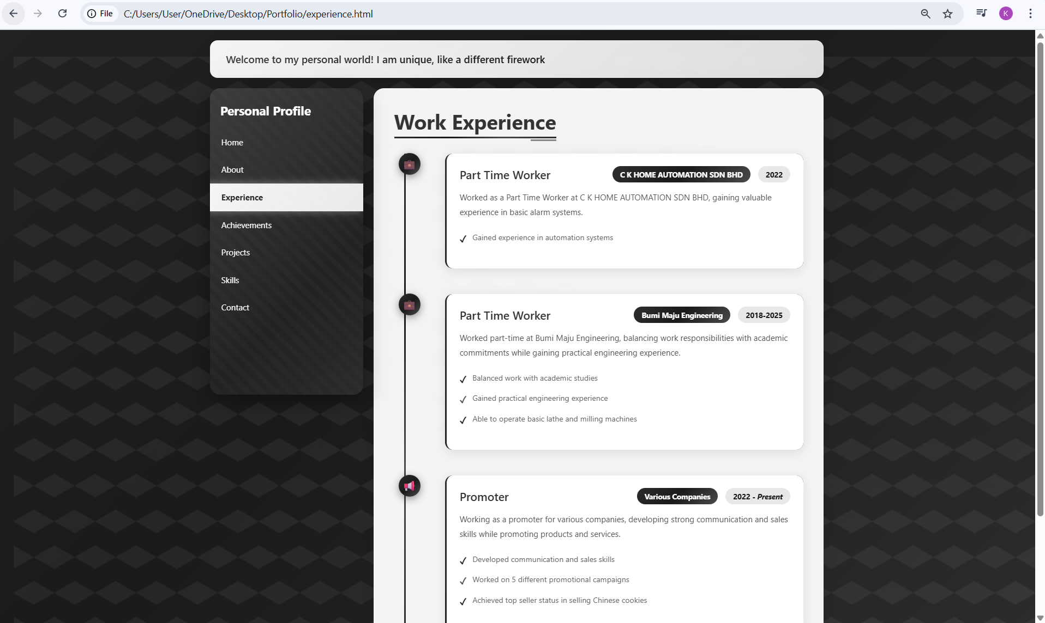

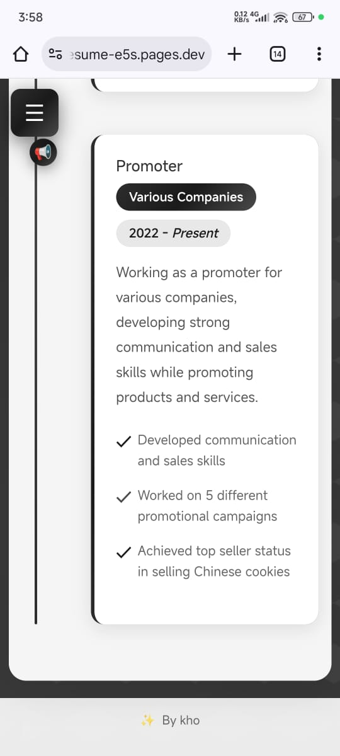
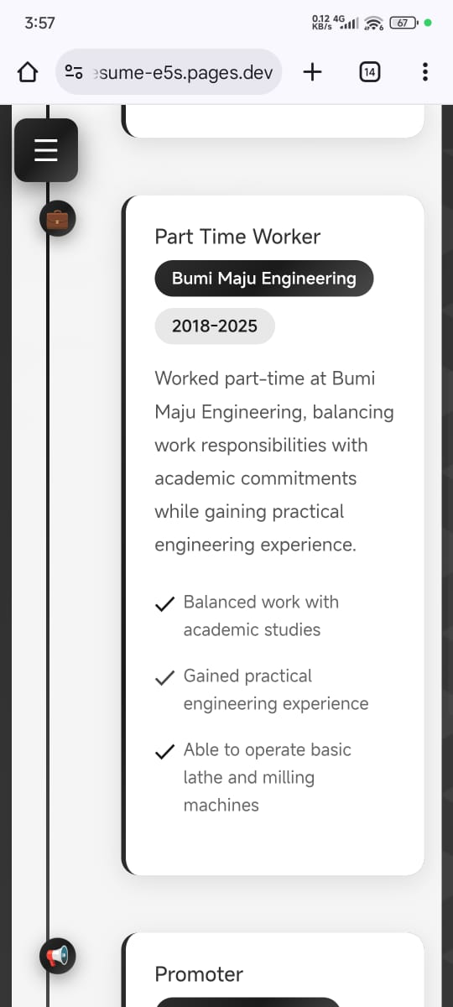
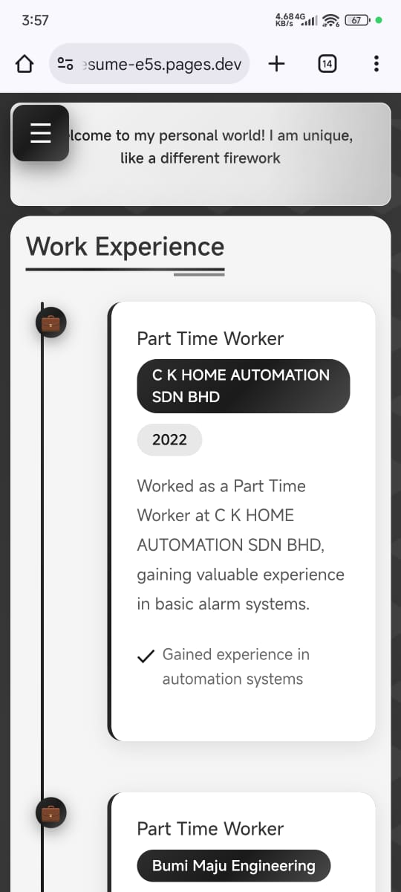
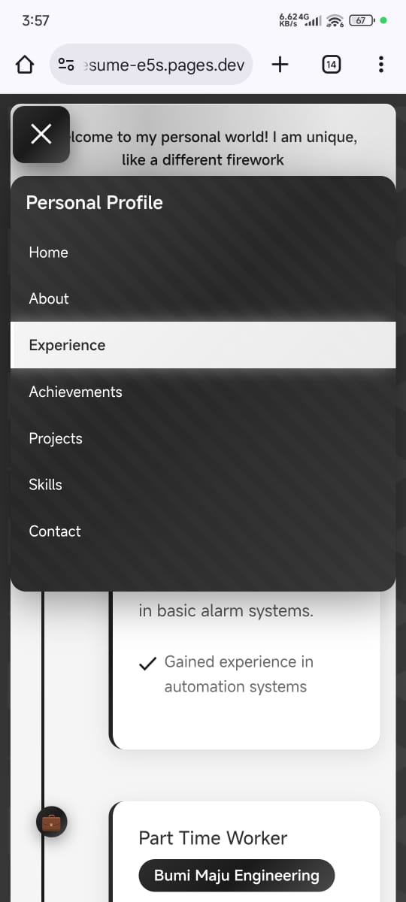
Mobile View

7.4 Achievements Page
Desktop View
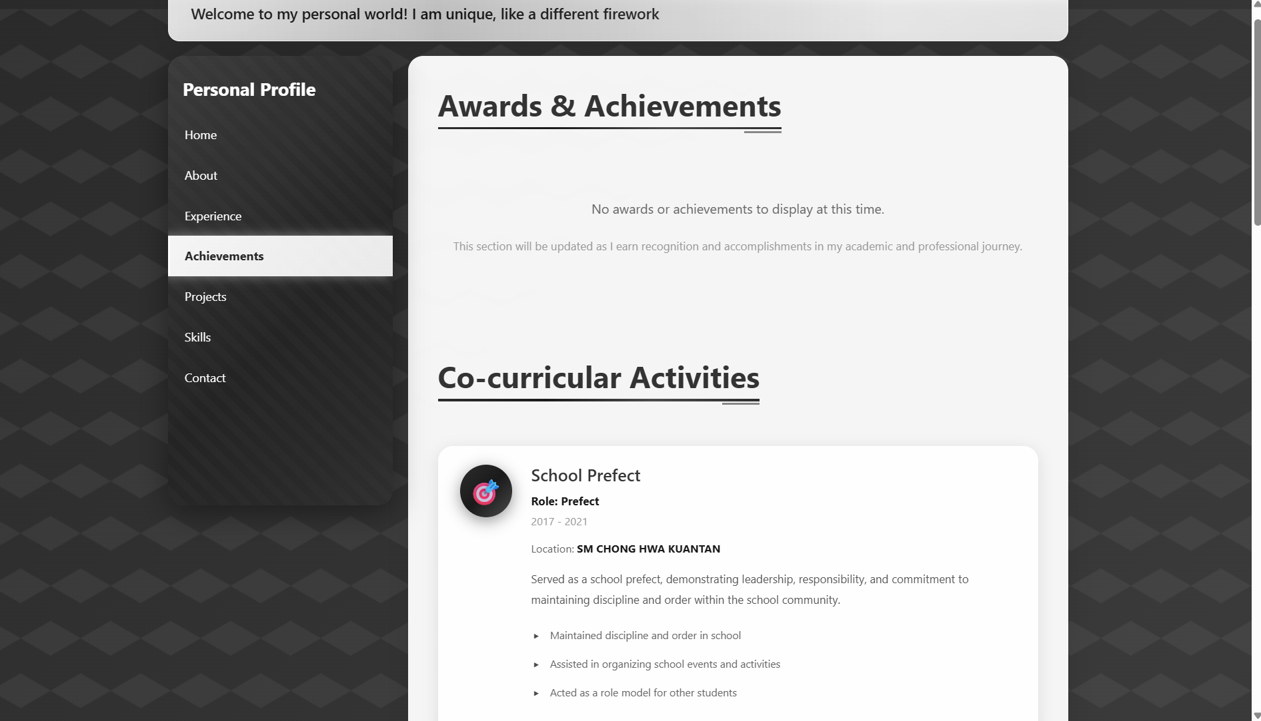
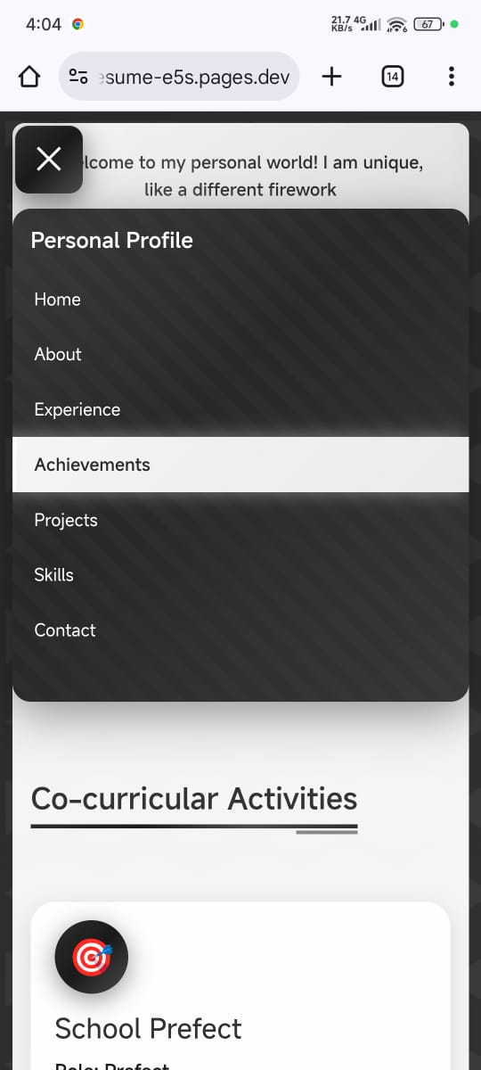
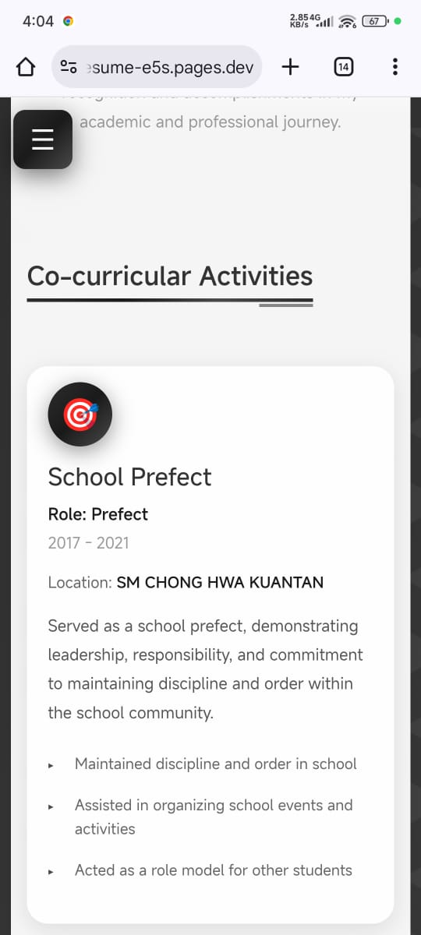
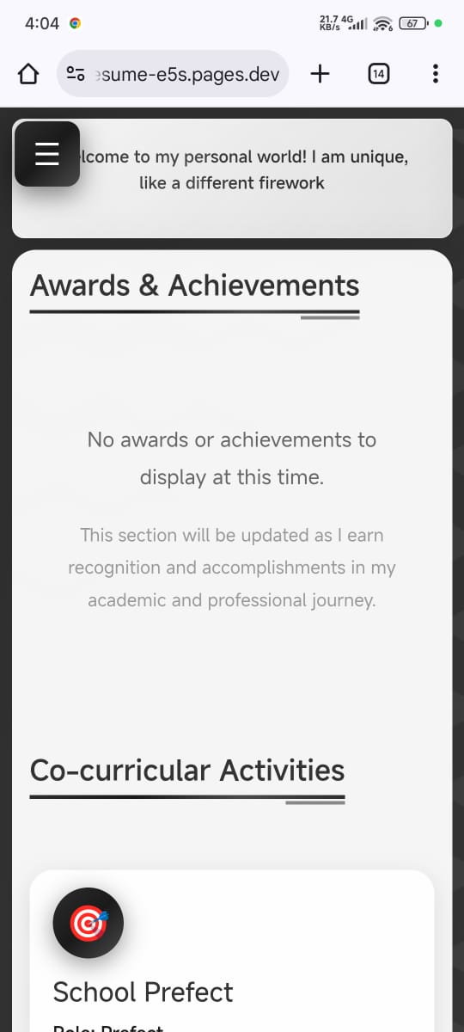
Mobile View

7.5 Project Page
Desktop View
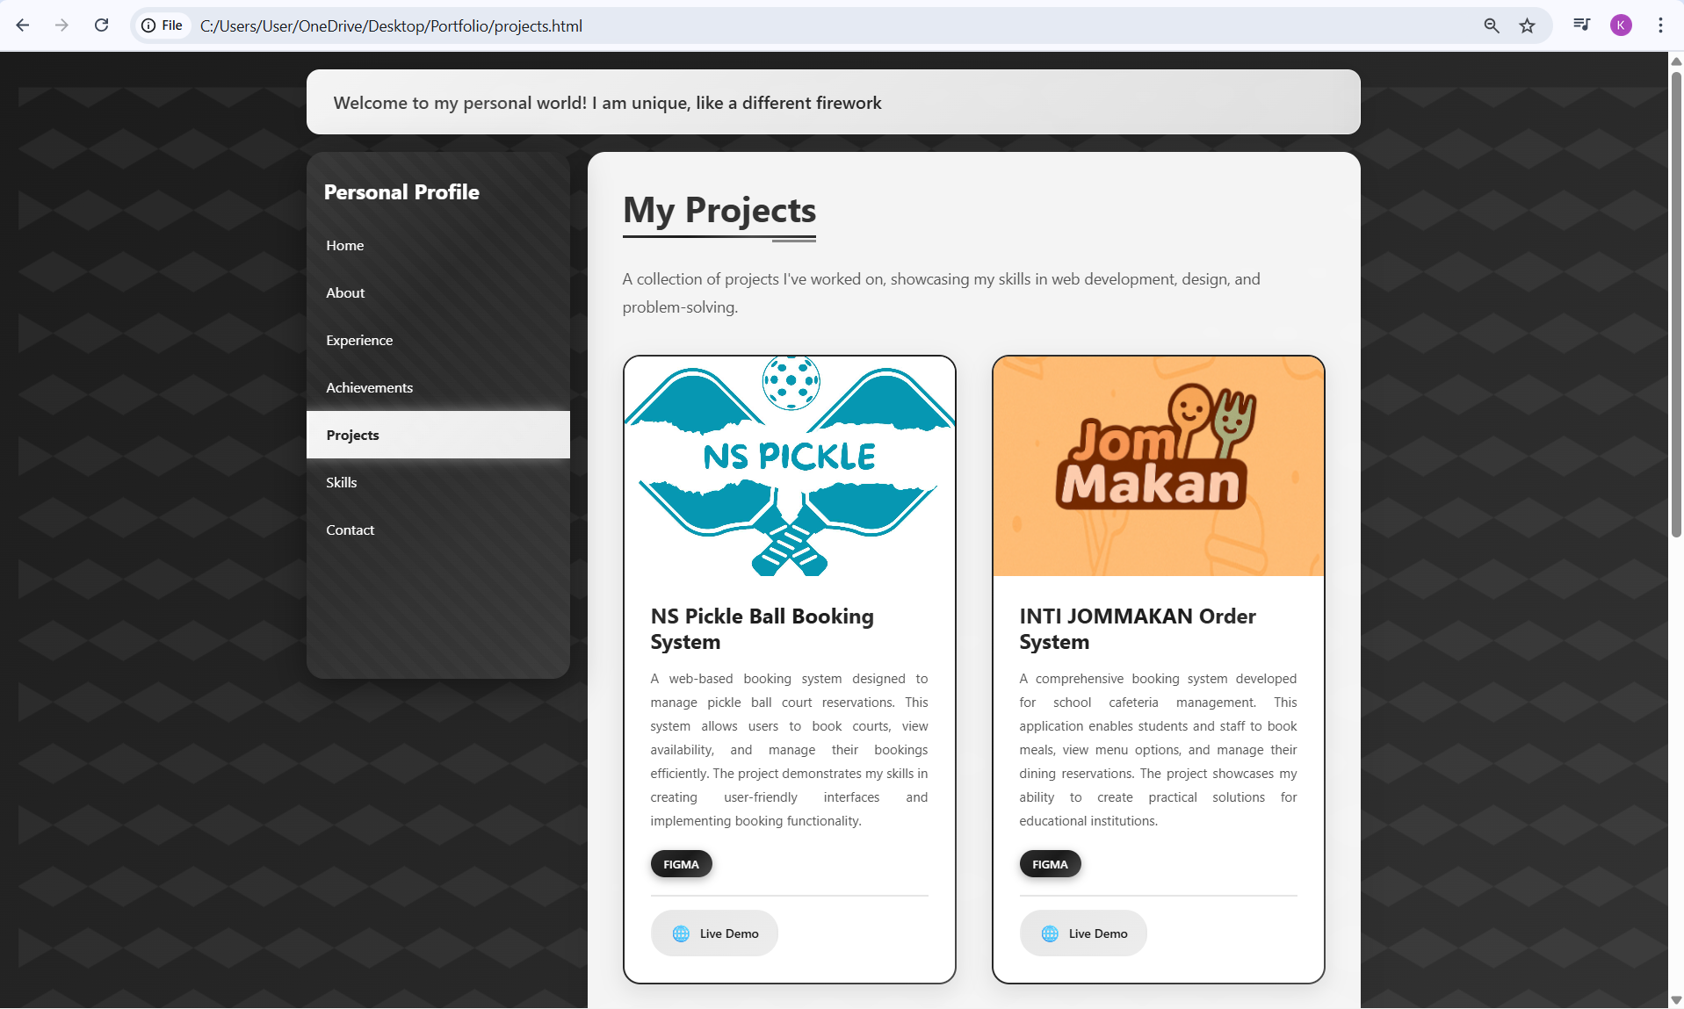
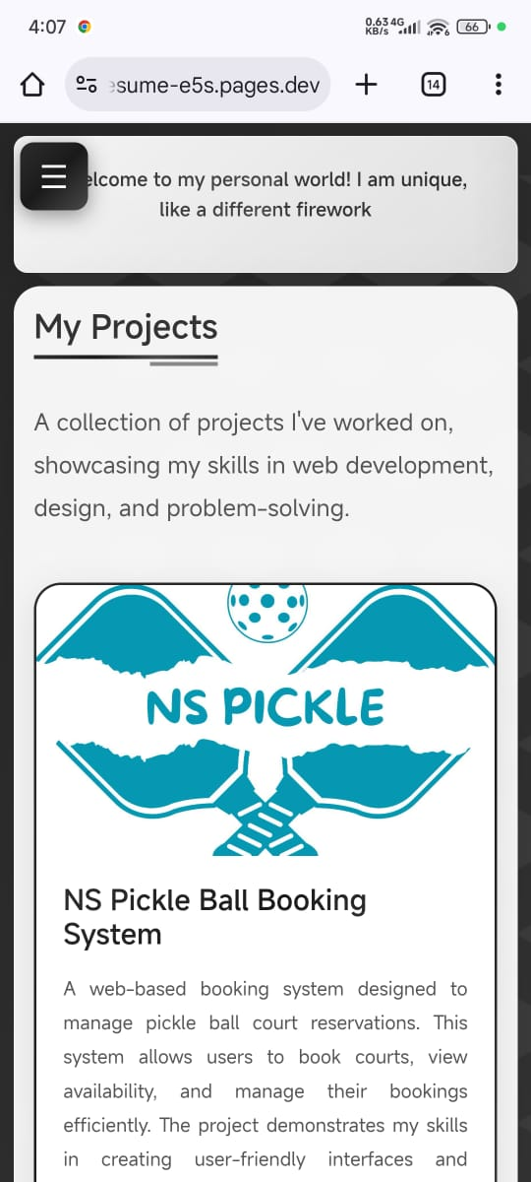
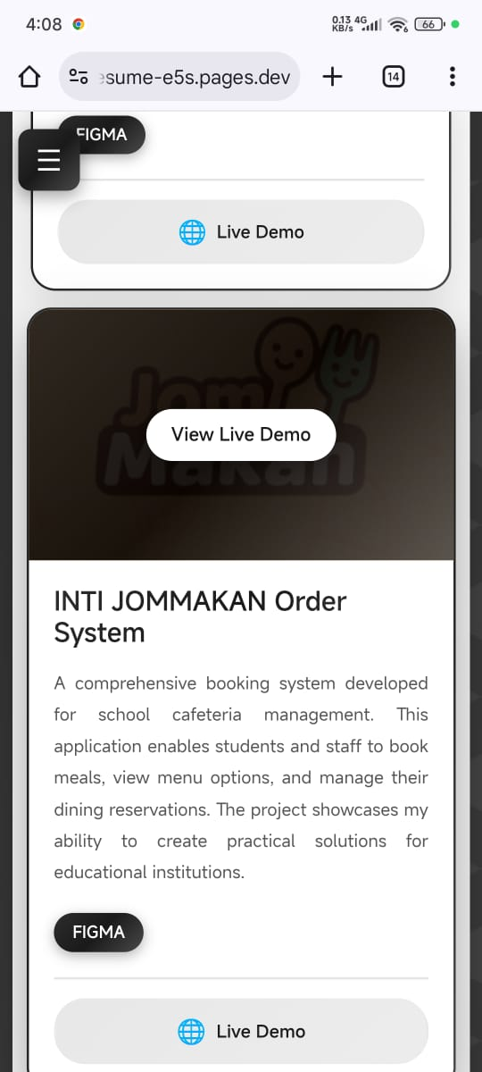
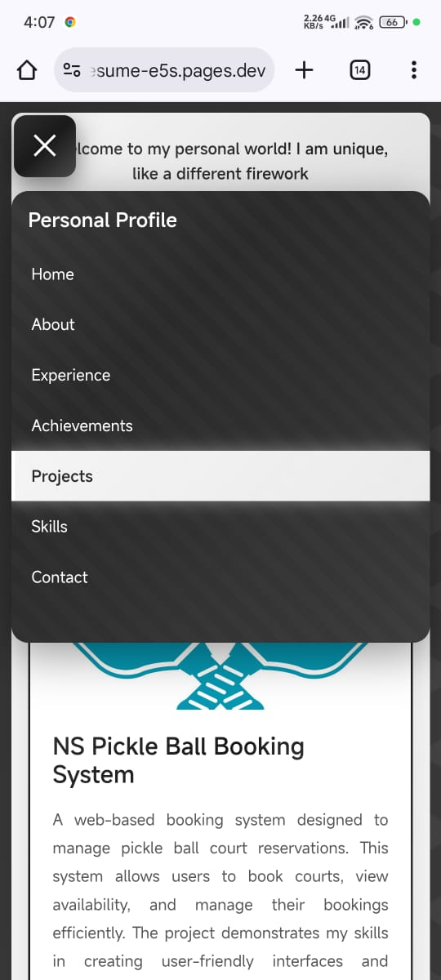
Mobile View

7.6 Skills Page
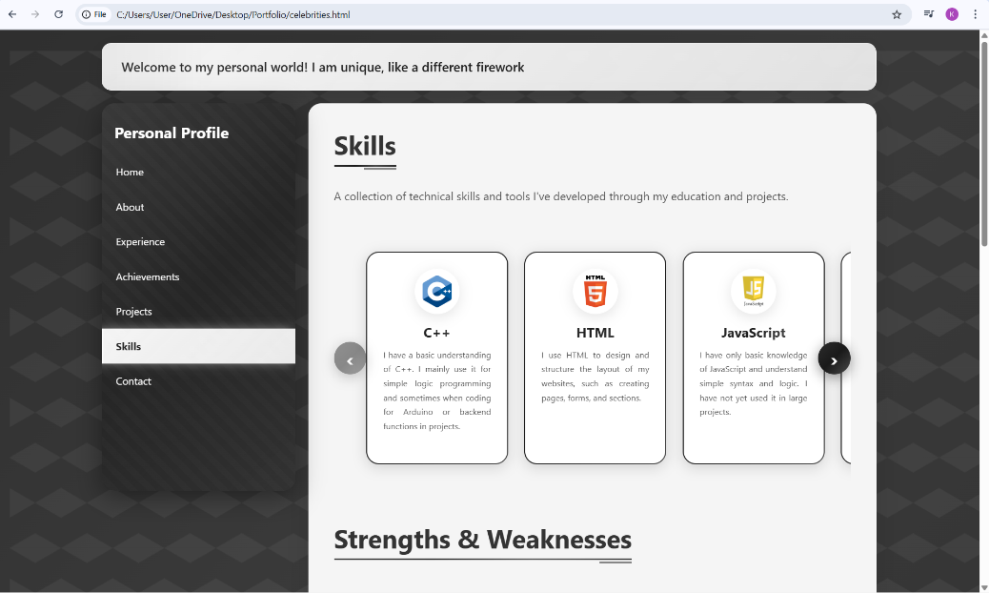
Desktop View

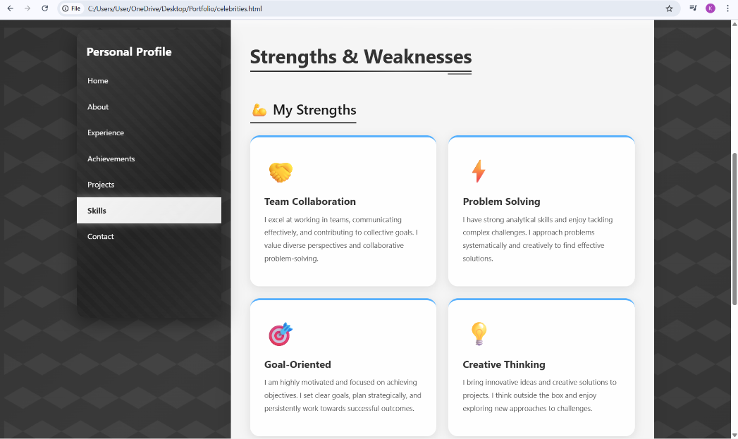
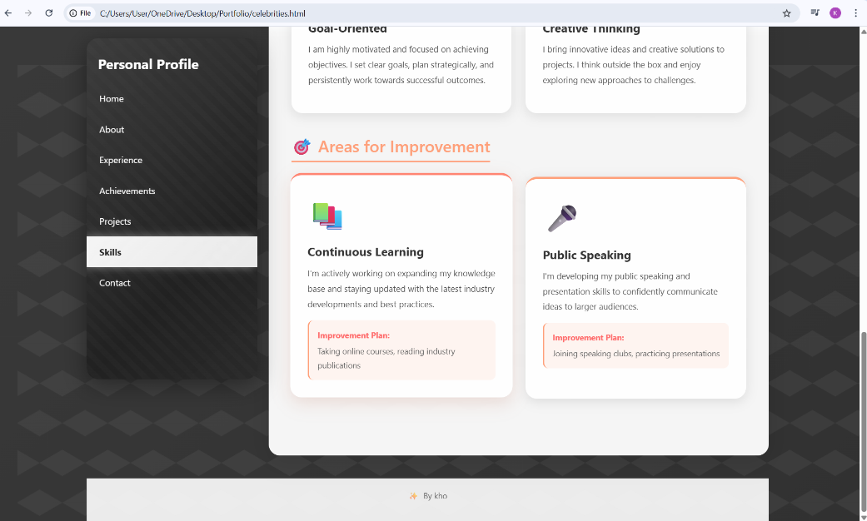
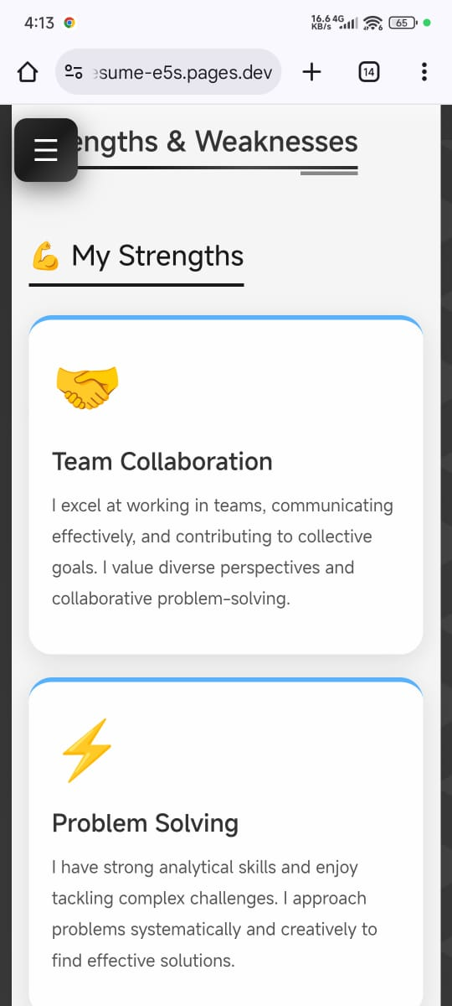
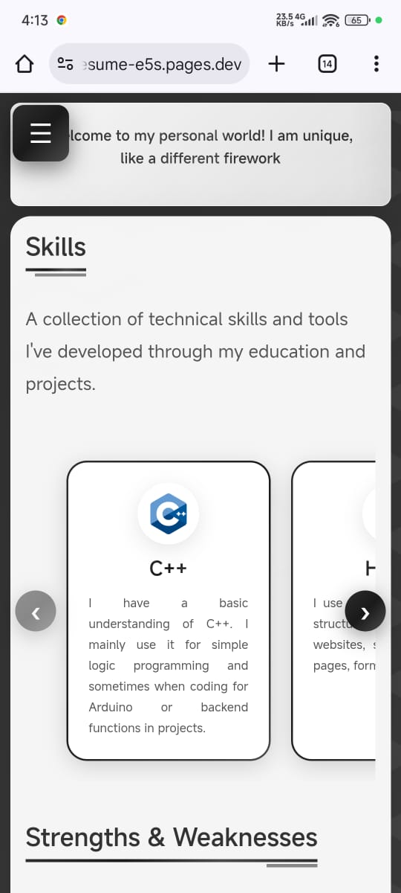
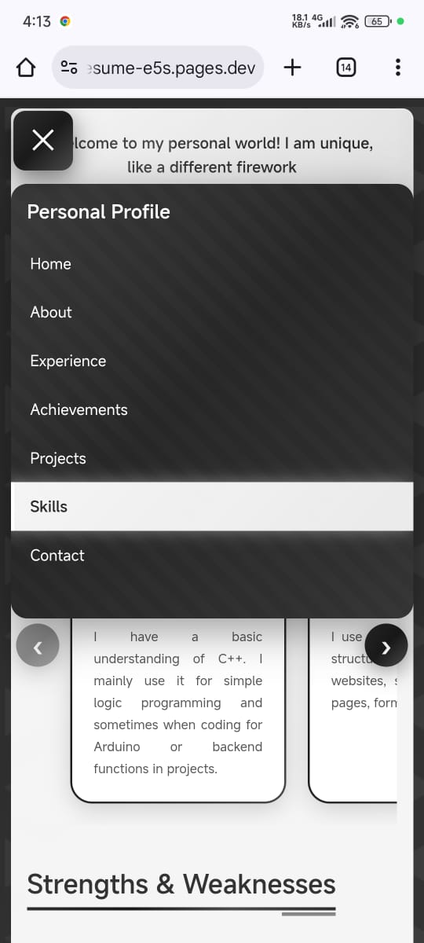
Mobile Page
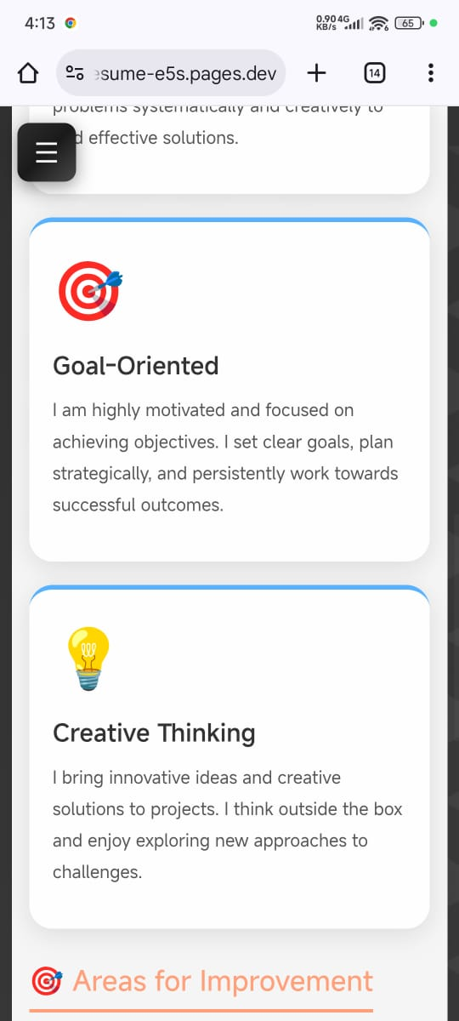
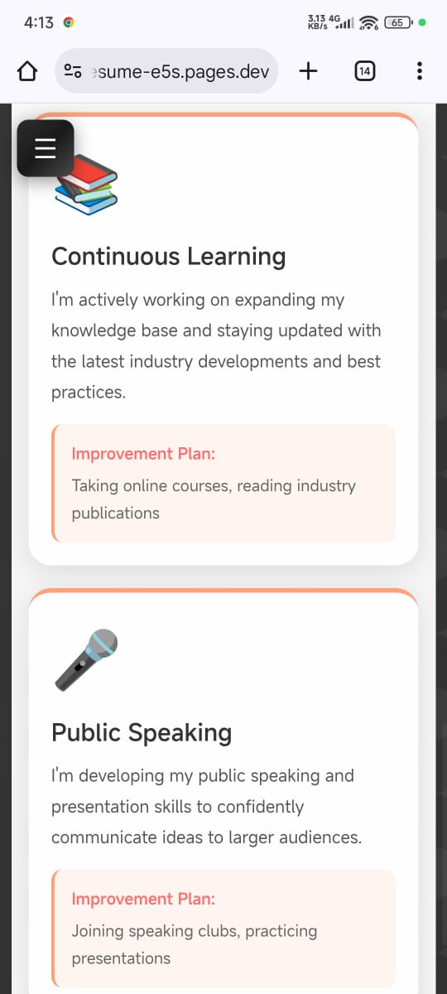

7.7 Contact Page
Desktop Page
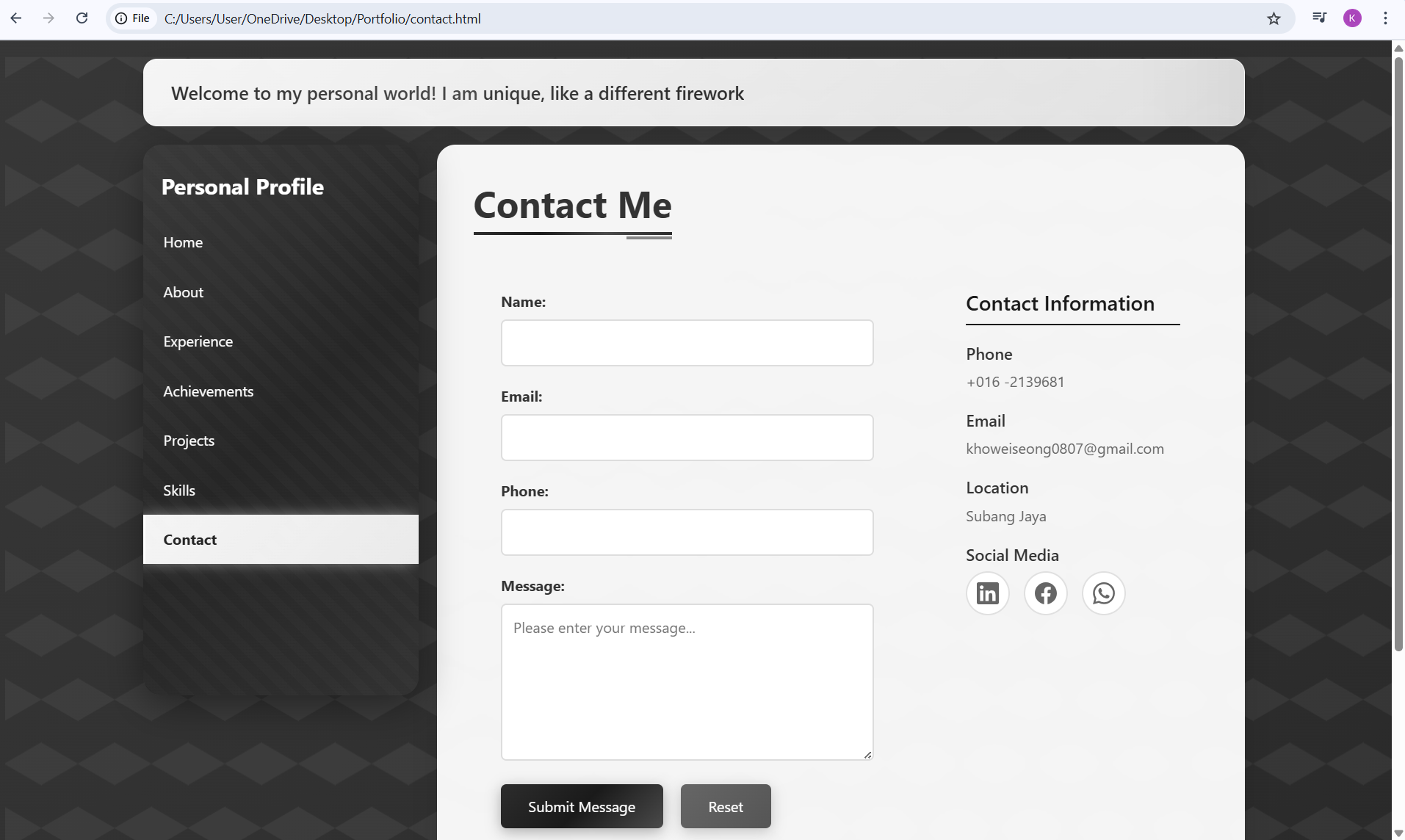
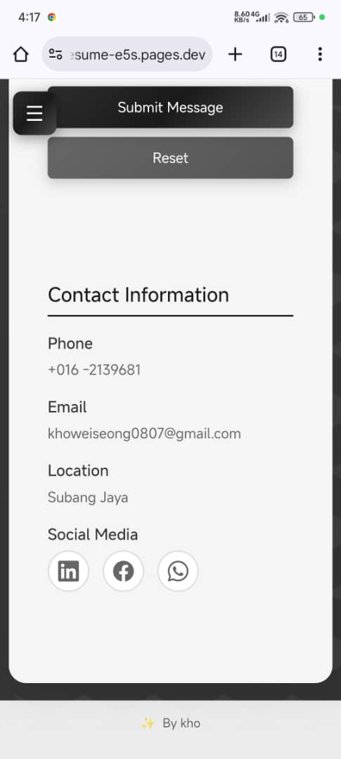
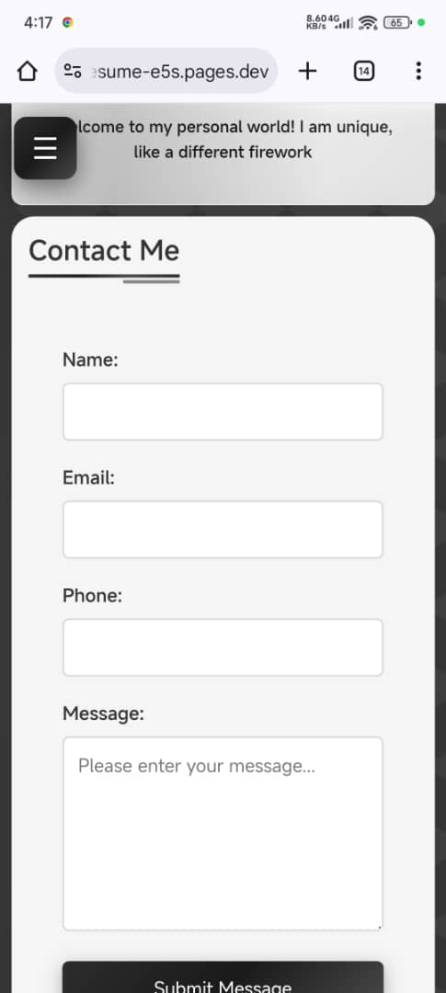
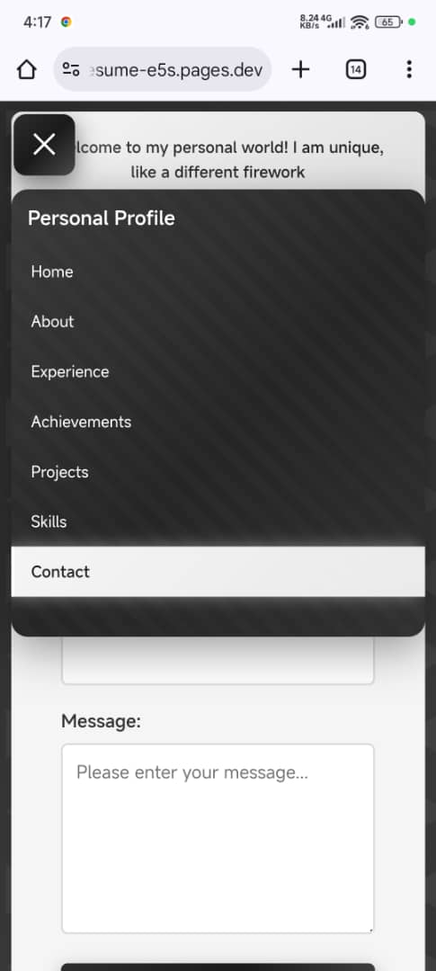
Mobile Page

8.0 CHALLENGES AND SOLUTIONS
Technical Challenges
Challenge 1: Mobile Menu Toggle
The sidebar needed to hide on mobile and show via a toggle. It was hidden by default on small screens using a CSS class. JavaScript toggles the class on button click and changes the icon. Clicking outside closes the menu.
Solution:
A mobile-hidden class hides the sidebar on screens ≤768px. JavaScript uses getElementById() and querySelector() to select elements, classList.toggle() to show/hide (Mmdn, 2018) , and addEventListener() for click events (W3Schools, 2019). A document clicks listener closes the menu when clicking outside. The button icon switches between ☰ and ✕. Media queries handle responsive behaviour (Mmdn, 2005)
.
Challenge 2: Horizontal Scrolling Galleries
The skills and projects galleries needed smooth horizontal scrolling. A container with horizontal scrolling was used. JavaScript buttons scroll the content smoothly. Buttons disable at the start or end of the scroll.
Solution:
The container uses overflow-x: auto and scroll-behavior: smooth. JavaScript buttons use scrollBy() with smooth behavior (Mmdn, 2025). An updateButtonVisibility() function checks scroll position via scrollLeft, scrollWidth, and clientWidth to enable/disable buttons (W3school, 2018). Opacity and pointerEvents provide visual feedback.

Design Challenges
Challenge 1: Responsive Layout
The layout needed to work on different screen sizes. Custom media queries were added at 768px, 480px, and 360px. Flexbox and CSS Grid adjust columns automatically. On mobile, grids switch to fewer columns and fonts get smaller.
Solution:
Media queries at 768px, 480px, and 360px adjust layouts (Mozilla.org, 2025). Flexbox handles the main container and navigation (Coyier, 2018). CSS Grid with repeat(auto-fit, minmax()) creates responsive grids. On mobile, grids switch to 1–2 columns, fonts scale down, buttons become full width, and forms stack vertically (House, 2021). The auto-fit and minmax() functions adjust columns based on available space.

Challenge 2: Glassmorphism Effect
A frosted glass effect was desired. CSS backdrop-filter: blur(10px) creates the effect. Semi-transparent backgrounds keep text readable.
Solution:
backdrop-filter: blur(10px) creates the blur. -webkit-backdrop-filter improves browser compatibility. Semi-transparent backgrounds (rgba(255, 255, 255, 0.95)) maintain readability. The effect is applied to content areas like the main content container and top info bar (Mmdn, 2025)
.

9.0 CONCLUSION AND REFLECTION
What I Learned
I learned how to build a responsive portfolio website using HTML, CSS, Bootstrap, and JavaScript. I used semantic HTML for structure, CSS for styling and animations, and JavaScript for interactivity. I applied Flexbox and CSS Grid for layouts, media queries for responsiveness, and JavaScript event handling for features like the mobile menu and scrolling galleries. I also used CSS techniques like glassmorphism and gradient borders, and organized code with comments and consistent naming.

Most Challenging Parts
The most challenging parts were implementing the mobile menu toggle and ensuring the layout worked across devices. The mobile menu required JavaScript to toggle visibility, handle outside clicks, and change the button icon. Responsive design needed careful media queries and testing on different screen sizes to ensure proper display.

Most Enjoyable Parts
The most enjoyable parts were designing the visual effects and seeing the site come together. Creating animations, glassmorphism, and hover effects was satisfying. Seeing the result with smooth interactions and a cohesive design was rewarding.

Future Improvements
I would improve the contact form with backend integration for real submissions, add more interactive features like animations on scroll, optimize images for faster loading, add a dark/light mode toggle, improve accessibility with more ARIA labels and keyboard navigation, add more projects and content as I continue learning, and optimize performance by minifying CSS and JavaScript files. These improvements would make the website more functional, accessible, and user-friendly.

10.0 REFERENCES
- Mmdn (2018). Element.classList - Web APIs | MDN. [online] developer.mozilla.org. Available at: https://developer.mozilla.org/en-US/docs/Web/API/Element/classList [Accessed 8 Nov. 2025].
- Mmdn (2005). EventTarget.addEventListener(). [online] MDN Web Docs. Available at: https://developer.mozilla.org/en-US/docs/Web/API/EventTarget/addEventListener.
- W3Schools (2019). JavaScript Events. [online] W3schools.com. Available at: https://www.w3schools.com/js/js_events.asp.
- Mmdn (2025). Element: scrollBy() method - Web APIs | MDN. [online] Mozilla.org. Available at: https://developer.mozilla.org/en-US/docs/Web/API/Element/scrollBy [Accessed 9 Nov. 2025].
- W3school (2018). CSS Overflow. [online] www.w3schools.com. Available at: https://www.w3schools.com/css/css_overflow.asp [Accessed 5 Nov. 2025].
- Coyier, C. (2018). A Complete Guide to Flexbox | CSS-Tricks. [online] CSS-Tricks. Available at: https://css-tricks.com/snippets/css/a-guide-to-flexbox/.
- House, C. (2021). A Complete Guide to Grid. [online] CSS-Tricks. Available at: https://css-tricks.com/snippets/css/complete-guide-grid/.
- Mmdn (2025). backdrop-filter - CSS | MDN. [online] Mozilla.org. Available at: https://developer.mozilla.org/en-US/docs/Web/CSS/Reference/Properties/backdrop-filter [Accessed 9 Nov. 2025].
- Mozilla.org. (2025). CSS media queries - CSS | MDN. [online] Available at: https://developer.mozilla.org/en-US/docs/Web/CSS/Guides/Media_queries [Accessed 9 Nov. 2025].
- https://cdn.jsdelivr.net/npm/bootstrap@5.3.2/dist/js/bootstrap.bundle.min.js.
- https://cdn.jsdelivr.net/npm/bootstrap@5.3.2/dist/css/bootstrap.min.css

