Das hier ist eine

**Kopie vom github-Copilot.**

Das Kopieren vom VisualStudioCode CoPilot ist nicht so einfach. Da werden die angeführten Kommandos nicht mitkopiert.

used github about 2 years ago. An hour ago I commited a directory (16 files, with Git Extensions) named "invgen". Now I logged in to github (I selected a new password) but the invgen directory is not visible. Git Extensions uses the OpenSSH. Using GIT Gui i have created an openSSH Key, named ".ssh\id_rsa" and ".ssh\id_rsa.pub". My question: I cannot find the invgen directory. Where is it? I see it in git extensions and Visual Studio but not in github.com. Maybe there is a connection via the rsa keys.

**Copilot said: Let's break down your situation and help**

Let's break down your situation and help you find your "invgen" directory on GitHub.

**What Might Be Happening**

**1. Local Commit vs. Pushed Commit**

* **Git Extensions and Visual Studio** show the "invgen" directory because you **committed locally**.
* **GitHub.com** only displays files that have been **pushed to the remote repository**.

**2. SSH Keys & Authentication**

* You created SSH keys (id_rsa and id_rsa.pub) for authentication.
* If your SSH keys are set up properly and added to your GitHub account, you should be able to push using Git Extensions or other git tools.

**3. Directory Not Visible on GitHub.com**

* If "invgen" is not visible in your repository on GitHub.com, your commit **has not been pushed** to GitHub.

**Steps to Troubleshoot & Fix**

**Step 1: Check Your Local vs. Remote Status**

Open Git Extensions or your terminal and run:

bash

git status

* If your branch is **ahead of origin/main (or master)** by some commits, it means you haven't pushed yet.

**Step 2: Try to Push Your Commit**

In Git Extensions, there should be a "Push" button. Or use the command line:

bash

git push origin main

*(Replace main with your branch name if different.)*

**Step 3: Check Your SSH Key Setup**

* Go to [GitHub SSH Keys Settings](https://github.com/settings/keys) and make sure your id_rsa.pub is added.
* If not, copy the contents of .ssh/id_rsa.pub and add it as a new key.

**Step 4: Verify Remote Repository**

* In your local repo, run:

bash

* git remote -v
* This shows where your repo is connected. Make sure it's your intended GitHub repository.

**Step 5: Refresh GitHub.com**

* After pushing, refresh your repository page on GitHub.com. The "invgen" directory should now appear.

**Summary**

**Main reason:** Your changes are likely committed locally but not pushed to GitHub. **Solution:**

1. Ensure your SSH key is added to GitHub.
2. Push your changes using Git Extensions or command line.
3. Check the repository on GitHub.com again.

If you still have trouble, let me know what you see when you run git status and git remote -v, or if there are any error messages when you try to push!

**You said: Your advice sounds good. I have addedhe**

Your advice sounds good. I have addedhe SSH Key to github. How I can push the changes in git extension (or visual studio or the command line)?

**Copilot said: Great! Since your SSH key is added**

Great! Since your SSH key is added to GitHub, you’re ready to push your changes. Here’s how to do it in each tool:

**1. Git Extensions**

1. **Open your repository in Git Extensions.**
2. Click the **“Commit”** button (if you haven’t already committed; otherwise, skip this).
3. Click the **“Push”** button (usually at the top toolbar).
4. In the dialog, make sure the remote is set to origin and the branch is correct (main or your branch name).
5. Click **“Push”**.

**2. Visual Studio**

1. Open your project.
2. Go to **View → Git Repository Window**.
3. Commit your changes if needed.
4. Click the **“Push”** button (usually labeled as "Push to Remote" or just "Push").
5. It may ask for credentials; since you have SSH, it should use your key automatically.

**3. Command Line (Git Bash or Terminal)**

1. Open the terminal in your repo directory.
2. If you have not committed yet:

bash

• git add .

git commit -m "Add invgen directory"

• Push your branch:

bash

1. git push origin main
2. *(Replace main with your branch name if different.)*

**What to expect**

* If successful, you’ll see your changes on GitHub.com in your repository.
* If there’s an error, let me know the message you see.

Would you like step-by-step screenshots or guidance for any specific tool?

**You said: I am not finished with my question,**

I am not finished with my question, sory: I tried it in git extensions, I got the following response: "C:\Program Files\Git\bin\git.exe" push --recurse-submodules=check --progress "invgen" refs/heads/main:refs/heads/main Everything up-to-date Done Press Enter or Esc to exit... This looks quuite okay but the new repository "invgen" is srtill missing. Maybe I should first initialise the repository?

**Copilot said: Thanks for the additional info! Your situation**

Thanks for the additional info! Your situation is now much clearer. Here’s what’s happening and how to fix it:

**What's Happening**

* **"Everything up-to-date"** means Git thinks there are no new changes to push to the remote repository.
* You mentioned a **new repository "invgen"**—but it sounds like you have only committed it locally and may not have set up a remote repository on GitHub yet.
* **You must initialize the repository on GitHub and connect your local repo to the remote.**

**Step-by-Step Solution**

**1. Create the Repository on GitHub**

1. Go to [github.com/new](https://github.com/new).
2. Name your repository **invgen**.
3. (Optional) Add a description, set it to public or private.
4. Click **Create repository**.

**2. Connect Your Local Repo to the Remote**

In your local Git repo (using Git Extensions, Command Line, or Visual Studio):

**Command Line Example:**

Replace weiserj with your GitHub username if different.

bash

git remote add origin git@github.com:weiserj/invgen.git

**Git Extensions:**

* Find the option to **add remote** (usually in the Repository menu or right-click repo in the sidebar).
* Paste the SSH URL from your GitHub repo (git@github.com:weiserj/invgen.git).

**3. Push Your Local Commits to GitHub**

Now push your changes:

bash

git push -u origin main

*(Replace main with your branch name if different.)*

**4. Check GitHub.com**

Refresh your repository page. You should now see the **invgen** directory and all your files.

**Summary**

* You need to create the repository on GitHub first!
* Then, link your local repository to the remote using git remote add origin ....
* Finally, push your files.

**If you need exact commands or want help using Git Extensions or Visual Studio for these steps, let me know!**

XXXXXXX

Der CoPilot von VisualSutdioCode:

Ein Bild vom Kopilot:

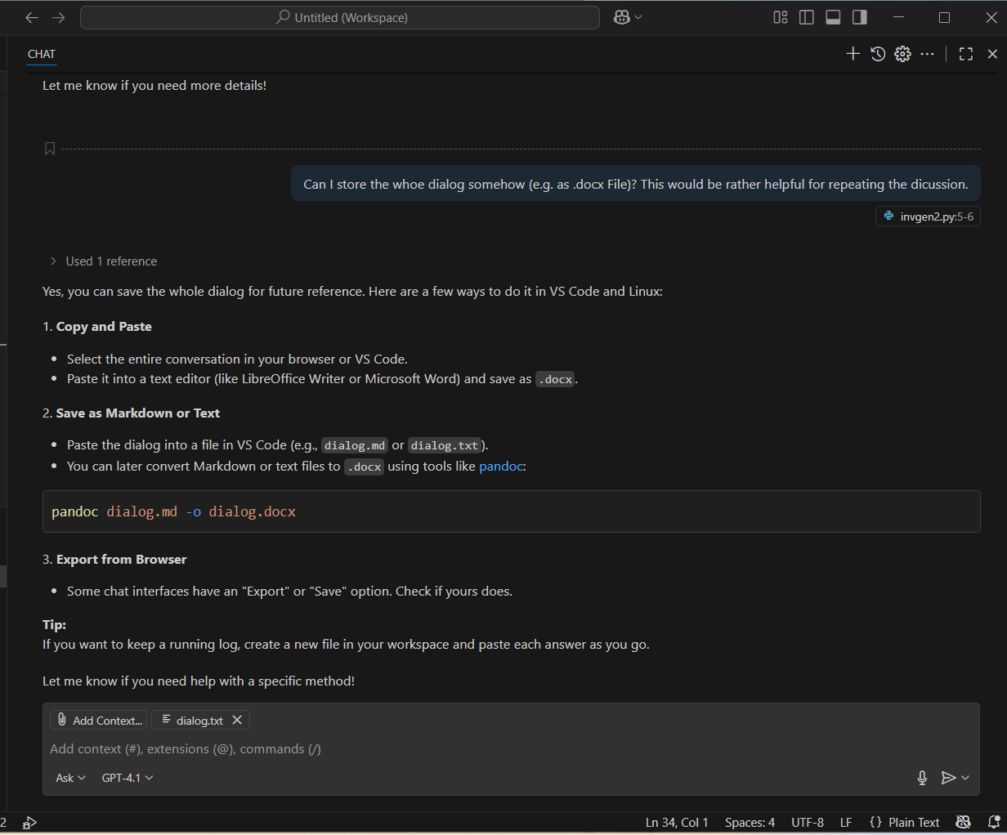

Der Versuch einer Kopie:

Can I store the whoe dialog somehow (e.g. as .docx File)? This would be rather helpful for repeating the dicussion.

Yes, you can save the whole dialog for future reference. Here are a few ways to do it in VS Code and Linux:

### 1. ****Copy and Paste****

* Select the entire conversation in your browser or VS Code.
* Paste it into a text editor (like LibreOffice Writer or Microsoft Word) and save as .docx.

### 2. ****Save as Markdown or Text****

* Paste the dialog into a file in VS Code (e.g., dialog.md or dialog.txt).
* You can later convert Markdown or text files to .docx using tools like [pandoc](vscode-file://vscode-app/c:/Users/Johann/AppData/Local/Programs/Microsoft%20VS%20Code/resources/app/out/vs/code/electron-browser/workbench/workbench.html" \o "):



### 3. ****Export from Browser****

* Some chat interfaces have an "Export" or "Save" option. Check if yours does.

**Tip:**  
If you want to keep a running log, create a new file in your workspace and paste each answer as you go.

Let me know if you need help with a specific method!

Das bringt eher wenig. Ich habe den Kopilot gefragt, wie man den Chat kopieren kann, aber das bringt auch wenig! Da verrennt er sich irgendwie in Antworten. Ich habe den Eindruck diese Maschinen können irgendwie nicht richtig NEIN sagen, das allein ist auch interessant!!