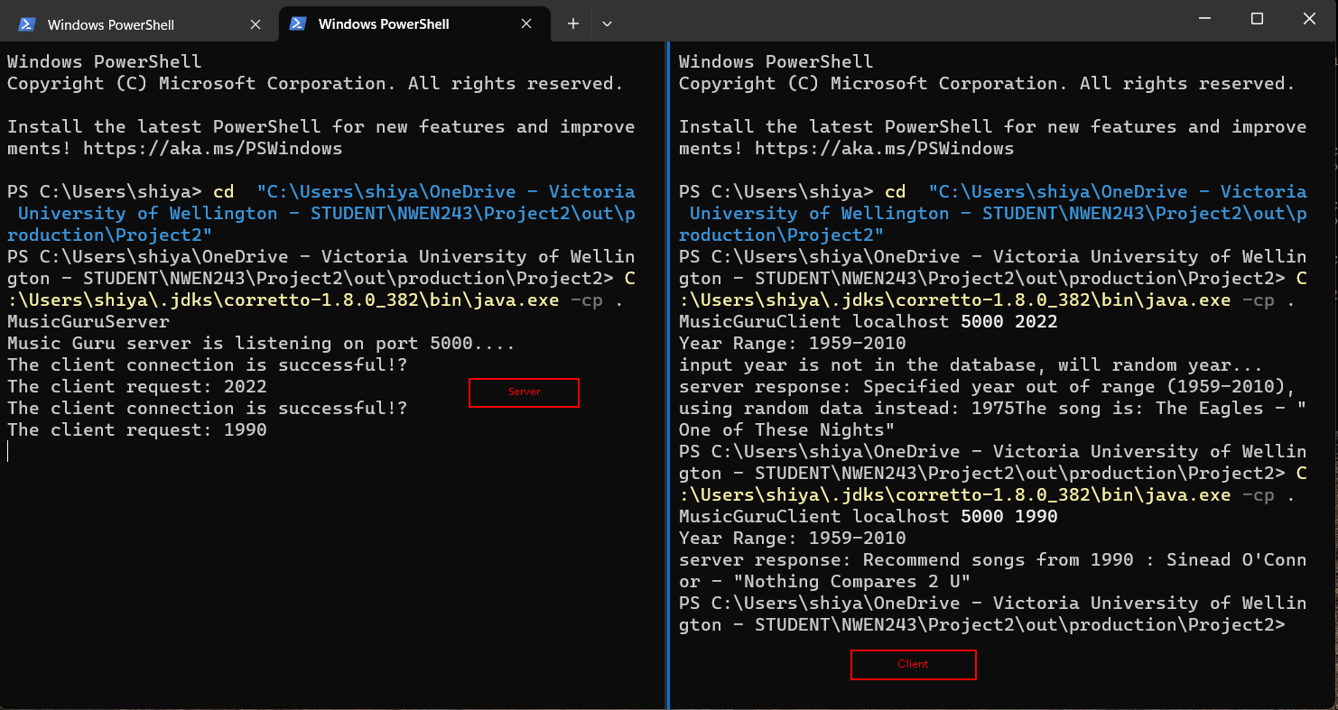

I am running my "Music Guru" code on my local machine. On the right side, I have the server, and on the left side, I have the client. To navigate to my project folder in PowerShell, I am using the "cd" command. Once in the project folder, I am using the "-cp" option to execute my MusicGuruServer code in Java. Next, I will open another PowerShell session to run the client. I will use the same command as I did for the server, but this time, I will execute the client code.

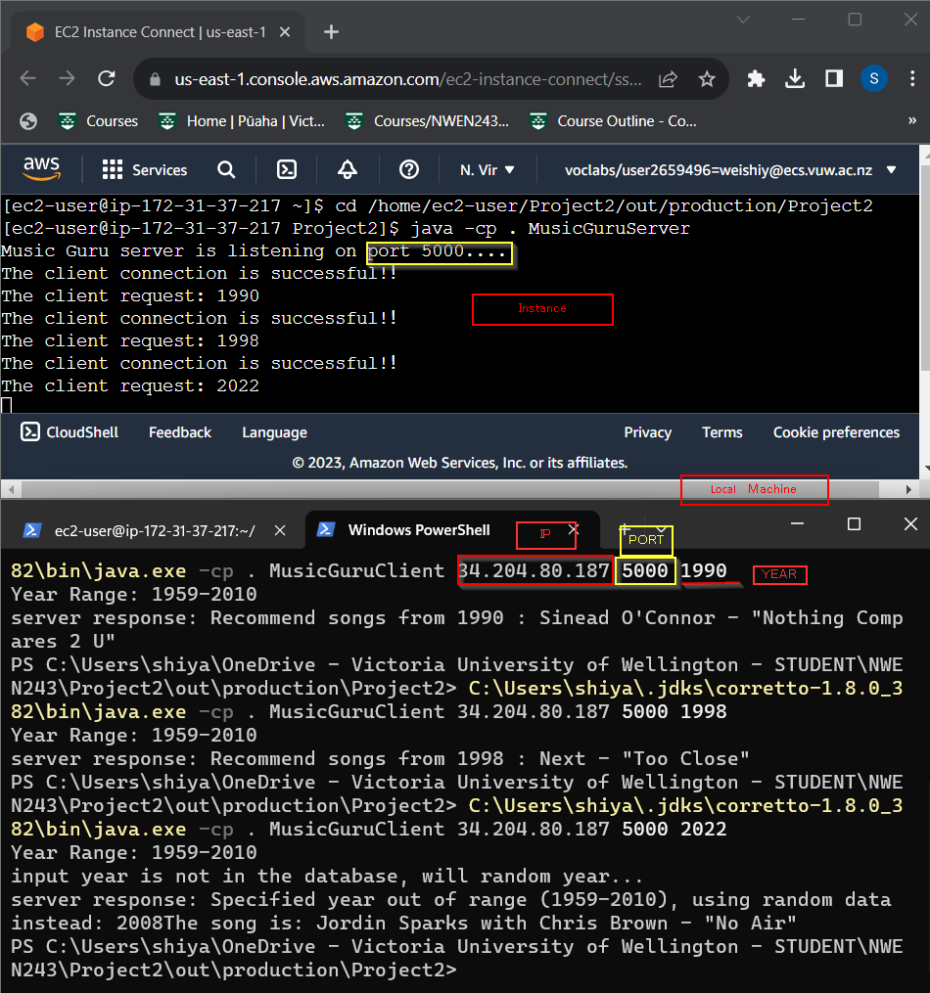

I run my Music Guru code on instance. In the upper part, it is the MusicGuru Server run on instance, and in the lower part, I run MusicGuruClient in my local machine but use instance IP address instead of localhost.

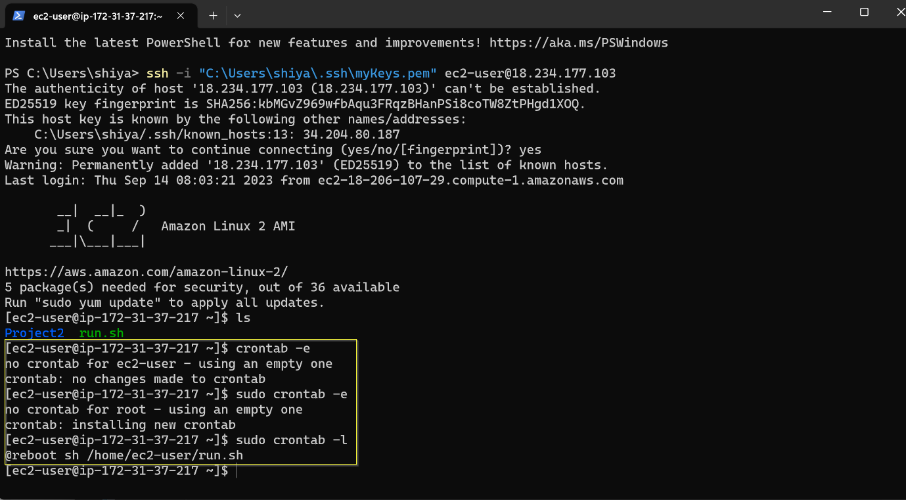

I use ssh to connect my instance in powershell and to show how I configured crontab in the instance. After that, my Music Guru Server will run automatically when the instance starts.

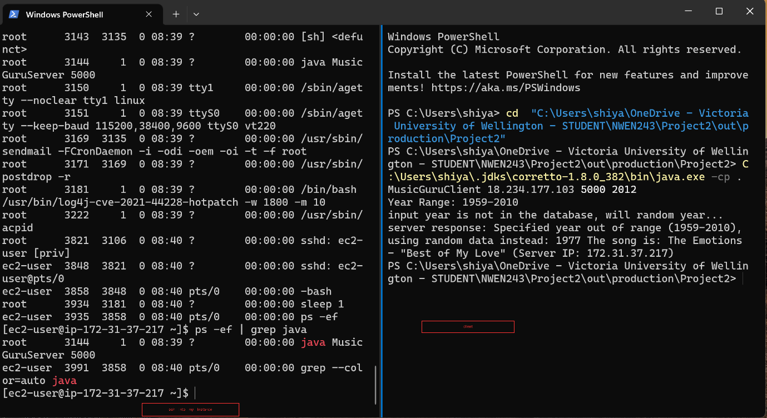

The right side of the image illustrates the successful automatic setup of my instance, while the left side of the image demonstrates my use of a client to establish a connection with the instance.

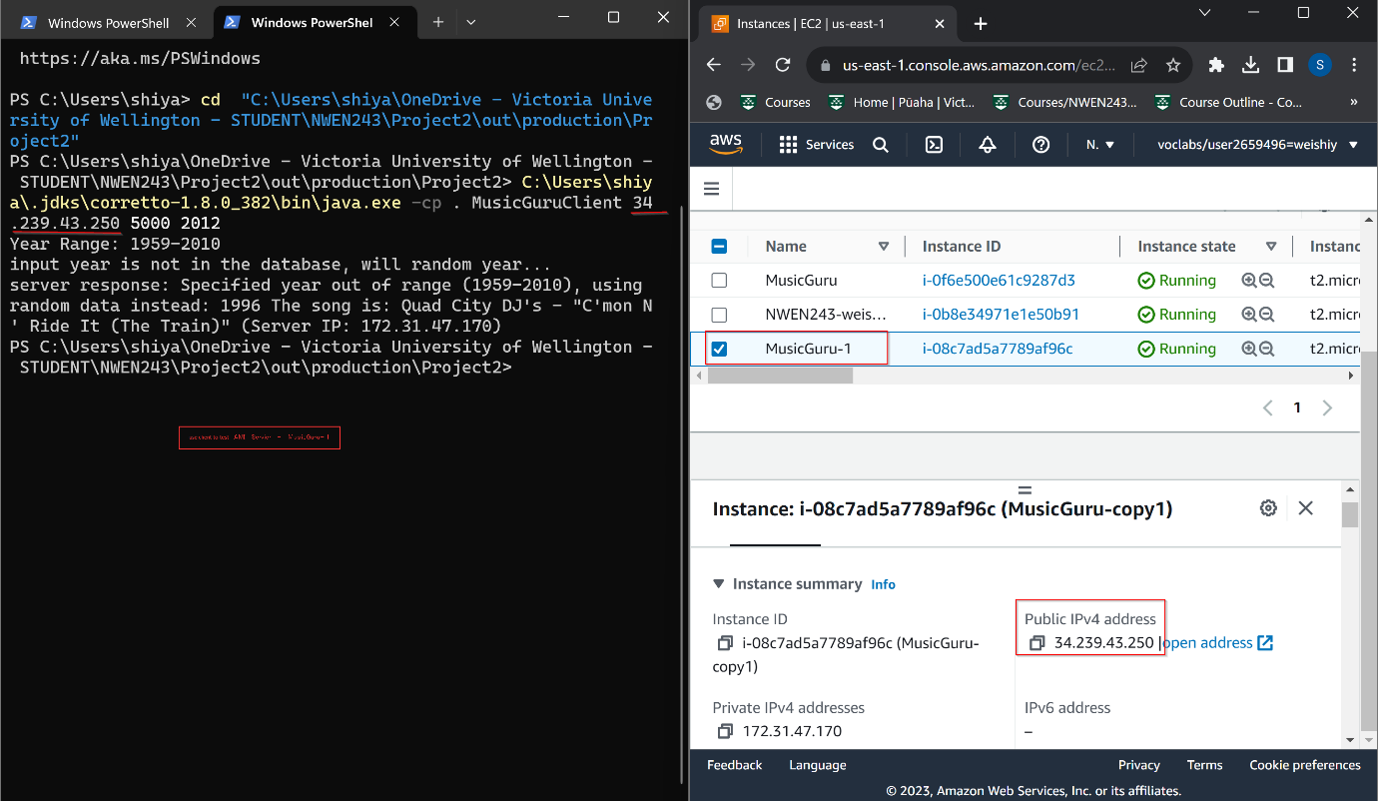

On the left side of the image, I am using a client to test the AMI instance. On the right side of the image, the AWS console page is displayed, indicating the selection of the AMI instance and displaying its corresponding IP address.

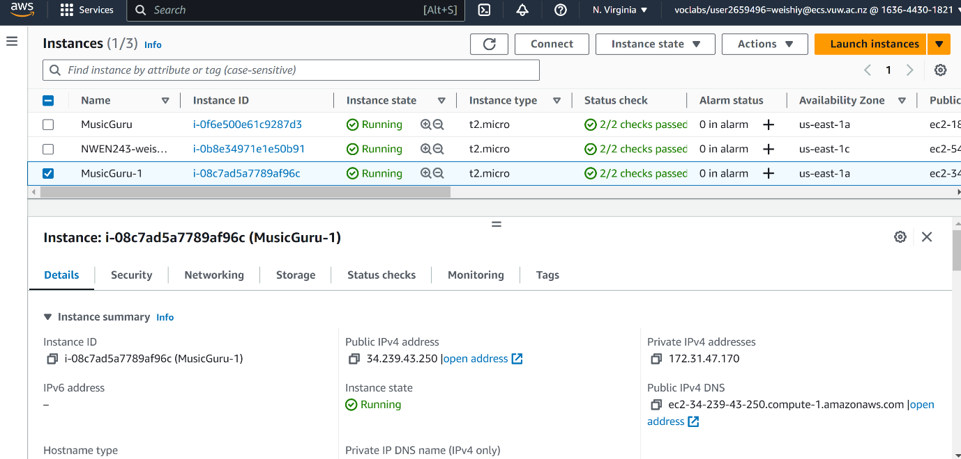

The AWS console displays three instances: one for Project 1 (NWEN243-weishiy) and two for Project 2 (MusicGuru and MusicGuru-1). Furthermore, it indicates that all three instances are in a running state and provides the relevant information for the AMI instances, including its IP addresses.

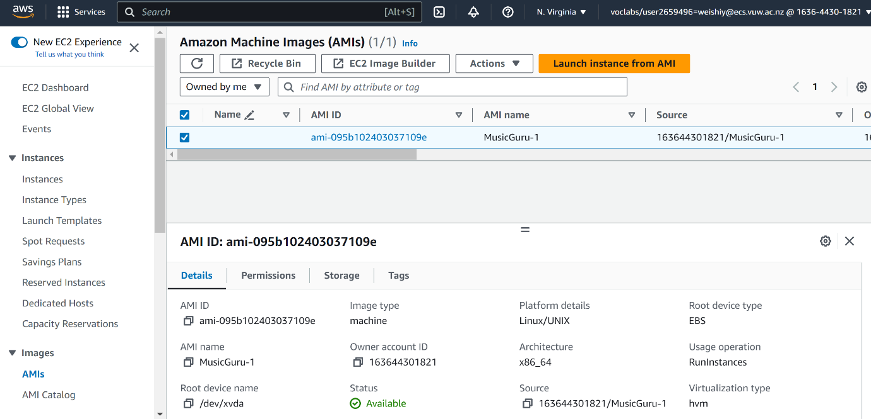

The screenshot for AMI instances which a copy of the Music Guru instance.