**Introduction（some pics）**

Clathrate hydrates are crystalline structures that consist of water molecules forming cages via a hydrogen-bonding network enclosing small guest molecules. Such structures normally form at a condition of high pressure and low temperature.

(from <http://www.globalspec.com/reference/55602/203279/2-what-are-natural-gas-clathrate-hydrates>)

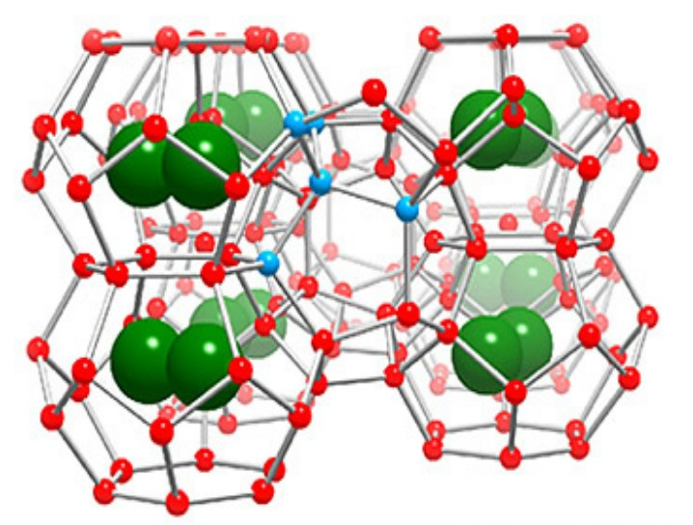

(From: httpps://uci.eduscholarkcjandaresearchgas-hydrate-structure)

Gas hydrates usually form three [crystallographic](http://en.wikipedia.org/wiki/Crystallography) cubic structures: structure I and structure IIand Structure H. Each type are formed of two or three small cages:

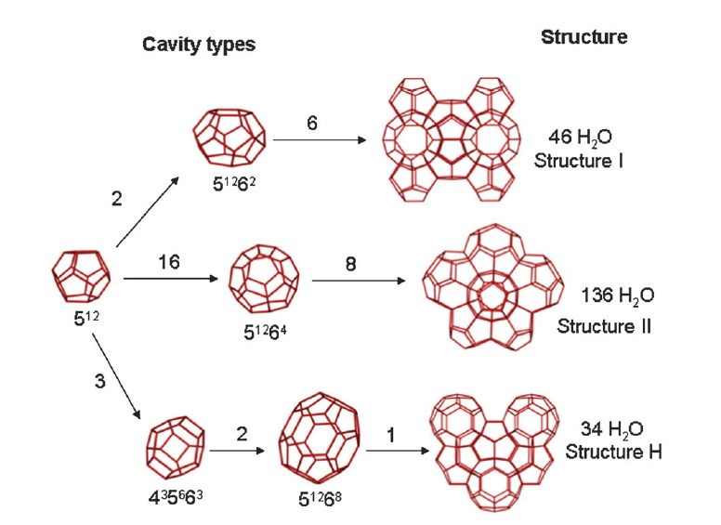

Figure 2: The three common clathrate hydrate structures, including the constituent cavities. Nomenclature: 5 126 8indicates 12 pentagonal and 8 hexagonal sides in a cavity; numbers along lines indicate the number of cavities in each unit crystal structure. The rightmost numbers indicate the water molecules per crystal structure

**Motivation**

1. **Solve the blockage in the oil pipelines.**

Clathrate hydrates could form at a condition of high pressure and low temperature. Gas and oil production and transportation in the pipelines happen to provide such a condition. Thus the formation of clathrate hydrate becomes the main reason of blockage in the pipelines which could result in the suspension even discontinuation of gas and oil production as well as ecological disasters like tragedy in Macondo well in the Mexico Gulf.

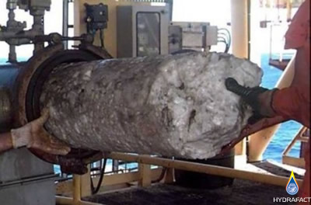 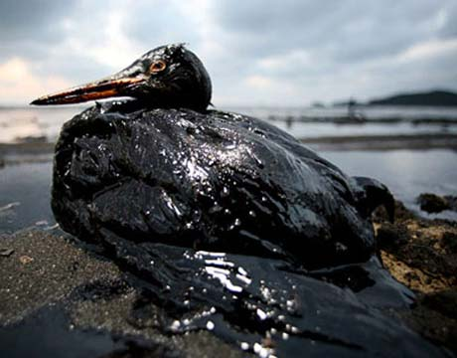

1. **Recovery of huge potential energy (buring ice)**

The global resource of methane in gas hydrate deposits in commonly cited as 20,000 trillion m3 making gas hydrates itself contain more energy than any other forms of energies we exploit today. Exploiting the resource while capturing CO2 would not only solve the energy crisis but also reduces the greenhouse gases.

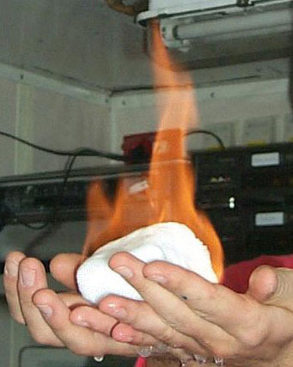 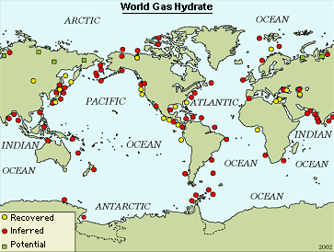

1. **Moreover, gas hydrate has applications in other fields like refrigeration, desalination and transportation.**

Solid-fluid secondary refrigerants have higher energy efficiency in refrigeration. Advances are reported in several aspects of Clathrate hydrate desalination fundamentals necessary to develop an economical means to produce municipal quantities of potable water from seawater. Using Clathrate transport gas like H2 would be safer and more efficient by reducing pressure and increasing temperature.

**Method ()**

1. Evaluate the change in free energy with temperature, starting from the limiting behavior at T → 0, where a harmonic analysis yields the free energy.

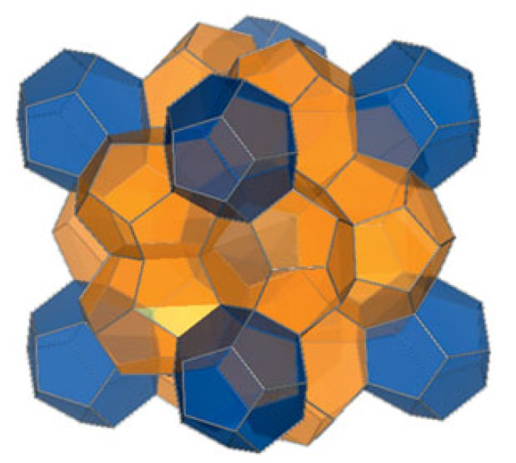

( **Energy science of clathrate hydrates: Simulation-based advances Amadeu K. Sum , David T. Wu , and Kenji Yasuoka**)

2. To evaluate the free energy with increasing temperature, we turn to the recently introduced harmonically targeted temperature perturbation (HTTP) method.

Temperature perturbation is accompanied by perturbation in the atom positions, applying the harmonic approximation to target the displacements. Specifically, all atom positions are scaled away from their respective lattice sites in proportion to the square root of the temperature ratios.

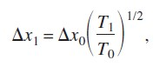

**Thus the quantity measured by the Monte Carlo process is strictly the change in the anharmonic contribution to the free energy; consequently,**

**sampling noise that normally accompanies the harmonic contribution—the largest component of the free energy—is eliminated**.

Then, the harmonically targeted temperature perturbation method, which is an efficient technique for evaluating the free energy as a function of temperature, will be used to calculate free energy up to temperatures of interest.

3. Having established the free energy of the fully occupied hydrate at the target temperature, we can then conduct additional molecular simulations to gauge the dependence on composition and/or pressure.

Simulation in an isobaric34 osmotic ensemble is appropriate for this purpose. The fundamental equation for such an ensemble is:

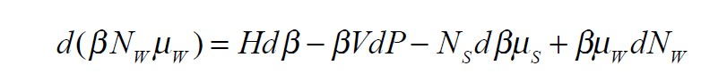

free energy for this ensemble can be evaluated from the full-occupancy state by integration along μS.

With the knowledge of free energy we can identify the stable crystalline form and locate the conditions where phase transitions occur.

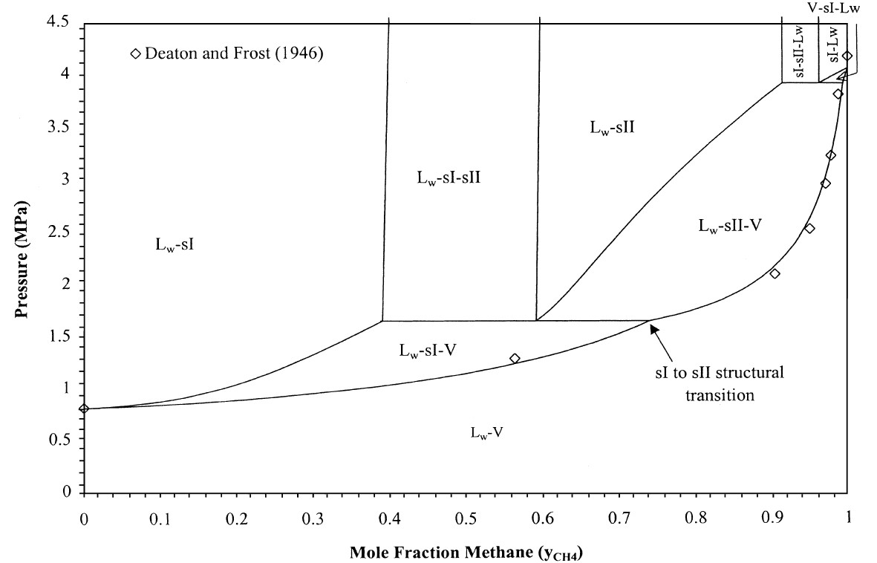

(Structural transitions in methane#ethane gas hydrates upper transition point and applications S. Subramanian, A. L. Ballard!, R. A. Kini!, S. F. Dec", E. D. Sloan Jr.,)

Advantages:

1.The free energy given in this fashion has almost no system size dependence at all.

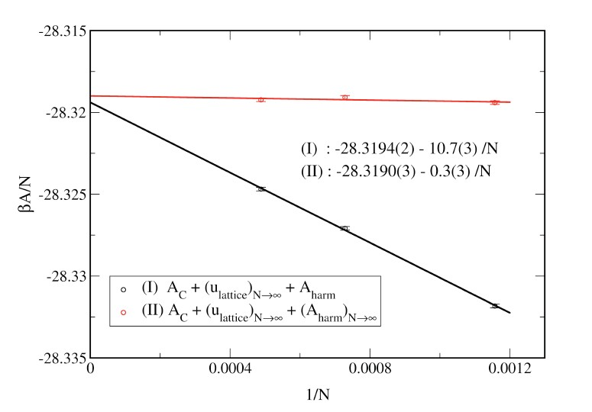

**Figure XX. Dependence of free-energy contributions on the size of the simulated system. From Ref. 31.**

2. the most efficient means for computing the difference in free energy of a crystalline system at two different temperatures by molecular simulation.

**Configuration space increases rapidly with temperature.  
        Measuring ΔβA with perturbation fails (change is too much**

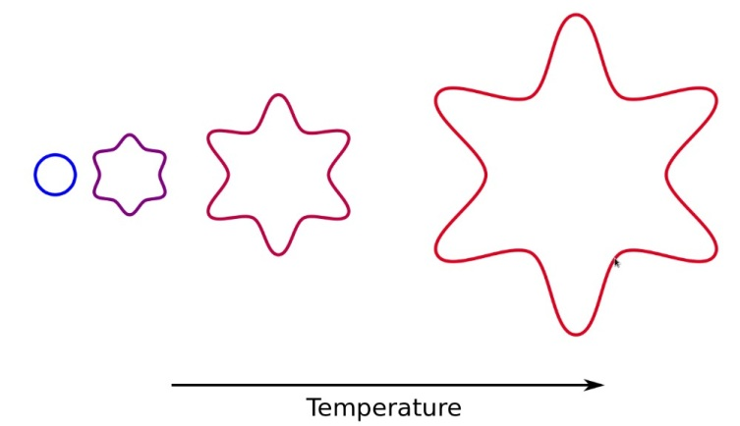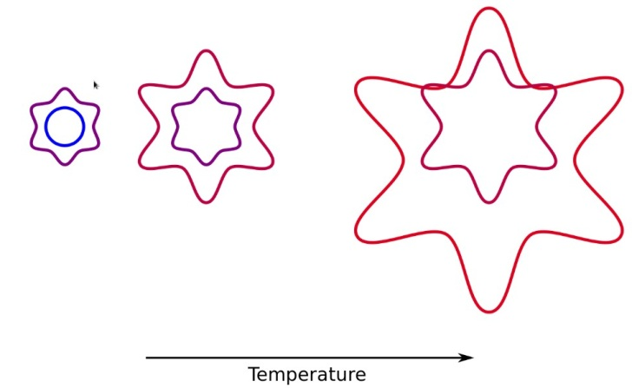

**Scale out the change in size we expect (from the harmonic system)  
        Use perturbation to measure the residual, ΔβAc**

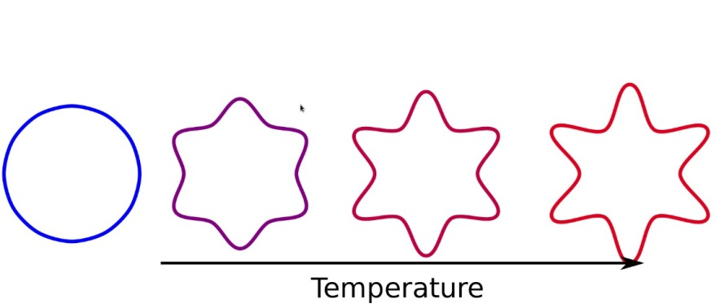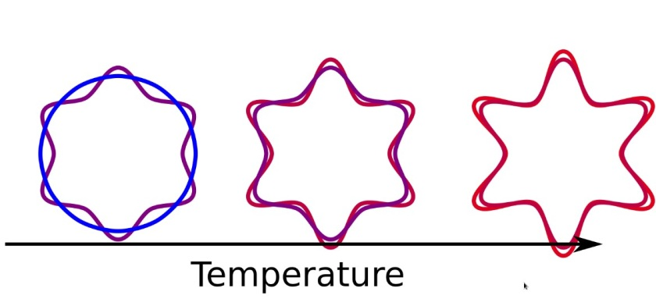

**Reference**

1.

2.

3.

**Preliminary result and future work**

Generation of the clathrate structures

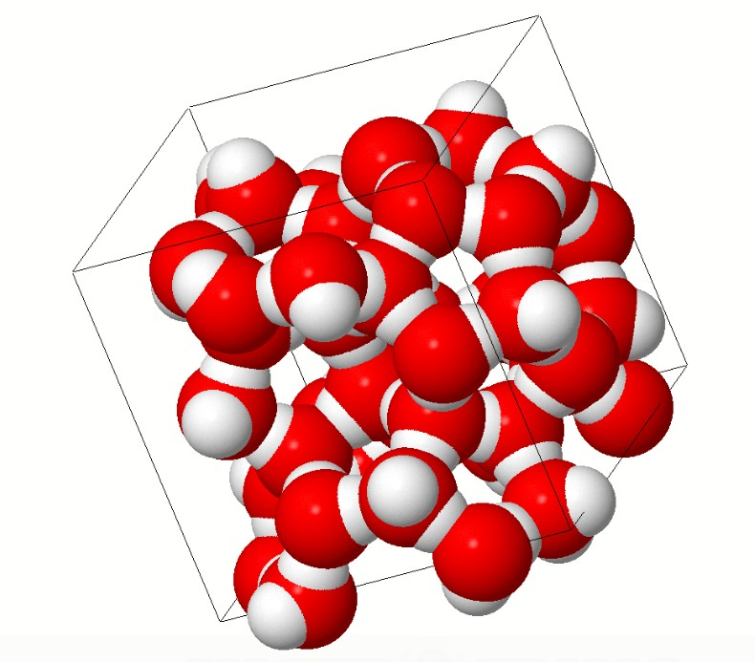

Structure type I.

**Acknowledgement**