10 Years of Historical Price 01/09/2008 ~ 01/09/2018

SECTION 0 - OBTAIN AND TRANSFORMING DATA

3M CSV dataset

dataset_MMM <- read.csv("MMM.csv")  
head(dataset_MMM)

## Date Open High Low Close Adj.Close Volume  
## 1 2008-01-08 81.35 82.07 80.10 80.21 60.62685 5711200  
## 2 2008-01-09 80.20 80.82 78.49 80.19 60.61175 6422300  
## 3 2008-01-10 79.75 80.71 79.02 80.21 60.62685 6835800  
## 4 2008-01-11 79.63 81.06 76.97 77.58 58.63898 8414500  
## 5 2008-01-14 78.13 78.64 77.50 78.50 59.33435 2927600  
## 6 2008-01-15 78.00 78.70 77.03 77.18 58.33664 4206500

summary(dataset_MMM)

## Date Open High Low   
## 2008-01-08: 1 Min. : 41.31 Min. : 42.45 Min. : 40.87   
## 2008-01-09: 1 1st Qu.: 81.26 1st Qu.: 81.83 1st Qu.: 80.50   
## 2008-01-10: 1 Median : 96.92 Median : 97.50 Median : 96.57   
## 2008-01-11: 1 Mean :118.35 Mean :119.20 Mean :117.52   
## 2008-01-14: 1 3rd Qu.:157.59 3rd Qu.:158.46 3rd Qu.:156.73   
## 2008-01-15: 1 Max. :243.19 Max. :244.23 Max. :239.18   
## (Other) :2513   
## Close Adj.Close Volume   
## Min. : 41.83 Min. : 32.86 Min. : 651000   
## 1st Qu.: 81.22 1st Qu.: 66.41 1st Qu.: 2026100   
## Median : 97.21 Median : 82.92 Median : 2782500   
## Mean :118.42 Mean :105.61 Mean : 3288103   
## 3rd Qu.:157.65 3rd Qu.:145.32 3rd Qu.: 3943750   
## Max. :243.14 Max. :238.47 Max. :16317000   
##

C CSV dataset

dataset_C <- read.csv("C.csv")  
head(dataset_C)

## Date Open High Low Close Adj.Close Volume  
## 1 2008-09-02 196.3 198.2 188.8 191.1 182.3512 7979000  
## 2 2008-09-03 191.2 196.6 187.7 196.1 187.1223 6362700  
## 3 2008-09-04 193.0 194.7 182.1 183.0 174.6220 8057300  
## 4 2008-09-05 180.5 191.8 179.3 190.7 181.9695 8401400  
## 5 2008-09-08 208.4 209.5 195.0 203.2 193.8972 17043000  
## 6 2008-09-09 200.2 203.8 188.1 188.8 180.1565 11634800

summary(dataset_C)

## Date Open High Low   
## 2008-09-02: 1 Min. : 10.20 Min. : 10.70 Min. : 9.70   
## 2008-09-03: 1 1st Qu.: 39.34 1st Qu.: 39.90 1st Qu.: 38.59   
## 2008-09-04: 1 Median : 47.60 Median : 48.00 Median : 47.07   
## 2008-09-05: 1 Mean : 50.17 Mean : 50.91 Mean : 49.28   
## 2008-09-08: 1 3rd Qu.: 54.46 3rd Qu.: 54.95 3rd Qu.: 54.01   
## 2008-09-09: 1 Max. :231.60 Max. :235.00 Max. :220.00   
## (Other) :2513   
## Close Adj.Close Volume   
## Min. : 10.20 Min. : 9.747 Min. : 3998000   
## 1st Qu.: 39.10 1st Qu.: 37.393 1st Qu.: 16221050   
## Median : 47.56 Median : 45.603 Median : 24164500   
## Mean : 50.04 Mean : 48.246 Mean : 32159178   
## 3rd Qu.: 54.48 3rd Qu.: 52.304 3rd Qu.: 39243400   
## Max. :230.00 Max. :219.470 Max. :377263800   
##

PG CSV dataset

dataset_PG <- read.csv("PG.csv")  
head(dataset_PG)

## Date Open High Low Close Adj.Close Volume  
## 1 2008-09-02 70.35 71.43 70.15 70.47 51.39056 11255200  
## 2 2008-09-03 70.42 71.50 70.18 71.42 52.08335 10433900  
## 3 2008-09-04 71.16 71.52 70.37 70.44 51.36869 12298000  
## 4 2008-09-05 70.39 71.07 69.73 70.78 51.61662 11578800  
## 5 2008-09-08 71.33 72.48 71.31 72.37 52.77613 16521200  
## 6 2008-09-09 71.66 72.46 71.47 71.89 52.42612 18542200

summary(dataset_PG)

## Date Open High Low   
## 2008-09-02: 1 Min. :44.51 Min. :45.19 Min. :39.37   
## 2008-09-03: 1 1st Qu.:63.40 1st Qu.:63.80 1st Qu.:62.97   
## 2008-09-04: 1 Median :76.39 Median :76.99 Median :75.81   
## 2008-09-05: 1 Mean :73.44 Mean :73.93 Mean :72.96   
## 2008-09-08: 1 3rd Qu.:82.56 3rd Qu.:83.08 3rd Qu.:82.10   
## 2008-09-09: 1 Max. :94.17 Max. :94.67 Max. :93.83   
## (Other) :2513   
## Close Adj.Close Volume   
## Min. :44.18 Min. :32.65 Min. : 2196700   
## 1st Qu.:63.33 1st Qu.:49.97 1st Qu.: 7058250   
## Median :76.41 Median :66.62 Median : 8970100   
## Mean :73.46 Mean :63.62 Mean : 10524215   
## 3rd Qu.:82.62 3rd Qu.:76.19 3rd Qu.: 11791750   
## Max. :94.40 Max. :91.31 Max. :123735700   
##

GOOG CSV dataset

dataset_GOOG <- read.csv("GOOG.csv")  
head(dataset_GOOG)

## Date Open High Low Close Adj.Close Volume  
## 1 2008-09-02 236.8446 239.5321 229.2191 231.1218 231.1218 12302400  
## 2 2008-09-03 232.8505 235.6126 228.3051 230.7045 230.7045 8685300  
## 3 2008-09-04 228.5137 230.1233 223.2480 223.6752 223.6752 9759900  
## 4 2008-09-05 221.3056 224.7681 218.6181 220.6896 220.6896 9127500  
## 5 2008-09-08 224.5495 225.0065 207.4259 208.6181 208.6181 18153000  
## 6 2008-09-09 210.2177 214.7930 206.1591 207.9773 207.9773 14553100

summary(dataset_GOOG)

## Date Open High Low   
## 2008-09-02: 1 Min. : 130.4 Min. : 133.8 Min. : 122.9   
## 2008-09-03: 1 1st Qu.: 285.6 1st Qu.: 287.6 1st Qu.: 282.7   
## 2008-09-04: 1 Median : 444.0 Median : 446.0 Median : 440.2   
## 2008-09-05: 1 Mean : 515.8 Mean : 520.1 Mean : 511.2   
## 2008-09-08: 1 3rd Qu.: 722.8 3rd Qu.: 727.3 3rd Qu.: 716.5   
## 2008-09-09: 1 Max. :1271.0 Max. :1273.9 Max. :1249.0   
## (Other) :2513   
## Close Adj.Close Volume   
## Min. : 127.9 Min. : 127.9 Min. : 7900   
## 1st Qu.: 286.0 1st Qu.: 286.0 1st Qu.: 1657600   
## Median : 442.6 Median : 442.6 Median : 3445800   
## Mean : 515.8 Mean : 515.8 Mean : 4289452   
## 3rd Qu.: 720.8 3rd Qu.: 720.8 3rd Qu.: 5423650   
## Max. :1268.3 Max. :1268.3 Max. :32690500   
##

MYL CSV dataset

dataset_MYL <- read.csv("MYL.csv")  
head(dataset_MYL)

## Date Open High Low Close Adj.Close Volume  
## 1 2008-09-02 12.89 13.14 12.68 12.83 12.83 5319000  
## 2 2008-09-03 12.84 12.90 12.60 12.87 12.87 5851400  
## 3 2008-09-04 12.82 13.01 12.66 12.84 12.84 5865200  
## 4 2008-09-05 12.72 12.84 12.46 12.50 12.50 3865900  
## 5 2008-09-08 12.69 12.80 12.33 12.42 12.42 3591700  
## 6 2008-09-09 11.80 12.45 10.93 11.10 11.10 28487100

summary(dataset_MYL)

## Date Open High Low   
## 2008-09-02: 1 Min. : 5.98 Min. : 6.25 Min. : 5.75   
## 2008-09-03: 1 1st Qu.:20.92 1st Qu.:21.12 1st Qu.:20.60   
## 2008-09-04: 1 Median :32.10 Median :32.64 Median :31.80   
## 2008-09-05: 1 Mean :33.14 Mean :33.58 Mean :32.66   
## 2008-09-08: 1 3rd Qu.:43.97 3rd Qu.:44.57 3rd Qu.:43.02   
## 2008-09-09: 1 Max. :75.40 Max. :76.69 Max. :73.63   
## (Other) :2513   
## Close Adj.Close Volume   
## Min. : 5.77 Min. : 5.77 Min. : 856200   
## 1st Qu.:20.89 1st Qu.:20.89 1st Qu.: 3795500   
## Median :32.13 Median :32.13 Median : 5237900   
## Mean :33.12 Mean :33.12 Mean : 6130334   
## 3rd Qu.:43.80 3rd Qu.:43.80 3rd Qu.: 7200400   
## Max. :76.06 Max. :76.06 Max. :50917600   
##

Retrieve the daily closing price

# Initialize date column for analyze purpose  
close_price = NULL  
close_price$date = dataset_MMM$Date  
  
close_price$MMM = dataset_MMM$Adj.Close  
close_price$C = dataset_C$Adj.Close  
close_price$PG = dataset_PG$Adj.Close  
close_price$GOOG = dataset_GOOG$Adj.Close  
close_price$MYL = dataset_MYL$Adj.Close  
  
#Show several example of each asset's close price  
head(close_price$MMM)

## [1] 60.62685 60.61175 60.62685 58.63898 59.33435 58.33664

head(close_price$C)

## [1] 182.3512 187.1223 174.6220 181.9695 193.8972 180.1565

head(close_price$PG)

## [1] 51.39056 52.08335 51.36869 51.61662 52.77613 52.42612

head(close_price$GOOG)

## [1] 231.1218 230.7045 223.6752 220.6896 208.6181 207.9773

head(close_price$MYL)

## [1] 12.83 12.87 12.84 12.50 12.42 11.10

Construct the log daily returns of each asset

# Initialize date column for analyze purpose  
returns = NULL  
returns$MMM = diff(log(close_price$MMM), lag = 1)  
returns$C = diff(log(close_price$C), lag = 1)  
returns$PG = diff(log(close_price$PG), lag = 1)  
returns$GOOG = diff(log(close_price$GOOG), lag = 1)  
returns$MYL = diff(log(close_price$MYL), lag = 1)  
  
#Show several example of each asset's close price  
head(returns$MMM)

## [1] -0.0002491946 0.0002491946 -0.0333383182 0.0117888012 -0.0169581124  
## [6] 0.0015540409

head(returns$C)

## [1] 0.02582777 -0.06913856 0.04121547 0.06348920 -0.07350256 -0.01064978

head(returns$PG)

## [1] 0.013390919 -0.013816555 0.004814910 0.022215387 -0.006654121  
## [6] 0.006930648

head(returns$GOOG)

## [1] -0.001807161 -0.030942593 -0.013437720 -0.056251814 -0.003076484  
## [6] -0.010806750

head(returns$MYL)

## [1] 0.003112843 -0.002333723 -0.026836654 -0.006420568 -0.112362968  
## [6] 0.032789823

Insert the result into data frame format

transformed_data.close <- data.frame(close_price$date, close_price$MMM, close_price$C, close_price$PG, close_price$GOOG, close_price$MYL)  
str(transformed_data.close)

## 'data.frame': 2519 obs. of 6 variables:  
## $ close_price.date: Factor w/ 2519 levels "2008-01-08","2008-01-09",..: 1 2 3 4 5 6 7 8 9 10 ...  
## $ close_price.MMM : num 60.6 60.6 60.6 58.6 59.3 ...  
## $ close_price.C : num 182 187 175 182 194 ...  
## $ close_price.PG : num 51.4 52.1 51.4 51.6 52.8 ...  
## $ close_price.GOOG: num 231 231 224 221 209 ...  
## $ close_price.MYL : num 12.8 12.9 12.8 12.5 12.4 ...

n <- nrow(transformed_data.close)  
  
returns$date <- close_price$date[2:n]  
  
transformed_data.returns <- data.frame(returns$date, returns$MMM, returns$C, returns$PG, returns$GOOG, returns$MYL)  
str(transformed_data.returns)

## 'data.frame': 2518 obs. of 6 variables:  
## $ returns.date: Factor w/ 2519 levels "2008-01-08","2008-01-09",..: 2 3 4 5 6 7 8 9 10 11 ...  
## $ returns.MMM : num -0.000249 0.000249 -0.033338 0.011789 -0.016958 ...  
## $ returns.C : num 0.0258 -0.0691 0.0412 0.0635 -0.0735 ...  
## $ returns.PG : num 0.01339 -0.01382 0.00481 0.02222 -0.00665 ...  
## $ returns.GOOG: num -0.00181 -0.03094 -0.01344 -0.05625 -0.00308 ...  
## $ returns.MYL : num 0.00311 -0.00233 -0.02684 -0.00642 -0.11236 ...

SECTION 1 - EXPLORATORY DATA ANALYSIS

Generate a time plot series of closing price on the same graph

# Load necessary packages  
library(tidyverse)

## -- Attaching packages --------------------------------------- tidyverse 1.2.1 --

## v ggplot2 3.0.0 v purrr 0.2.5  
## v tibble 1.4.2 v dplyr 0.7.6  
## v tidyr 0.8.1 v stringr 1.3.1  
## v readr 1.1.1 v forcats 0.3.0

## -- Conflicts ------------------------------------------ tidyverse_conflicts() --  
## x dplyr::filter() masks stats::filter()  
## x dplyr::lag() masks stats::lag()

library(ggplot2)  
  
  
# View time plot of the closing price  
 ggplot(data = transformed_data.close,   
 aes(x=as.Date(close_price$date), y=value, group=1) ) +   
 geom_line(aes(y=close_price$MMM, col='3M'), size = 1) +   
 geom_line(aes(y=close_price$C, col='C'), size = 1) +   
 geom_line(aes(y=close_price$PG, col='PG'), size = 1) +   
 geom_line(aes(y=close_price$GOOG, col='GOOG'), size = 1) +   
 geom_line(aes(y=close_price$MYL, col='MYL'), size = 1) +   
 labs(x = "Time", y = "Daily adjusted closing price")

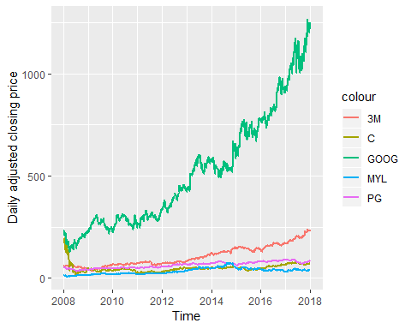

Discussion: (Akmal)

(Mark)

(Sudheer)

(Surya) By looking at the daily closing price in 10 years from 2008 to 2018, I could see that the growth of the close price for GOOG (Alphabet Inc.) was positively growth over time. Initially, C (Citigroup Inc.) has a similar close price in 2008. However, their got a negative trend from early 2008 to mid 2008 which made them stuck for years ahead. Interestingly, even though the MMM (3M Company)’s performance was overshadowed with GOOG, they enjoyed quite a positive trend. The 3 others assets have a similar stagnant closing price over time.

Generate a time plot series of return series

# View time plot of the 3M return price  
 ggplot(data = transformed_data.returns,   
 aes(x=as.Date(returns$date), y=value, group=1) ) +   
 geom_line(aes(y=returns$MMM, col='3M'), size = 1, color='darkblue') +   
 labs(x = "Time", y = "Daily return series")

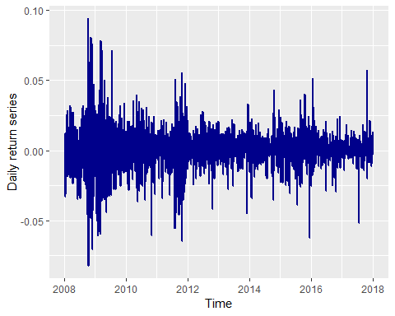

# View time plot of the C return price  
 ggplot(data = transformed_data.returns,   
 aes(x=as.Date(returns$date), y=value, group=1) ) +   
 geom_line(aes(y=returns$C, col='C'), size = 1, color='darkred') +   
 labs(x = "Time", y = "Daily return series")

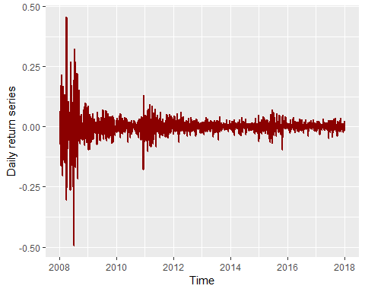

# View time plot of the GOOG return price  
 ggplot(data = transformed_data.returns,   
 aes(x=as.Date(returns$date), y=value, group=1) ) +   
 geom_line(aes(y=returns$GOOG, col='GOOG'), size = 1, color='yellowgreen') +   
 labs(x = "Time", y = "Daily return series")

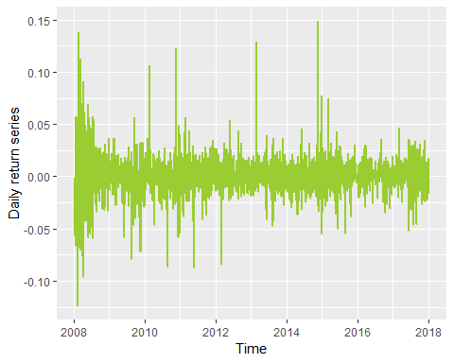

# View time plot of the MYL return price  
 ggplot(data = transformed_data.returns,   
 aes(x=as.Date(returns$date), y=value, group=1) ) +   
 geom_line(aes(y=returns$MYL, col='MYL'), size = 1, color='deeppink') +   
 labs(x = "Time", y = "Daily return series")

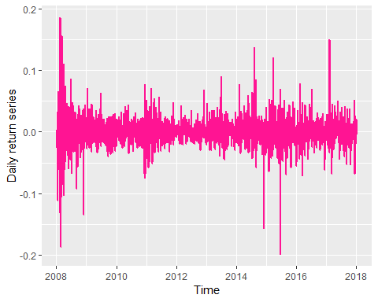

# View time plot of the PG return price  
 ggplot(data = transformed_data.returns,   
 aes(x=as.Date(returns$date), y=value, group=1) ) +   
 geom_line(aes(y=returns$PG, col='PG'), size = 1, color='blueviolet') +   
 labs(x = "Time", y = "Daily return series")

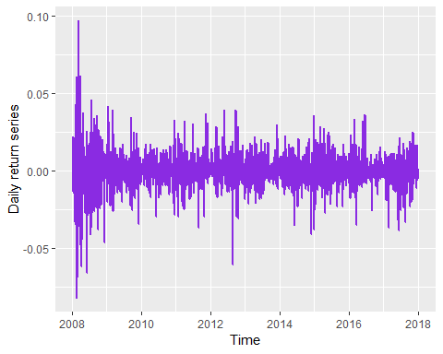

Discussion: Similarities The average value of all assets over 10 years was quite stable where the mean of log return is almost zero.

Difference - MMM (Surya) The average value of 3M asset over 10 years was quite stable where the mean of log return is almost zero. However, the volatility becomes larger for quite a long time at the end of 2008 and at the end of 2011; for a short time at the end of 2015 and mid 2017.

* C
* GOOG
* MYL
* PG

Generate a kernel density plot of return series

library(kdensity)  
  
# MMM  
hist(transformed_data.returns$returns.MMM, breaks = 64, freq = FALSE, main = "3M Company", xlab = "Daily log returns")  
kde_mmm = kdensity(transformed_data.returns$returns.MMM, start = "normal")

## Warning: namespace 'extraDistr' is not available and has been replaced  
## by .GlobalEnv when processing object ''

lines(kde_mmm, col="blue")  
lines(kde_mmm, plot_start = TRUE, col="red")

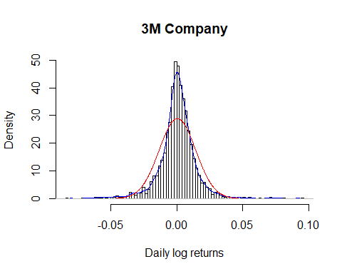

# C  
hist(transformed_data.returns$returns.C, breaks = 64, freq = FALSE, main = "Citigroup Inc.", xlab = "Daily log returns")  
kde_c = kdensity(transformed_data.returns$returns.C, start = "normal")  
lines(kde_c, col="blue")  
lines(kde_c, plot_start = TRUE, col="red")

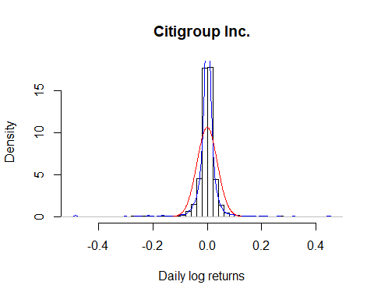

# PG  
hist(transformed_data.returns$returns.PG, breaks = 64, freq = FALSE, main = "The Procter & Gamble Company", xlab = "Daily log returns")  
kde_pg = kdensity(transformed_data.returns$returns.PG, start = "normal")  
lines(kde_pg, col="blue")  
lines(kde_pg, plot_start = TRUE, col="red")

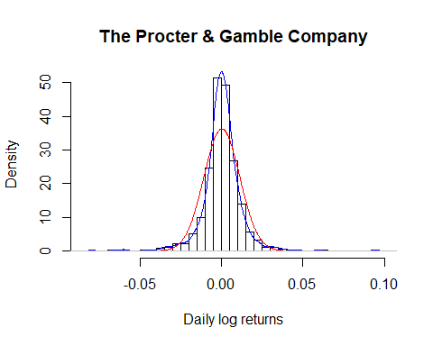

# GOOG  
hist(transformed_data.returns$returns.GOOG, breaks = 64, freq = FALSE, main = "Alphabet Inc.", xlab = "Daily log returns")  
kde_goog = kdensity(transformed_data.returns$returns.GOOG, start = "normal")  
lines(kde_goog, col="blue")  
lines(kde_goog, plot_start = TRUE, col="red")

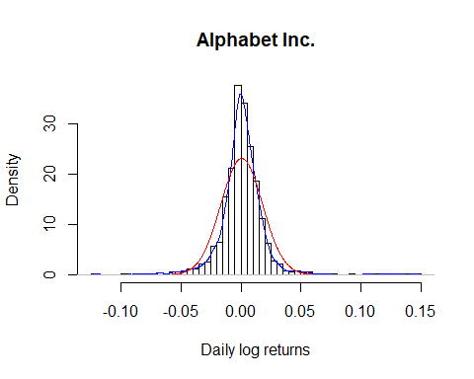

# MYL  
hist(transformed_data.returns$returns.MYL, breaks = 64, freq = FALSE, main = "Mylan N.V.", xlab = "Daily log returns")  
kde_myl = kdensity(transformed_data.returns$returns.MYL, start = "normal")  
lines(kde_myl, col="blue")  
lines(kde_myl, plot_start = TRUE, col="red")

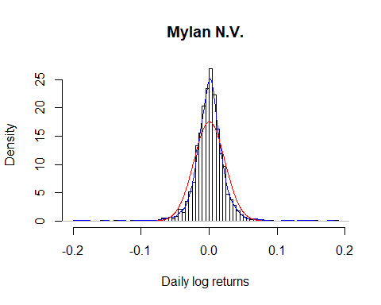

Discussion: Similarities

Difference - MMM (Surya) There is a slight different in the left and left side which the density is quite lower than the right side. Thus, we could say that the data doesn’t normally distributed. The kernel density has a higher kurtosis which result in much longer than normal tails of the density

* C
* GOOG
* MYL
* PG

Generate a normal Q-Q plot of return series

#MMM  
mean_mmm = mean(transformed_data.returns$returns.MMM)  
sd_mmm = sd(transformed_data.returns$returns.MMM)  
mmm_std = (transformed_data.returns$returns.MMM - mean_mmm) / sd_mmm  
qqnorm(mmm_std, main="3M Company Normal Q-Q Plot", plot.it = TRUE, datax = TRUE)  
qqline(mmm_std, datax = FALSE, distribution = qnorm, probs = c(0.25, 0.75), qtype = 7)

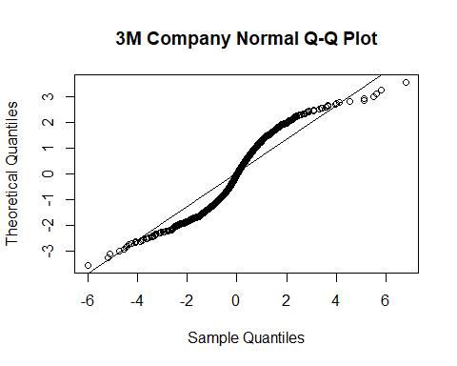

#C  
mean_c = mean(transformed_data.returns$returns.C)  
sd_c = sd(transformed_data.returns$returns.C)  
c_std = (transformed_data.returns$returns.C - mean_c) / sd_c  
qqnorm(c_std, main="Citigroup Inc. Normal Q-Q Plot", plot.it = TRUE, datax = TRUE)  
qqline(c_std, datax = FALSE, distribution = qnorm, probs = c(0.25, 0.75), qtype = 7)

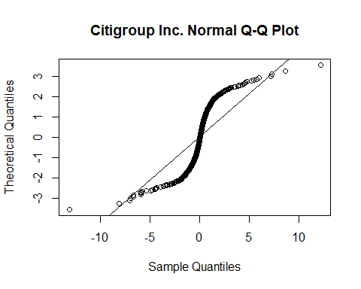

#GOOG  
mean_goog = mean(transformed_data.returns$returns.GOOG)  
sd_goog = sd(transformed_data.returns$returns.GOOG)  
goog_std = (transformed_data.returns$returns.GOOG - mean_goog) / sd_goog  
qqnorm(goog_std, main="Alphabet Inc. Normal Q-Q Plot", plot.it = TRUE, datax = TRUE)  
qqline(goog_std, datax = FALSE, distribution = qnorm, probs = c(0.25, 0.75), qtype = 7)

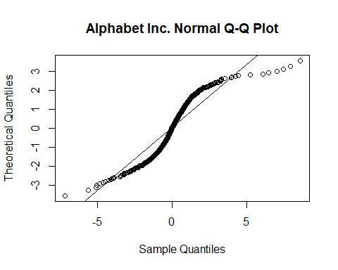

#MYL  
mean_myl = mean(transformed_data.returns$returns.MYL)  
sd_myl = sd(transformed_data.returns$returns.MYL)  
myl_std = (transformed_data.returns$returns.MYL - mean_myl) / sd_myl  
qqnorm(myl_std, main="Mylan N.V. Normal Q-Q Plot", plot.it = TRUE, datax = TRUE)  
qqline(myl_std, datax = FALSE, distribution = qnorm, probs = c(0.25, 0.75), qtype = 7)

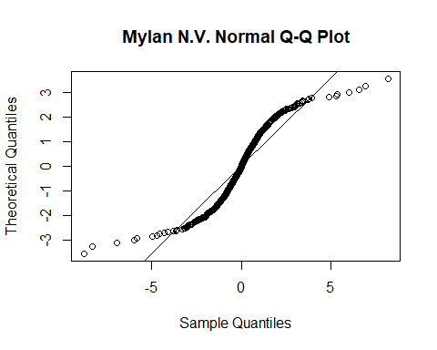

#PG  
mean_pg = mean(transformed_data.returns$returns.PG)  
sd_pg = sd(transformed_data.returns$returns.PG)  
pg_std = (transformed_data.returns$returns.PG - mean_pg) / sd_pg  
qqnorm(pg_std, main="The Procter & Gamble Company Normal Q-Q Plot", plot.it = TRUE, datax = TRUE)  
qqline(pg_std, datax = FALSE, distribution = qnorm, probs = c(0.25, 0.75), qtype = 7)

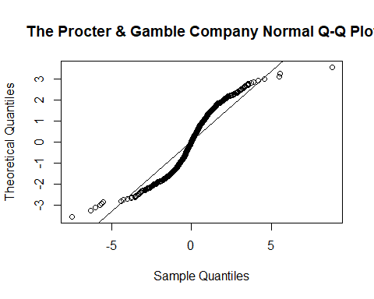

Discussion: Similarities

Difference - MMM (Surya) The 3M asset has a thick tails which mean that, compared to the normal distribution, there is more data located at the extremes of the distribution and less data in the center of the distribution. In terms of quantiles this means that the first quantile is much less than the first theoretical quantile and the last quantile is greater than the last theoretical quantile.

* C
* GOOG
* MYL
* PG

Generate a scatter plot of return series for one asset againts the others

ggplot(data = transformed_data.returns, aes(returns$MMM, (returns$C + returns$PG + returns$GOOG + returns$MYL))) +  
 geom_point() +   
 labs(x = "3M Company", y = "Others")

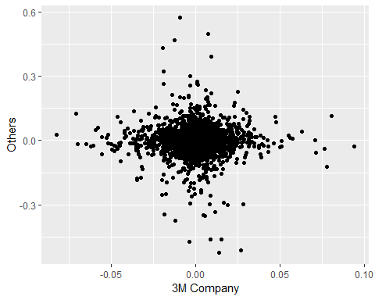

ggplot(data = transformed_data.returns, aes(returns$C, (returns$MMM + returns$PG + returns$GOOG + returns$MYL))) +  
 geom_point() +   
 labs(x = "Citigroup Inc.", y = "Others")

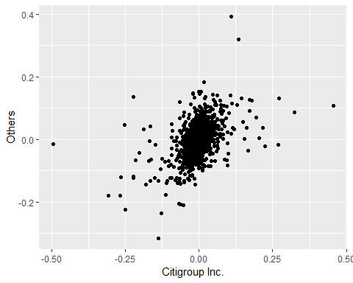

ggplot(data = transformed_data.returns, aes(returns$PG, (returns$MMM + returns$C + returns$GOOG + returns$MYL))) +  
 geom_point() +   
 labs(x = "The Procter & Gamble Company", y = "Others")

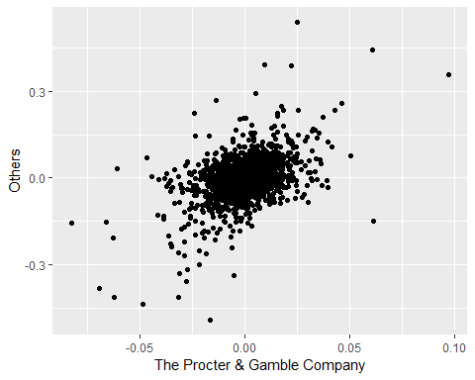

ggplot(data = transformed_data.returns, aes(returns$GOOG, (returns$MMM + returns$C + returns$PG + returns$MYL))) +  
 geom_point() +   
 labs(x = "Alphabet Inc.", y = "Others")

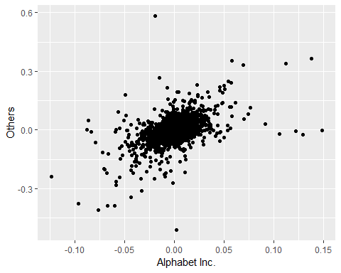

ggplot(data = transformed_data.returns, aes(returns$MYL, (returns$MMM + returns$C + returns$GOOG + returns$PG))) +  
 geom_point() +   
 labs(x = "Mylan N.V.", y = "Others")

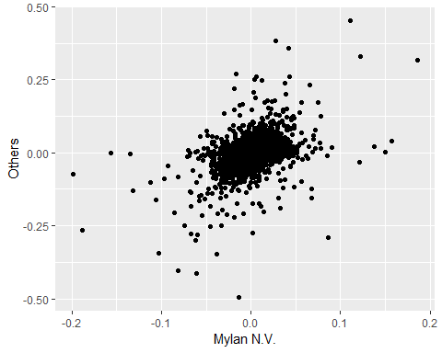

Compute the correlation matrix between all assets

return_assets <- data.frame(transformed_data.returns$returns.MMM, transformed_data.returns$returns.C, transformed_data.returns$returns.GOOG, transformed_data.returns$returns.MYL, transformed_data.returns$returns.PG)  
  
cor(return_assets)

## transformed_data.returns.returns.MMM  
## transformed_data.returns.returns.MMM 1.00000000  
## transformed_data.returns.returns.C -0.01547224  
## transformed_data.returns.returns.GOOG 0.01443115  
## transformed_data.returns.returns.MYL -0.01088348  
## transformed_data.returns.returns.PG -0.01881660  
## transformed_data.returns.returns.C  
## transformed_data.returns.returns.MMM -0.01547224  
## transformed_data.returns.returns.C 1.00000000  
## transformed_data.returns.returns.GOOG 0.41930042  
## transformed_data.returns.returns.MYL 0.34499815  
## transformed_data.returns.returns.PG 0.35257870  
## transformed_data.returns.returns.GOOG  
## transformed_data.returns.returns.MMM 0.01443115  
## transformed_data.returns.returns.C 0.41930042  
## transformed_data.returns.returns.GOOG 1.00000000  
## transformed_data.returns.returns.MYL 0.38438938  
## transformed_data.returns.returns.PG 0.40576726  
## transformed_data.returns.returns.MYL  
## transformed_data.returns.returns.MMM -0.01088348  
## transformed_data.returns.returns.C 0.34499815  
## transformed_data.returns.returns.GOOG 0.38438938  
## transformed_data.returns.returns.MYL 1.00000000  
## transformed_data.returns.returns.PG 0.37663423  
## transformed_data.returns.returns.PG  
## transformed_data.returns.returns.MMM -0.0188166  
## transformed_data.returns.returns.C 0.3525787  
## transformed_data.returns.returns.GOOG 0.4057673  
## transformed_data.returns.returns.MYL 0.3766342  
## transformed_data.returns.returns.PG 1.0000000

Discussion: Difference - MMM (Surya) Based on the result, the correlation between MMM with the others is quite small, which is either -0.01 or 0.01. Thus, I could conclude that MMM asset has quite a strong correlation with the other assets

* C
* GOOG
* MYL
* PG

SECTION 2 - UNIVARIATE TIME SERIES ANALYSIS

Load required libraries

library(stats)  
library(tseries)  
library(forecast)

SECTION 2.1 - AUTOCORRELATION Stationary analysis of the price series

# MMM  
mmm_percentage_change <- ts(transformed_data.close$close_price.MMM, frequency = 12, start = 2008)  
mmm_percentage_change_truncated <- window(mmm_percentage_change, start = 2013)  
acf(mmm_percentage_change)

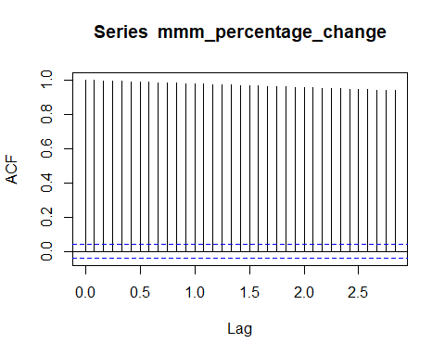

acf(mmm_percentage_change_truncated)

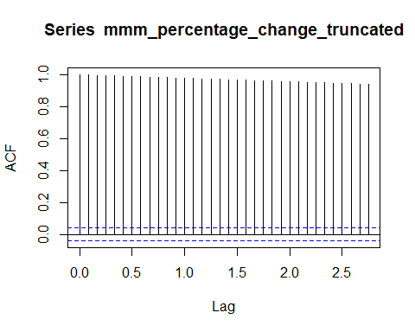

# C  
c_percentage_change <- ts(transformed_data.close$close_price.C, frequency = 12, start = 2008)  
c_percentage_change_truncated <- window(c_percentage_change, start = 2013)  
acf(c_percentage_change)

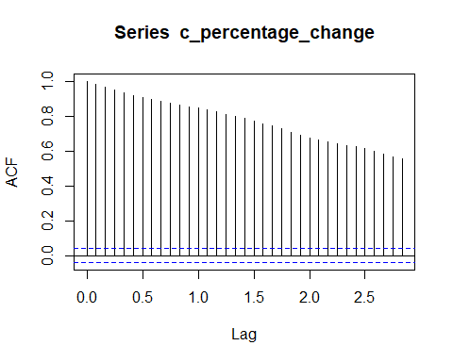

acf(c_percentage_change_truncated)

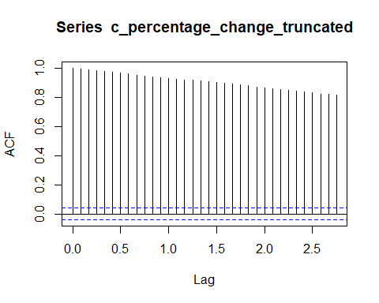

# PG  
pg_percentage_change <- ts(transformed_data.close$close_price.PG, frequency = 12, start = 2008)  
pg_percentage_change_truncated <- window(pg_percentage_change, start = 2013)  
acf(pg_percentage_change)

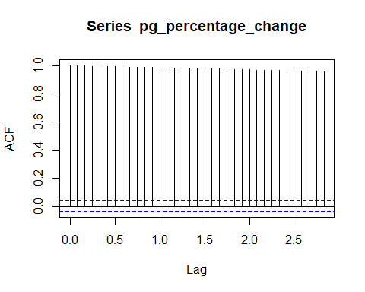

acf(pg_percentage_change_truncated)

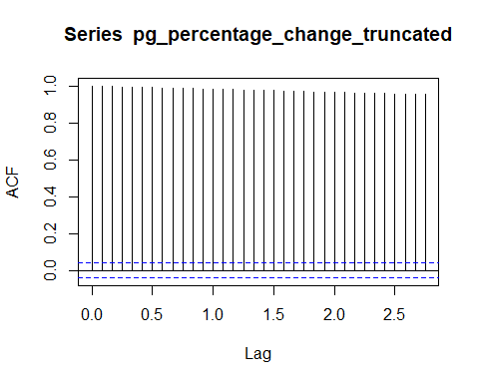

# GOOG  
goog_percentage_change <- ts(transformed_data.close$close_price.GOOG, frequency = 12, start = 2008)  
goog_percentage_change_truncated <- window(goog_percentage_change, start = 2013)  
acf(goog_percentage_change)

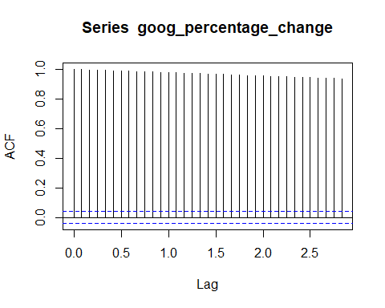

acf(goog_percentage_change_truncated)

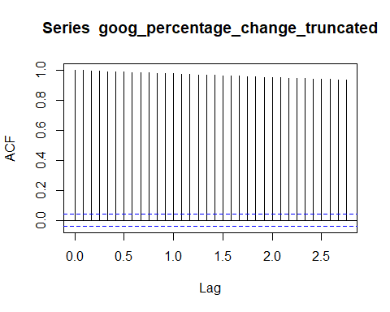

# MYL  
myl_percentage_change <- ts(transformed_data.close$close_price.MYL, frequency = 12, start = 2008)  
myl_percentage_change_truncated <- window(myl_percentage_change, start = 2013)  
acf(myl_percentage_change)

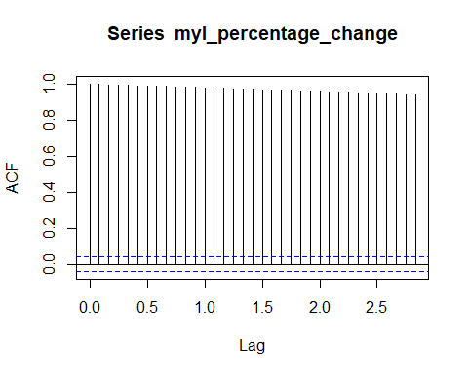

acf(myl_percentage_change_truncated)

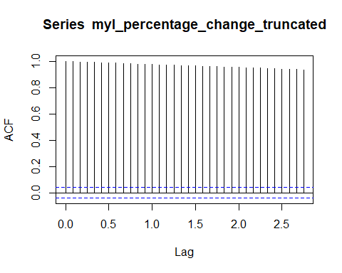

Discussion: Similarities

Difference - MMM (Surya) In this full autocorrelation, the spike was quite stable on each lag, where it barely decreased. Because the spike has a value that is significantly different from zero, it becomes the evidence of autocorrelation. It also means when the close price of MMM stock rises, it tends to continue rising and vise versa. It also means that this is a non-stationary series because it is decaying.

The truncated autocorrelation also shows quite a similar result with the full autocorrelation which reinforced my argument that the MMM asset is quite stable over time.

* C
* GOOG
* MYL
* PG

Stationary analysis of the returns series

# MMM  
mmm_percentage_change <- ts(transformed_data.returns$returns.MMM, frequency = 12, start = 2008)  
mmm_percentage_change_truncated <- window(mmm_percentage_change, start = 2013)  
acf(mmm_percentage_change)

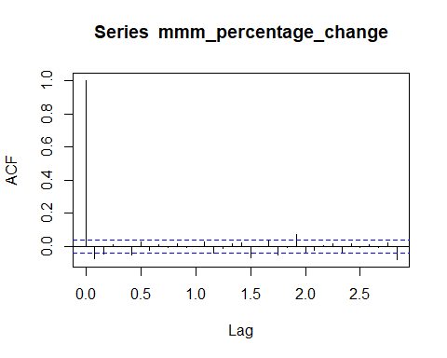

acf(mmm_percentage_change_truncated)

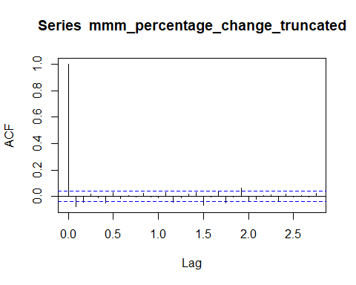

# C  
c_percentage_change <- ts(transformed_data.returns$returns.C, frequency = 12, start = 2008)  
c_percentage_change_truncated <- window(c_percentage_change, start = 2013)  
acf(c_percentage_change)

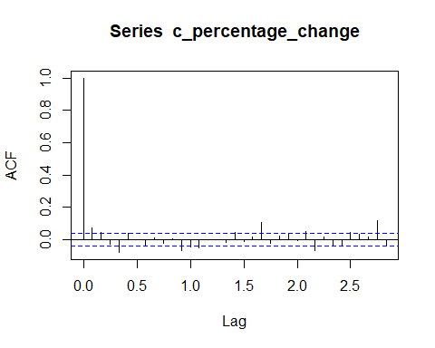

acf(c_percentage_change_truncated)

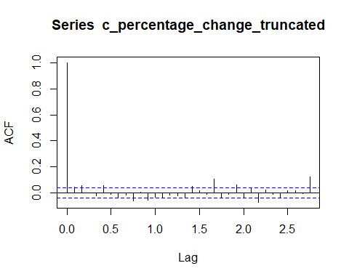

# PG  
pg_percentage_change <- ts(transformed_data.returns$returns.PG, frequency = 12, start = 2008)  
pg_percentage_change_truncated <- window(pg_percentage_change, start = 2013)  
acf(pg_percentage_change)

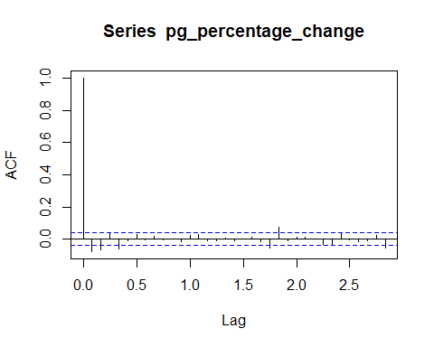

acf(pg_percentage_change_truncated)

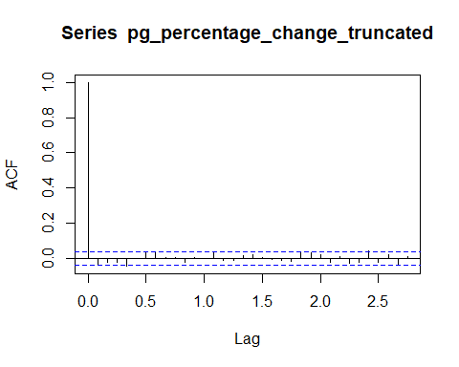

# GOOG  
goog_percentage_change <- ts(transformed_data.returns$returns.GOOG, frequency = 12, start = 2008)  
goog_percentage_change_truncated <- window(goog_percentage_change, start = 2013)  
acf(goog_percentage_change)

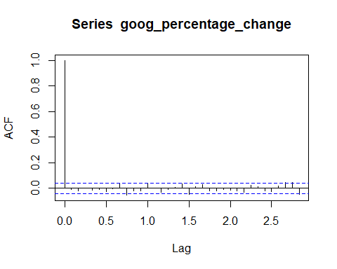

acf(goog_percentage_change_truncated)

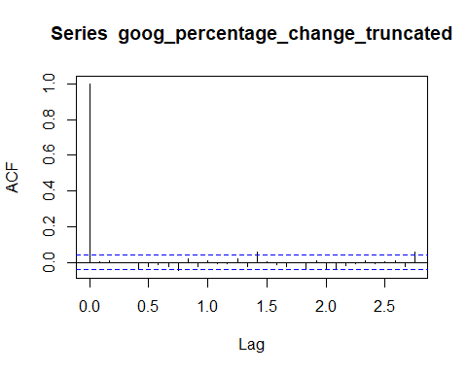

# MYL  
myl_percentage_change <- ts(transformed_data.returns$returns.MYL, frequency = 12, start = 2008)  
myl_percentage_change_truncated <- window(myl_percentage_change, start = 2013)  
acf(myl_percentage_change)

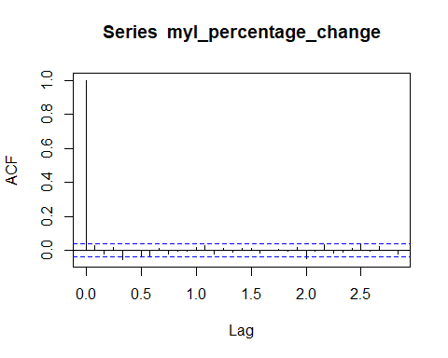

acf(myl_percentage_change_truncated)

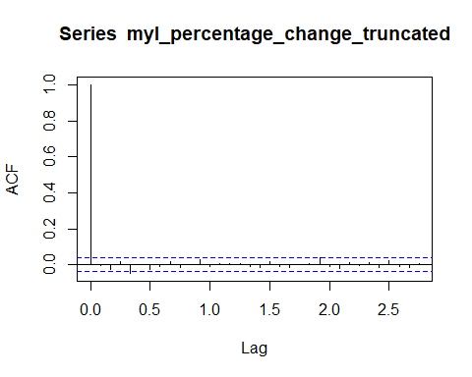

Discussion: Similarities

Difference - MMM (Surya) From the full autocorrelation and the truncated autocorrelation of MMM returns price, there is no significant different of the result. The impact on every lag was quite weak, which if between -0.1~0.1. However, I could see that the highest peak is at around lag 1.9 and the lowest one at around lag 0.1

* C
* GOOG
* MYL
* PG

Stationary analysis of the square of the returns series

# MMM  
mmm_percentage_change <- ts(transformed_data.returns$returns.MMM, frequency = 12, start = 2008)  
mmm_percentage_change_truncated <- window(mmm_percentage_change, start = 2013)  
acf(mmm_percentage_change^2)

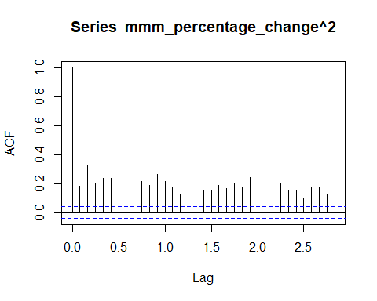

acf(mmm_percentage_change_truncated^2)

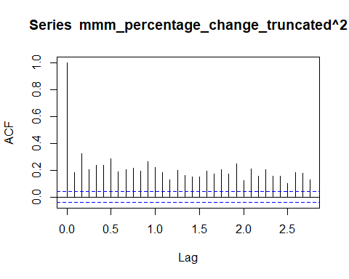

# C  
c_percentage_change <- ts(transformed_data.returns$returns.C, frequency = 12, start = 2008)  
c_percentage_change_truncated <- window(c_percentage_change, start = 2013)  
acf(c_percentage_change^2)

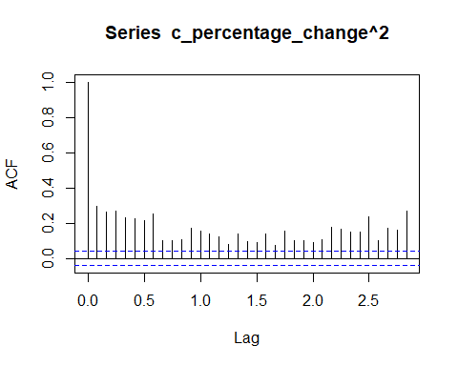

acf(c_percentage_change_truncated^2)

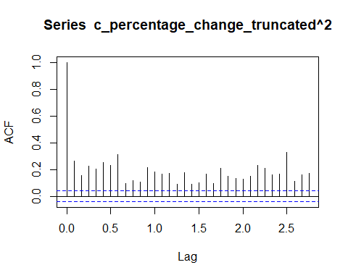

# PG  
pg_percentage_change <- ts(transformed_data.returns$returns.PG, frequency = 12, start = 2008)  
pg_percentage_change_truncated <- window(pg_percentage_change, start = 2013)  
acf(pg_percentage_change^2)

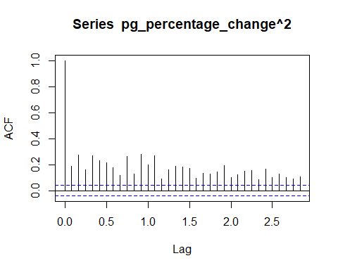

acf(pg_percentage_change_truncated^2)

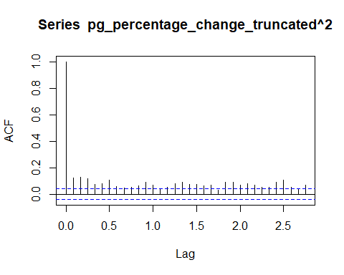

# GOOG  
goog_percentage_change <- ts(transformed_data.returns$returns.GOOG, frequency = 12, start = 2008)  
goog_percentage_change_truncated <- window(goog_percentage_change, start = 2013)  
acf(goog_percentage_change^2)

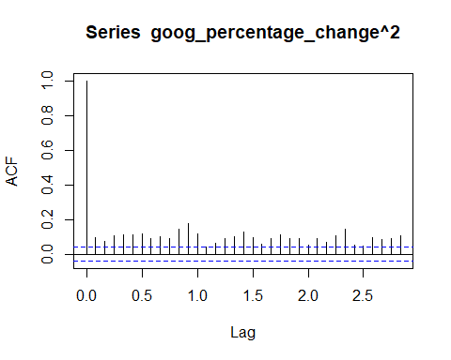

acf(goog_percentage_change_truncated^2)

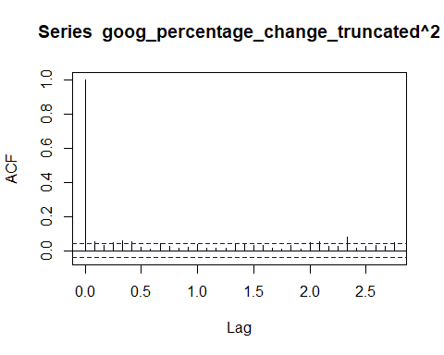

# MYL  
myl_percentage_change <- ts(transformed_data.returns$returns.MYL, frequency = 12, start = 2008)  
myl_percentage_change_truncated <- window(myl_percentage_change, start = 2013)  
acf(myl_percentage_change^2)

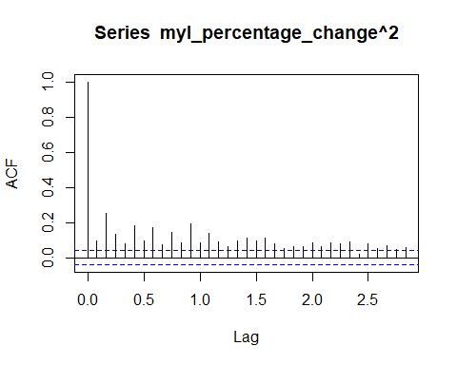

acf(myl_percentage_change_truncated^2)

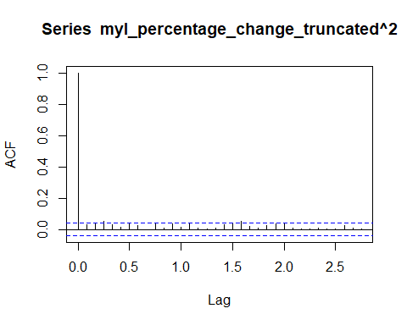

Discussion: Similarities

Difference - MMM (Surya) On the squared return of 3M asset, we could see that the progress of each lag was quite stable. There is no extreme increase nor decrease. I also could concluded that MMM stock didn’t experience a significant increase or decrease of their price for quite a long time. It’s positively stable.

* C
* GOOG
* MYL
* PG

SECTION 2.2 - PARTIAL AUTOCORRELATION Stationary analysis of the price series

# MMM  
mmm_percentage_change <- ts(transformed_data.close$close_price.MMM, frequency = 12, start = 2008)  
mmm_percentage_change_truncated <- window(mmm_percentage_change, start = 2013)  
pacf(mmm_percentage_change)

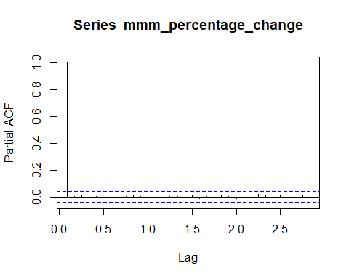

pacf(mmm_percentage_change_truncated)

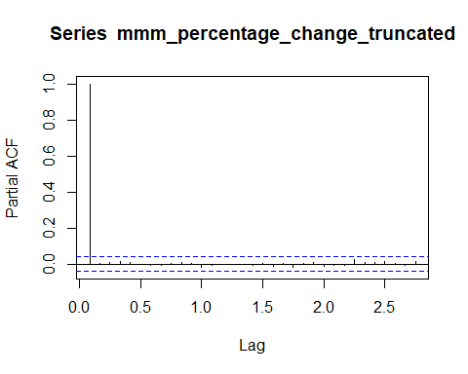

# C  
c_percentage_change <- ts(transformed_data.close$close_price.C, frequency = 12, start = 2008)  
c_percentage_change_truncated <- window(c_percentage_change, start = 2013)  
pacf(c_percentage_change)

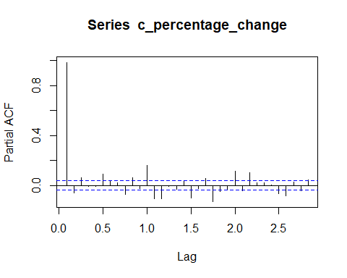

pacf(c_percentage_change_truncated)

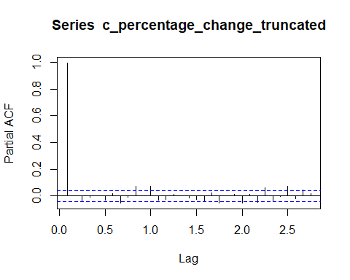

# PG  
pg_percentage_change <- ts(transformed_data.close$close_price.PG, frequency = 12, start = 2008)  
pg_percentage_change_truncated <- window(pg_percentage_change, start = 2013)  
pacf(pg_percentage_change)

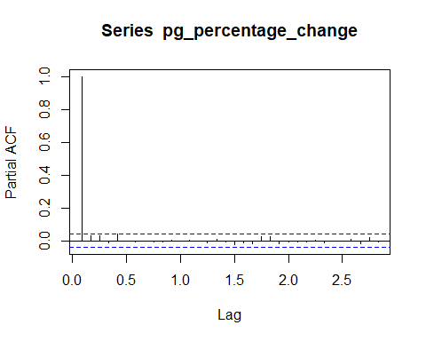

pacf(pg_percentage_change_truncated)

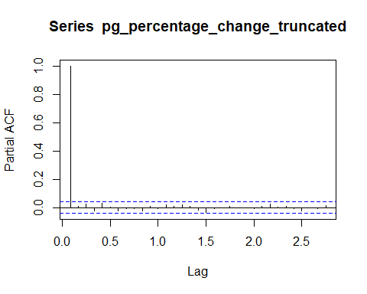

# GOOG  
goog_percentage_change <- ts(transformed_data.close$close_price.GOOG, frequency = 12, start = 2008)  
goog_percentage_change_truncated <- window(goog_percentage_change, start = 2013)  
pacf(goog_percentage_change)

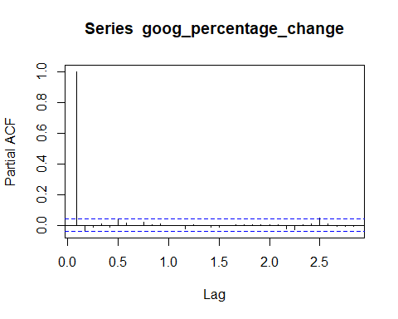

pacf(goog_percentage_change_truncated)

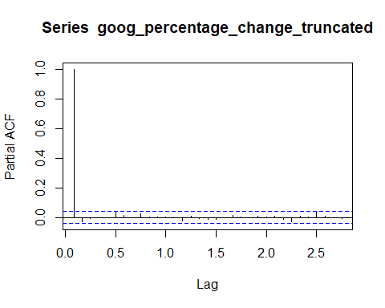

# MYL  
myl_percentage_change <- ts(transformed_data.close$close_price.MYL, frequency = 12, start = 2008)  
myl_percentage_change_truncated <- window(myl_percentage_change, start = 2013)  
pacf(myl_percentage_change)

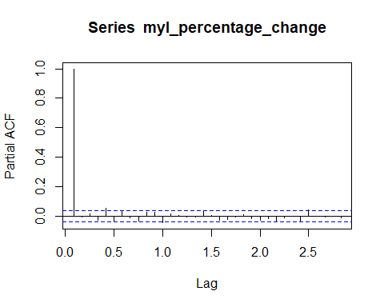

pacf(myl_percentage_change_truncated)

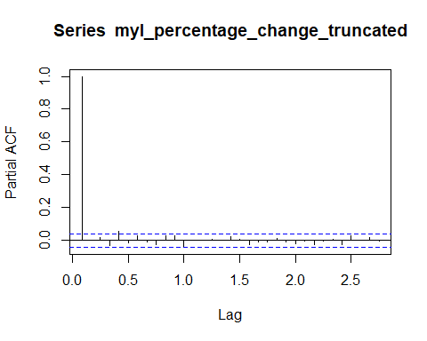

Discussion: Similarities

Difference - MMM (Surya)

* C
* GOOG
* MYL
* PG

Stationary analysis of the returns series

# MMM  
mmm_percentage_change <- ts(transformed_data.returns$returns.MMM, frequency = 12, start = 2008)  
mmm_percentage_change_truncated <- window(mmm_percentage_change, start = 2013)  
pacf(mmm_percentage_change)

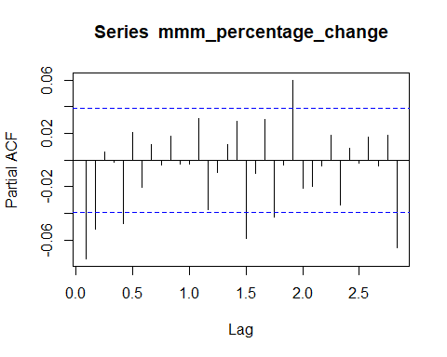

pacf(mmm_percentage_change_truncated)

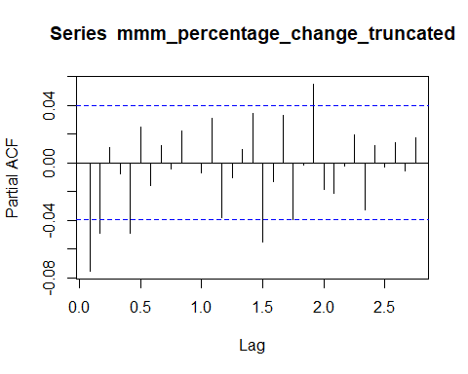

# C  
c_percentage_change <- ts(transformed_data.returns$returns.C, frequency = 12, start = 2008)  
c_percentage_change_truncated <- window(c_percentage_change, start = 2013)  
pacf(c_percentage_change)

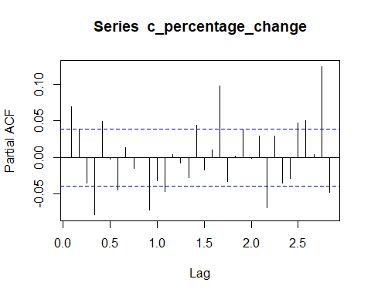

pacf(c_percentage_change_truncated)

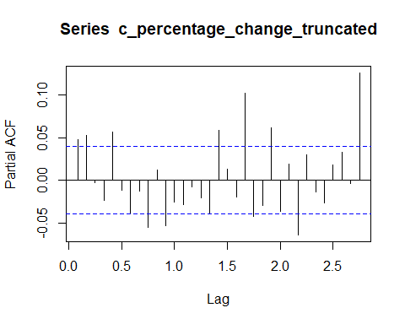

# PG  
pg_percentage_change <- ts(transformed_data.returns$returns.PG, frequency = 12, start = 2008)  
pg_percentage_change_truncated <- window(pg_percentage_change, start = 2013)  
pacf(pg_percentage_change)

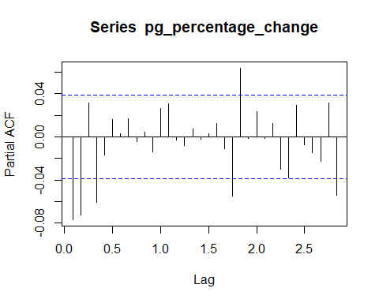

pacf(pg_percentage_change_truncated)

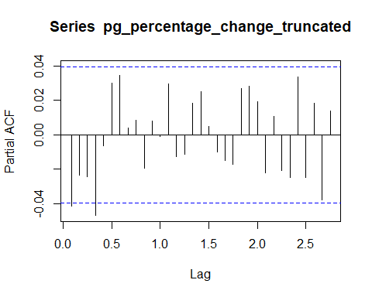

# GOOG  
goog_percentage_change <- ts(transformed_data.returns$returns.GOOG, frequency = 12, start = 2008)  
goog_percentage_change_truncated <- window(goog_percentage_change, start = 2013)  
pacf(goog_percentage_change)

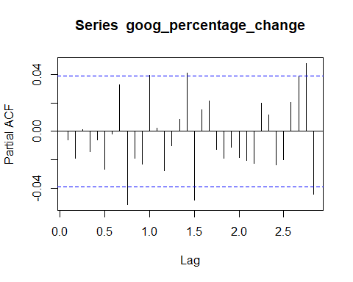

pacf(goog_percentage_change_truncated)

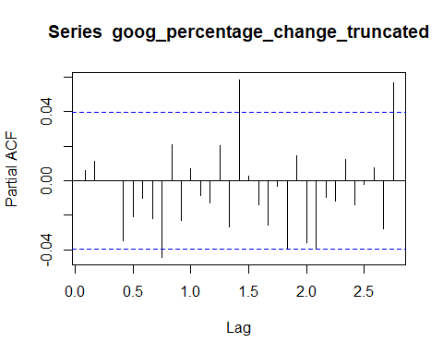

# MYL  
myl_percentage_change <- ts(transformed_data.returns$returns.MYL, frequency = 12, start = 2008)  
myl_percentage_change_truncated <- window(myl_percentage_change, start = 2013)  
pacf(myl_percentage_change)

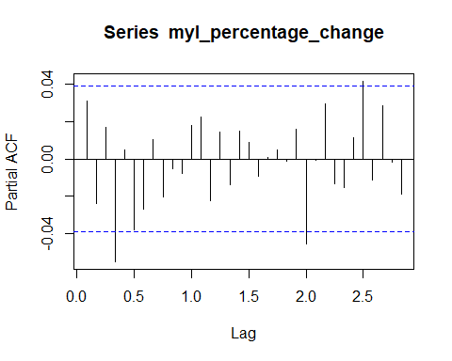

pacf(myl_percentage_change_truncated)

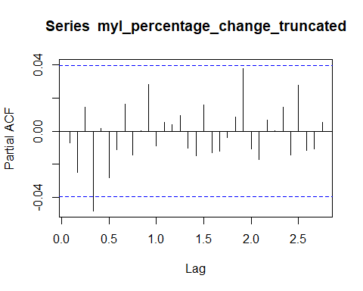

Discussion: Similarities

Difference - MMM (Surya)

* C
* GOOG
* MYL
* PG

Stationary analysis of the square of the returns series

# MMM  
mmm_percentage_change <- ts(transformed_data.returns$returns.MMM, frequency = 12, start = 2008)  
mmm_percentage_change_truncated <- window(mmm_percentage_change, start = 2013)  
pacf(mmm_percentage_change^2)

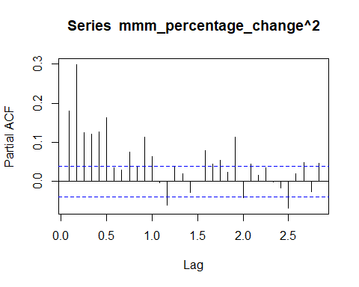

pacf(mmm_percentage_change_truncated^2)

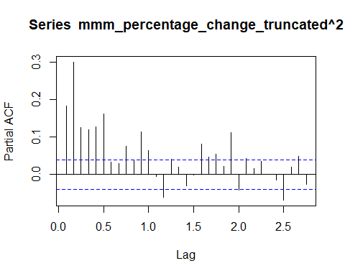

# C  
c_percentage_change <- ts(transformed_data.returns$returns.C, frequency = 12, start = 2008)  
c_percentage_change_truncated <- window(c_percentage_change, start = 2013)  
pacf(c_percentage_change^2)

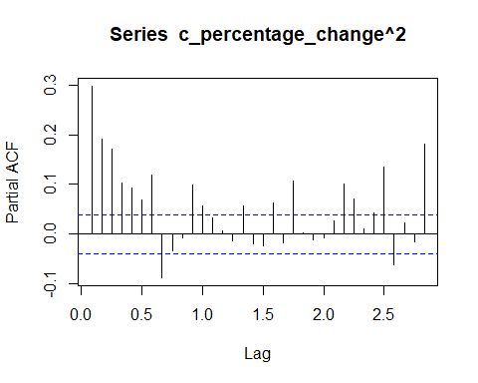

pacf(c_percentage_change_truncated^2)

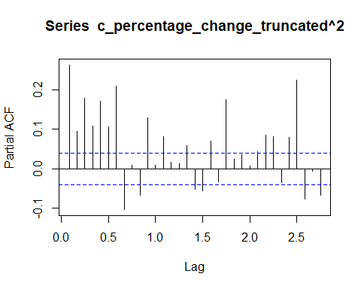

# PG  
pg_percentage_change <- ts(transformed_data.returns$returns.PG, frequency = 12, start = 2008)  
pg_percentage_change_truncated <- window(pg_percentage_change, start = 2013)  
pacf(pg_percentage_change^2)

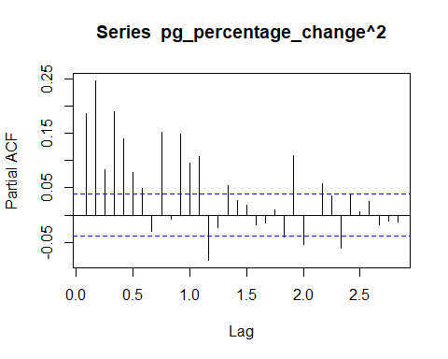

pacf(pg_percentage_change_truncated^2)

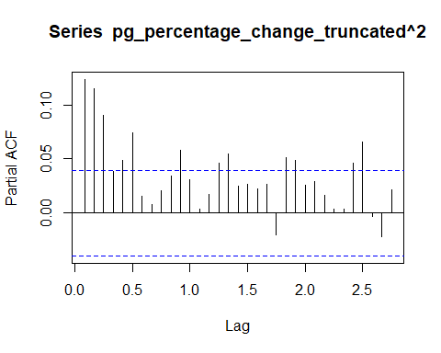

# GOOG  
goog_percentage_change <- ts(transformed_data.returns$returns.GOOG, frequency = 12, start = 2008)  
goog_percentage_change_truncated <- window(goog_percentage_change, start = 2013)  
pacf(goog_percentage_change^2)

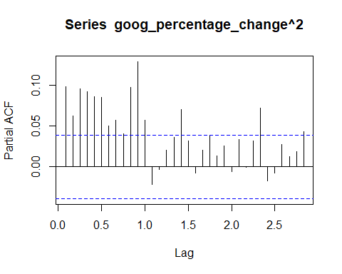

pacf(goog_percentage_change_truncated^2)

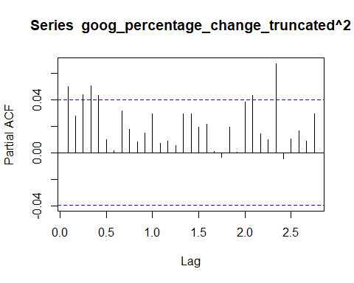

# MYL  
myl_percentage_change <- ts(transformed_data.returns$returns.MYL, frequency = 12, start = 2008)  
myl_percentage_change_truncated <- window(myl_percentage_change, start = 2013)  
pacf(myl_percentage_change^2)

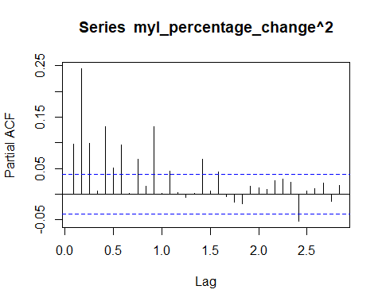

pacf(myl_percentage_change_truncated^2)

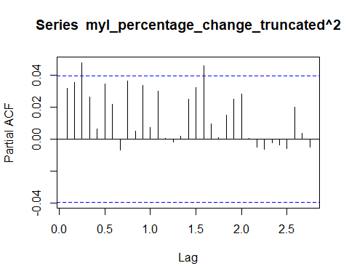

Discussion: Similarities

Difference - MMM (Surya)

* C
* GOOG
* MYL
* PG

SECTION 2.3 - ARIMA MODEL Stationary analysis of the returns series

# MMM  
mmm_percentage_change_returns <- ts(transformed_data.returns$returns.MMM, frequency = 12, start = 2008)  
  
mmm_decompose_returns <- stl(mmm_percentage_change_returns, s.window = "periodic")  
mmm_deseasonal_returns <- seasadj(mmm_decompose_returns)  
  
mmm_fit_returns <- auto.arima(mmm_deseasonal_returns, seasonal = FALSE)  
mmm_fit_returns

## Series: mmm_deseasonal_returns   
## ARIMA(1,0,1) with non-zero mean   
##   
## Coefficients:  
## ar1 ma1 mean  
## 0.4030 -0.4829 5e-04  
## s.e. 0.1948 0.1864 2e-04  
##   
## sigma^2 estimated as 0.0001885: log likelihood=7226.04  
## AIC=-14444.08 AICc=-14444.06 BIC=-14420.75

tsdisplay(residuals(mmm_fit_returns), lag.max = 12, main = "MMM Model Residuals - Returns price")

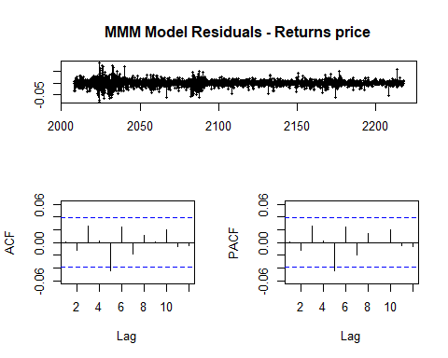

# C  
c_percentage_change_returns <- ts(transformed_data.returns$returns.C, frequency = 12, start = 2008)  
  
c_decompose_returns <- stl(c_percentage_change_returns, s.window = "periodic")  
c_deseasonal_returns <- seasadj(c_decompose_returns)  
  
c_fit_returns <- auto.arima(c_deseasonal_returns, seasonal = FALSE)  
c_fit_returns

## Series: c_deseasonal_returns   
## ARIMA(3,0,2) with zero mean   
##   
## Coefficients:  
## ar1 ar2 ar3 ma1 ma2  
## -0.3333 -0.8841 0.0704 0.4038 0.9610  
## s.e. 0.0250 0.0282 0.0208 0.0149 0.0187  
##   
## sigma^2 estimated as 0.001375: log likelihood=4725.26  
## AIC=-9438.52 AICc=-9438.49 BIC=-9403.53

tsdisplay(residuals(c_fit_returns), lag.max = 12, main = "C Model Residuals - Returns price")

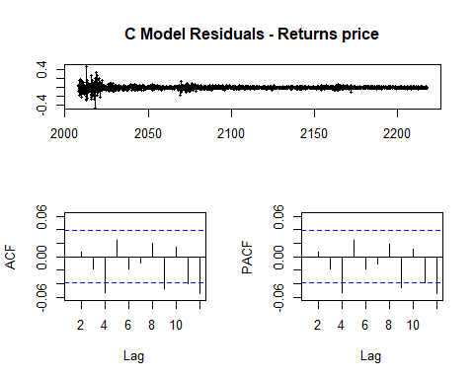

# PG  
pg_percentage_change_returns <- ts(transformed_data.returns$returns.PG, frequency = 12, start = 2008)  
  
pg_decompose_returns <- stl(pg_percentage_change_returns, s.window = "periodic")  
pg_deseasonal_returns <- seasadj(pg_decompose_returns)  
  
pg_fit_returns <- auto.arima(pg_deseasonal_returns, seasonal = FALSE)  
pg_fit_returns

## Series: pg_deseasonal_returns   
## ARIMA(1,0,2) with zero mean   
##   
## Coefficients:  
## ar1 ma1 ma2  
## -0.4994 0.4225 -0.1099  
## s.e. 0.1372 0.1369 0.0199  
##   
## sigma^2 estimated as 0.0001192: log likelihood=7803.12  
## AIC=-15598.24 AICc=-15598.22 BIC=-15574.92

tsdisplay(residuals(pg_fit_returns), lag.max = 12, main = "PG Model Residuals - Returns price")

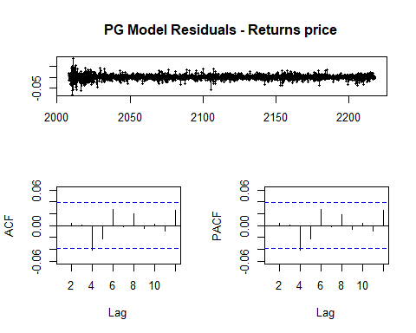

# GOOG  
goog_percentage_change_returns <- ts(transformed_data.returns$returns.GOOG, frequency = 12, start = 2008)  
  
goog_decompose_returns <- stl(goog_percentage_change_returns, s.window = "periodic")  
goog_deseasonal_returns <- seasadj(goog_decompose_returns)  
  
goog_fit_returns <- auto.arima(goog_deseasonal_returns, seasonal = FALSE)  
goog_fit_returns

## Series: goog_deseasonal_returns   
## ARIMA(2,0,2) with non-zero mean   
##   
## Coefficients:

## Warning in sqrt(diag(x$var.coef)): NaNs produced

## ar1 ar2 ma1 ma2 mean  
## 0.1945 0.737 -0.199 -0.7492 7e-04  
## s.e. NaN NaN NaN NaN 3e-04  
##   
## sigma^2 estimated as 0.0002986: log likelihood=6648.3  
## AIC=-13284.59 AICc=-13284.56 BIC=-13249.6

tsdisplay(residuals(goog_fit_returns), lag.max = 12, main = "GOOG Model Residuals - Returns price")

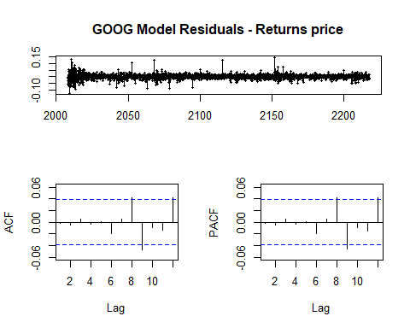

# MYL  
myl_percentage_change_returns <- ts(transformed_data.returns$returns.MYL, frequency = 12, start = 2008)  
  
myl_decompose_returns <- stl(myl_percentage_change_returns, s.window = "periodic")  
myl_deseasonal_returns <- seasadj(myl_decompose_returns)  
  
myl_fit_returns <- auto.arima(myl_deseasonal_returns, seasonal = FALSE)  
myl_fit_returns

## Series: myl_deseasonal_returns   
## ARIMA(1,0,1) with zero mean   
##   
## Coefficients:  
## ar1 ma1  
## -0.7090 0.7491  
## s.e. 0.1503 0.1420  
##   
## sigma^2 estimated as 0.0005146: log likelihood=5961.32  
## AIC=-11916.64 AICc=-11916.63 BIC=-11899.15

tsdisplay(residuals(myl_fit_returns), lag.max = 12, main = "MYL Model Residuals - Returns price")

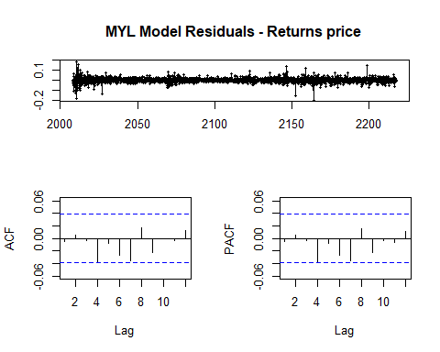 Discussion: - MMM (Surya)

* C
* GOOG
* MYL
* PG

Stationary analysis of the square of the returns series

# MMM  
mmm_percentage_change_squared_returns <- ts(transformed_data.returns$returns.MMM^2, frequency = 12, start = 2008)  
mmm_decompose_squared_returns <- stl(mmm_percentage_change_squared_returns, s.window = "periodic")  
mmm_deseasonal_squared_returns <- seasadj(mmm_decompose_squared_returns)  
  
mmm_fit_squared_returns <- auto.arima(mmm_deseasonal_squared_returns, seasonal = FALSE)  
mmm_fit_squared_returns

## Series: mmm_deseasonal_squared_returns   
## ARIMA(3,1,5)   
##   
## Coefficients:  
## ar1 ar2 ar3 ma1 ma2 ma3 ma4 ma5  
## -0.3882 -0.5259 -0.5522 -0.5897 0.3199 -0.0509 -0.4801 0.0269  
## s.e. 0.2091 0.1824 0.0976 0.2091 0.1525 0.1564 0.1113 0.0345  
##   
## sigma^2 estimated as 2.291e-07: log likelihood=15672.74  
## AIC=-31327.47 AICc=-31327.4 BIC=-31274.99

tsdisplay(residuals(mmm_fit_squared_returns), lag.max = 12, main = "MMM Model Residuals - Squared returns price")

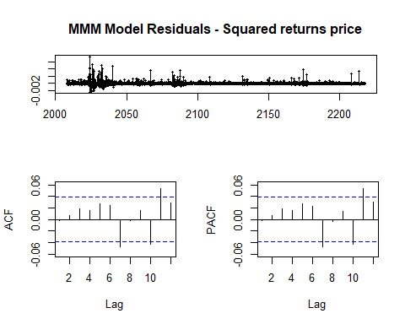

# C  
c_percentage_change_squared_returns <- ts(transformed_data.returns$returns.C^2, frequency = 12, start = 2008)  
c_decompose_squared_returns <- stl(c_percentage_change_squared_returns, s.window = "periodic")  
c_deseasonal_squared_returns <- seasadj(c_decompose_squared_returns)  
  
c_fit_squared_returns <- auto.arima(c_deseasonal_squared_returns, seasonal = FALSE)  
c_fit_squared_returns

## Series: c_deseasonal_squared_returns   
## ARIMA(1,1,2)   
##   
## Coefficients:  
## ar1 ma1 ma2  
## 0.8073 -1.6433 0.6490  
## s.e. 0.0329 0.0392 0.0382  
##   
## sigma^2 estimated as 6.055e-05: log likelihood=8651.37  
## AIC=-17294.75 AICc=-17294.73 BIC=-17271.42

tsdisplay(residuals(c_fit_squared_returns), lag.max = 12, main = "C Model Residuals - Squared returns price")

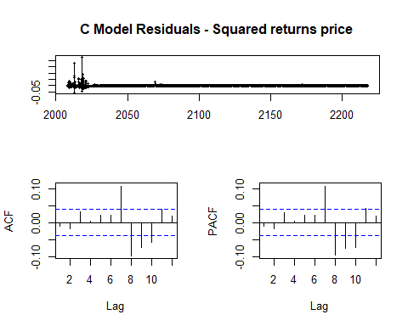

# GOOG  
goog_percentage_change_squared_returns <- ts(transformed_data.returns$returns.GOOG^2, frequency = 12, start = 2008)  
goog_decompose_squared_returns <- stl(goog_percentage_change_squared_returns, s.window = "periodic")  
goog_deseasonal_squared_returns <- seasadj(goog_decompose_squared_returns)  
  
goog_fit_squared_returns <- auto.arima(goog_deseasonal_squared_returns, seasonal = FALSE)  
goog_fit_squared_returns

## Series: goog_deseasonal_squared_returns   
## ARIMA(1,1,2)   
##   
## Coefficients:  
## ar1 ma1 ma2  
## 0.5764 -1.5660 0.5804  
## s.e. 0.2330 0.2282 0.2208  
##   
## sigma^2 estimated as 1.06e-06: log likelihood=13742.54  
## AIC=-27477.08 AICc=-27477.07 BIC=-27453.76

tsdisplay(residuals(goog_fit_squared_returns), lag.max = 12, main = "GOOG Model Residuals - Squared returns price")

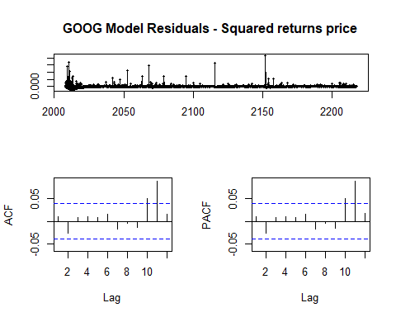

# PG  
pg_percentage_change_squared_returns <- ts(transformed_data.returns$returns.PG^2, frequency = 12, start = 2008)  
pg_decompose_squared_returns <- stl(pg_percentage_change_squared_returns, s.window = "periodic")  
pg_deseasonal_squared_returns <- seasadj(pg_decompose_squared_returns)  
  
pg_fit_squared_returns <- auto.arima(pg_deseasonal_squared_returns, seasonal = FALSE)  
pg_fit_squared_returns

## Series: pg_deseasonal_squared_returns   
## ARIMA(2,1,3)   
##   
## Coefficients:  
## ar1 ar2 ma1 ma2 ma3  
## -1.8272 -0.9776 0.9006 -0.6714 -0.8934  
## s.e. 0.0066 0.0072 0.0127 0.0183 0.0153  
##   
## sigma^2 estimated as 1.204e-07: log likelihood=16480.42  
## AIC=-32948.84 AICc=-32948.8 BIC=-32913.85

tsdisplay(residuals(pg_fit_squared_returns), lag.max = 12, main = "PG Model Residuals - Squared returns price")

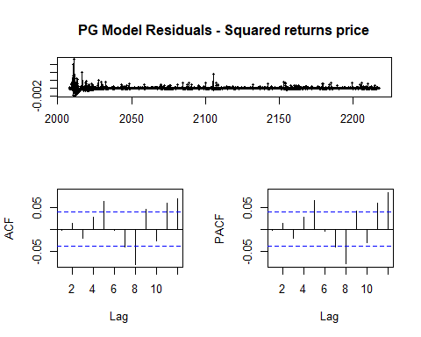

# MYL  
myl_percentage_change_squared_returns <- ts(transformed_data.returns$returns.MYL^2, frequency = 12, start = 2008)  
myl_decompose_squared_returns <- stl(myl_percentage_change_squared_returns, s.window = "periodic")  
myl_deseasonal_squared_returns <- seasadj(myl_decompose_squared_returns)  
  
myl_fit_squared_returns <- auto.arima(myl_deseasonal_squared_returns, seasonal = FALSE)  
myl_fit_squared_returns

## Series: myl_deseasonal_squared_returns   
## ARIMA(5,1,5)   
##   
## Coefficients:  
## ar1 ar2 ar3 ar4 ar5 ma1 ma2 ma3  
## 0.1664 0.5238 -0.2476 0.1512 0.1366 -1.1418 -0.2012 0.6161  
## s.e. 0.1707 0.1620 0.1837 0.1318 0.0391 0.1716 0.2664 0.1508  
## ma4 ma5  
## -0.5437 0.2780  
## s.e. 0.2397 0.1162  
##   
## sigma^2 estimated as 3.185e-06: log likelihood=12361.02  
## AIC=-24700.05 AICc=-24699.94 BIC=-24635.91

tsdisplay(residuals(myl_fit_squared_returns), lag.max = 12, main = "MYL Model Residuals - Squared returns price")

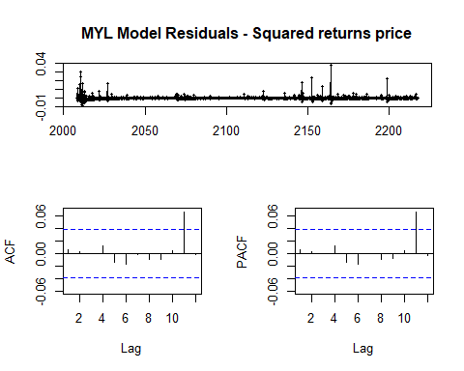

Discussion: - MMM (Surya)

* C
* GOOG
* MYL
* PG