### 必须信息

**project_id :0c9433636e000fe02f6fc00a6e3661f6**

**product_id:60b9c9383744a602a5cb9bf3**

**IAM用户名：hw12224441**

**IAM密码：5812870huawei**

**IAMDoaminId:hw12224441**

**region:cn-north-4**

**IOTDAEndpoint: iotda.cn-north-4.myhuaweicloud.com**

**device_id: 60b9c9383744a602a5cb9bf3_smart_control_01**

### 鉴权认证

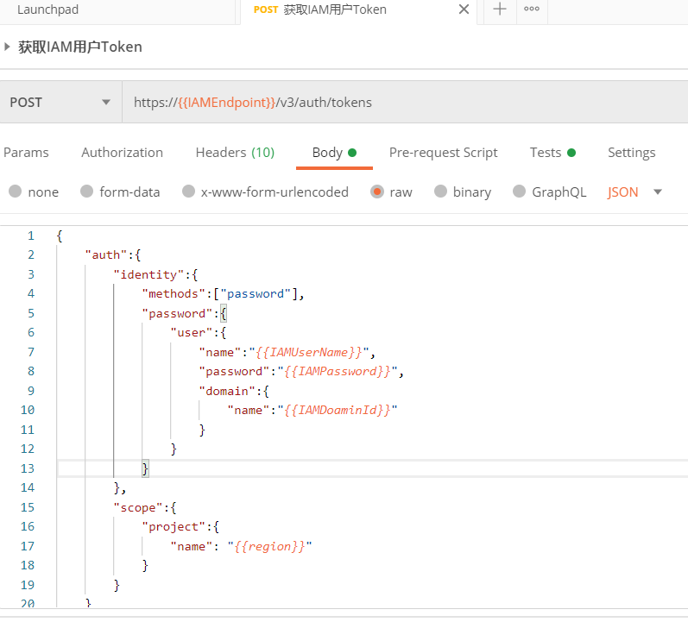

### 下发设备命令

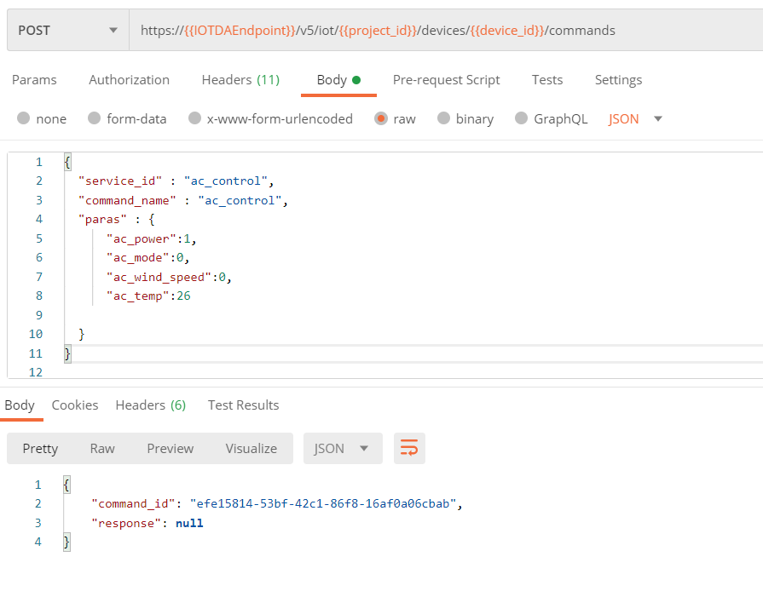

### 查询设备属性

