系统部署

1. Uniapp ： kangyi_guanliyuan 和 kangyi_caozuo

更改 服务器位置

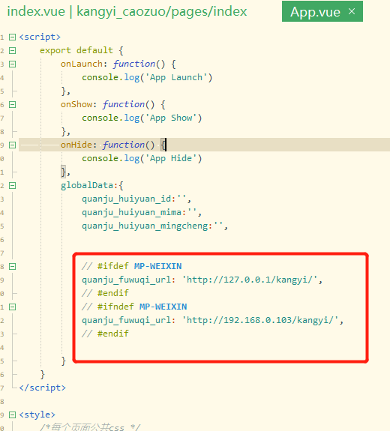

1. php

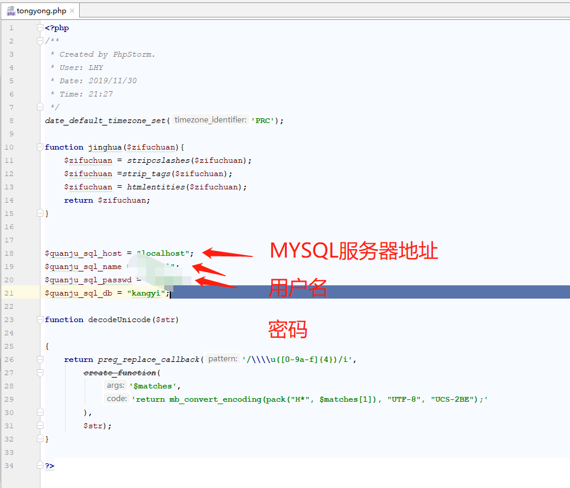

1. Mysql

数据库名称：kangyi

字节集：utf-8

建表函数如下，或者看本目录的mysql。Txt

CREATE TABLE `caozuo` (

`guanliyuan_id` varchar(11) NOT NULL,

`caozuo_id` varchar(11) NOT NULL,

`caozuo_mingcheng` varchar(20) DEFAULT NULL,

`caozuo_mima` varchar(20) DEFAULT NULL,

PRIMARY KEY (`caozuo_id`) USING BTREE

) ENGINE=InnoDB DEFAULT CHARSET=utf8;

CREATE TABLE `guanliyuan` (

`guanliyuan_id` varchar(11) NOT NULL,

`guanliyuan_mingcheng` varchar(20) DEFAULT NULL,

`guanliyuan_mima` varchar(12) DEFAULT NULL,

PRIMARY KEY (`guanliyuan_id`)

) ENGINE=InnoDB DEFAULT CHARSET=utf8;

CREATE TABLE `renyuan` (

`renyuan_id` varchar(11) NOT NULL,

`renyuan_xingming` text DEFAULT NULL,

`renyuan_shenfenzheng` varchar(20) DEFAULT NULL,

`renyuan_dizhi` text DEFAULT NULL,

`renyuan_zanzhu` text DEFAULT NULL,

`renyuan_fangdong` varchar(11) DEFAULT NULL,

`renyuan_shouji` varchar(11) DEFAULT NULL,

PRIMARY KEY (`renyuan_id`)

) ENGINE=InnoDB DEFAULT CHARSET=utf8;

CREATE TABLE `shuju` (

`ID` int(20) NOT NULL AUTO_INCREMENT,

`riqi` date DEFAULT NULL,

`shijian` time DEFAULT NULL,

`renyuan_id` varchar(11) DEFAULT NULL,

`caozuo_id` varchar(11) DEFAULT NULL,

`tiwen` varchar(1) DEFAULT NULL,

`lukou` varchar(10) DEFAULT NULL,

PRIMARY KEY (`ID`)

) ENGINE=InnoDB AUTO_INCREMENT=7 DEFAULT CHARSET=utf8;