Anchors計算方法

1. process程式打開並執行
2. 更改current_dir、 file_train.write路徑

import glob, os

# Current directory

current_dir = os.path.dirname(os.path.abspath(__file__))

print(current_dir)

current_dir = '/home/g11016003/yolor/data/car_train81_total'

# Percentage of images to be used for the test set

percentage_test = 100;

# Create and/or truncate train.txt and test.txt

file_train = open('data/car_train81.txt', 'w')

file_test = open('data/car_test81.txt', 'w')

# Populate train.txt and test.txt

counter = 1

index_test = round(100 / percentage_test)

for pathAndFilename in glob.iglob(os.path.join(current_dir, "*.jpg")):

title, ext = os.path.splitext(os.path.basename(pathAndFilename))

if counter == index_test:

counter = 1

file_train.write("/home/g11016003/yolor/data/car_train81_total" + "/" + title + '.jpg' + "\n")

else:

file_test.write("/home/g11016003/yolor/data/car_train81_total" + "/" + title + '.jpg' + "\n")

counter = counter + 1

先用下面這一支程式會產生car_train81.txt和car_test81.txt

但因為我沒有測試集,所以圖片都放在car_train81裡面

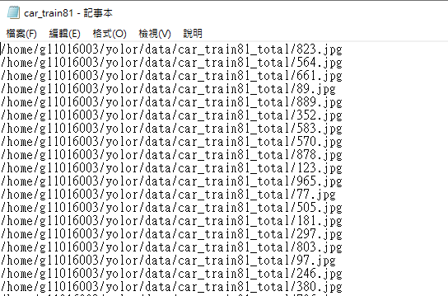

2.Car_train81.txt包含所有圖片的路徑(放在Darknet 🡪Data底下)

3.創建car81.data 檔案(放在Darknet 🡪Data底下)

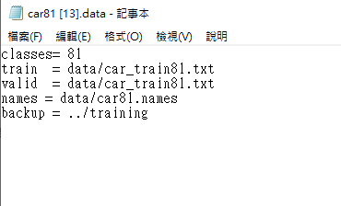

Car81.data裡面的路徑要連結到Car_train81.txt

4.創建car81.name(放在Darknet 🡪Data底下)

5.執行以下指令

./darknet detector calc_anchors data/car81.data -num_of_clusters 12 -width 1280 -height 1280

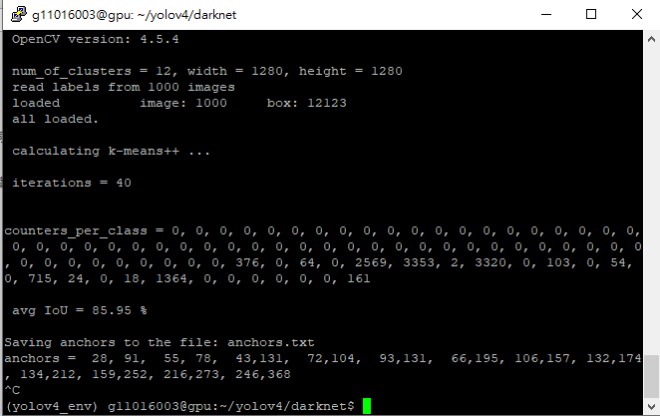

#counters_per_class🡪0的話代表那類沒Label(如果太多0會造成IoU下降準確度降低)

跑完Anchors就出現囉!!!