PACIFIC BIOARCHIVE
AWS Serverless Wildlife Media Platform · Team Report
DRAFT COMPLETION REQUIRED: insert Group 8 member names/student IDs, final live URL and confirmed AWS screenshots before submission.
FIT5225 Cloud Computing and Security · Assignment 2 · Due 30 August 2026

Executive overview
Pacific BioArchive converts authenticated wildlife images and short videos into private, searchable evidence. A browser calculates SHA-256 before a presigned upload; Amazon EventBridge invokes container-based AWS Lambda processing, which creates proportional compressed thumbnails, samples video at exactly one frame per second, and runs the supplied MegaDetector/classifier without retraining. Amazon DynamoDB stores file type, stable object keys, automatic/manual tags, species counts, confidence evidence, owner and processing state. Users can run strict minimum-count AND, species, thumbnail and temporary-image queries, then bulk-edit tags, delete complete records and subscribe to watched-tag email through Amazon SNS.

Architecture and design
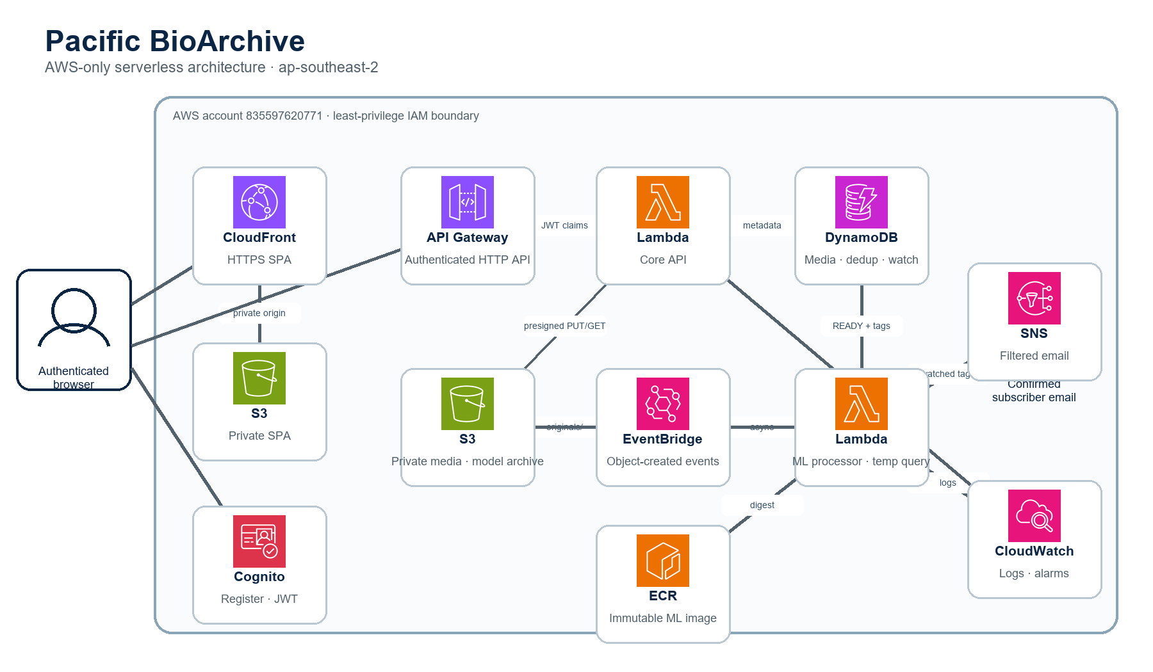
Figure 1. Pacific BioArchive AWS-only architecture using official AWS Architecture Icons.
Amazon Cognito issues short-lived JWTs that API Gateway validates before invoking separate least-privilege functions. CloudFront serves the React SPA from a private S3 origin. The core Lambda owns lightweight API orchestration; two 3008 MiB image-based Lambdas isolate supplied-model processing and temporary visual query. Stable S3 keys, not expiring signed URLs, are persisted. ECR digest pinning makes the runtime reproducible, while seven-day CloudWatch logs and alarms support troubleshooting.

Correctness, security and cost controls
Duplicate reservation uses a conditional DynamoDB checksum record, and the processor recomputes SHA-256/MIME metadata before analysis. S3 replay and SNS notification IDs are idempotent. Query files are user-scoped and deleted in a finally path on success or failure. Owner claims protect tag/delete actions; browsers receive no AWS credentials. All buckets block public access and require TLS. The stack is restricted to Sydney, uses on-demand DynamoDB, bounded file/video limits, API throttling, seven-day logs and one-day temporary-object expiry. It contains no EC2, NAT Gateway, RDS, OpenSearch, SageMaker, EFS or WAF. Reserved Lambda concurrency is omitted because this Academy account exposes only AWS's minimum unreserved pool.

Verification
Automated evidence currently records 110 passing backend tests with 90.12% domain/application coverage and 20 passing frontend tests plus TypeScript, production build, ESLint and CloudFormation lint gates. Three hash-bound supplied fixtures produce the expected australian brushturkey, southern cassowary and domestic cat predictions locally and in the Linux Lambda image. The ML image is published by branch-bound GitHub OIDC as an immutable Sydney ECR digest. Final submission must add the completed live Cognito, SNS, CloudFront and end-to-end AWS evidence; mocked results are not represented as live proof.

Team contribution table
Name and student ID | Contribution | Major contribution (maximum 100 words each)
[MEMBER 1 NAME / ID] | 25% | Supplied ML integration; image/video processing; real-model and Linux container proof.
[MEMBER 2 NAME / ID] | 25% | Domain model; persistence; four query paths; bulk tag/delete; REST API contracts.
[MEMBER 3 NAME / ID] | 25% | S3/DynamoDB/SNS/EventBridge adapters; SAM/IAM/OIDC/ECR; live AWS deployment evidence.
[MEMBER 4 NAME / ID] | 25% | Cognito authentication; React UI; CloudFront deployment; integration, user/demo/report delivery.

Simple user guide
- Open the CloudFront URL; register with every required field, enter the Cognito email code and sign in.
- Upload an image/video and follow hashing, duplicate check, private upload and analysis; open the thumbnail/original result.
- Search by strict AND minimum counts, one species, thumbnail URL, or a temporary image that is never archived.
- In Manage, select up to 25 owned records to add/remove tags or explicitly confirm complete file/metadata deletion.
- Watch tags, confirm the SNS email, upload/update matching media, then sign out and verify protected routes are blocked.

Repository and Generative AI declaration
Private official repository: https://github.com/weiwei0618seu/FIT5225_Assignment2_Group8. All four students must contribute substantive commits from their own accounts and be able to run, test, modify and explain their code.
OpenAI Codex assisted with requirement/rubric review, architecture, implementation, tests, infrastructure, debugging and documentation in the private Prototype repository. Students remain accountable for every submitted statement and line of code. AI output was reviewed through unit/integration/UI tests, lint/build gates, real supplied-model runs and observed AWS evidence. Failed deployment attempts and account quota adaptations are recorded rather than hidden.

UI evidence (excluded from word count)
[INSERT LIVE SCREENSHOT 1: authenticated upload result with thumbnail and real ML tags]
Replace this panel with a captioned live UI screenshot.
[INSERT LIVE SCREENSHOT 2: strict AND query or bulk management/notification result]
Replace this panel with a captioned live UI screenshot.

References
Amazon Web Services. (2026). AWS Architecture Icons, Icon package 31 July 2026. https://aws.amazon.com/architecture/icons/
Monash University FIT5225. (2026). Assignment 2 specification and marking rubric.
FINAL CHECK: keep body <=1,000 words; replace every bracketed placeholder; add final UI screenshots; export to PDF; confirm all four members and the teaching team can access the private repository.

