**Homework #1 -** there are 7 problems (the first two are shown in class notes.)

We covered 3 problems already. Welcome to think about them. In next two weeks we will cover algorithms. Usually there will be 1~2 weeks for you to do the problems.

**1. (15 points)**

Please complete this truth table and its logic functions F and G (they are in a slide.)

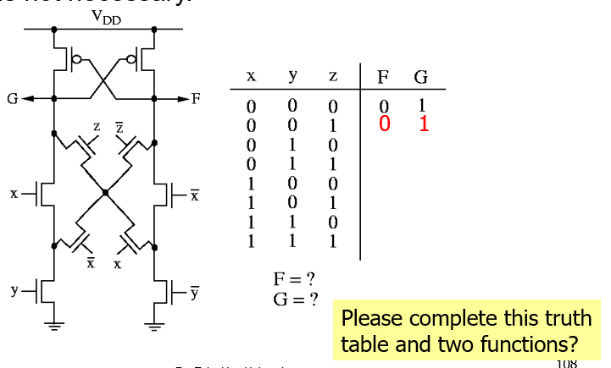

1. **Draw a layout for an ordering of input nets (15 points**)

One slide shows a transistor design and a possible stick layout (please see a picture below)

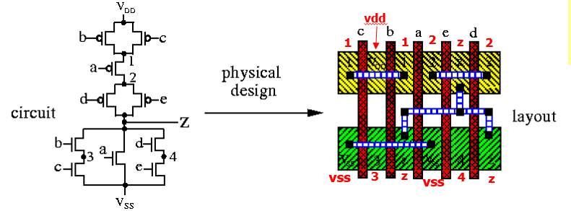

Now if the input gate ordering is changed to a, b, c, d, e, please draw a new stick layout. Then, compare what you newly get with the above result and comment.

**3. CMOS Circuit Design (20 points)**

(a) Design a CMOS logic gate F=(A+B)(CD+E). Draw the transistor-level (PMOS, NMOS) schematic. Please indicate all the names of signals (F, A, B, C, D, E) and also the power/ground.

(b) Draw a stick diagram for the design in (a).

(c) The following PMOS network was designed to implement the Boolean function G(w,x,y,z). Please write the Boolean equation of G. Also complete the NMOS network.

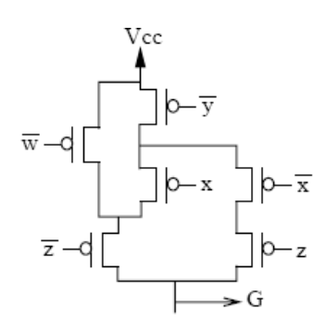

**4. Computation Complexity** **(5 points**) Determine which of the following is correct.

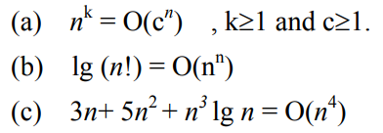

**5. Dijkstra Shortest-path** Algorithm (**15 points**) For the directed graph of Fig. 3.15 in the textbook, use the Dijkstra shortest-path algorithm to find the shortest path from v6 to v5. Please show all the iterations in the same table as Fig 3.16. What is the shortest distance, and such a path?

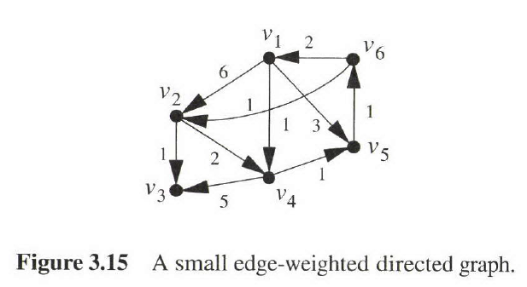

**6. Prim’s Algorithm** for MST (**15 points**) For the following graph, use Prim’s algorithm (page-37 in ref. book) to find the minimum spanning tree. Please start from V1. What is the tree weight of your result? Also list the edges in this MST.

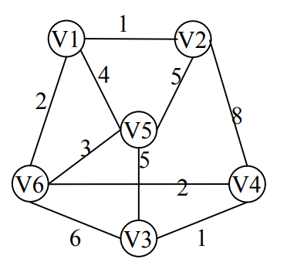

Show the iteration using the following table. The definition of the variables are the same as our lecture note. (here “pi” column is to let you list how your “wavefront” expansion does.)

|  |  |  |  |
| --- | --- | --- | --- |
| Iteration | key | π (pi) | Vertex in MST |
| 1 | Key[V1]=0 key[V2]=∞ key[V3]=∞ key[V4]=∞ key[V5]=∞ key[V6]=∞ | π [V1]=NIL | V1 |
|  | V2=1, v6=2, v5=4, | V2, v5, v6 | V1, v2 |
|  | V1=0, v2=1, v6=2, v5=4, v4=8 | V1-v6=2, v1-v5=4, v2-v5=5, v2-v4=8 | V1, v2, v6 |
|  |  |  |  |

**7. Branch and Bound** (**15 points**)

Use the branch and bound algorithm to solve the TSP problem in above Figure HW-6. Start and end with V1. Show the search tree as Fig. 5.6 in the textbook. How many nodes do you have in your search tree?

