**Homework #2**

**1. (30 pts)** Given the following Polish expression, E = 12H3V4HV5.

(a) (6 pts) Dose the above expression satisfy the balloting property? Justify your answer.

(b) (6 pts)

Is E a normalized Polish expression? If not, exchange an operator and its adjacent operand to transform E into a normalized Polish expression E’.

(c) (6 pts)

Give the slicing tree corresponding to the expression E, or explain why no such a slicing tree exists. Also, give the slicing tree corresponding to the “resulting” normalized Polish expression E’ , if E is not a normalized Polish expression.

(d) (12 pts)

Assume the modules 1, 2, ..., 5 have the sizes and shapes indicated in Table 1. If all modules are hard and have free orientations, what will be the size of the smallest bounding rectangle corresponding to E if it is a normalized Polish expression or E’ otherwise? Show all steps that lead to your answer.

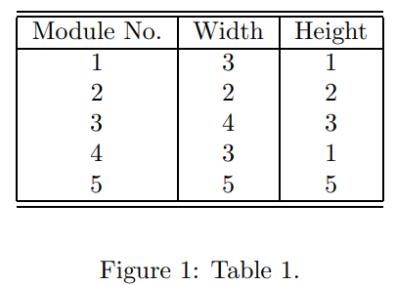

**2. (20 pts)**

Derive the B*-tree for the packing of the five modules, a, b, c, d, and e shown in Figure 2. Show all steps for computing the coordinates of the modules from the resulting B*-tree?

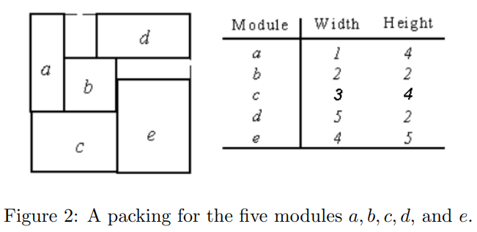

**3. (25 pts)**

For the floorplanning problem discussed, we were asked to minimize the area of the final bounding rectangle for the given set of hard blocks. Suppose we need to pack a set of hard blocks into a die with a fixed bounding rectangle (i.e., fixed-outline floorplanning). Discuss how you can modify the cost function of floorplanning to address the fixed-outline floorplanning.

(Note: in a slide, we showed a cost function is like

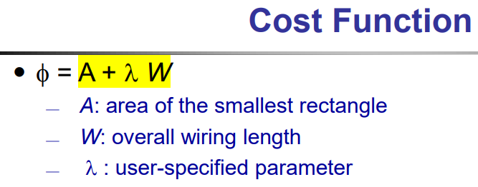

How to enhance?)

**4. (25 pts) Partitioning**

Let the three tuple (u, v, w) denotes an edge (u, v) with weight w. Given a circuit C of 6 vertices, n1, n2, ...,n6, and 5 edges, C = {(n1, n4, 4), (n4, n2, 2), (n2, n3, 3), (n2, n5, 5), (n3, n6, 6)},

apply the Kernighan-Lin heuristic to find the balanced min-cut for C with the initial partitions {n1, n2, n3} and {n4, n5, n6}. Show all steps that lead to your answer.