**Homework #3 (total points 100)**

1. Check whether the following Boolean function f(w, x, y, z) is the tautology (from **chapter-6**: logic synthesis from page-13, …) If not, show the counter-example: (**10 points**)

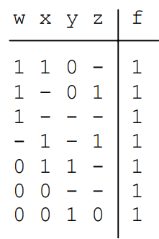

1. Use BDD to build the above function. First, from the Boolean equation, you can try to simplify; then, pick a variable ordering to build BDD. ( build the cubes row by row, and then OR them together.) (**15 pts**)
2. Convert the above function to CNF. Solve f = 0. (**15 pts**)
3. Another Boolean function: ***f = ab + cd + ef (hint:*** with ordering ***a ≤ b ≤ c ≤ d ≤ e ≤ f*** )

Please show your steps to create this BDD. (note: other ordering will yield a complicated one) (**30 points**)

3)

(a) The Boolean difference ‘d’ of two Boolean functions ‘f’ and ‘g’ is defined as “d = 1 iff ((f = 1 ∧ g = 0) ∨ (f = 0 ∧ g = 1))”. In other words, “d = f ⊕ g”, where ‘⊕’ is the “exclusive-OR” operator.

If we define the operator ‘–’ as the Boolean difference, that is, “d = f – g”, prove that

“(f – g) ⋅ h = (f ⋅ h – g ⋅ h)”, where ‘⋅’ is the AND operator. **(5 pts)**

(b) Prove that “f – (g – h) = (f – g) – h”. (**5 pts)**

(c) Given a Boolean function f, prove that f’ = 1 – f, where f’ is the inversion of f. (**10 pts**)

(d) Let fx and fx’ be the positive and negative cofactors of a Boolean function f, and fd is the Boolean difference function of fx and fx’. Prove that “f = fx’ – x ⋅ fd”. (**10 pts**)