* Input with different method is different
* Select method
  + first line contains 3 integers: 𝑁,𝐾,G
  + The second line contains 𝑁 integers: 𝑎1, 𝑎2, . . . , 𝑎𝑁, each separated by a single space.
* Iterative method
  + first line contains 2 integers: 𝑁, K
  + The second line contains 𝑁 integers: 𝑎1, 𝑎2, . . . , 𝑎𝑁, each separated by a single space.

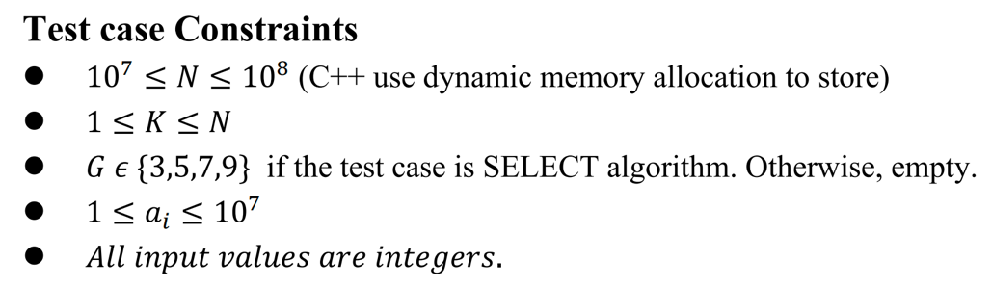

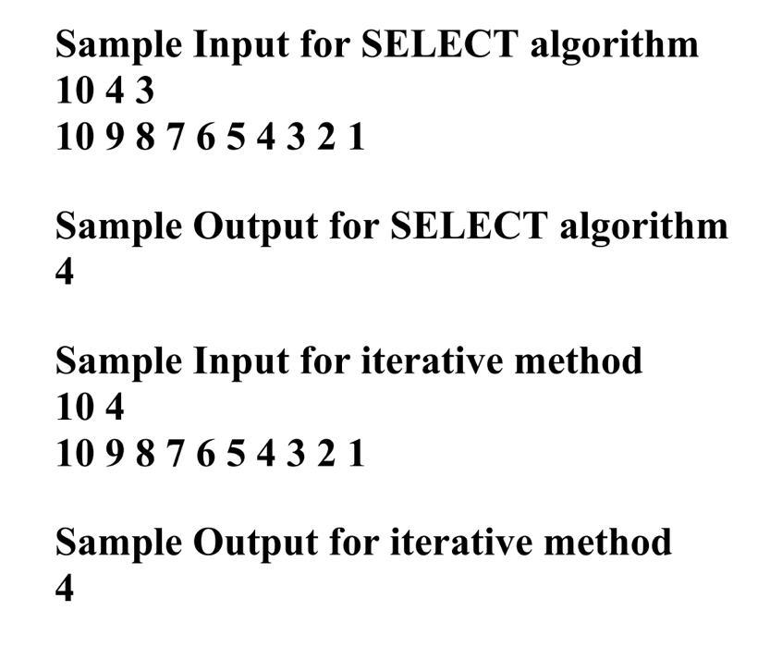

* Can put test case in a file, ex: input.txt
* Then use command like:
  + “python x1136010_select.py < input.txt”
  + “python x1136010_iterative.py < input.txt”
  + Important !! first line of input.txt for select and iterative is different!