黃偉祥 X1136010

**Limitations:**

VDD = 1.8v

L = 0.18um

W >= 0.25um

Settings:

pFET(w=0.5u),nFET(w=0.25u), .tem=30

h1.sp : .tran 0.01n 260n

h1_bonus.sp : .tran 0.01n 520n

**How to perform the simulation**

1. Enter the command below to switch to hspice.chsrc, it will give you the hspice version
   * source /usr/cad/synopsys/CIC/hspice.cshrc
2. Use hspice to compile your .sh file and output as .lis file
   * hspice -i input.sh -o output.lis
3. If the last line showed hspice job concluded then you are good to go and check the waveview. But if showed aborted or something else then you need to check the error message in .lis file

For example:

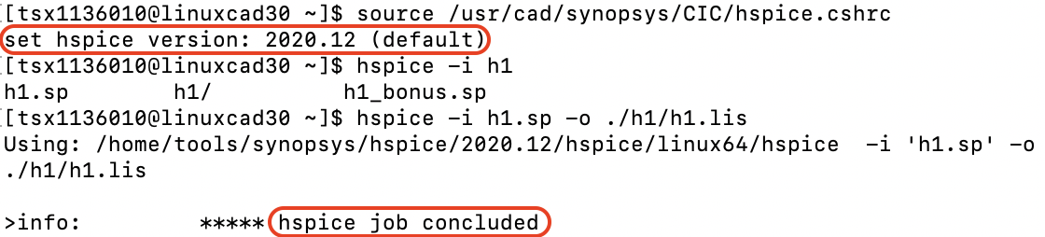

1. Enter the command below to switch to source customexplorer.cshrc, it will give you customerexplorer version
   * source /usr/cad/synopsys/CIC/customexplorer.cshrc
2. Use custom waveview to check your result wave, using wv target_file.tr0
   * wv file.tr0

For example:

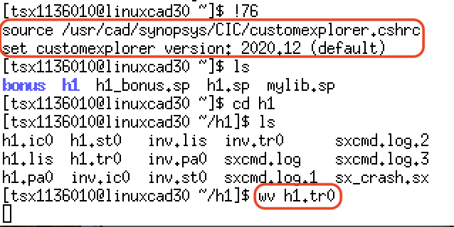

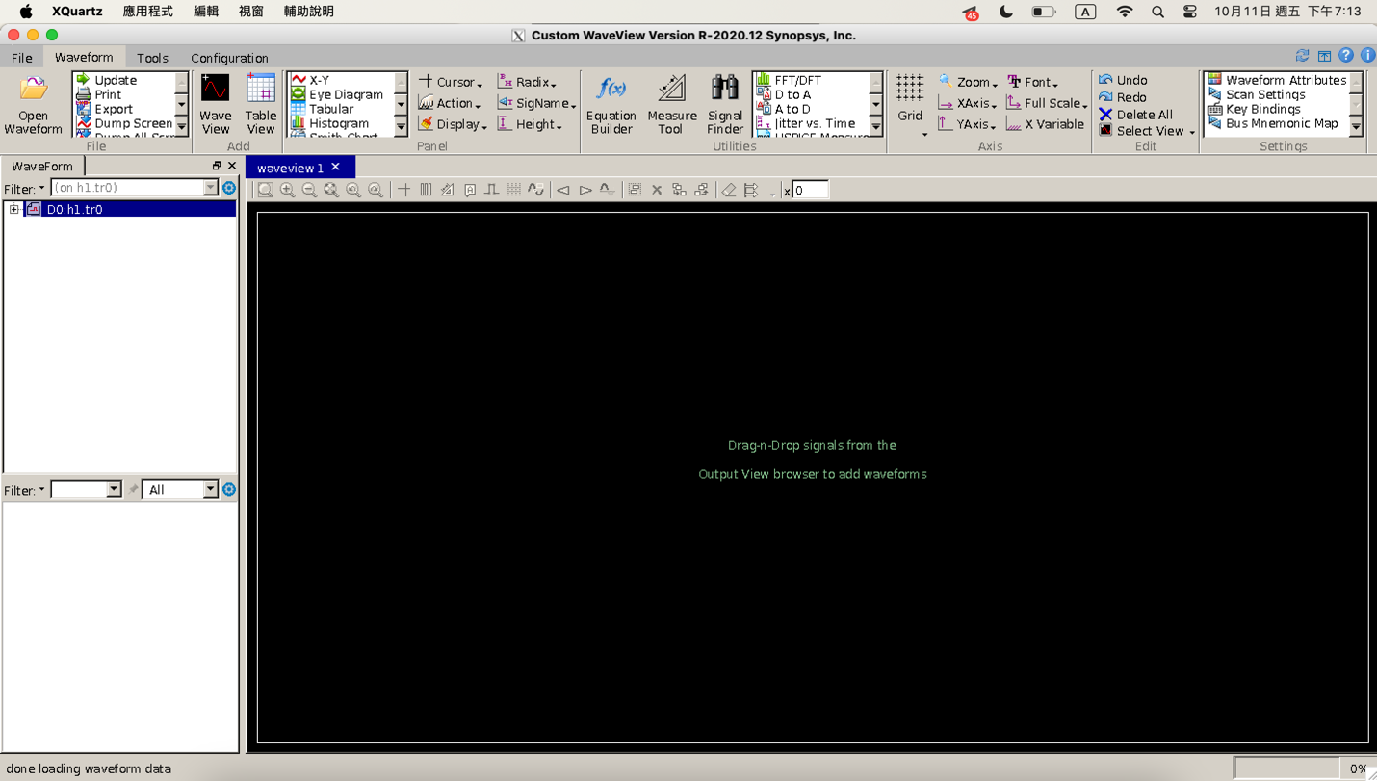

1. Drag the thing into waveview window then you can see all wave of your program, you can delete the useless wave and ungroup some of them to have a clean view.

For example:

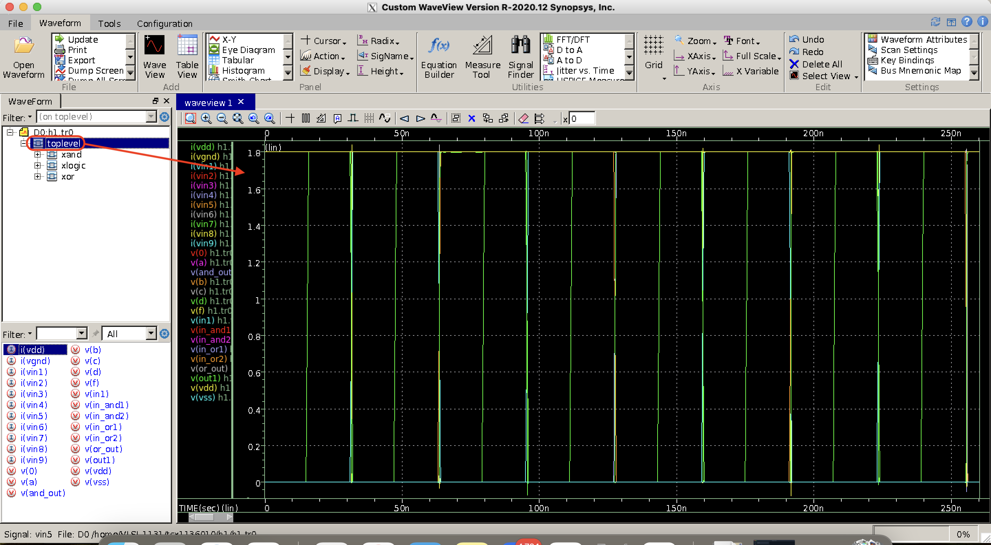

**The completion of the assignment**

* Done all including bonus

**The waveform of OR gate, AND gate, inverter, and the specific logic function**

1. Inverter waveform

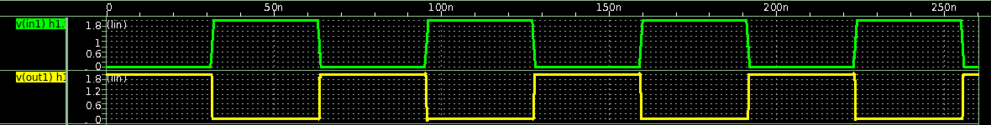

* Output is the inverse of input

1. AND2 gate waveform

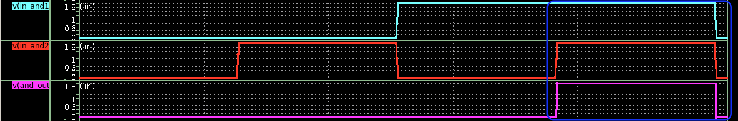

* We can see the output will be high only when both inputs are high, which is the AND gate function.

1. OR2 gate waveform

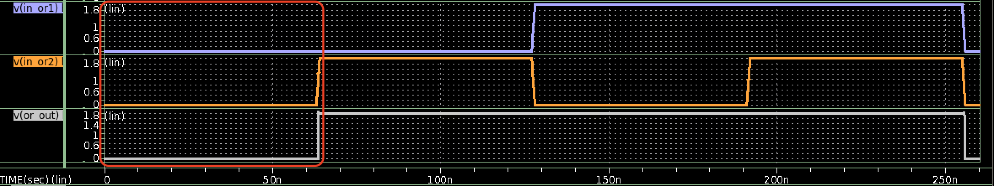

* We can see the output will be low only when both inputs are low, which is the OR gate function.

1. The specific logic function

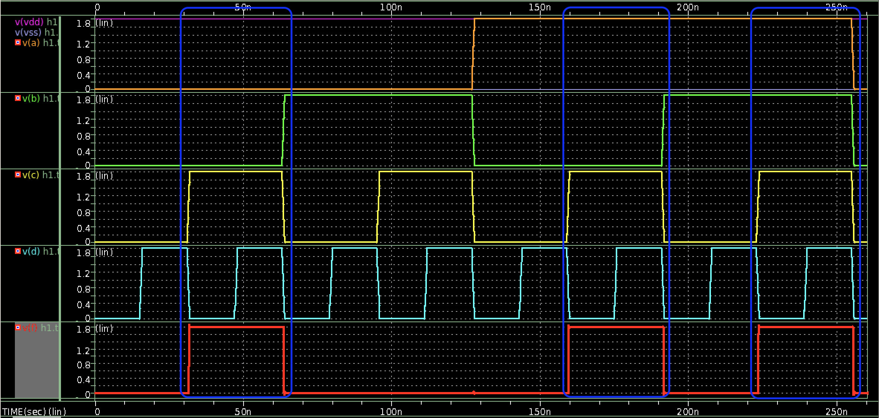

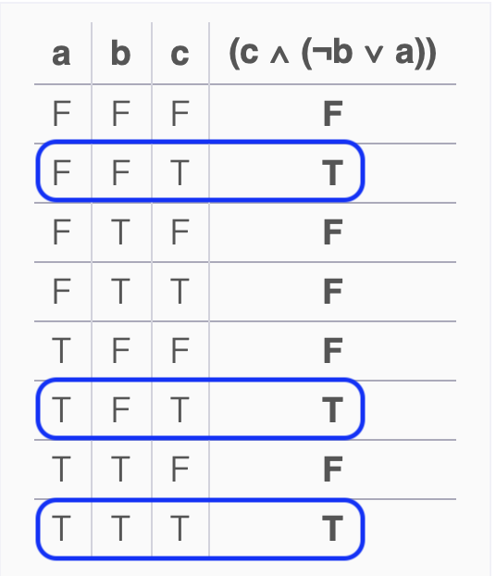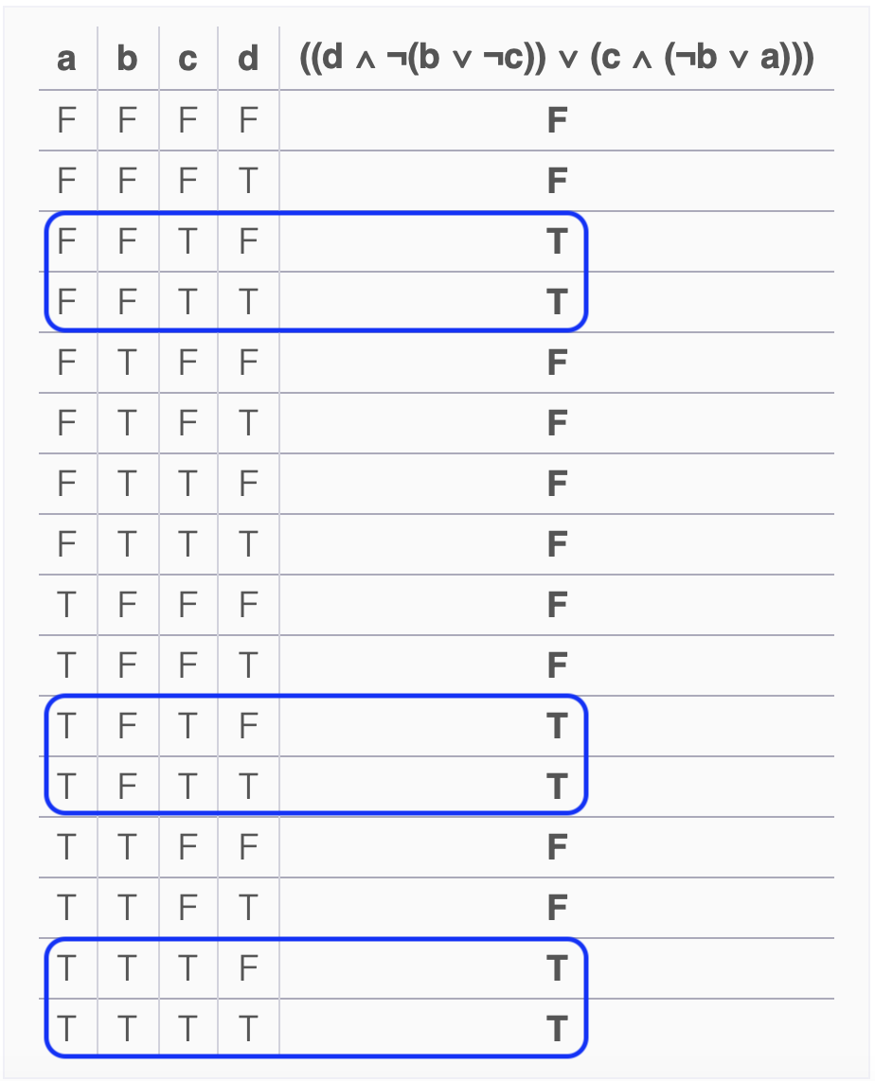

* From the true table, we can know that output will be high only when a,b,c = {(0,0,1),(1,0,1),(1,1,1)}
  + True table from Truth Table Generator (https://web.stanford.edu/class/cs103/tools/truth-table-tool/)

This is my prove:

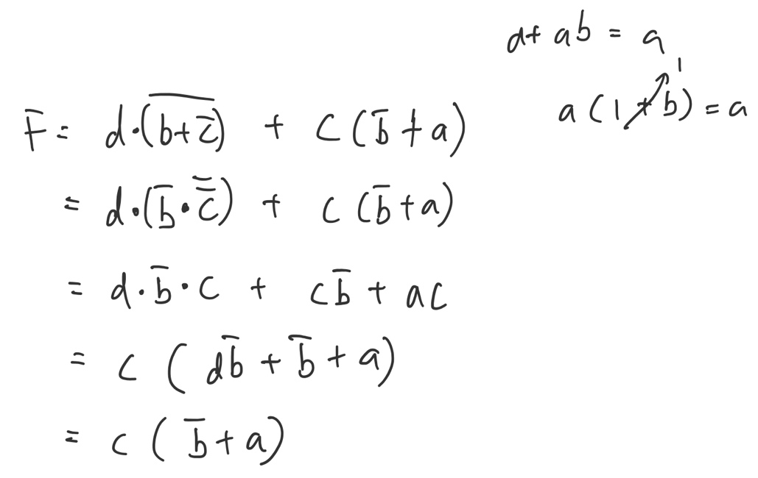

**The hardness of this assignment and how you overcame it**

1. Mac m1 cannot use MobaXterm and default mac terminal can only connect to workstation but cannot open waveview

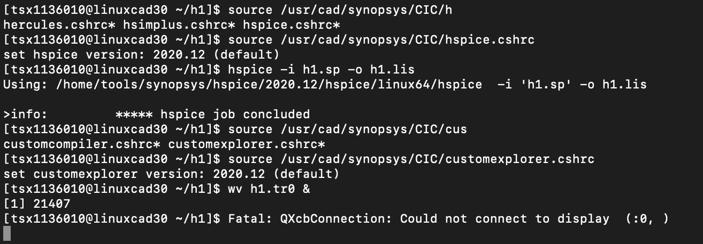

* + I found an alternative software for mac m1 which is XQuartz (https://www.xquartz.org/releases/XQuartz-2.8.5.html)
    1. ssh -X ts_stuID@server_ip -p 22

1. Logic function too complicated, so I simplified the logic function.

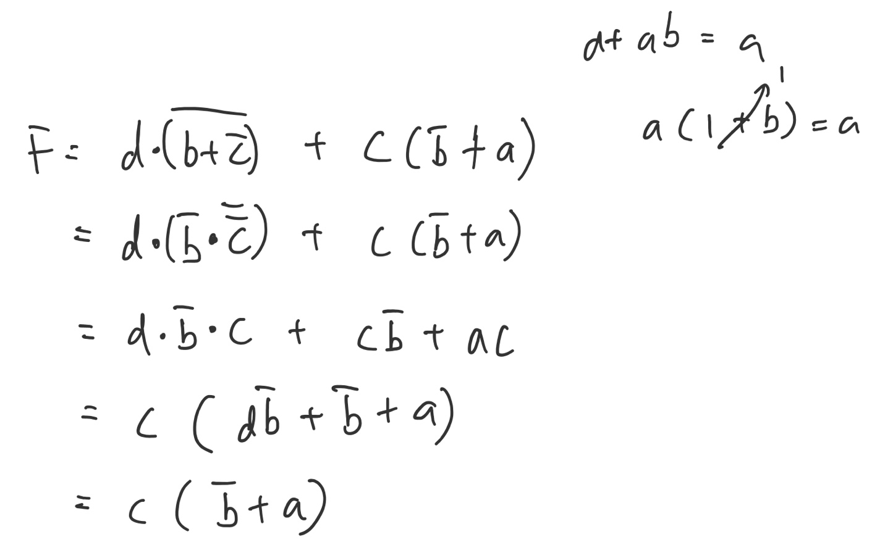

1. When I’m doing bonus I don’t want to rewrite all the basic gates again, so I copy “h1.sp” without the simulation part as “mylib.sp”.

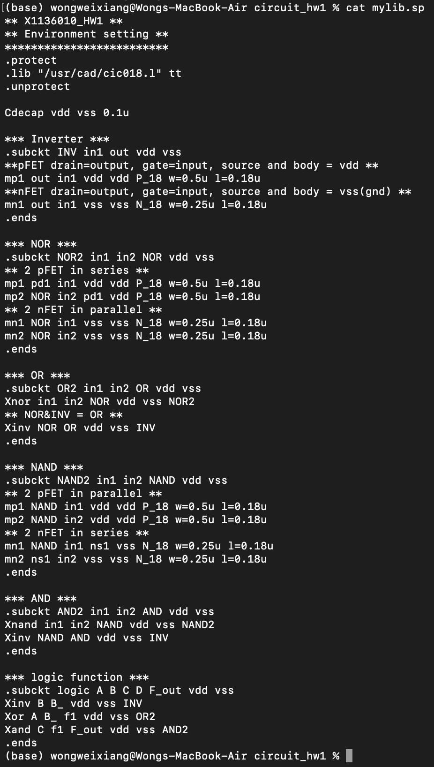

**Bonus – MUX 4 to 1**

* transistor-based schematic diagram

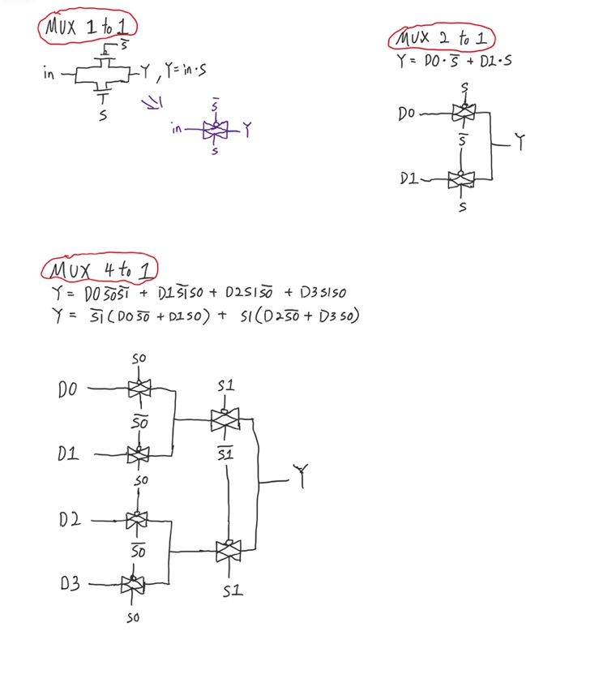

**MUX 4 to 1 waveforms**

1. S1=0,S0=0

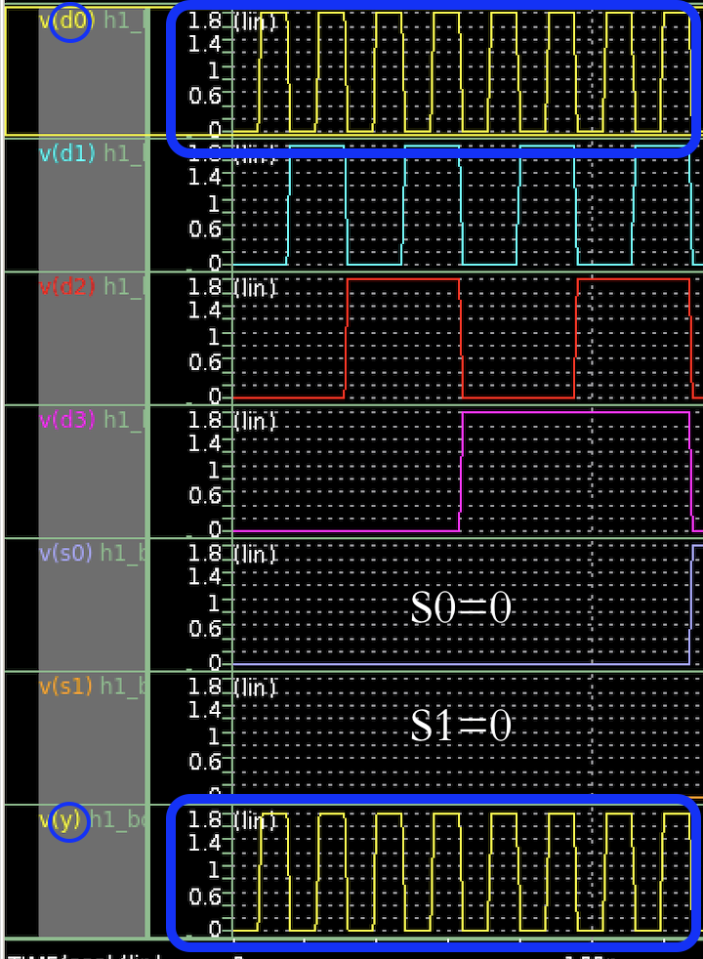

* When S0 and S1 are both equal to 0, output will same as D0.

1. S1=0,S0=1

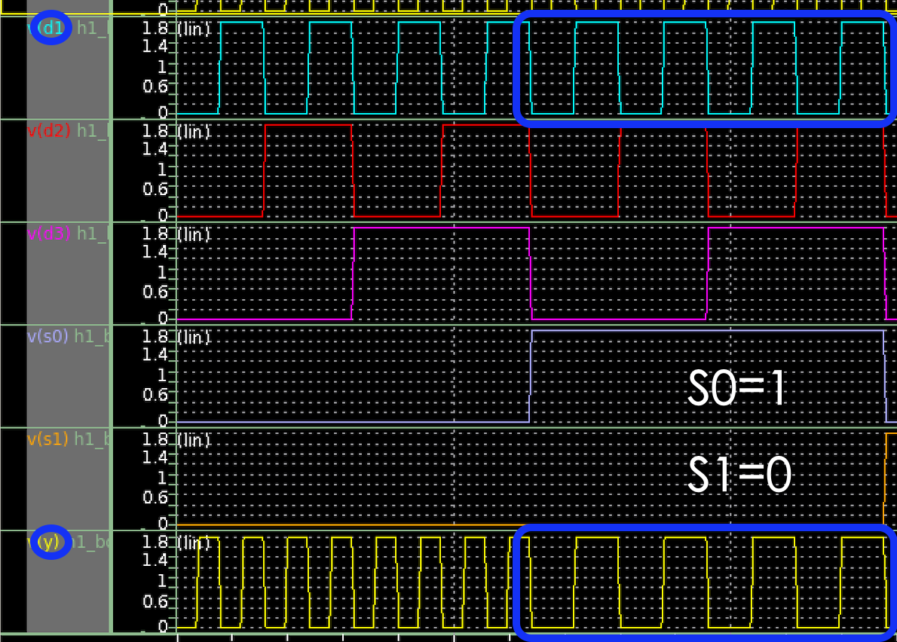

* When S1 = 0 and S0 = 1, output will same as D1.

1. S1=1,S0=0

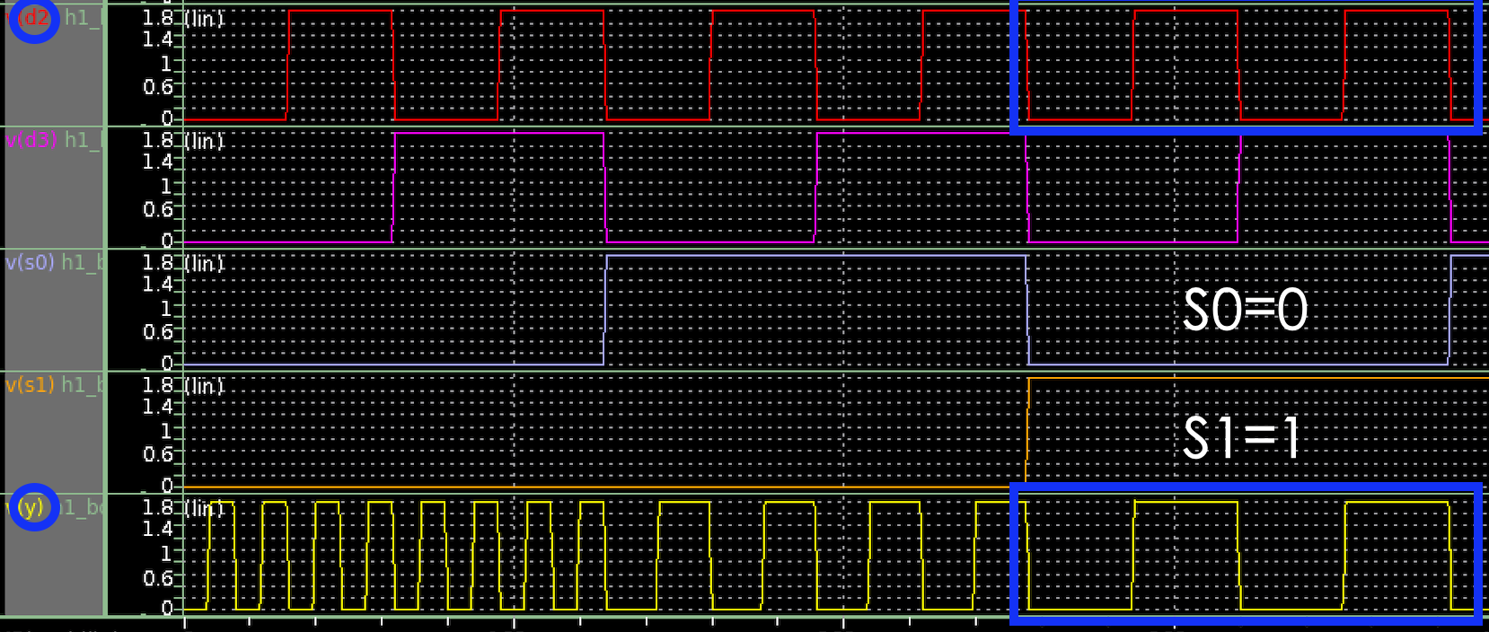

* When S1 = 1 and S0 = 0, output will same as D2.

1. S1=1,S0=1

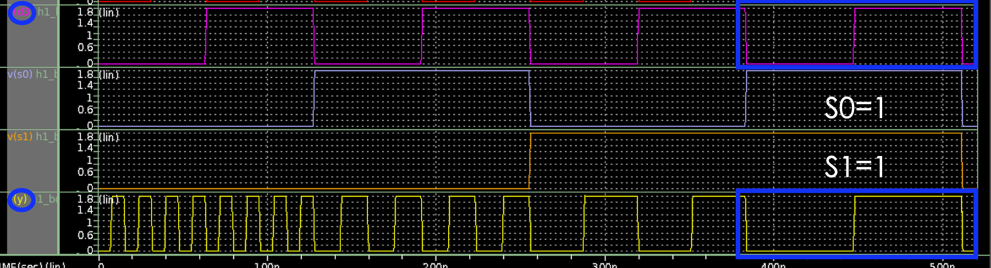

* When S1 = 1 and S0 = 1, output will same as D3.

Full wave for 520n

