X1136010 黃偉祥

# Basic & Bonus

## Basic

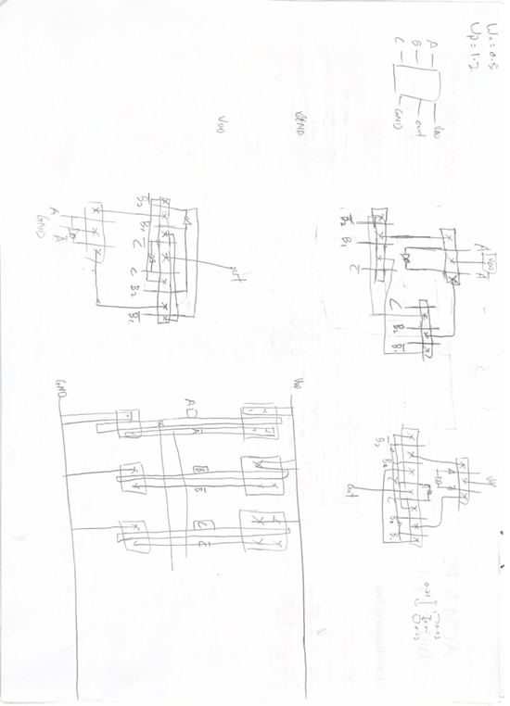

1. First I draw a very simply layout from the design in document.

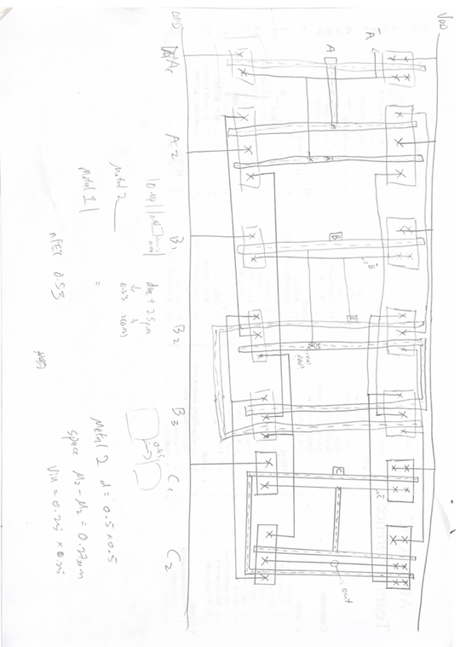

1. Then I convert into the more similar layout with using virtuoso.

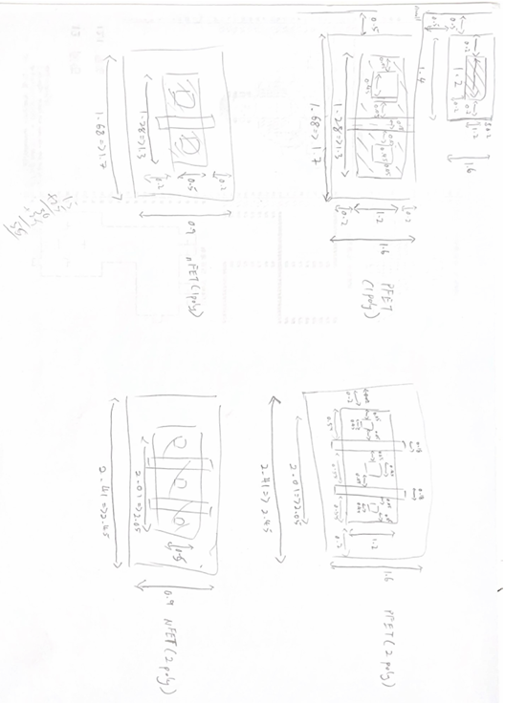

1. From the second graph I knew that I only need 2 sizes of pFET and nFET to done the layout, so I calculate these 2 sizes of FETs.

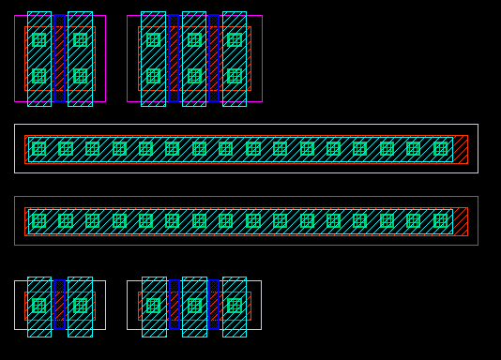

1. After that I start to draw these needed FETs, VDD and GND with virtuoso.

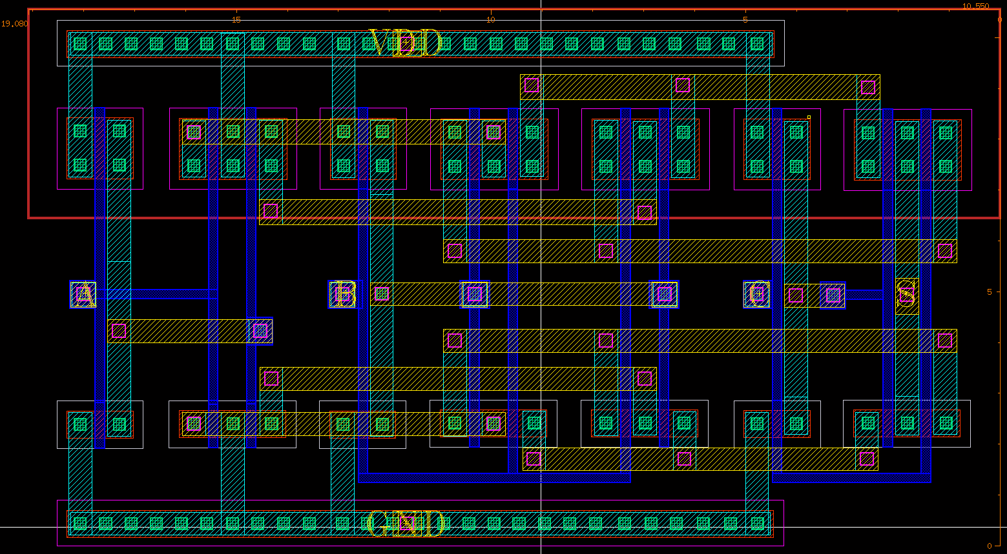

1. After that I use all the FETs in step 4 and combined the graph in step 2, and then everything done and start to run DRC, LVS and PEX and do the post simulation and check the wave of it.

## Bonus

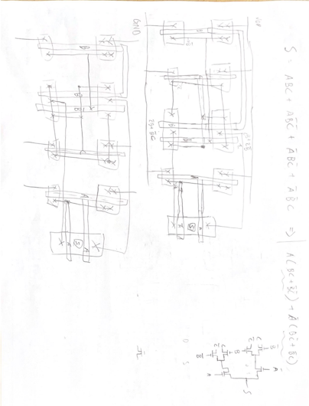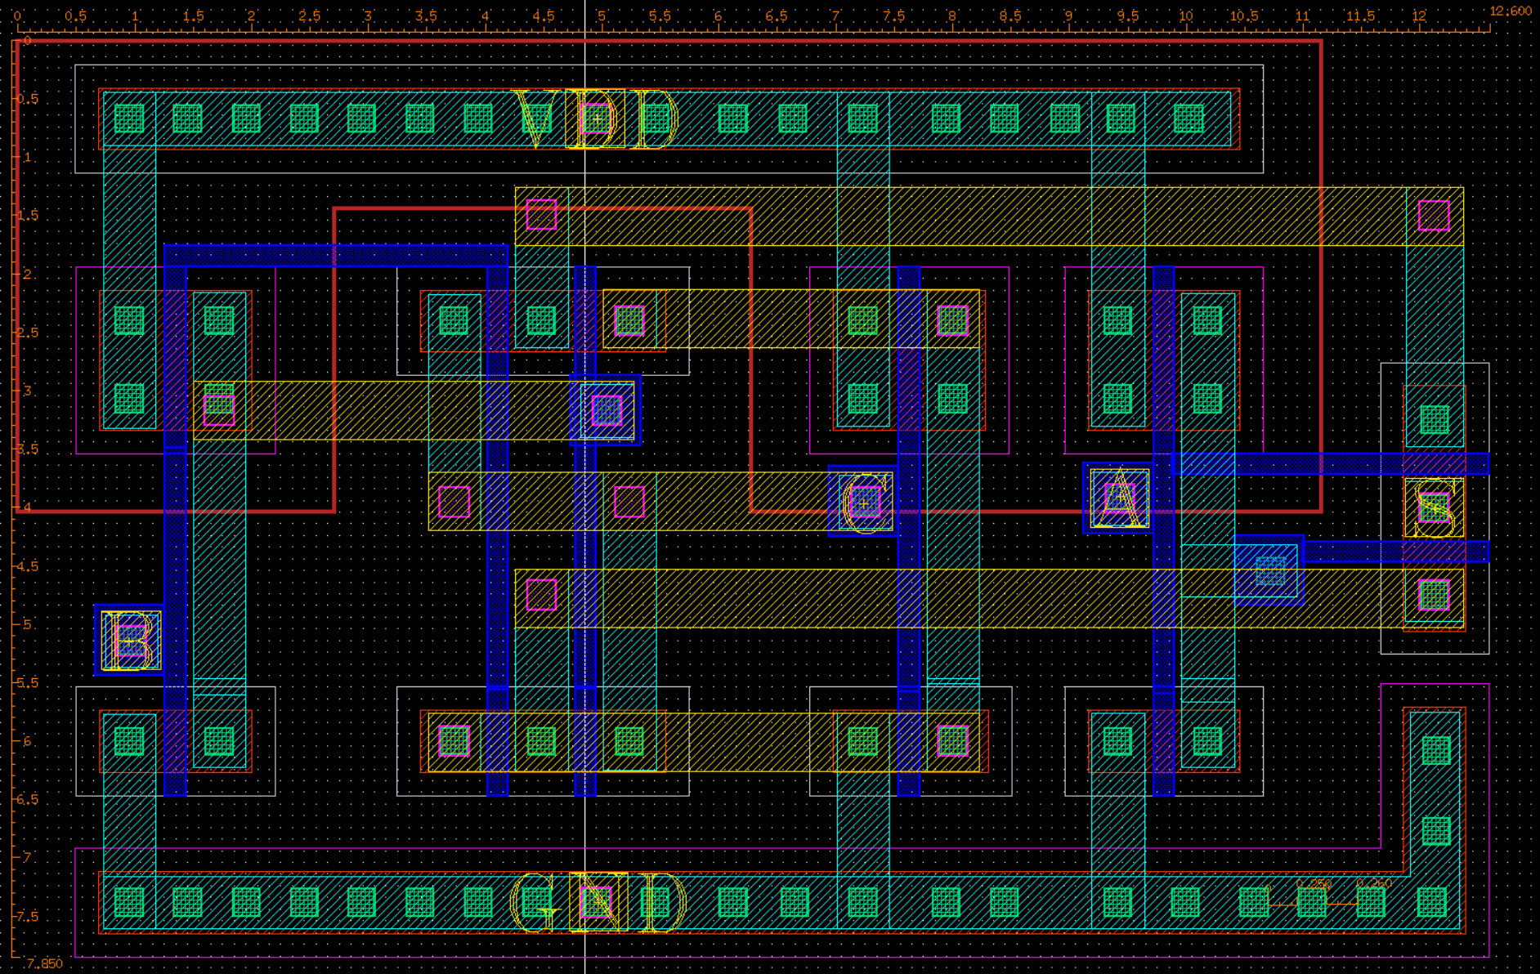

* Same method I used in basic part

# DRC summary report

## Basic

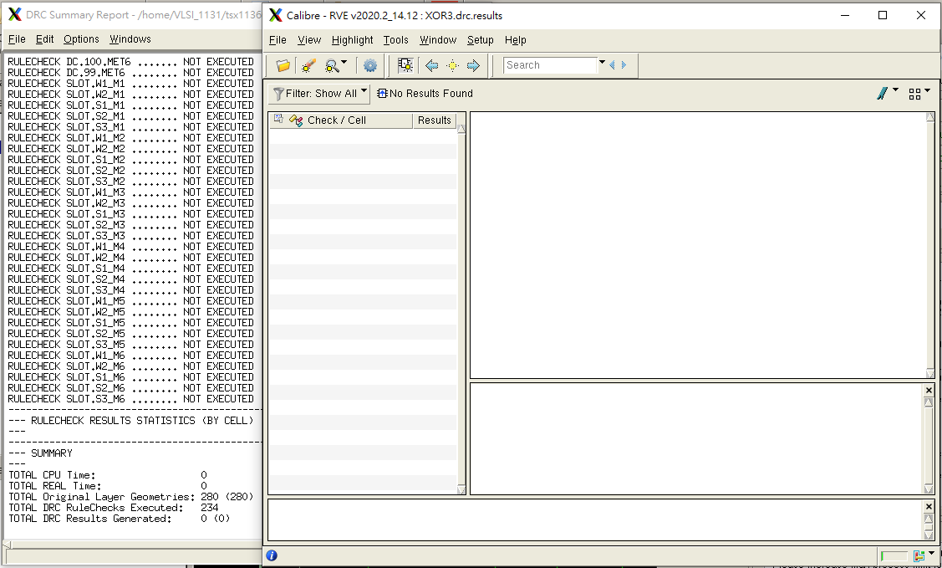

## Bonus

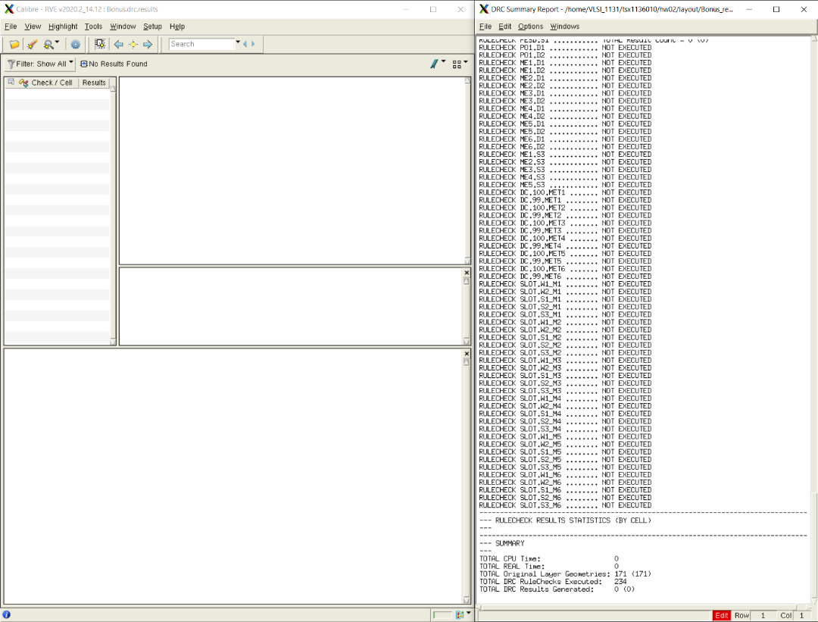

# LVS report

## Basic

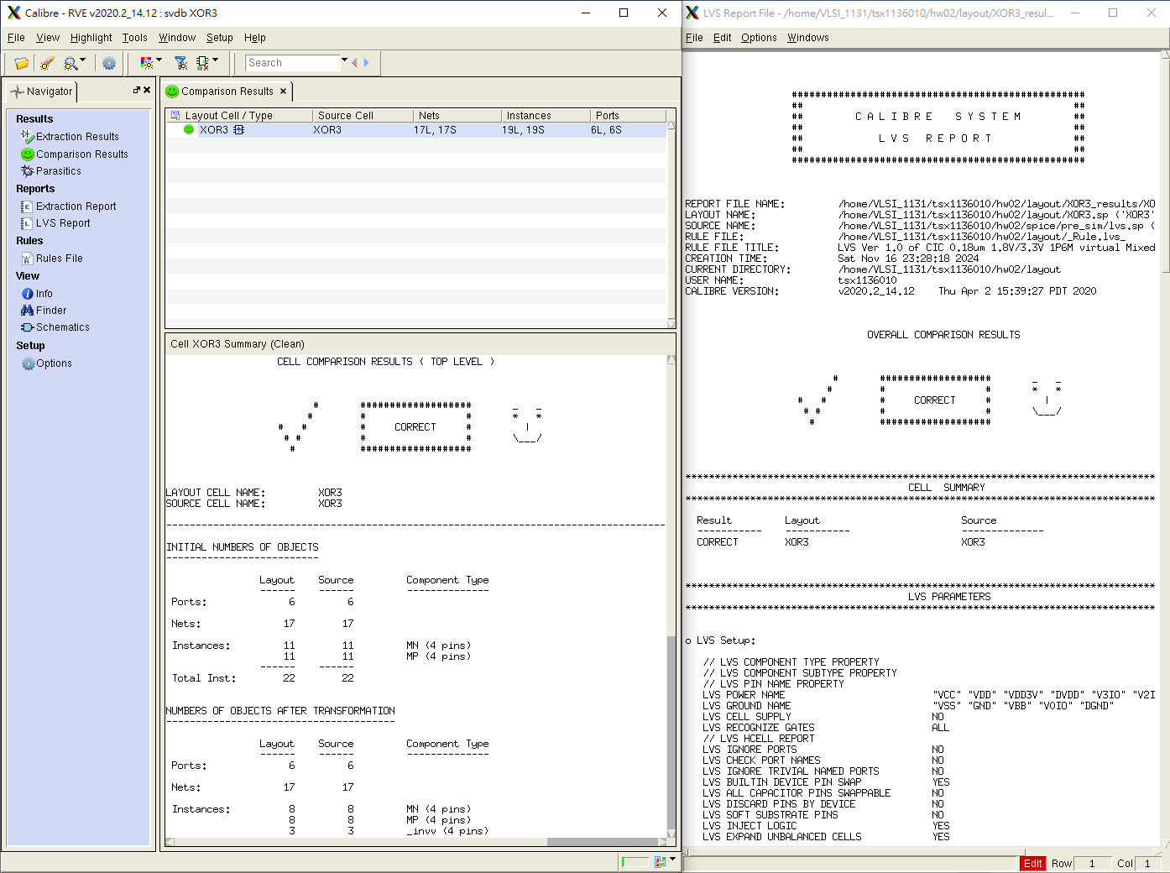

## Bonus

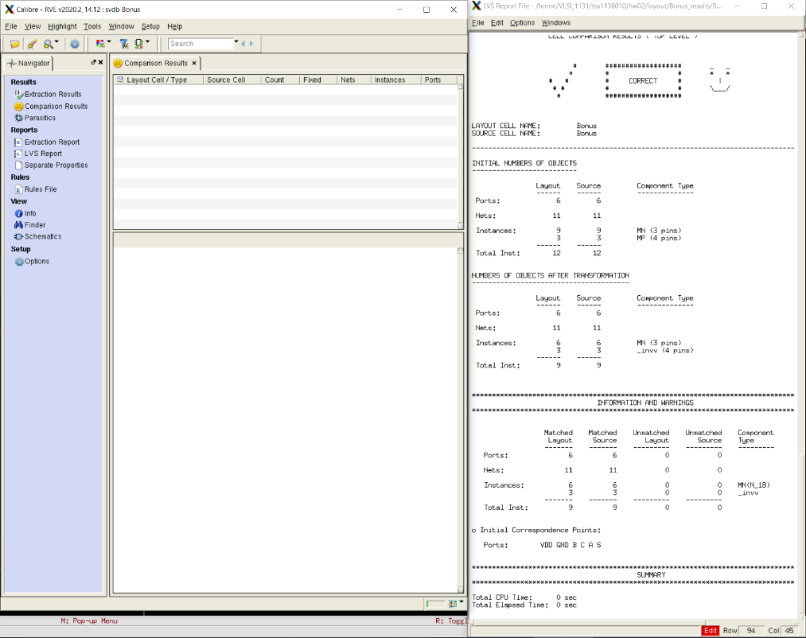

# Pre-sim and Post-sim waveforms

## Basic

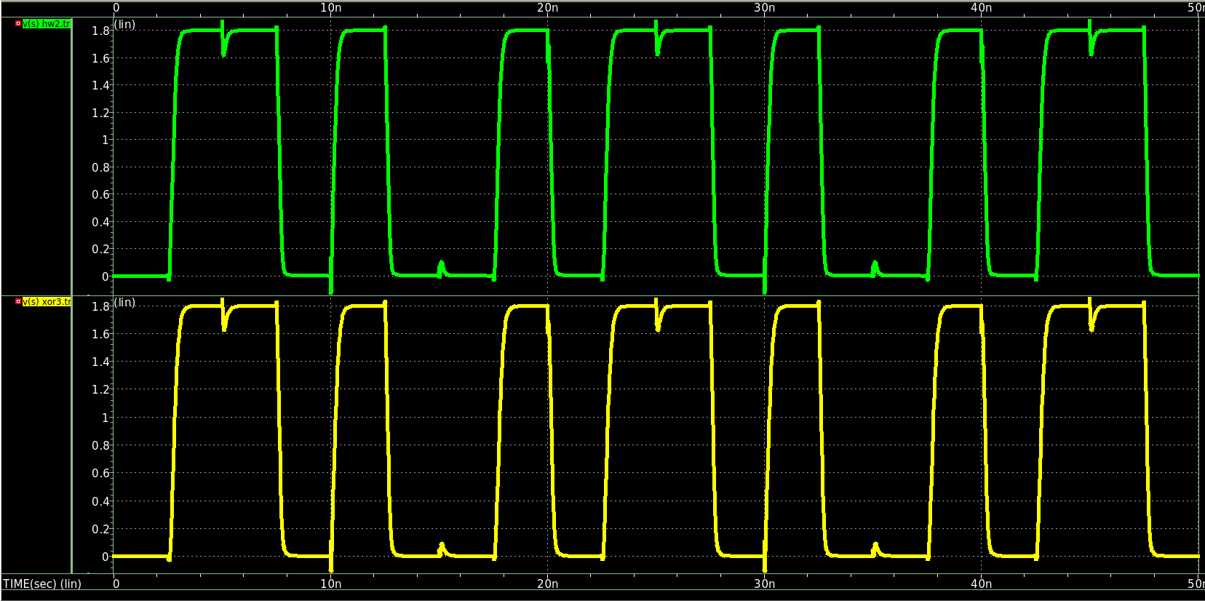

- upper wave is pre-sim wave, and the below one is the post-sim wave

## Bonus

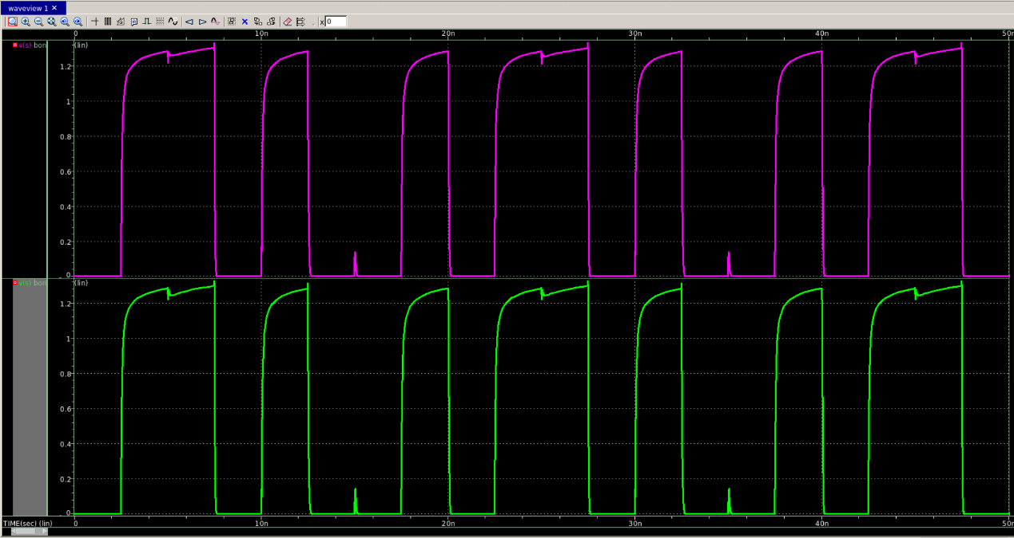

- upper wave is pre-sim wave, and the below one is the post-sim wave

# Post simulation result

## Basic

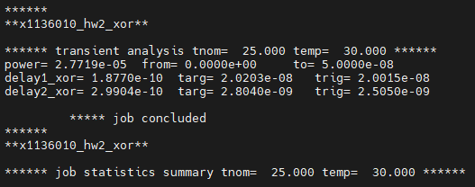

## Bonus

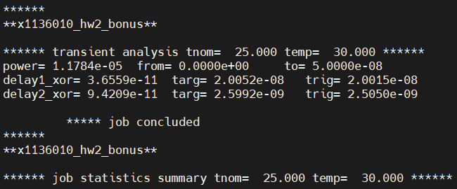

# Delay time analysis

## Basic

1. Delay1_XOR = 187 ps
2. Delay2_XOR = 299 ps
3. Diff abs = 112 ps

## Bonus

1. Delay1_XOR = 36.56 ps
2. Delay2_XOR = 94.21 ps
3. Diff abs = 57.65 ps

# Hardness

1. Unfamiliar with the software virtuoso

* Thankyou the helping from TA, it let me get familiar with it.

1. Test bench file, I forget to define VDD in the test bench file and I get stuck in this bug (passed drc, lvs, pex but getting weird wave) for 3~4 hours.

* Nothing surprise, just check from 0 to the end.

1. There is some weird bug in the LVS testing, I get incorrect in overall but correct at the bottom, I don’t know why but the TA explain there may be the tool error. Also even I reopen and run LVS test again and still getting the same result, but the PEX result and the wave is good even though this LVS test error occur.

* Not overcome this problem, still getting stuck in the LVS error even the others works well and the wave form is good.