黃偉祥 X1136010

Exercise 1

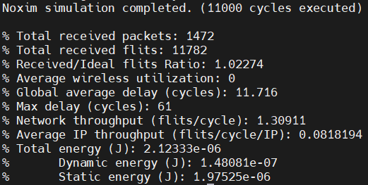

1. Total Received Flits
   1. Total received flits in the network. (Flit is flow control digit)
2. Total Received Packets
   1. Total received packets in the network, a packet may contain many flit.
   2. 11782 / 1472 = 8.004, which means that on average 1 packet contain 8 flits.
3. Global Average Delay
   1. (Total delay for all packets) / (Total number of packets)
   2. Average delay time(cycles) that a packet from source to destination.
4. Network throughput
   1. (Total number of flits received) / (Total number of cycles)
   2. 11782 / 9000 = 1.30911
   3. Only collect data after 1000 cycles, so total cycles = 10000 – 1000 = 9000
   4. Total number of flits received per cycle
5. Average IP throughput
   1. (Total number of flits received by an IP) / (Total number of cycles)
   2. Also can see as (Network throughput) / (Total number of IP)
   3. 1.30911 / 16 = 0.08181938
   4. 4*4 mesh network, total 16 IP

Exercise 2

1. 20000 simulation time

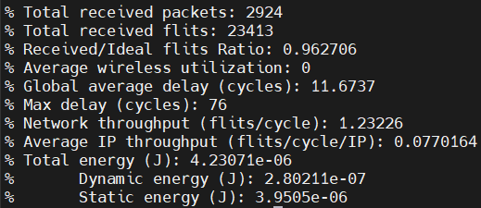

1. Packet size
   1. 4~16

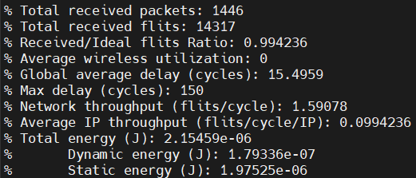

1. 4~4

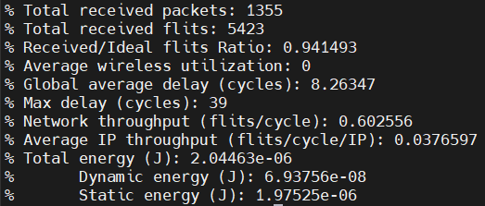

1. 2~2

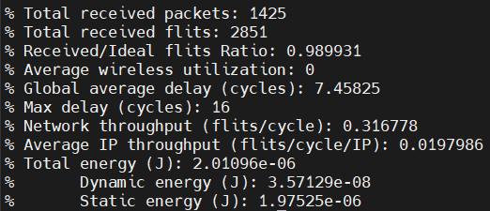

1. 16~16

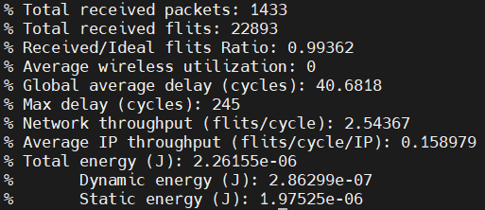

1. 32~32

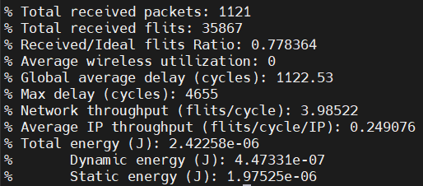

Packet Injection rate

1. 0.1 , 10000 cycles, 16~16 packet size

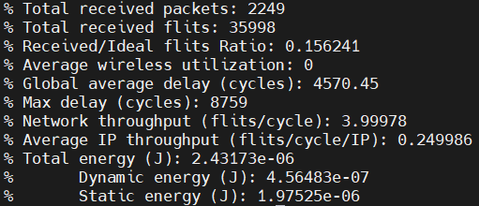

# Exercise 3

9000 cycles data collection, packet size = 16

1. 1.0 => 5295
2. 0.9 => 5217
3. 0.8 => 5326
4. 0.7 => 5300
5. 0.6 => 5246
6. 0.5 => 5299
7. 0.4 => 5163
8. 0.3 => 5127
9. 0.2 => 4978
10. 0.1 => 4563
11. 0.09 => 4504
12. 0.08 => 4442
13. 0.07 => 4206
14. 0.06 => 3974
15. 0.05 => 3663
16. 0.04 => 3327
17. 0.03 => 2453
18. 0.02 => 1369
19. 0.019 => 1086
20. 0.018 => 1057
21. 0.017 => 711
22. 0.016 => 627
23. 0.015 => 279
24. 0.014 => 200
25. 0.0135 => 130
26. 0.013 => 91
27. 0.0125 => 90
28. 0.012 => 86
29. 0.0118 => 75
30. 0.0115 => 50
31. 0.011 => 56
32. 0.01 => 35
33. 0.009 => 34
34. 0.008 => 30
35. 0.007 => 22
36. 0.006 => 20
37. 0.005 => 18
38. 0.004 => 14
39. 0.003 => 11
40. 0.002 => 9
41. 0.001 => 8
42. 0.0005 => 7