黃偉祥 X1136010

### Exercise 1

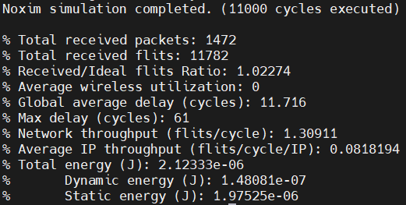

1. Total Received Flits
   1. Total received flits in the network. (Flit is flow control digit)
   2. Related to simulation cycles, packet injection rate and packet size, but also packet loss and flit loss.
2. Total Received Packets
   1. Total received packets in the network, a packet may contain many flit.
   2. 11782 / 1472 = 8.004, which means that on average 1 packet contain 8 flits.
3. Global Average Delay
   1. (Total delay for all packets) / (Total number of packets)
   2. Average delay time(cycles) that a packet from source to destination.
4. Network throughput
   1. (Total number of flits received) / (Total number of cycles)
   2. 11782 / 9000 = 1.30911
   3. Only collect data after 1000 cycles, so total cycles = 10000 – 1000 = 9000
   4. Total number of flits received per cycle
5. Average IP throughput
   1. (Total number of flits received by an IP) / (Total number of cycles)
   2. Also can see as (Network throughput) / (Total number of IP)
   3. 1.30911 / 16 = 0.08181938
   4. 4*4 mesh network, total 16 IP

### Exercise 2

1. 20000 simulation time

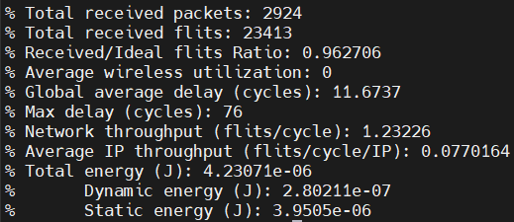

1. Packet size
   1. 4~16

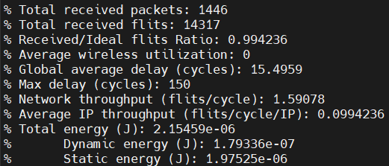

1. 4~4

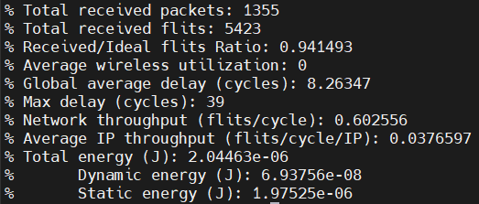

1. 2~2

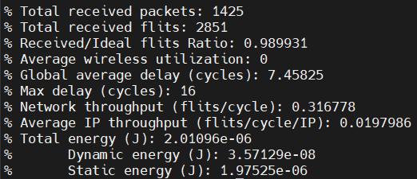

1. 16~16

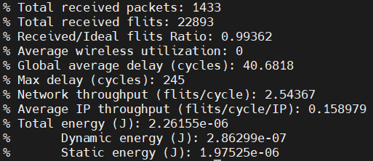

1. 32~32

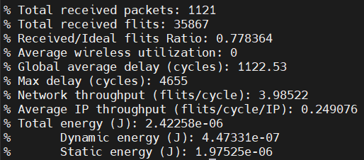

Packet Injection rate

1. 0.1 , 10000 cycles, 16~16 packet size

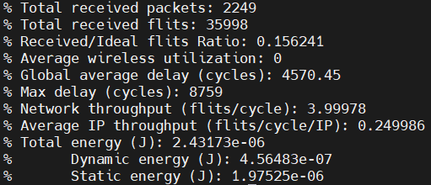

1. Packet size will affect the delay time, because it needs to wait all flits and then pass to next node.
   1. Since packet injection rate is the same, so smaller packet size will have lower network throughput.
2. Packet injection rate will affect the Received/Ideal flits Ratio very much, because higher injection rate will cause more packet occur in the network in the same time, so will have higher chance of collision (packet drop).
   1. Since having more packet on the network also need to wait others packet so it will also affect the delay time.
   2. Have more packet also will get more on Network throughput.
3. Longer simulation time will only get more total received flits and total received packet, since the experiment time is longer, but others output like average delay will not be affected.

### Exercise 3

9000 cycles data collection, packet size = 16

1. 0.02 => 1369
2. 0.019 => 1086
3. 0.018 => 1057
4. 0.017 => 711
5. 0.016 => 627
6. 0.015 => 279
7. 0.014 => 200
8. 0.0135 => 130
9. 0.013 => 91
10. 0.0125 => 90
11. 0.012 => 86
12. 0.0118 => 75
13. 0.0115 => 50
14. 0.011 => 56
15. 0.01 => 35
16. 0.009 => 34
17. 0.008 => 30
18. 0.007 => 22
19. 0.006 => 20
20. 0.005 => 18
21. 0.004 => 14
22. 0.003 => 11
23. 0.002 => 9
24. 0.001 => 8
25. 0.0005 => 7

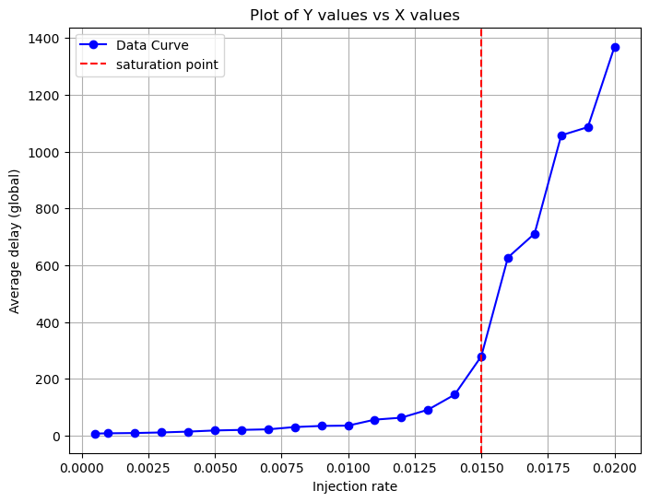

* + - Since the average delay growing exponentially after the injection rate larger than 0.015, I will say that the saturation point is at 0.015 injection rate.

### Exercise 4

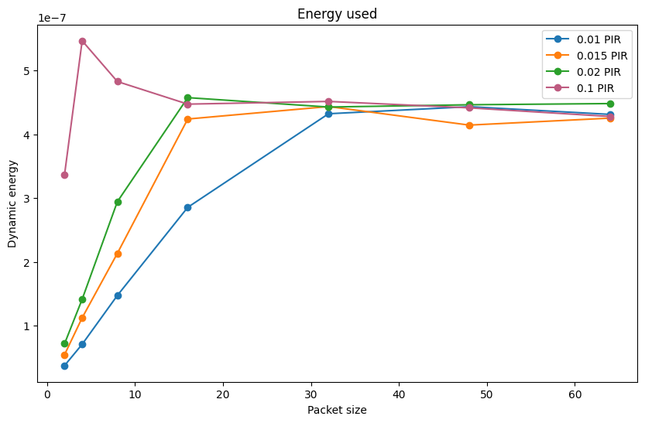

* + - After some experiments, I found that packet size = 32 with packet injection rate = 0.01 will have the best results.
    - Dynamic energy used maintain the same with others packet injection rate, and even increase the packet size will maintain the similar energy used, but others results will be affected.
    - Out of all packet sizes, 32 packet size will have the boundary of total received flits, but the received/ideal flits ratio will be so much different on all PIRs.
    - From all PIR, all of the total received flits will maintain around 34k,35k, but PIR = 0.01 will have the highest received/ideal flits ratio from PIR = (0.015,0.02,0.1), which means that PIR = 0.01 has the lowest possibility to loss packet.
    - Even if I increase the packet size, the total received flits will maintain around 34k, but the received/ideal flits ratio will drop significantly.
    - Since I give very high PIR will also result in 34k total received flits, and increasing packet size will also result with around 34k total received flits, we can conclude that this represents the maximum of network load.
    - Average delay: (packet size =32)
      1. 1662 (PIR = 0.01)
      2. 2663 (PIR = 0.015)
      3. 3171 (PIR = 0.02)
      4. 5101 (PIR = 0.1)
    - When network utilization reaches its maximum, the network may experience heavy load, which can degrade performance and increase average delay of the network. This increases the likelihood of congestion, leading to a higher packet loss rate.