**Java**

1. 請寫出main方法

public static void main(String[] args) { }

1. 請以Java寫出九九乘法

for (int i = 1; i <= 9; i++) {

for (int j = 1; j <= 9; j++) {

System.***out***.println(i + " × " + j + " = " + (i * j));

}

}

1. 請用程式畫出

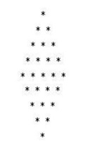

for (int i = 1; i <= 5; i++) {

for (int j = 5; j >= i+1; j--) {

System.***out***.print(" ");

}

for (int j = 1; j <= i; j++) {

System.***out***.print("*");

if (j < i) {

System.***out***.print(" ");

}

}

System.***out***.println();

}

for (int i = 4; i >= 1; i--) {

for (int j = i+1; j <= 5; j++) {

System.***out***.print(" ");

}

for (int j = i; j >= 1; j--) {

System.***out***.print("*");

if (j > 1) {

System.***out***.print(" ");

}

}

System.***out***.println();

}

1. 請寫出List 、set 、Map三大特性

List：可重複、有順序、可變動

Set：不可重複、無順序、可變動

Map：Key-Value配對、無順序、可變動

1. 物件的三大特性，並說明三個特性是什麼

封裝：可用修飾字規範存取類別屬性與方法的權限

繼承：子類別可繼承與覆寫父類別的屬性與方法

多型：一個共通父類別能衍生多種形態的子類別、父類別能兼容所有子類別

**Sql**

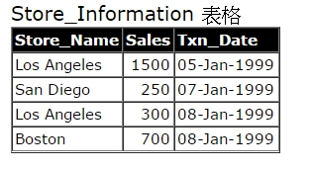

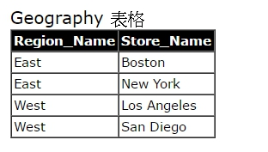

1. 請用sql語法查出store_information table 語法

select Store_Name, Sales, format(Txn_Date, 'dd-MMM-yyyy') as Txn_Date from Store_Information;

1. 請新增store_information語法

create table Store_Information(

Store_Name varchar(50),

Sales int,

Txn_Date date,

);

insert into Store_Information values ('Los Angeles', 1500, '19990105');

insert into Store_Information values ('San Diego', 250, '19990107');

insert into Store_Information values ('Los Angeles', 300, '19990108');

insert into Store_Information values ('Boston', 700, '19990108');

1. Geography做group by群組

select Region_Name, count(Store_Name) as [Store_Count] from Geography group by Region_Name;

1. Geography、store_information二張table做join

select s.Store_Name, s.Sales, format(s.Txn_Date, 'dd-MMM-yyyy') as Txn_Date, g.Region_Name from Store_Information as s left join Geography as g on s.Store_Name = g.Store_Name;

1. Left join 、right join 、inner join差別

Left join：以左邊的表有的值為主

Right join：以右邊的表有的值為主

Inner join：以兩邊的表皆有的值為主