Source to Documentation: <https://firebase.google.com/docs/storage/web/start>

Link to Github Repository: <https://github.com/weixianlow/CS4830_Exploration3_Fall2017>

Link to Code Instances: <http://cs4830.weixianlow.me/exploration3/>

Journal:

For this exploration, I have decided to continue working on the exploration 2 and further expand functionality with the Google Firebase’s Storage feature.

In this exploration, I have added a feature to the website which allowed users to upload files to the website while separating the user’s file from other users. To achieve this, we would have to use Firebase Authentication to obtain user’s UID to identify each user, creating a key/value pair system to identify which files belong to which users, and generating the right URL link for each user to their own files.

Obtaining User’s UID:

1. To obtain user’s UID, we would have the user login with the website and create a user object using the Firebase Authentication function as such:



Creating A Key/Value Pair:

1. When a user has decided to upload a file, the website would then take the uploaded file and store it in a folder labeled with the user’s UID as so in Firebase Storage:

../Screenshots/Creating%20Pathway%20for%20Refence%20to%20Firebase%20Storage.png

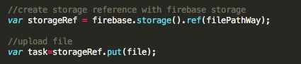

1. Once that is done, we would then obtain the file path inside the Firebase Storage and store it with the user’s information inside Firebase’s Database.
2. We would then also generate a download link to the file to be dynamically inserted in the user’s dashboard.
3. After performing all task, we would then upload all the obtained data to the user’s database entry with the following code:

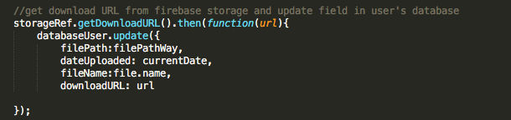

1. The Firebase’s database would look like so:

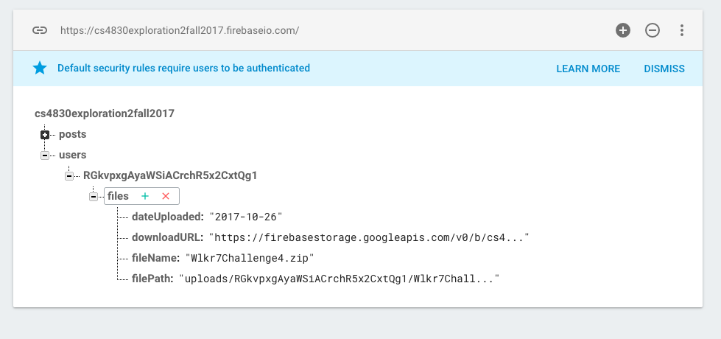

Generating the right URL link for each user:

1. To provide user with their file information, we would dynamically insert the latest file name and download link from the Firebase’s database when they load the dashboard as so:

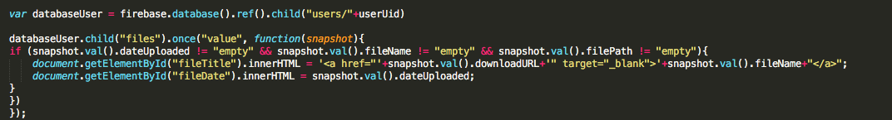

1. This is how the website would look like:

