S = stepinfo(sys)computes the step-response characteristics for a dynamic system model sys

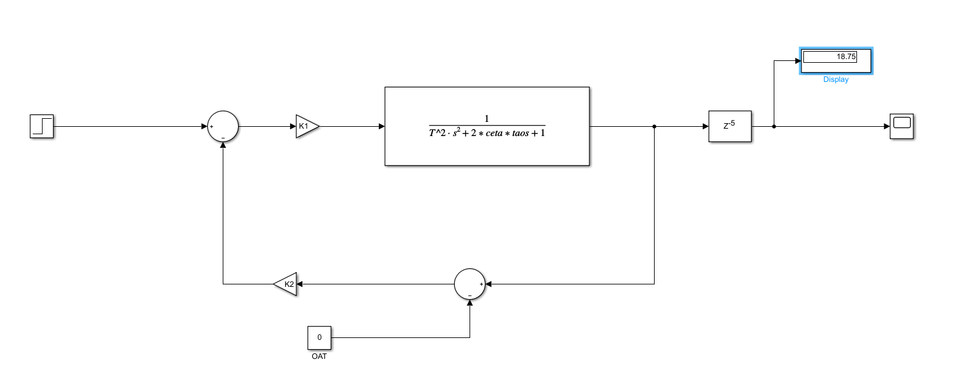

steady state response： 18.75s

RiseTime: 5.9505

SettlingTime: 99.9609

SettlingMin: 13.0990

SettlingMax: 29.0435

Overshoot: 54.8985

Undershoot: 0

Peak: 29.0435

PeakTime: 16.0500

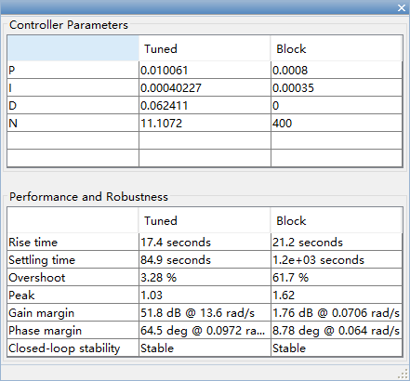

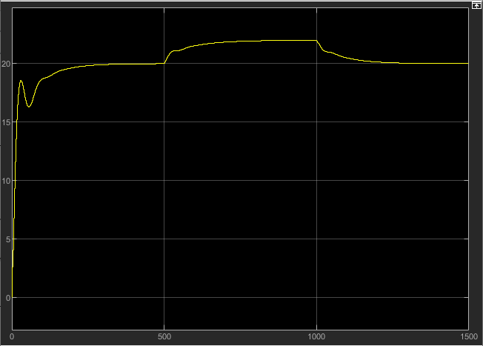

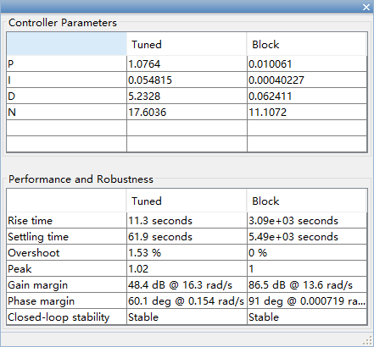

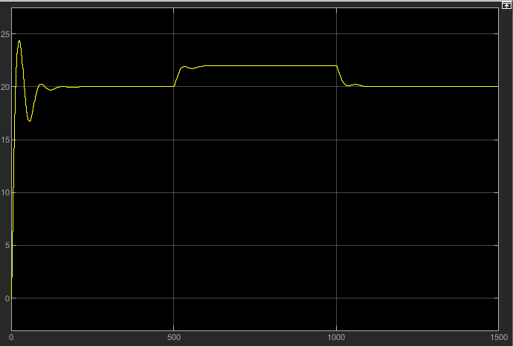

Ziegler-Nichols Method