Academic Year 2026-2027 1st Semester
Grade 4 English Language Practice
Time: 60 minutes Name:__________________ Class:__________________
Part 1: Listening
I. Listen and choose the right words.听两遍，选出你听到的单词。
1. ( ) A. forest B. village C. park
2. ( ) A. band B. queen C. school
3. ( ) A. mother B. father C. brother
4. ( ) A. sword B. helmet C. hat
5. ( ) A. lake B. forest C. river

II. Listen and choose the right picture.听两遍，选出正确的图片。
1. What couldn't she play?
A.  B.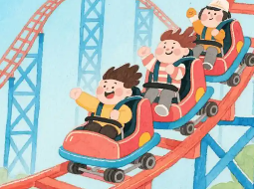 C.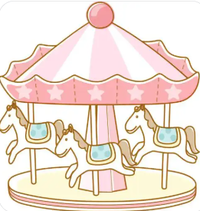

2. What could Grandpa do?
A.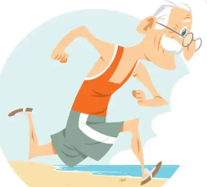 B. C.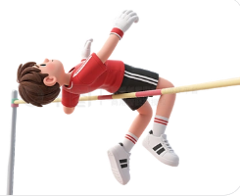

3. Who is he writing to?
A. B. C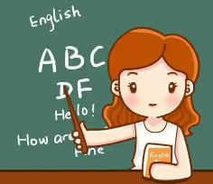

4. Where lost the phone?
A. B. C. 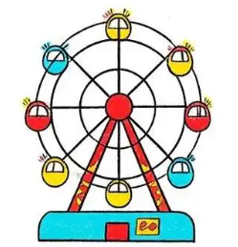

5. What photo did she take?
A.  B. 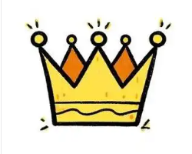 C. 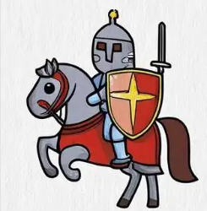

III. Listen and choose the right answer.听两遍，选出正确的回答。
1. ( ) A. Yes, I did. B. A village. C. A park.
2. ( ) A. A knight. B. Crown missing. C. School.
3. ( ) A. Didn't work. B. Went to bed. C. Was tired.
4. ( ) A. Swam in lake. B. Restaurant. C. Museum.
5. ( ) A. She loves it. B. Father bought one.C. A T-shirt.

IV. Listen and write YES or NO.听两遍，判断对错，写YES或NO。
1. ( ) Girl wants a crown.
2. ( ) Be quiet in museum.
3. ( ) Emma played dodgem cars.
4. ( ) Grandpa could run fast.
5. ( ) Buy a bracelet for mother.
Part 2: Vocabulary and Grammar

I. Look at the pictures and write the words. 首字母填空（5题）
- Look at the q_______, she is so beautiful.
- When you drive the e-bike, don’t forget to wear the h________.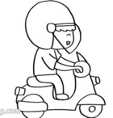
- There is a big bridge on the r_______.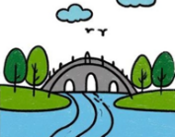
- It’s a good day, let’s climb the m___________.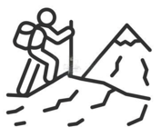
- Our b______ plays nice music together.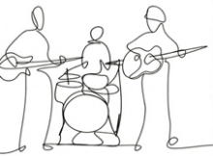

II. Read and choose the best answer. 选择题（10题）
( ) 1. ______ you like reading storybooks?
A. Are B. Do C. Is
( ) 2. -______ does he get up every day?
-About 7 o’clock in the morning.
A. What B. Where C. When
( ) 3. -_______ did she go yesterday?
-She went to Nanjing.
A. What B. Where C. When
( ) 4. ______ she scared of the dog?
A. Was B. Were C. Do
( ) 5. Does Tom _______ any treasure?
A. found B. find C. finds
( ) 6. We must _______ safe in the classroom.
A. keeping B. keep C. keeps
( ) 7. Please give ______ the book.
A. her B. she C. hers
( ) 8. We went to the gym ________ it was the swimming class.
A. so B. because C. but
( ) 9. I am so tired _____ I go to bed.
A. but B. because C. and
( ) 10. I ________ eat 100 hamburgers when I was 5 years old.
- must B. could C. couldn’t

III. Put the words in the correct order. 连词成句（5题）
- you/ Could/ song/ the/ sing/ ?
_____________________________________________________________________
- had/ banana/ a/ and/ juice/ some/ She/ .
_____________________________________________________________________
- the/ Give/ us/ please/ books/ .
_____________________________________________________________________
- take/ We/ in/ mustn’t/ photos/ the/ museum/ .
_____________________________________________________________________
- have/ school/ she/ fun/ Did/ at/ ?
_____________________________________________________________________

Part 3: Reading
I. Read and complete the passage. 阅读短文并选择正确答案。

Giotto the Skateboarding Dog
Giotto is a cool dog. He loves skateboarding very much. He hopes to get a Guinness World Record.
Greg and Danny were 70 1 they got Giotto. They wanted a quiet pet, but he is very active. When Giotto first 2 people skateboarding in the park, he was so excited.
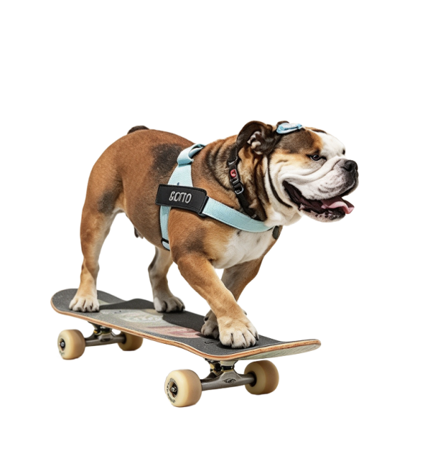
They bought Giotto a cheap skateboard. Soon they found kid’s skateboards were not good for dogs’ paws. So Greg made a new strong board 3 Giotto.
Giotto is great at skateboarding now. He 4 many fans online. Lots of kids come to watch him. He had a health problem and 5 one eye. But he still loves skateboarding and practises every day!

Fill in the blanks.
( ) 1. A. when B. how C. where
( ) 2. A. saw B. went C. cleaned
( ) 3. A. for B. to C. of
( ) 4. A. has B. tells C. teaches
( ) 5. A. lost B. ran C. started
II. Read and choose the right answer. 阅读短文，选择正确答案。
Giraffes are the tallest animals on land. They can be 14 to 19 feet tall. Their legs are as tall as a grown man.
Giraffes have spots. The spots can be light brown, brown or black. Every giraffe has different spots. No two giraffes look the same.
Giraffes live in Africa. They like hot and dry places. Giraffes like to stay together. A group usually has 6 to 12 giraffes.
Giraffes eat a lot. They eat for 16 to 20 hours every day. Their long necks help them get leaves high up in trees.
A baby giraffe is called a calf. It is big when it is born.
Giraffes can run fast. They run away from dangerous animals like lions. They can also kick these animals with their feet.
Choose the right answer.
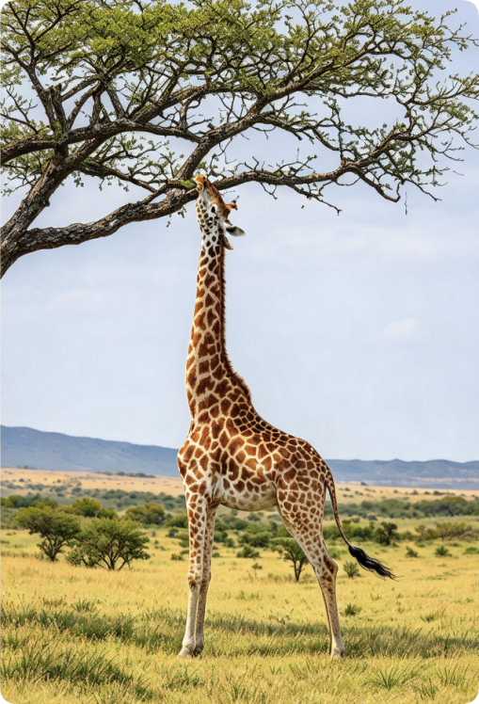
( ) 1. How tall can giraffes be?
A. 14 to 19 feet B. 6 to 12 feet C. 16 to 20 feet
( ) 2. Why are no two giraffes the same?
- They have different spots.
- They have different necks.
- They live in different places.
( ) 3. How many hours do giraffes eat every day?
A. 6–12 B. 14–19 C. 16–20
( ) 4. How do giraffes get leaves high up in trees?
A. With their long necks B. With their long legs C. With their big feet
( ) 5. What can giraffes do to keep safe from lions?
- They can swim fast.
- They can run fast and kick.
- They can hide in trees.

III. Read and write T (True) or F (False). 阅读短文，判断正误。
The 15th National Games
The 15th National Games has two lovely mascots. Their names are Xiyangyang and Lerongrong. One is white, and the other is pink. They look round and cute. Lots of people in China like them very much.
The mascots come from the Chinese white dolphin. It is a special animal we need to protect. Liu Pingyun is the main designer. He also helped make Bing Dwen Dwen for the Winter Olympics.
On their heads, there are three small water shapes. They are red, purple and green. Red stands for Guangdong. Purple is for Hong Kong. Green is for Macao.
You can buy many cute mascot gifts now. These two mascots help more people learn about the National Games and the GBA.

Read and write T (True) or F (False).
( ) 1. Xiyangyang and Lerongrong are cute and popular.
( ) 2. The mascots are from the Chinese white dolphin.
( ) 3. The designer made Bing Dwen Dwen too.
( ) 4. The three water shapes on the mascots’ heads are the same colour.
( ) 5. The mascots help people know the National Games and the GBA.

IV. Read and choose the correct answer. 阅读短文，选择正确答案。
Steve’s Banana Car
Steve is an old man from the UK. He has a cool banana car. It is bright yellow. Steve spent two and a half years making this car by hand. The car is not very long, but it can take four people. Three people sit behind the driver.
Steve loves his funny banana car. He drives it to many places and visits different countries. People can have a free ride in this banana car. Now it is his daily car. He even drives it to the shop to buy fresh bananas.
Many people stop to look at his special car. Steve enjoys driving his banana car very much. He hopes he can drive it around the world one day!
Choose the correct answer according to the passage.
( ) 1. How many people can the banana car take?
A. Three people B. Four people C. Five people
( ) 2. What does Steve buy when he drives to the shop?
A. Fresh bananas B. Toy cars C. New clothes
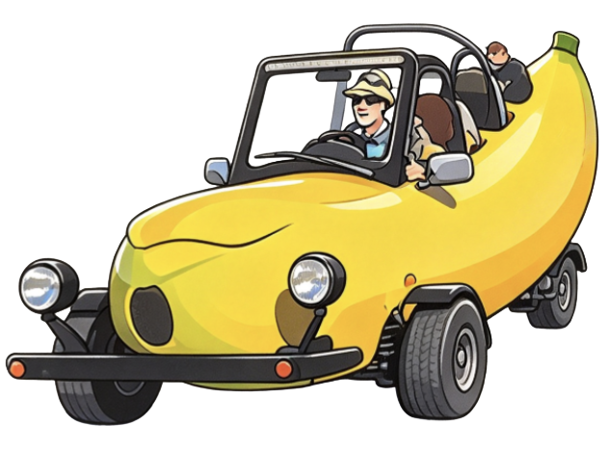
( ) 3. Why do many people stop to look at Steve’s car?
- Because it is very fast
- Because it looks very special
- Because it is very big
( ) 4. What can we know about Steve’s banana car?
- Steve uses it for his everyday life
- It can carry five people
- Steve makes it to sell bananas
( ) 5. What is the main idea of the passage?
- It is about Steve and his special banana car.
- It tells us how to make a banana car.
- It talks about different cars in the UK.

Part 4: Writing
Write about one of the people below. Write about 60 words. You may use the following questions to help you.
回答以下问题并从这四个人中选一个人进行写作，不少于60词。
Your brother | Your sister | Your cousin | Your best friend
- Are you the same age?
- Is he / she taller or shorter than you?
- Are his / her legs longer or shorter than your legs?
- Do you have the same hobbies?
- Do you like the same food?
My ______________

