# INSTRUCTION

This project is to design a blackjack game by using Golang. The game program consists of the structure of the game, a User Interface of the game, and a simple AI of dealer. As most members in our group are not very familiar with Go language and do not have much working experience with it. By developing this significant project, we all acquired a lot of new skills and knowledge about Go language and Go program developing.

# What is Blackjack

The closest historical cousin to blackjack is the French game Vingt-et-Un — which, as anyone who took the language in high school will note, translates to “twenty one.” Vingt-et-Un was the most popular in a family of related games which included Chemin de Fer and French Ferme. Like a lot of French culture at the time, Vingt-et-Un became popular among Americans during the 18th century and was soon Anglicized and imported overseas. By the time gambling was legalized in Nevada in 1931, “twenty one” was one of the most popular games in the country. Blackjack is a simple card game that has more players than roulette, craps, and baccarat combined. Blackjack is mainly a luck and chance game, but also a strategy game.

# Basic Rules of Blackjack

While there will normally be other players sitting at a blackjack table with you, the goal of the game is not for you to beat them. Instead, you and your tablemates all have the same goal, to beat the dealer or the house. Since you and your tablemates have a common goal, it is possible for more than one person to win in a single round of play.

Every blackjack table in a casino has minimum and maximum betting limits that are clearly visible. Before the dealer deals, players place bets within these limits. Once everyone has wagered, the dealer gives every player a single card working in a clockwise rotation, with the dealer getting the last card. All of the cards in this first pass are dealt face-up. The dealer then hands out a second round of face-up card but deals their second card face down. Because the players’ cards are dealt face-up, there is no need for players to touch them.

If you are at a table using only one deck, the cards will normally be dealt face down. If this is the case, you may touch your cards. As a general rule, if you receive cards face-up, avoid touching them. If the first two cards you are dealt are an ace and a face card or a ten, your hand is a “natural” or “blackjack.” If you have a natural and the dealer does not, you will receive one-and-a-half times the amount of your wager. If you and your dealer have blackjacks, the round is a stand-off or a tie, and you get to keep your bet. If the dealer has a natural and you do not, the dealer will collect your wager.

Dealers only look at their face down cards before it is their turn to act, when the face-up card is an Ace or it has a value of ten to see if they have a blackjack. If the dealer’s first card is not an ace and does not have a value of ten, the dealer will wait to look at their second card.

The action at a blackjack table begins with the person to the left of the dealer and moves from one player to the next in succession. When it is your turn, you will need to decide if you want to “stand,” which means not asking for another card, or “hit,” which means requesting another card to bring the overall value of your hand closer to 21. When you hit, you will receive one card at a time until your hand equals 21, you are satisfied with your hand’s total or your hand goes “bust.” If your hand goes bust, it means the value of your hand exceeded 21 and you lost your bet.

If your initial two cards include an ace and a card that does not have a value of ten, you have a “soft hand.” This is because you have the option of treating the ace as if it has a value of 11 or a value of one. If you are using a value of 11 and you get a card that would put the value of your hand over 21, you can simply change the value of your ace to one in order to keep playing.

Depending on where you play blackjack, verbally telling the dealer what you want to do may not be sufficient to move the action along. Some establishments will require you to use hand signals that can be recorded on their security cameras to avoid disputes at the table. If you want to hit, you simply scratch the table lightly in a motion toward yourself with one or two of fingers. Alternatively, you can wave your hand the same way you would to signal someone to head in your direction. To stand, wave your hand from side to side slightly above the table.

Whereas players have options during play, a dealer’s actions at a blackjack table are formulaic and they are dictated by the cards. Here are the actions you will see a blackjack dealer take depending on the first two cards in their hand:

* Total is 17 or Greater: Blackjack dealers must stand if the total value of their first two cards is equal to, or greater than 17.
* Value is 16 or Less: If the combined value of the first two cards a dealer gets is 16 or less, the dealer must take cards one at a time until the value of their hand is 17 or more without going over 21.
* Dealer Has an Ace: When dealers have an ace and giving the card a value of 11 would bring their hand to a total of at least 17, they have to use the value of 11 and stand.

In addition to hitting or standing, you have the option of doing the following when it is your turn to act:

* Splitting Pairs: If your first two cards are the same, you can split them into two separate hands. Your original bet will go on one hand and you will have to place another wager of the same amount on the second hand. You will play the hand on the left-hand side first and then you will play your second hand after you are done with the first one. If you split aces, you will only be able to hit once per hand. If you get a ten card to pair with one of your aces, the payout will only be one-to-one instead of the usual one-to-one-and-a-half you would normally get for a blackjack.
* Doubling Down: When your first two cards have a combined value of nine, 10 or 11, you can double down by doubling the amount of your bet. If you do this, you will get just one more card, dealt face down. That card will not be turned over until all of the other bets are settled at the end of the hand.
* Buying Insurance: If the dealer’s face-up card is an ace, you can buy insurance, which is a side bet of up to one-half of your original bet. If the dealer’s face down card has a value of ten, you will win twice the amount of your side bet, which means you will break even on the hand overall unless you also have a blackjack. If you have a natural, you will do more than break even, you will win money. Unless you are certain that many cards that have a value of ten are left in the shoe, it is generally unwise to buy insurance.

When players go bust, they lose their wagers, even if the dealer ultimately goes bust in the same round of play. When dealers go over 21, they pay the players who stood the amount that they bet. When dealers stand with a 21 or a lesser value, players who have a higher value while remaining under 21 win. Players whose hands have a value lower than the dealer’s cards lose their wagers. When there is a stand-off or a tie between a dealer and a player, no chips are exchanged between the dealer and that person.

# Requirements completed and not completed

|  |  |  |
| --- | --- | --- |
| requirements | completed | Not completed |
| Doing research of the blackjack game: learning the history, rules of the game, and the strategy to play it | done |  |
| Setup the Github repository: learning how to work on a group project as a team through Github | done |  |
| Developing the game program: learning how to use Go language to design program by creating class, object and instance. | done |  |
| Design a game UI: learning how to use JavaScript and html to show the game UI of the GO program | done |  |
| Testing the game and modifying it | done |  |
| Adding more rules to realize the variants of Blackjack | done |  |

# Result of the game developing：

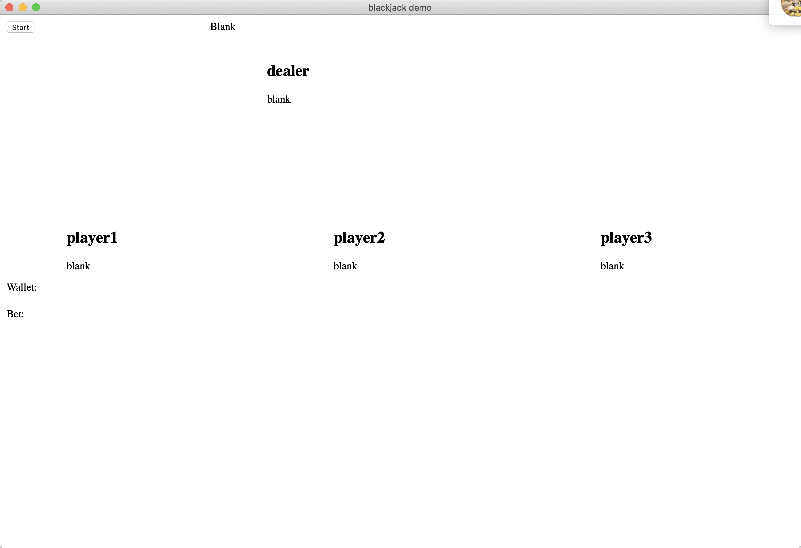

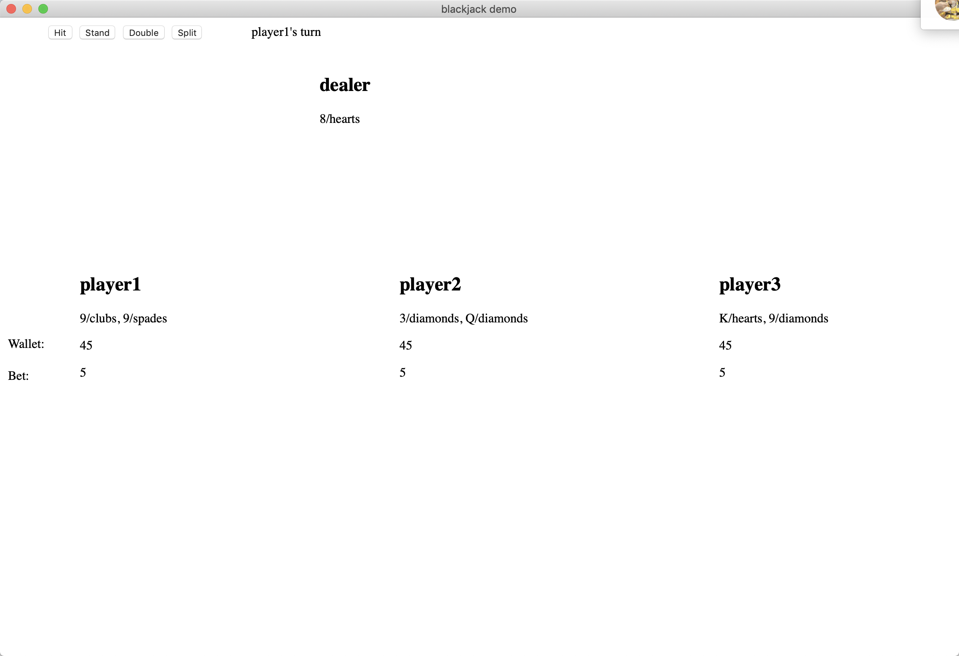

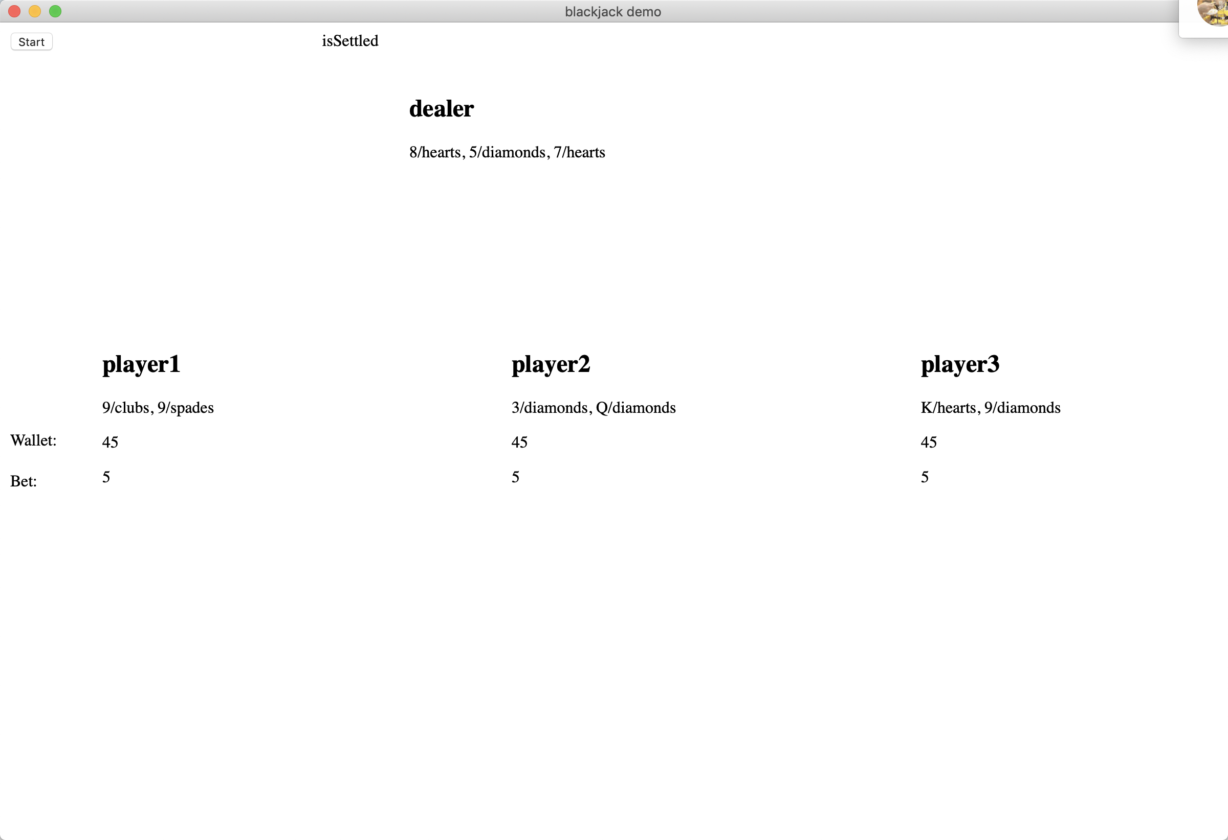

There are one dealer and three players in this game.

Start button: Start a new game, it is active when the status is “blank” or “isSettled”

Hit: Get another card.

Stand: Finish getting new card, turn to the next player

Double: double the bet and get a new card, then finish this turn

Split: Split two same cards into two hand. Once a hand wins the player win.

Settle: Settle this game, it is active when the status is “dealer’s turn”

Status: Show the status of the game. There are 9 stages in the game which are “blank”, “player1’s turn, ”player1’s Split turn”,”player2’s turn”, ”player2’s Split turn”,”player3’s turn”, ”player3’s Split turn”, ”dealer’s turn”,”isSettled”.

When the wallets of all three players are empty, the game is over.

# The space of improvement and What we have learned

We learned a lot of the basic syntax of the go language, how to import third-party plugins and how to combine go with other programming languages such as Html and JavaScript. What needs to be improved is that we need to modularize our code and remove some duplicate parts.

# Citation

* <https://www.blackjackapprenticeship.com/how-to-play-blackjack/>
* <https://bicyclecards.com/how-to-play/blackjack/>
* <https://www.doverdowns.com/casino/beginners-guide-to-blackjack/>