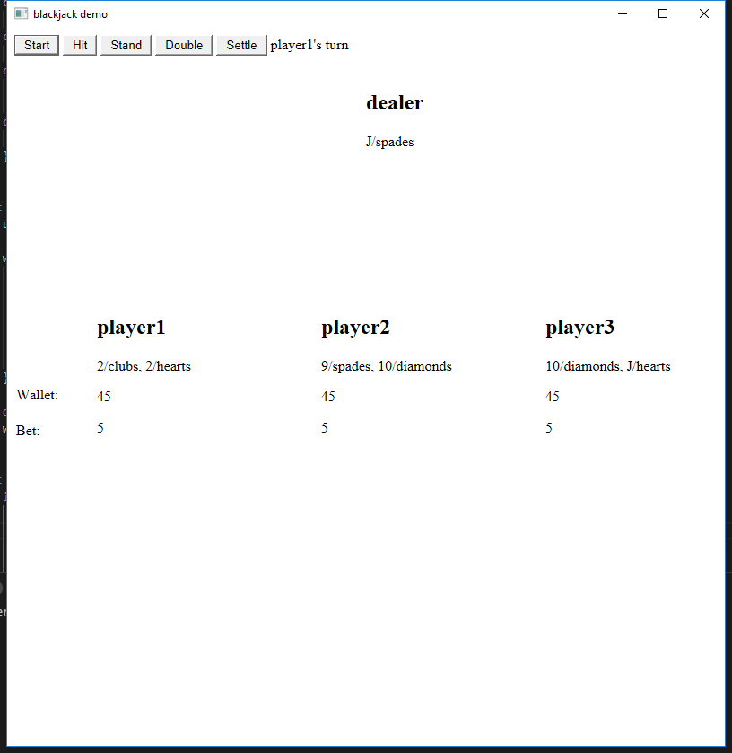

There are one dealer and three players in this game.

Start button: Start a new game, it is active when the status is “blank” or “isSettled”

Hit: Get another card.

Stand: Finish getting new card, turn to the next player

Double: double the bet

Settle: Settle this game, it is active when the status is “end”

Status: Show the status of the game. There are 6 stages in the game which are “blank”,”player1’s turn”,”player2’s turn”,”player3’s turn”,”end”,”isSettled”.