Switch1

Switch>en

Switch#conf t

Enter configuration commands, one per line. End with CNTL/Z.

Switch(config)#int port-channel 1

Switch(config-if)#exit

Switch(config)#int fa0/2

Switch(config-if)#channel-group 1 mode on

Switch(config-if)#

%LINK-5-CHANGED: Interface Port-channel 1, changed state to up

%LINEPROTO-5-UPDOWN: Line protocol on Interface Port-channel 1, changed state to up

%LINEPROTO-5-UPDOWN: Line protocol on Interface FastEthernet0/2, changed state to down

%LINEPROTO-5-UPDOWN: Line protocol on Interface FastEthernet0/2, changed state to up

Switch(config-if)#exit

Switch(config)#int fa0/3

Switch(config-if)#channel-group 1 mode on

Switch(config-if)#

%LINEPROTO-5-UPDOWN: Line protocol on Interface FastEthernet0/3, changed state to down

%LINEPROTO-5-UPDOWN: Line protocol on Interface FastEthernet0/3, changed state to up

Switch(config-if)#exit

Switch(config)#int fa0/4

Switch(config-if)#channel-group 1 mode on

Switch(config-if)#

%LINEPROTO-5-UPDOWN: Line protocol on Interface FastEthernet0/4, changed state to down

%LINEPROTO-5-UPDOWN: Line protocol on Interface FastEthernet0/4, changed state to up

Switch(config-if)#exit

Switch(config)#int port-channel 1

Switch(config-if)#switchport mode trunk

Switch(config-if)#switchport trunk allowed vlan all

Switch(config-if)#exit

Switch(config)#end

Switch 4

Switch>en

Switch#conf t

Enter configuration commands, one per line. End with CNTL/Z.

Switch(config)#int port-channel 1

Switch(config-if)#exit

Switch(config)#int fa0/1

Switch(config-if)#channel-group 1 mode on

Switch(config-if)#

%LINK-5-CHANGED: Interface Port-channel 1, changed state to up

%LINEPROTO-5-UPDOWN: Line protocol on Interface Port-channel 1, changed state to up

%LINEPROTO-5-UPDOWN: Line protocol on Interface FastEthernet0/1, changed state to down

%LINEPROTO-5-UPDOWN: Line protocol on Interface FastEthernet0/1, changed state to up

Switch(config-if)#exit

Switch(config)#int fa0/2

Switch(config-if)#channel-group 1 mode on

Switch(config-if)#

%LINEPROTO-5-UPDOWN: Line protocol on Interface FastEthernet0/2, changed state to down

%LINEPROTO-5-UPDOWN: Line protocol on Interface FastEthernet0/2, changed state to up

Switch(config-if)#exit

Switch(config)#int fa0/3

Switch(config-if)#channel-group 1 mode on

Switch(config-if)#

%LINEPROTO-5-UPDOWN: Line protocol on Interface FastEthernet0/3, changed state to down

%LINEPROTO-5-UPDOWN: Line protocol on Interface FastEthernet0/3, changed state to up

Switch(config-if)#exit

Switch(config)#int port-channel 1

Switch(config-if)#switchport mode trunk

Switch(config-if)#switchport trunk allowed vlan all

Switch(config-if)#exit

Switch(config)#end

Switch 7

Switch>en

Switch#conf t

Enter configuration commands, one per line. End with CNTL/Z.

Switch(config)#int port-channel 1

Switch(config-if)#exit

Switch(config)#int fa0/3

Switch(config-if)#channel-group 1 mode on

Switch(config-if)#

%LINK-5-CHANGED: Interface Port-channel 1, changed state to up

%LINEPROTO-5-UPDOWN: Line protocol on Interface Port-channel 1, changed state to up

%LINEPROTO-5-UPDOWN: Line protocol on Interface FastEthernet0/3, changed state to down

%LINEPROTO-5-UPDOWN: Line protocol on Interface FastEthernet0/3, changed state to up

Switch(config-if)#exit

Switch(config)#int fa0/4

Switch(config-if)#channel-group 1 mode on

Switch(config-if)#

%LINEPROTO-5-UPDOWN: Line protocol on Interface FastEthernet0/4, changed state to down

%LINEPROTO-5-UPDOWN: Line protocol on Interface FastEthernet0/4, changed state to up

Switch(config-if)#exit

Switch(config)#int fa0/5

Switch(config-if)#channel-group 1 mode on

Switch(config-if)#

%LINEPROTO-5-UPDOWN: Line protocol on Interface FastEthernet0/5, changed state to down

%LINEPROTO-5-UPDOWN: Line protocol on Interface FastEthernet0/5, changed state to up

Switch(config-if)#exit

Switch(config)#int port-channel 1

Switch(config-if)#switchport mode trunk

Switch(config-if)#switchport trunk allowed vlan all

Switch(config-if)#exit

Switch(config)#end

教学楼

Switch>en

Switch#conf t

Enter configuration commands, one per line. End with CNTL/Z.

Switch(config)#int port-channel 1

Switch(config-if)#exit

Switch(config)#int fa0/3

Switch(config-if)#channel-group 1 mode on

Switch(config-if)#

%LINK-5-CHANGED: Interface Port-channel 1, changed state to up

%LINEPROTO-5-UPDOWN: Line protocol on Interface Port-channel 1, changed state to up

%LINEPROTO-5-UPDOWN: Line protocol on Interface FastEthernet0/3, changed state to down

%LINEPROTO-5-UPDOWN: Line protocol on Interface FastEthernet0/3, changed state to up

Switch(config-if)#exit

Switch(config)#int fa0/4

Switch(config-if)#channel-group 1 mode on

Switch(config-if)#

%LINEPROTO-5-UPDOWN: Line protocol on Interface FastEthernet0/4, changed state to down

%LINEPROTO-5-UPDOWN: Line protocol on Interface FastEthernet0/4, changed state to up

Switch(config-if)#exit

Switch(config)#int fa0/5

Switch(config-if)#channel-group 1 mode on

Switch(config-if)#

%LINEPROTO-5-UPDOWN: Line protocol on Interface FastEthernet0/5, changed state to down

%LINEPROTO-5-UPDOWN: Line protocol on Interface FastEthernet0/5, changed state to up

Switch(config-if)#exit

Switch(config)#int port-channel 1

Switch(config-if)#switchport mode trunk

Switch(config-if)#switchport trunk allowed vlan all

Switch(config-if)#exit

Switch(config)#end

Switch 1

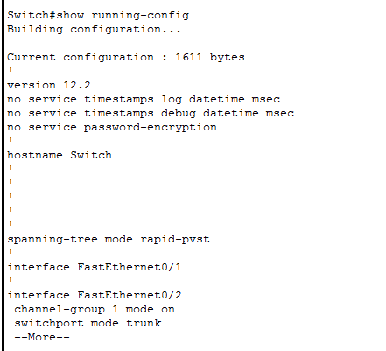

Switch 7

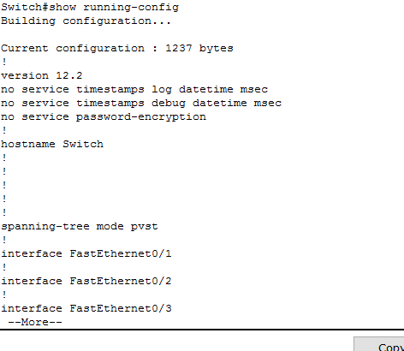

Switch 4

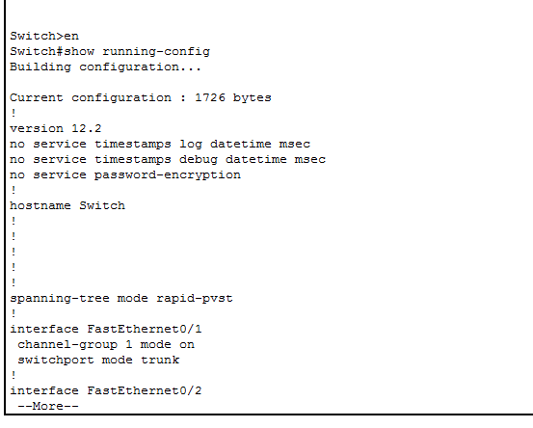

教学楼

