BIOSTAT 721 Project 2
Weizhao Liu
2025-11-21
This report presents the data cleaning function and exploratory plots as required in BIOSTAT 721 Project 2.
GitHub repository: https://github.com/weizhaoliu1/BIOSTAT721_Project2

Function
The following function processes the daily air quality dataset by renaming variables, converting dates, removing duplicate rows, averaging multiple measurements, and setting negative pollutant values to zero, as required by the assignment.

Run Function on Datasets
## # A tibble: 6 × 4
## date co pm25 o3
## <date> <dbl> <dbl> <dbl>
## 1 2018-01-01 0.2 7.5 0.037
## 2 2018-01-02 0.7 8.95 0.034
## 3 2018-01-03 0.9 15.2 0.032
## 4 2018-01-04 0.2 9.7 0.035
## 5 2018-01-05 0.2 7.75 0.036
## 6 2018-01-06 0.2 7.6 0.036
## # A tibble: 6 × 4
## date co pm25 o3
## <date> <dbl> <dbl> <dbl>
## 1 2019-01-01 0.2 8.5 0.033
## 2 2019-01-02 0.3 9.2 0.027
## 3 2019-01-03 0.6 7.9 0.015
## 4 2019-01-04 0.7 8.9 0.026
## 5 2019-01-05 0.2 6 0.039
## 6 2019-01-06 0.6 6.75 0.034
## # A tibble: 6 × 4
## date co pm25 o3
## <date> <dbl> <dbl> <dbl>
## 1 2020-01-01 0.5 3.7 0.036
## 2 2020-01-02 0.8 8.2 0.03
## 3 2020-01-03 0.4 8.5 0.01
## 4 2020-01-04 0.4 1.93 0.033
## 5 2020-01-05 0.4 2.7 0.032
## 6 2020-01-06 0.7 4.7 0.033

Bind data
The three cleaned datasets were combined into a single dataset for plotting.

Plot 1：Monthly averages with 95% CI (CO & O3)
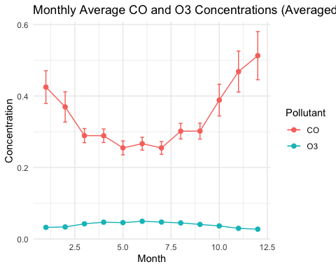

Plot 2（PM2.5 vs Month by Year）
