Q.N. 1)

a) “ln” in r means “natural log” so that we can directly convert “ln(3)” to “log(3)”



b)the function of acquiring the “square root” in r is “sqrt()”



c)



d)



e)”log” in r takes 10 as base



Q.N. 2)

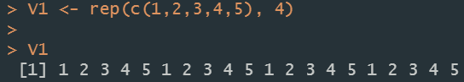

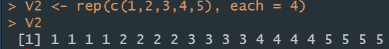

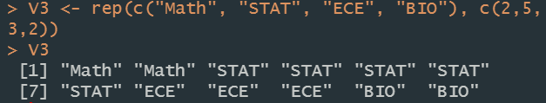

Q.N. 3)

a) Setting up the “header = T” identifies the first row as the header and won’t include it into the observations. “na.strings = ‘\*’” is for replacing the ‘\*’ marks by ‘NA’



b) Variables are characteristics or quantities that can be measured in a data set.



c) replace all of the “\*” marks by “NA”, filter all of the other elements by command “data[!is.na(data)]” and then compound a new data set.

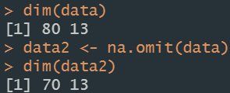



Q.N. 4)

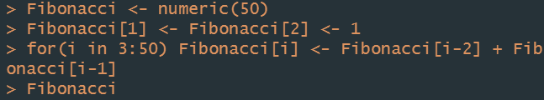

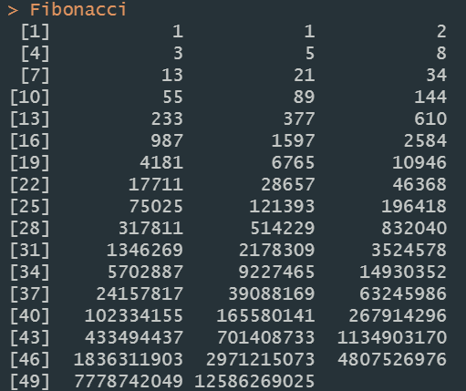

Q.N. 5)

“solve” function is for acquiring the inverse of matrix in R, “nrow” is the desired number of the rows and after we specify it, we determine that the data is arranged by row(byrow = T)

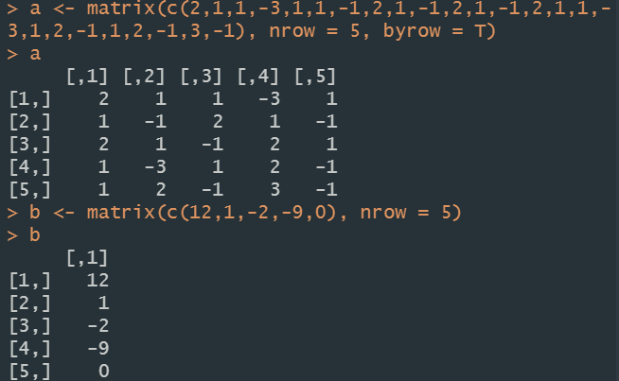

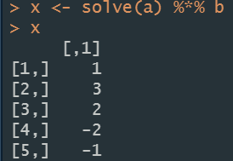

Q.N. 6)

a)



b)

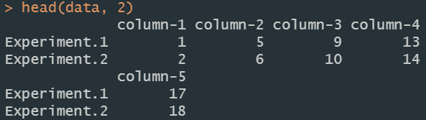

c)

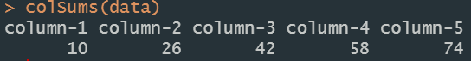

d)

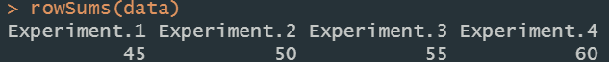

e)

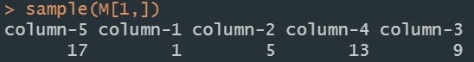

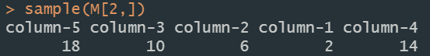

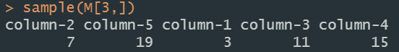

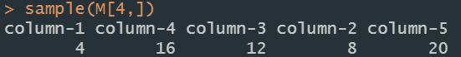

Q.N. 7)

a)

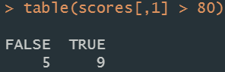

b)

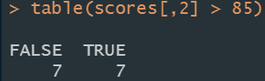

c) For the Test 1, the 7th student didn’t take the test while the 12th student didn’t take the test for Test 2.





d) 1st 11th 13th 15th

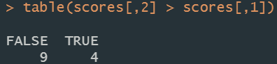

e)4th 8th 14th

