Q.N. 1)

a)  
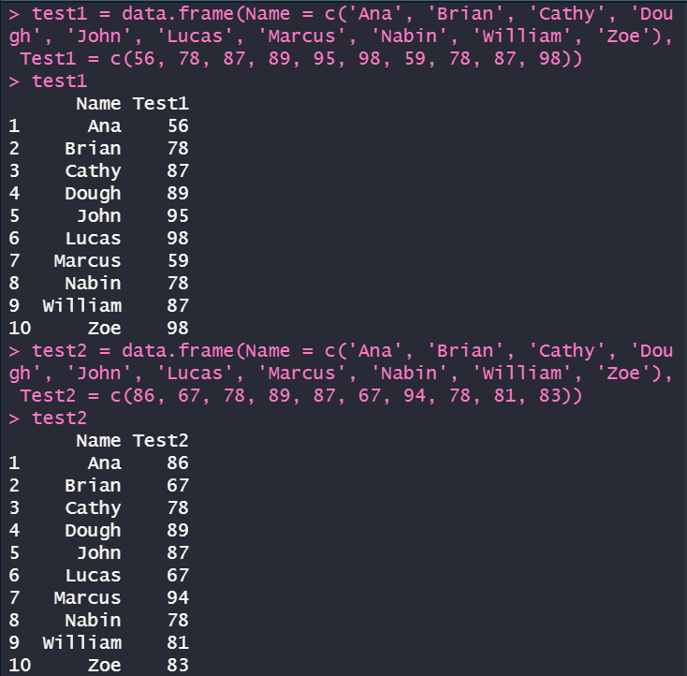

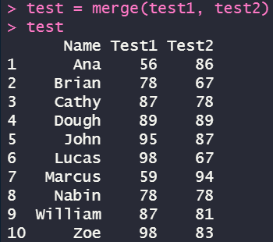

b)There are 2 students who did better in the second test.  


c)There are 6 students did better in the first test.  


d)There are 2 students played a draw.  


e)  
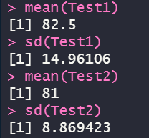

Q.N. 2)

a)  
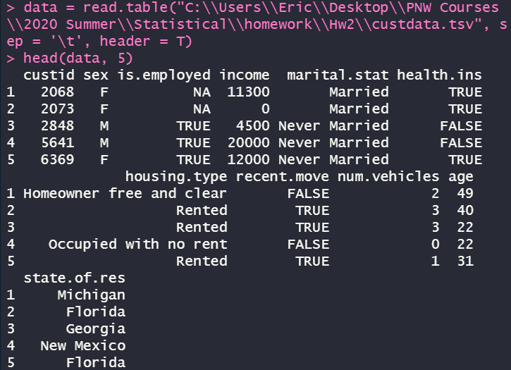

b)  
  
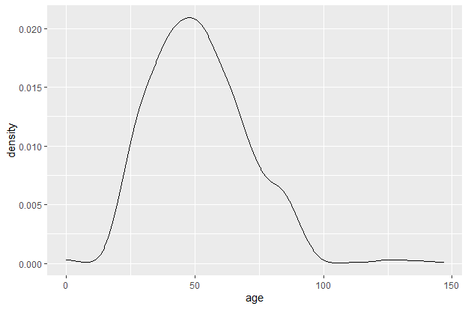  
c)  
  
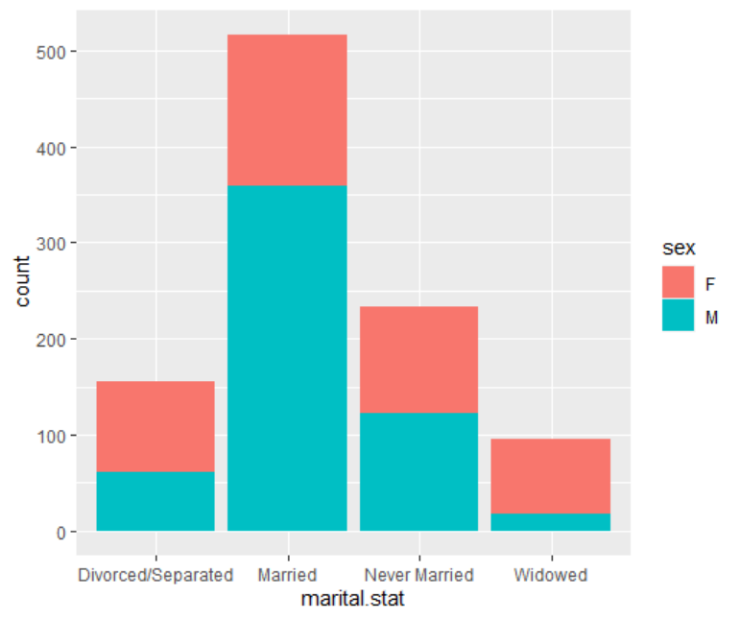  
d)*There are 29 people from Indiana.*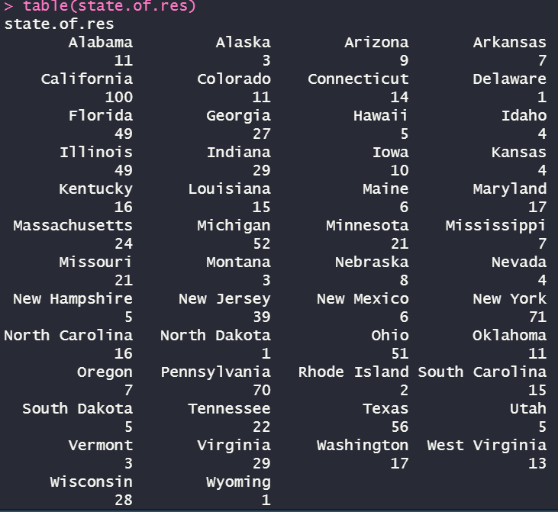

Q.N. 3)

a)There are 4 variables included in the survey.  
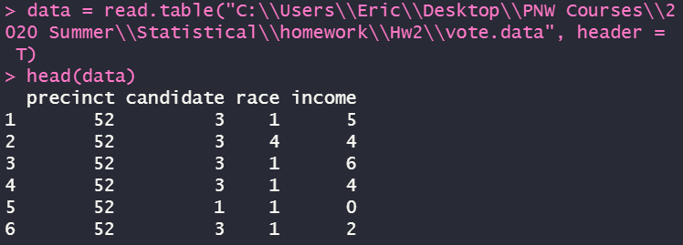

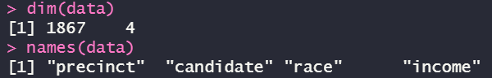

b)   
  
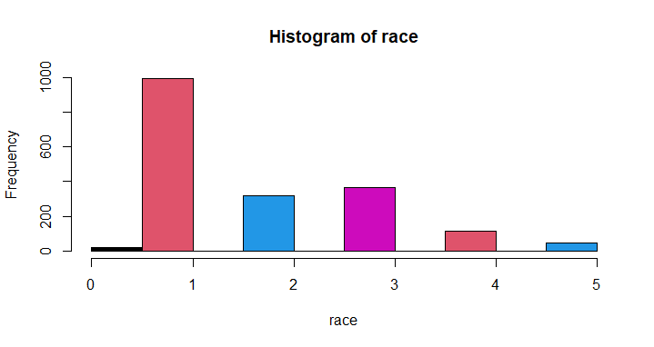

Q.N. 4)

a)  
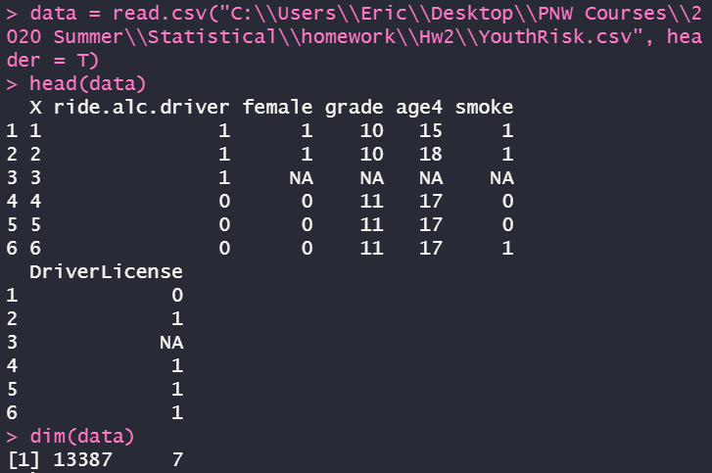

b)  
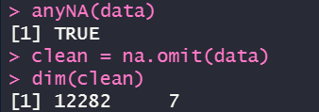

c)  
  
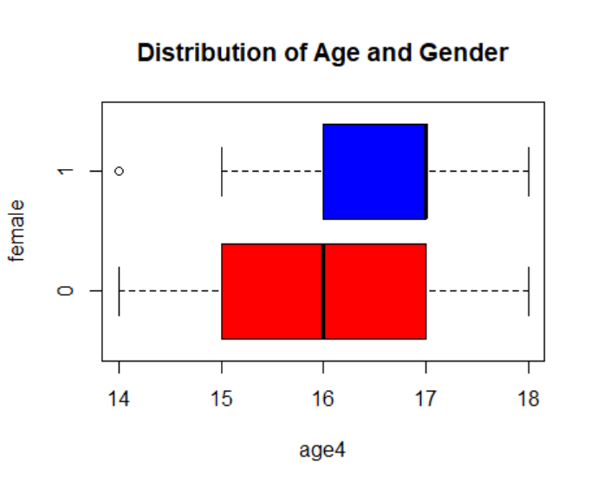

d)  


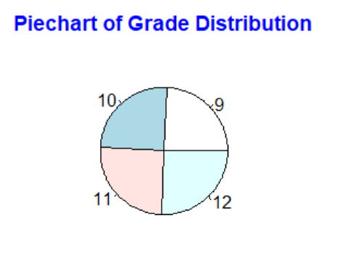

Q.N. 5)  
We combine the two columns of data into a data frame first, then use the “pie()” function to make a pie chart and also define the label as the country name.





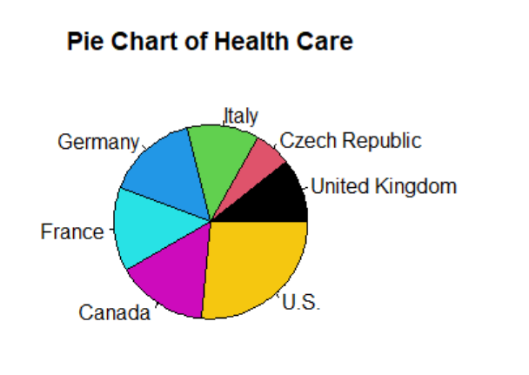

Q.N. 6)

a)

  


b)



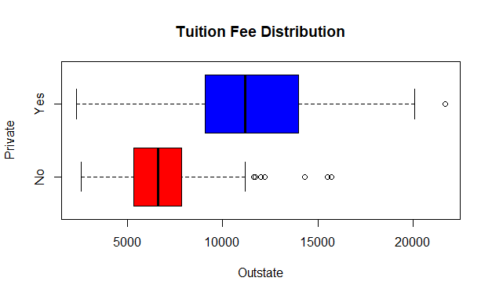

c)



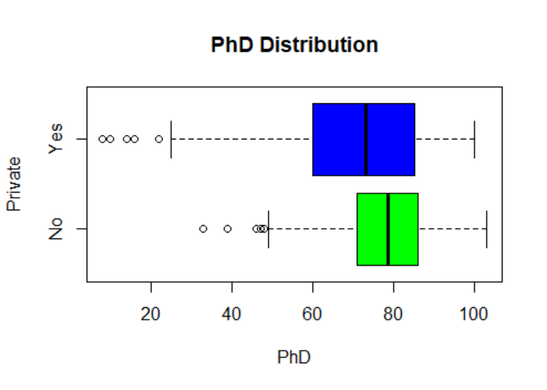

Q.N. 7)

a)  
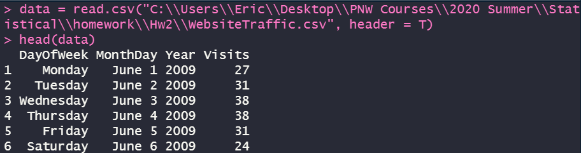  


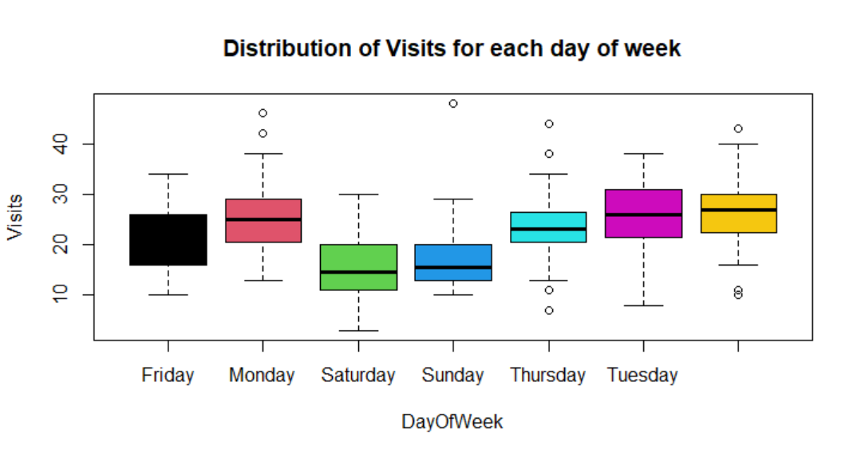

b)  
