Q.N. 1)

  
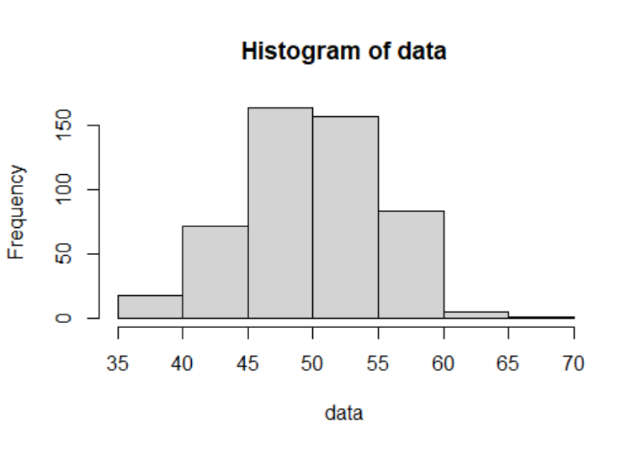

Within 1SD:  
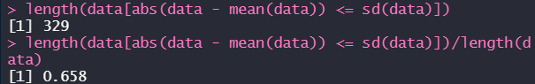

Within 2SDs:  


Within 3SDs:  
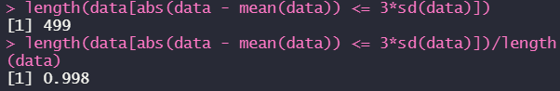

Q.N. 2)

a) There are 654 children included in this study.

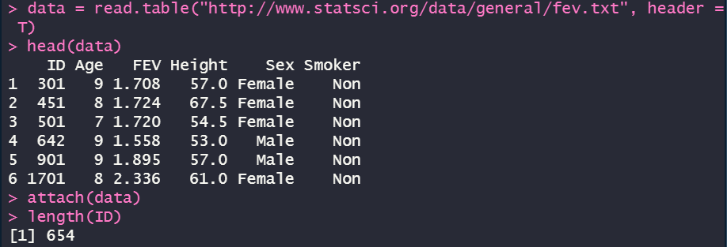

b)   
  
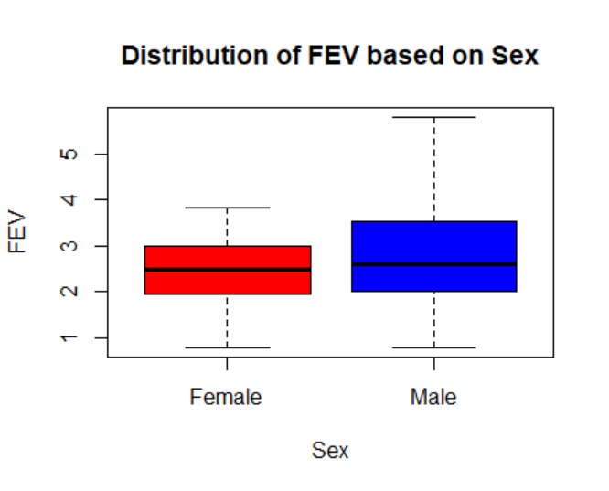

c) the p-value is way much smaller than 0.05 which is against the null hypothesis and indicates that there is difference between them.  
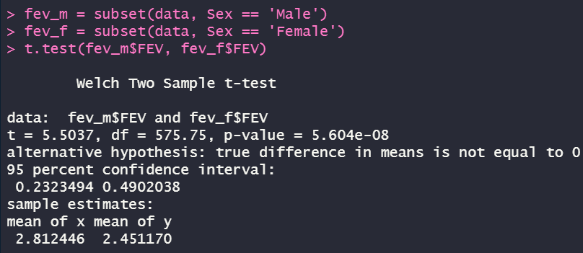

Q.N. 3)

a)  


b)  


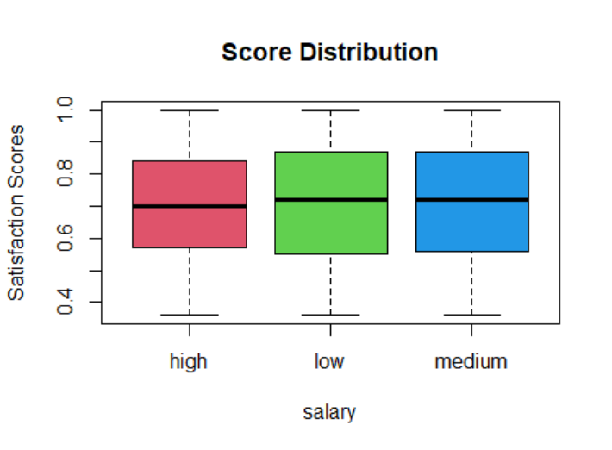

c) the p-value is extremely small for approving the alternative hypothesis that there’s a significant difference between them.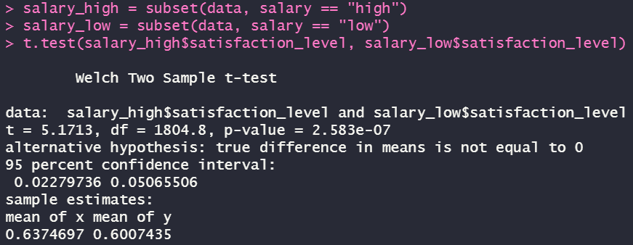

Q.N. 4)

a) There are 10 variables included in the data set.  


b)  
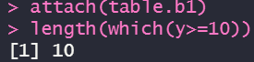

c) “sd(data)” is for getting the standard deviation  
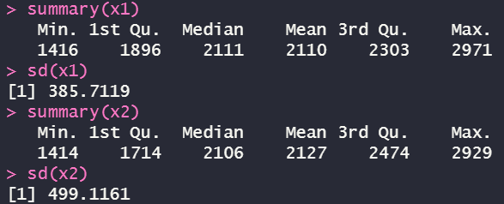

Q.N. 5)

a) There are 30 observations recorded in the data set.  
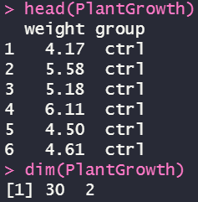

b)  
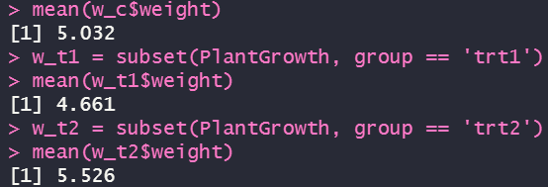

c) the p-value is 0.009298 which is way less than the significance level of 0.05 such that we can reject the null hypothesis and say there’s a significant difference between them.  
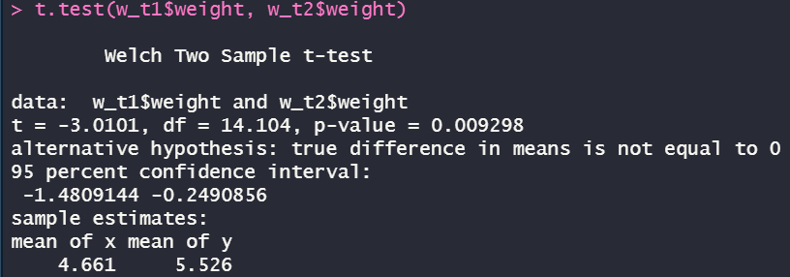

Q.N. 6)

a)  




b)



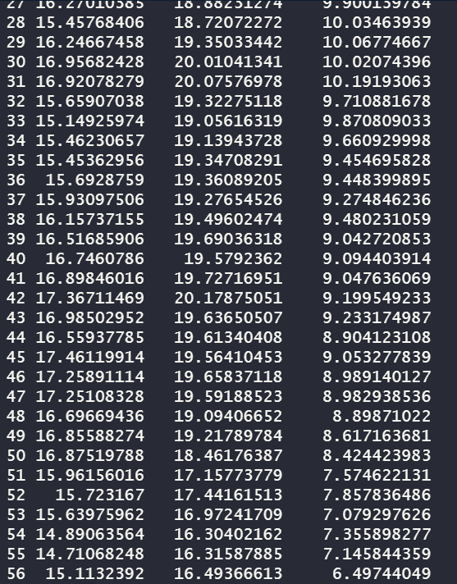

Q.N. 7)

Based on the test result below, we can see that the p-value is extremely tiny which is in favor of the alternative hypothesis that dads are generally older than moms.

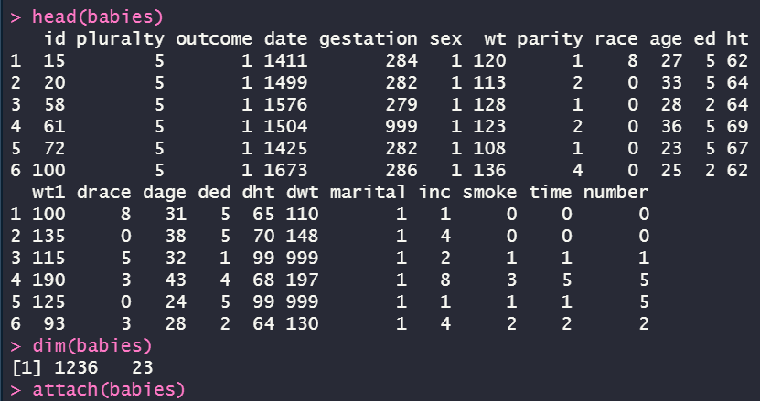

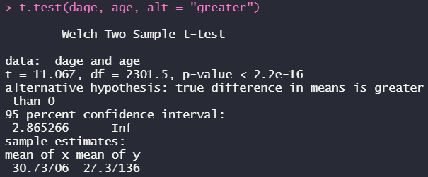

Q.N. 8)

a)  


b)  


c)  
  
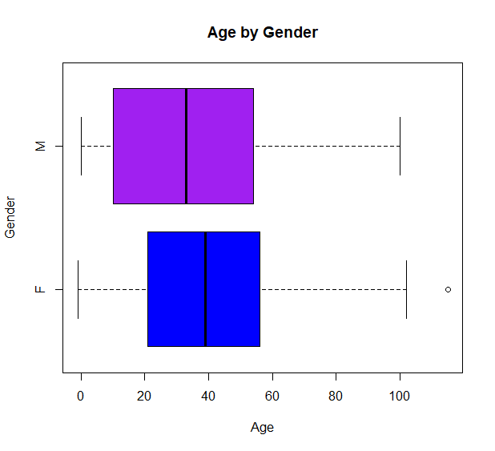

d)From the proportion test we can see that the p-value is pretty large which means that we don’t have evidence to support the alternative hypothesis that female are more likely to miss the appointment.  
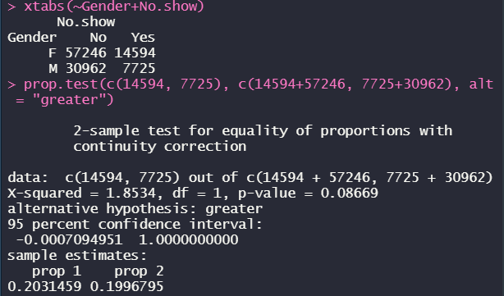

e)the pr-value is totally equal to 1, meaning that we don’t have any evidence to say that there’s a more proportion for people who received SMS and were at present .  
  
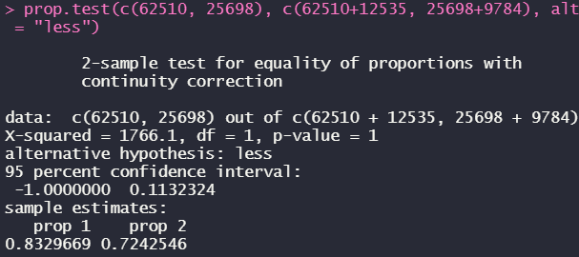

f)The p-value is pretty small which means that the null hypothesis can be rejected and the alternative hypothesis can be approved that the female are older than male.  
