Q.N. 1)

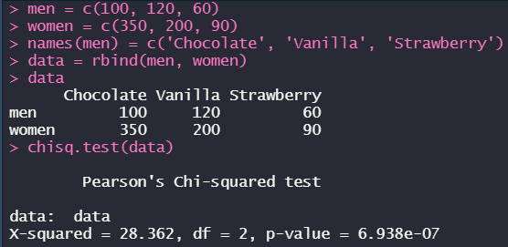

*(Since the p-value is less than significance level, then we can reject the Null Hypothesis and can’t say that the ice cream flavor and gender are independent)*

Q.N. 2)

  
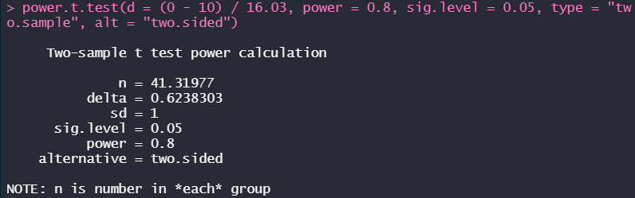  
*(there should be 42 subjects in each group)*

Q.N. 3)

a)  
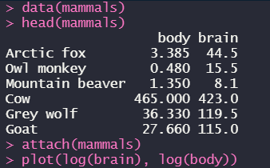

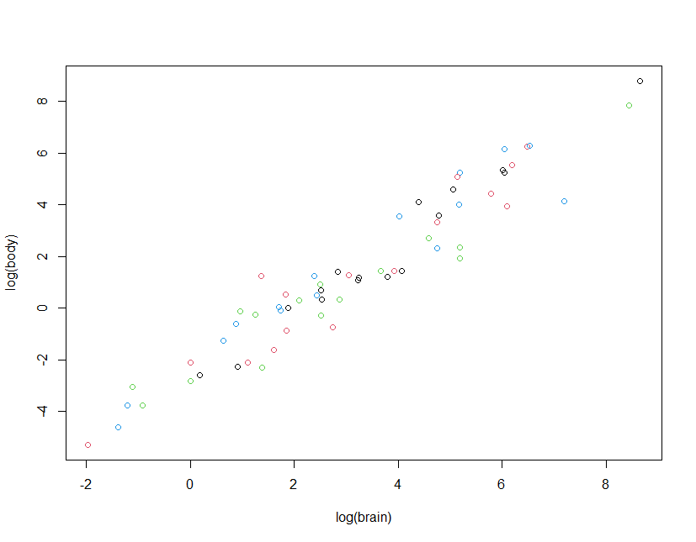

b)  
  
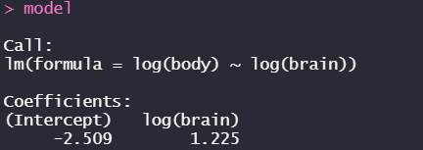

c)  
***log(body) = -2.509 + 1.225 \* log(brain)***

Q.N. 4)

a)  
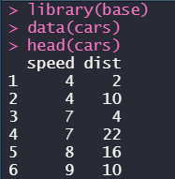  


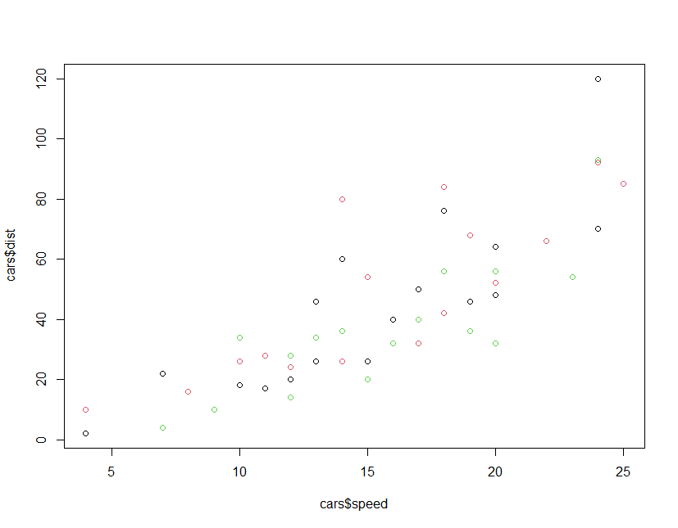

b)

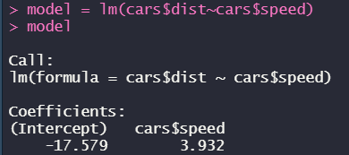

c)  


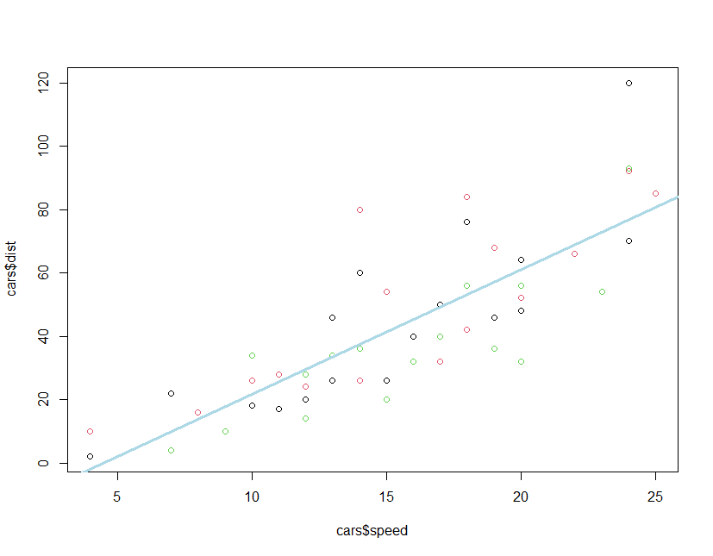

d)  




e)

  
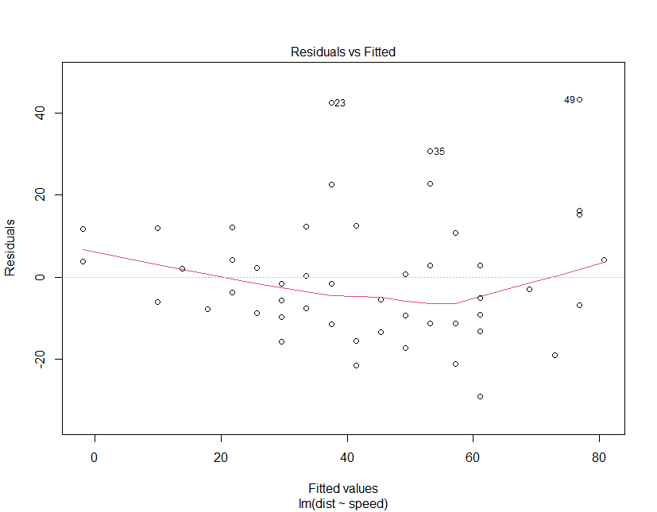

f)  
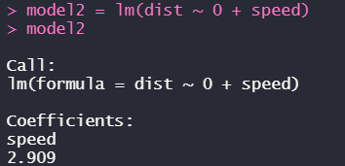

g)  
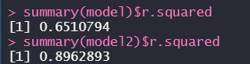

h)  


Q.N. 5)

a)  
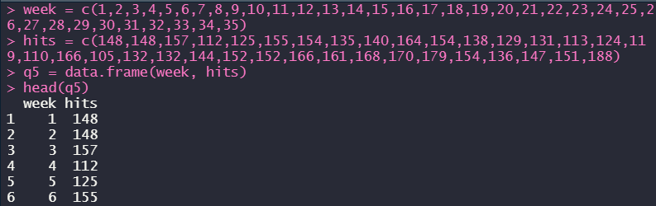



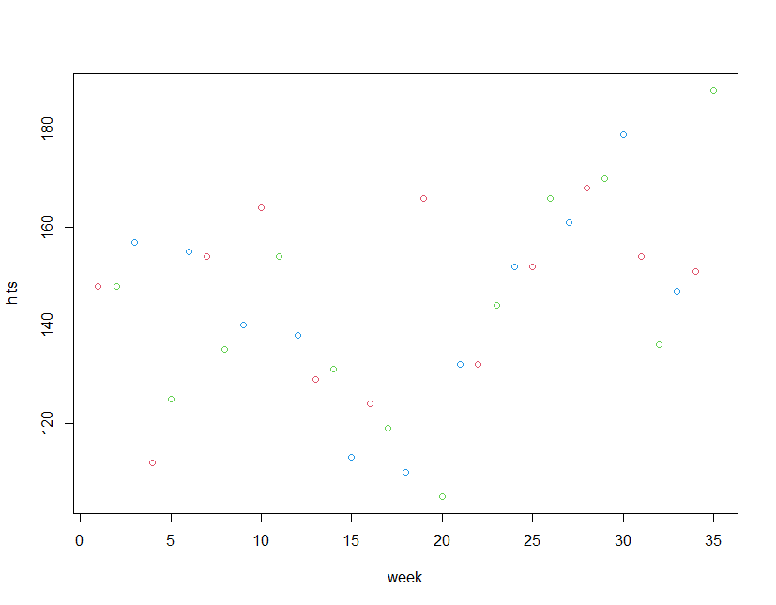

b)



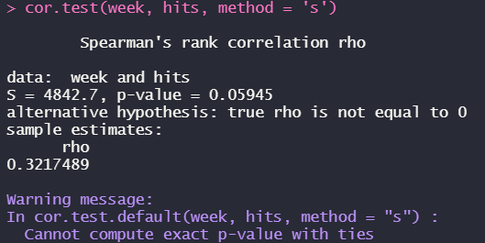  
*(the p-value is greater than significance level, meaning that we can’t reject the null hypothesis that they don’t have a rank order relationship)*

c)

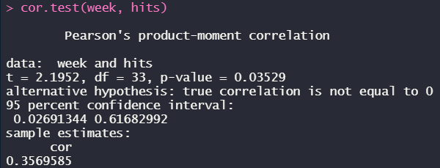

(for the 0.05 significance level, the p-value is less than that which means that we can reject the null hypothesis and say that they have correlation)