Q.N. 1)

a)  




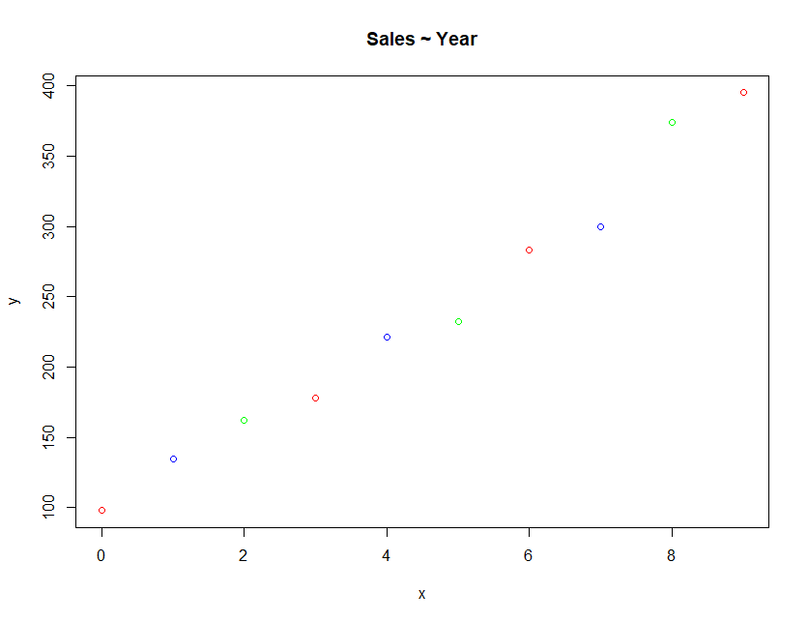

b)  


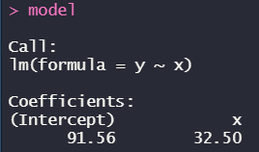

**(y = 91.56 + 32.5 * x)**



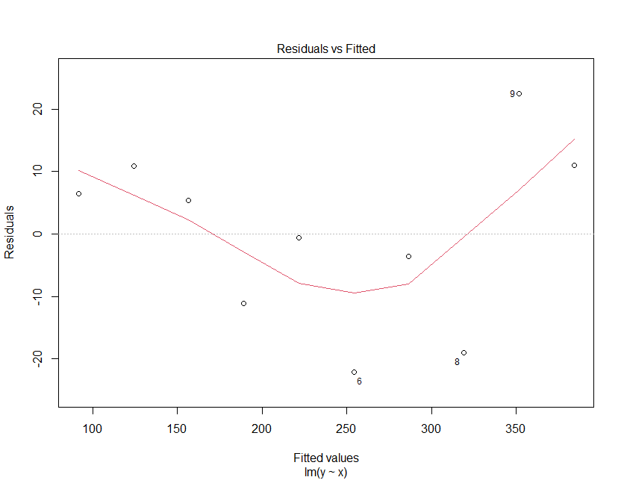

c)  
  


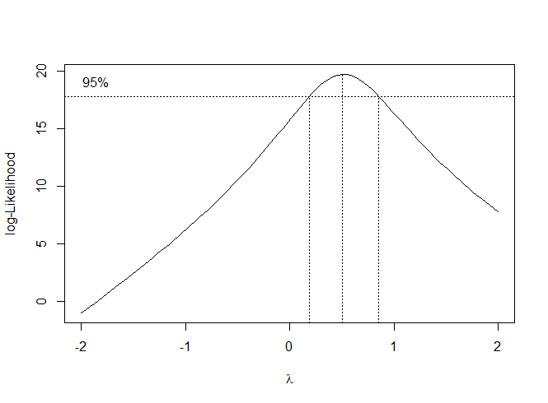

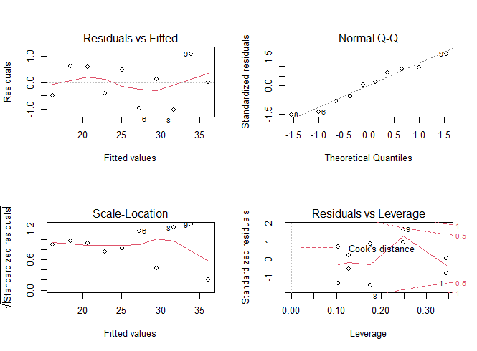

d)  
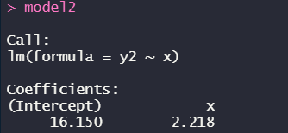

(*y2 = 16.15 + 2.218 * x)*

e) *Basically, the smaller the AIC value, the better it fits. Then we can see the value of model2 is less than that of the previous model, so the model after transformation works better*



Q.N. 2)

a)  


b)  


c)  
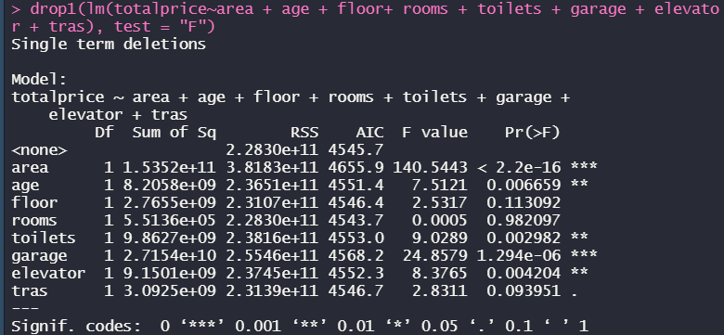

(from all of the variables above, we can see that the ‘rooms’ variable holds the greatest p-value, meaning that it’s the most insignificant independent variable to the dependent variable, so we need to remove it first)

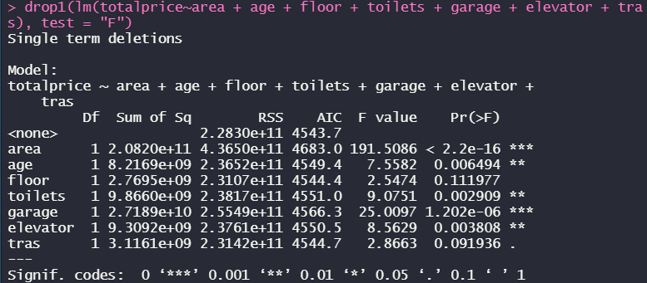

(then following the above pattern, remove the ‘floor’ variable this time)

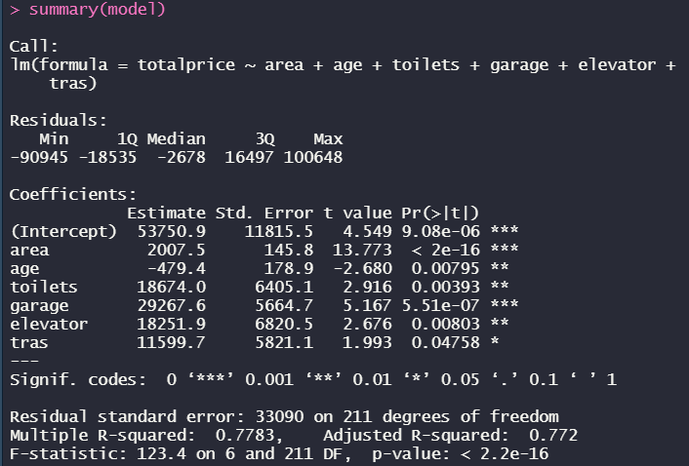

(then we found that all of the p-values of independent variables are less than 0.05, meaning that the model for now is parsimonious and with a R-squared value of 0.772)

Q.N. 3)

a)  
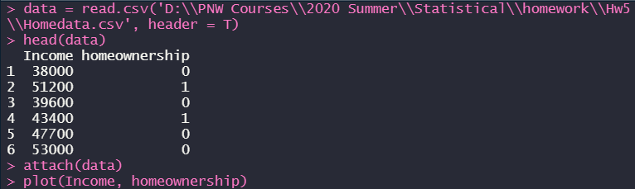







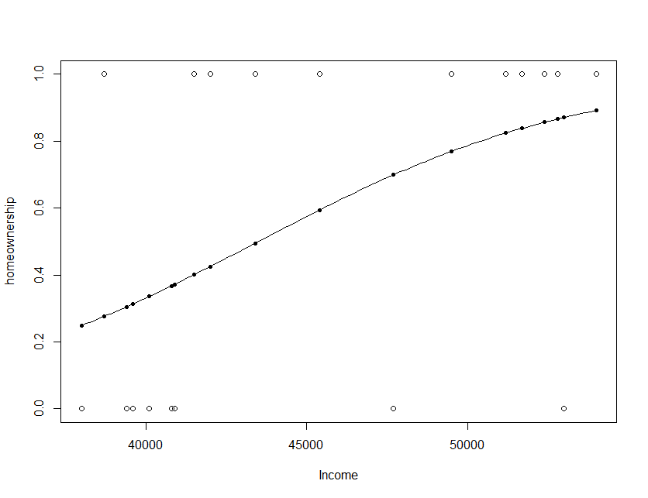

b)  


Q.N. 4)

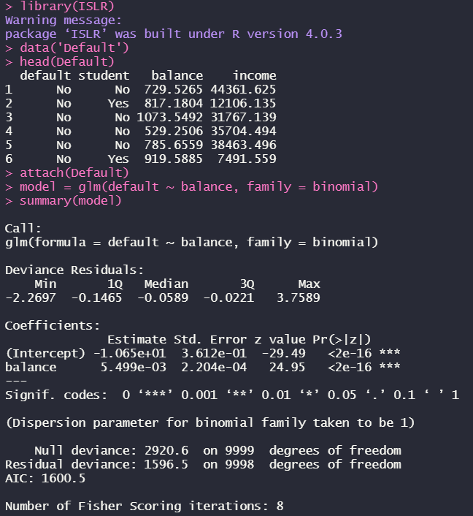

model:

**π = [1 + exp(10.65 − 0.005499 × balance)]-1**

Q.N. 5)

a)  
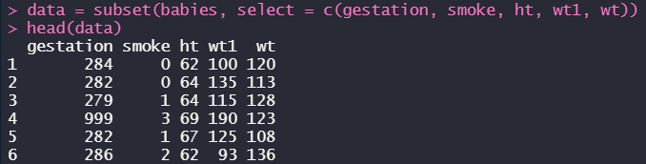

b)  


c)  


d)  
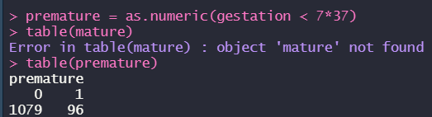

e)  
