**STAT 40001/STAT 59800 Statistical Computing Fall 2020**

**Lab -22**

**1.**  The effective life of insulating fluids at an accelerated load of 35 KV is being studied. Test data have been obtained for four types of fluids. The result from a completely randomized experiment is as follows:

|  |  |  |  |
| --- | --- | --- | --- |
| Type I | Type II | Type III | Type IV |
| 17.6 | 16.9 | 21.4 | 19.3 |
| 18.9 | 15.3 | 23.6 | 21.1 |
| 16.3 | 18.6 | 19.4 | 16.9 |
| 17.4 | 17.1 | 18.5 | 17.5 |
| 20.1 | 19.5 | 20.5 | 18.3 |
| 21.6 | 20.3 | 22.3 | 19.8 |

1. Is there any indication that the fluids differ at α = 0.1. What about at α = 0.05?



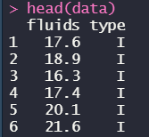



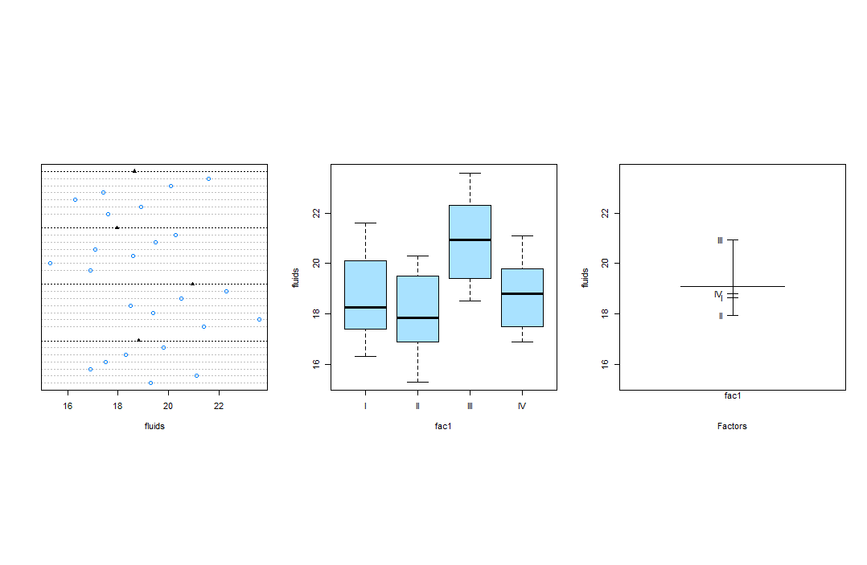



1. Use the Tukey’s HSD test to identify the fluid types that are different (if any).

