LITERATURE SEARCH PROTOCOL

# NCircle Stone Extractor

EU Class: 11a

**Prepared Exclusively For**

**Cook Medical**

Bloomington, Indiana, United States

**Prepared By**

Edward Drower, M.S.

Cite Medical LLC

**Date**

Dec 20, 2022

LITERATURE SEARCH

PROTOCOL

To Address the Requirement for GSPR as part of the technical documentation containing information to demonstrate the conformity with the Medical Device Regulation (MDR) 2017/745

Table of Contents

[Insert table of contents here ]

# 

# Overview

## Background

Cook Medical is conducting a scientific literature search to demonstrate the performance and safety of their devices and State of the Art devices.

The literature search will identify data not held by the manufacturer that are needed for the

clinical evaluation. The literature search will identify potential sources of clinical data for establishing:

* Clinical data relevant to the devices under evaluation and to the equivalent devices for which equivalency has been demonstrated
* Current knowledge/ the state of the art.

## Device Description

The NCircle Stone Extractor is a 4-wire tipless nitinol basket available in a range of French sizes, lengths, and basket diameters.

## Target Device

The NCircle Stone Extractordevice or system is the intended focus of this literature search and review.

**Indication of Use**

The NCircle Stone Extractor is intended for stone manipulation and removal in the urinary tract

**Comparative Devices**

* Uromed Stonizer Stone Retrieval Basket
* Escape Nitinol Stone Retrieval Basket

# State of the Art

NCircle Stone Extractor would be compared to the state-of-the-art (SoTA) urinary stone extraction/removal devices Or devices most commonly used to remove stones/calculi from the urinary track. A separate SoTA search would include the use of standard urinary stone extraction/removal devices.

## Safety Claims

No adverse events related to device usage

## Performance Claims

High stone-free rate/ Low residual stone %   
Flexible easy to use

## Other Info

None

# Literature Search Methodology and Selection Criteria

This review of published clinical data further provides support for the clinical evaluation of the NCircle Stone Extractor.

## Scope

The scope of the literature search includes a query of select adverse event report databases as well as scientific databases for the past 5 years. This period of time is felt to provide sufficient clinical experience with these devices from both a safety and performance perspective. Performance assessments include reports designed to .

## Date of Search

Nov 01, 2022

## Name of Person(s) Undertaking Search

Edward Drower, M.S.

## Period Covered by Search

5 years prior to Nov 01, 2022 unless otherwise stated Literature sources used to identify data.

## Scientific Databases

* Pubmed
* Pubmed Central
* Cochrane Library

### 

### 

## Adverse Event Databases

* FDA MAUDE
* Germany AEs
* Germany Recalls
* UK MHRA AEs

## Database Search Details

Because different databases offer different limiting options and search fields, different approaches were taken appropriate to the database. All unique circumstances are identified in the final report. All searches are performed through online databases.

# Systematic Literature Review

This Systematic Literature Review will search specifically for evidence of safety and efficacy of the target device. Search terms will be adapted for use in the relevant database and be guided by the suggested keywords and inclusion/exclusion criteria detailed in this protocol. In addition to single term word searches, search terms involving multiple words will be evaluated using Boolean parameters such as parentheses or quotation marks.

Suggested search terms have been collected including the target and similar devices described above.

State of the Art (SOTA) search will also be performed in the same systematic manner. Different terms will be included as part of the search parameters to identify devices/systems also used in similar treatments or conditions.

## Focused Search and Review Plan

The resulting number of citations (abstracts) from each database search outlined (less duplicates) is captured and reviewed electronically to determine if further review is warranted. Those articles that satisfy inclusion/exclusion criteria are “retained” for a secondary review. Each “retained” article is subsequently reviewed to assess relevancy and inclusion within the final review.

Search term relevancy criteria is established to promote the most efficient review of appropriate citations for the devices. Searches terms results with citation results in excess of 200 are considered too broad and are excluded from the review process. In contrast, search terms without citation results (i.e., zero) are considered too narrow. All search term citation results regardless of results are tabulated in the final result tables.

The search results (abstracts identified) are reviewed in detail and assessed for relevancy to similar and equivalent systems for clinical safety and efficacy. Similar based studies (i.e., no unique safety or efficacy results) are considered duplicate information and only referenced once. The analysis of each study reviewed is conducted based on the criteria below.

In some instances, information obtained from these reviews that fall outside the inclusion/exclusion criteria may be included within the scope of this report if the information obtained provides new or unanticipated safety or performance signals of interest within current device indications or uses.

# Handling of Duplicate Literature References

Duplicate citations found in the search results of the databases are screened and removed prior to any review. The duplicate counts are captured in the final review and summarized in search-term tables.

## How Duplicates Are Identified?

A duplicate citation is identified through electronic signatures based on a match in one of the following fields of information across the databases.

* PubMed Unique Identifier
* PubMed Central Unique Identifier
* Cochrane Library Unique Identifier
* Embase Library Unique Identifier
* Academic Citation (in APA format)

# Stage 1 – Abstract Review

# Selection criteria

The following criteria is used to assess the suitability of material (articles, reports, etc.) for inclusion/exclusion in the analysis stage of this report.

## Inclusion Criteria

* Citation addresses performance, risks, and/or safety of the NCircle Stone Extractor Device (products or equivalent products).
* Products are used in ways like indications for use of the NCircle Stone ExtractorDevice products.
* Any articles considered relevant to the state of the art/current knowledge identified during this search will be included in the state-of-the-art section

## Exclusion Criteria

* Articles unrelated to the device of interest, an equivalent device, similar device, accessory, or device component relevant to device
* Algorithm, simulations or bench test relevant to the device of interest or an equivalent device but not in a scientifically validated method/methodology
* Non-peer reviewed articles (e.g. letters to editor, opinions, editorials, press releases, advertisements, books, dissertations, thesis)
* Conference abstracts or proceedings, posters (unless previously unknown benefits, risks/complications are reported)
* Non-human studies (e.g. in vitro, in vivo, animal, cadaver, phantom studies, simulations) that is not acceptable data for safety or performance.
* The device is not used as per the specified intended use
* Duplicate article
* Product usage instructions
* Video publications without significant data availablity

Clinical literature was also excluded in situations where multiple papers appear to report on the same study. Consideration was given to the extent of duplication and reported safety or performance outcomes, prior to the excluding of any literature.

# Outputs

All literature citations selected for inclusion are listed as References.

## Data Selection Process

Figure 1 visually outlines the process used in assessing citations retrieved from queries of online databases for suitability for inclusion in the clinical evaluation report.

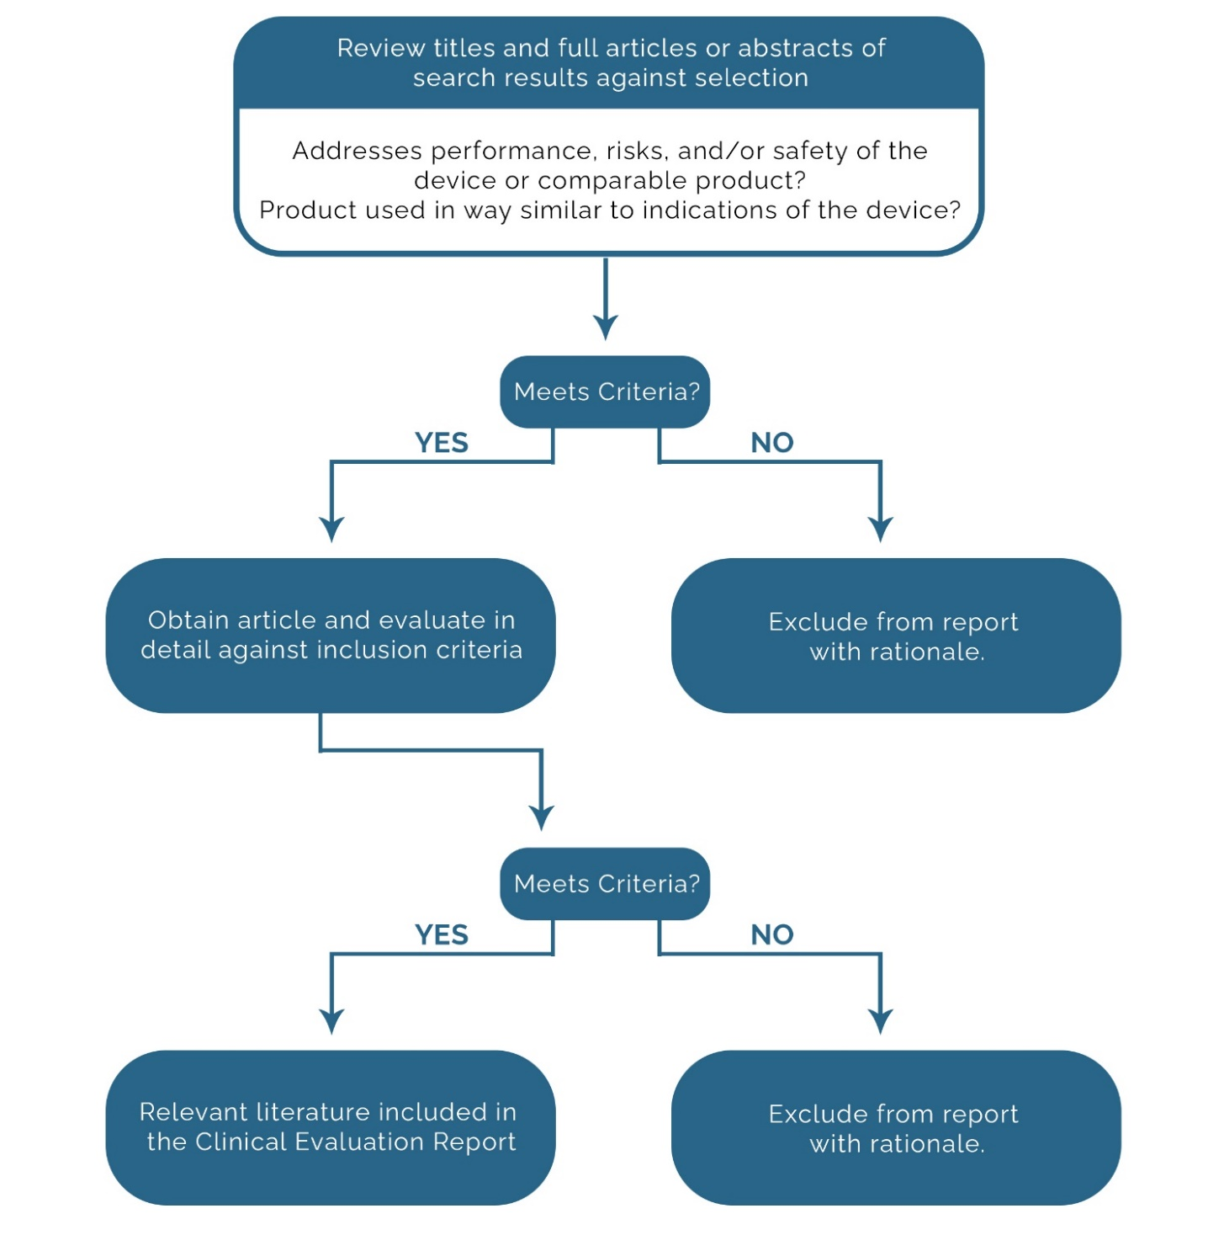

Figure 1 Citation Assessment Flowchart

Stage 2 – Full Text Review and Data Extraction

## Clinical Literature Appraisal Plan

The following section outlines the criteria for suitability and data contribution used to appraise the literature to be included in this clinical evaluation (adapted from MEDDEV 2.7/1, Rev.4).

Clinical Literature Analysis Plan

Citations selected for in-depth review are qualitatively summarized to include:

* An overall study evaluation
* A transformation table of evaluation criteria is included in Tables 2 and 3.
* An in-depth analysis of the citation
* Comprehensive Summary to include:
  + Reported Safety Data
  + New identified Risks
  + Performance Benefits/Issues

## Overview of Extraction Process

1. Determine if the article is relevant to the State of Art or the Target Device
2. Complete Extraction Fields based on either SoTA or Target Device.

## Suitability Criteria – State of the Art

SoTA Suitability Criteria only applies to articles in the State of the Art Search.

|  |  |
| --- | --- |
| Criteria | Description |
| CK0 | No SoTA information. |
| CK1 | Establishment of current knowledge/ the state of the art on the medical condition |
| CK2 | Establishment of current knowledge/ the state of the art on alternative therapies/treatments |
| CK3 | Determination and justification of criteria for the evaluation of the risk/benefit relationship |
| CK4 | Determination and justification of criteria for the evaluation of acceptability of undesirable side-effects |
| CK5 | Determination of equivalence |
| CK6 | Justification of the validity of surrogate endpoints |

Table 1 Criteria for State of the Art

## Suitability, Contribution, and Acceptability Criteria – Device

Suitability, Contribution, and Acceptability criteria apply to all articles in the safety/performance Search.

|  |  |  |
| --- | --- | --- |
| Suitability Criteria | Description | Grading System |
| Appropriate device | Were the data generated from the device in question? | D1 Actual device  D2 Comparable device  D3 Other devices |

Table 2 Criteria for Suitability

|  |  |  |
| --- | --- | --- |
| Contribution Criteria | Description | Grading System |
| Appropriate device application | Was the device used for the same intended use (e.g., methods of deployment, application, etc.)? | A1 Same use  A2 Minor deviation  A3 Major deviation |
| Appropriate patient group | Were the data generated from a patient group that is representative of the intended treatment population (e.g., age, sex, etc.) and clinical condition (i.e., disease, including state and severity)? | P1 Applicable  P2 Limited  P3 Different |
| Acceptable report/data collation | Do the reports or collations of data contain sufficient information to be able to undertake a rational and objective assessment? | R1 High quality  R2 Minor deficiencies  R3 Insufficient information |

Table 3 Criteria for Data Contribution

|  |  |  |
| --- | --- | --- |
| Accountability Level | Description | Grading |
| Data source type | Was the design of the study appropriate? | Yes  No |
| Outcome measures | Do the outcome measures reported reflect the intended performance of the device? | Yes  No |
| Appropriate follow-up | Is the duration of follow-up long enough to assess whether the duration of treatment effects and identify complications? | Yes  No |
| Statistical significance | Has a statistical analysis of the data been provided and is it appropriate? | Yes  No |
| Clinical significance | Was the magnitude of the treatment effect observed clinically significant? | Yes  No |

Table 4 Criteria for Data Acceptability Level

# Long-Form Extraction Fields

These are where the reviewer will pull out relevant info from the article to support the specific category. These extraction fields apply to the articles related to device safety/performance.

|  |  |
| --- | --- |
| Category | Description |
| Safety | Any acknowledgment of how the device safety claim(s) was(were) described for patients. |
| Performance | Any acknowledgment of how the device performance claim(s) was(were) described for patients (I.e.to improve patient outcome, procedural outcome, long term outcome) |
| Adverse Event | Patient-reported AEs |
| State of the Art | Describe any (predefined) SOTA procedures used within the article |
| Guidance | List any guidance used for patient assessment, procedural assessment |
| Other (Commentary) | General field to describe potential new information. |
| Study Design | Type of study (e.g., Case Series, Randomized, Placebo-Controlled, Double-Blind) including any follow-up. |
| Total Sample Size | Number of patients by group evaluated. Also includes Sex, Age (mean, percent, range as available) |
| Objective | Describe the primary objective of the article/ study |
| Treatment Modality | List all treatment arms (I.e., what was tested or compared) |
| Study Conclusions | Briefly describe study results/outcomes/main conclusions |
| Justification (Writeup) | This is a general overview of the information gathered that provides support to the device claims, capabilities, and overall safety. |

Table 5 Extracted Data from Retained Articles

# Grade Scores

A GRADE Score is assessed for every retained citation pertaining to the Target Device. The steps for determining the GRADE score are as follows.

| Grade Evidence | What it means?  Quality of evidence and definitions) |
| --- | --- |
| Very low=1 | The true effect is probably markedly different from the estimated effect. |
| Low=2 | The true effect might be markedly different from the estimated effect. |
| Moderate=3 | The authors believe that the true effect is probably close to the estimated effect. |
| High=4 | The authors have a lot of confidence that the true effect is similar to the estimated effect. |

Table 6 Study Design Score

| Certainty can be rated down for | | Certainty can be rated up for | |
| --- | --- | --- | --- |
| Certainty | Rate | Certainty | Rate |
| Risk of bias | -1 Likely  -2 Very likely | RCT Large Magnitude of effect | +1 Large  +2 Very large |
| Observational study Imprecision | -1 Serious  -2 Very serious | RCT Dose-response gradient | +1 Strong |
| RCT Inconsistency | -1 Serious  -2 Very serious | Observational study residual confounding would decrease the magnitude of effect (in situations with an effect) | +1 Confounding would reduce demonstrated effect  +2 Confounding spurious effect when results show no effect |
| Observational study Indirectness | -1 Serious  -2 Very serious |
| RCT Study Limitations | -1 Serious  -2 Very serious |

Table 7 Certainty Ratings

|  |  |  |  |  |  |  |  |  |  |  |  |
| --- | --- | --- | --- | --- | --- | --- | --- | --- | --- | --- | --- |
| **GRADE SCORE** | **=** | Grade of  Study Score | **+** | Risk of Bias | + | Observational Study Imprecision | RCT Inconsistency | + | Observational Study Indirectness | + | RCT Study Limitations |

Table 8 GRADE Calculation

# Scientific Databases

## Cochrane

### Search Strategy

The following filters are to be applied in the search:

* Publication dates: 5 years back from Nov 01, 2022

### Search Terms

* Cook Medical
* Escape Nitinol Stone Retrieval Basket
* NCircle Nitinol Stone Extractor
* Nephrolithotomy basket
* Tipless nitinol stone basket
* Urinary calculi extraction
* Urinary stone basket
* Urinary stone extractor
* Urinary stone grasper
* Urinary track stone removal
* UROMED STONIZER Stone Retrieval Basket

## Pubmed

### Search Strategy

The following filters are to be applied in the search:

* Publication dates: 5 years back from Nov 01, 2022

### Search Terms

* Cook Medical
* Escape Nitinol Stone Retrieval Basket
* NCircle Nitinol Stone Extractor
* Nephrolithotomy basket
* Tipless nitinol stone basket
* Urinary calculi extraction
* Urinary stone basket
* Urinary stone extractor
* Urinary stone grasper
* Urinary track stone removal
* UROMED STONIZER Stone Retrieval Basket

# Adverse Event Databases / Recalls

## FDA MAUDE

https://www.accessdata.fda.gov/

### Date Range

1 years prior to Nov 01, 2022

### Search Strategy

['The MAUDE safety database search is based on the relevant 510K codes\r\n\r\nIf the number of safety event results exceeds the download limitation of 500 for the range of years searched, a year-by-year download of the events will be captured and reviewed to assess relevance or new events related to the current medical device class.']

**Search Terms**

* FFL
* Urinary track stone removal

## Germany AEs

### https://www.bfarm.de/

### Date Range

1 years prior to Nov 01, 2022

### Search Strategy

Searches included Device Safety Information reports in all medical specialties. The safety database consists of a keyword search based on the following terms. If compound terminology is not permitted by the database, simple text searches are conducted per term.

**Search Terms**

* Escape Nitinol Stone Retrieval Basket
* NCircle Nitinol Stone Extractor
* Nephrolithotomy basket
* Tipless nitinol stone basket
* Urinary calculi extraction
* Urinary stone basket
* Urinary stone extractor
* Urinary stone grasper
* Urinary track stone removal
* UROMED STONIZER Stone Retrieval Basket

## Germany Recalls

<https://www.bfarm.de/>

### Date Range

1 years prior to Nov 01, 2022

### Search Strategy

['Searches included Device Safety Information reports in all medical specialties. The safety database consists of a keyword search based on the following terms. If compound terminology is not permitted by the database, simple text searches are conducted per term.']

**Search Terms**

* Escape Nitinol Stone Retrieval Basket
* NCircle Nitinol Stone Extractor
* Nephrolithotomy basket
* Tipless nitinol stone basket
* Urinary calculi extraction
* Urinary stone basket
* Urinary stone extractor
* Urinary stone grasper
* Urinary track stone removal
* UROMED STONIZER Stone Retrieval Basket

## UK MHRA AEs

### Date Range

1 years prior to Nov 01, 2022

### Search Strategy

['Searches included Device Safety Information reports in all medical specialties. The safety database consists of a keyword search based on the following terms. Compound terminology is not permitted by the database, simple text searches were conducted manually per each term. Due to the ‘simple’ nature of the MHRA database search engine, single-word terms were consolidated in order to provide the most targeted search possible.']

**Search Terms**

* Escape Nitinol Stone Retrieval Basket
* NCircle Nitinol Stone Extractor
* Nephrolithotomy basket
* Tipless nitinol stone basket
* Urinary calculi extraction
* Urinary stone basket
* Urinary stone extractor
* Urinary stone grasper
* Urinary track stone removal
* UROMED STONIZER Stone Retrieval Basket

# Search Verification

All search results have been exported from each relevant Database and included via Zip file for verification purposes.

An extensive verification process is conducted to ensure the validity of all search results. Results are validated on an individual search basis and are recorded in such a way that any other party could easily duplicate results.

All searches are conducted on 3rd party databases that are subject to change in their literature availability. We are not responsible for future changes/modifications to a public database that could affect previously conducted searches.

|  |  |  |  |
| --- | --- | --- | --- |
| Scientific Databases | Searches Verified  Yes / No | Method of Verification | Backup Files |
| PubMed | Yes | Export Files and Exact Search URL | Full Results Attached (Zip File) |
| PubMed Central | Yes | Export Files and Exact Search URL | Full Results Attached (Zip File) |
| Cochrane Library | Yes | Export Files and Exact Search URL | Full Results Attached (Zip File) |
| ClinicalTrials.gov | Yes | Export Files and Exact Search URL | Full Results Attached (Zip File) |
| PubMed Central – Europe  (If Applicable) | Yes | Export Files and Exact Search URL | Full Results Attached (Zip File) |
| Embase  (If Applicable) | Yes | Export Files and Exact Search URL | Full Results Attached (Zip File) |
| Google Scholar  (If Applicable) | Yes | Export Files and Exact Search URL | Full Results Attached (Zip File) |

Table 9 GRADE Calculation

# Acknowledgment and Agreement

SEARCH PERFORMED AND WRITTEN

By:

Name: Edward Drower, MS

Title: Medical Writer (CV Attached)

Date:

**CITE MEDICAL, LLC**

By:

Name: Edward Drower, M.S.

Date:

**Cook Medical**

By: ____________________________________

Name:

Title:

Date: