LITERATURE SEARCH PROTOCOL

**{{ device_name }}**

EU Class: {{ device_classification }}

**Prepared Exclusively For**

**{{ company_name }}**

{{ company_address }}

**Prepared By**

{{ preparer }}

Cite Medical LLC

**Date**

{{ prepared_date }}

LITERATURE SEARCH

PROTOCOL

To address the requirement for GSPR as part of the technical documentation containing information to demonstrate conformity with the Medical Device Regulation (MDR) 2017/745

Table of Contents

**Insert Table of Contents Here After Document Is Generated**

# Overview

## Background

{{ company_name }} is conducting a scientific literature search to demonstrate the performance and safety of their devices and state-of-the-art devices as well as to demonstrate its classification to the state-of-the-art device ({{sota_product_name}}).

The literature search will identify data not held by the manufacturer that are needed for the

clinical evaluation. The literature search will identify potential sources of clinical data for establishing:

* Clinical data relevant to the devices under evaluation and to the similar (or equivalent) devices for which comparable safety and performance assessments has been demonstrated.
* Current knowledge/ the state of the art.

## Device Description

{{ device_description }}

## Target Device

The {{ device_name }}device or system is the intended focus of this literature search and review.

## Intended Use

{{ intended_use }}

## Indication of Use

{{ indication_of_use }}

## Similar Devices

{% for device in comparator_devices %}

* {{ device }}

{% endfor %}

## State of the Art

{{ sota_description }}

## Safety Claims

{{ safety_claims }}

## Performance Claims

{{ performance_claims }}

{%if other_info %}

## Other Info

{{ other_info }}

{% endif %}

## Equivalent Devices

Equivalence is not being claimed. However, some comparable devices are assessed to evaluate safety & performance **[to be added]** [Remove section if equivalence is not claimed].

## Equivalence Requirements

In line with MEDDEV 2.7/1 rev 4, Clinical, technical, and biological characteristics will be taken into consideration for the demonstration of equivalence. **[Determine if we want to go after equivalence]**

Information obtained on these devices has established equivalence to the **[Name of The Company and Medical Device]** based on the criteria below. **[Determine if we will do a full MEDDEV equivalence table in this protocol.]**

* Clinical characteristics including clinical purpose, same intended purposes, same patient population, and not foreseen to deliver significantly clinically different device performance.
* Technological characteristics, including the principle of action, conditions of use, and locations of use.
* Biological characteristics

The equivalent devices are CE-certified [Remove section if equivalence is not claimed].

# Literature Search Methodology and Selection Criteria

This review of published clinical data further provides support for the clinical evaluation of the {{ device_name }}.

## Scope

The scope of the literature search includes a query of select adverse event report databases as well as scientific databases within the timeframe spanning from {{start_lit_date_of_search}} to {{ lit_date_of_search }}. This period of time is felt to provide sufficient clinical experience with these devices from both a safety and performance perspective. Performance assessments include reports designed to {{ scope }}

## Date of Search

{{ lit_date_of_search }}

## Name of Person(s) Undertaking Search

{{preparer}}

## Period Covered by Search

Starting From {{start_lit_date_of_search}} to {{ lit_date_of_search }}.

## Scientific Databases

{%p for database in lit_search_databases %}

### {{ database.name }}

{{ database.description }}

{%p endfor %}

## Adverse Event Databases

{%p for database in ae_databases %}

* {{ database.name}}

{%p endfor %}

## Database Search Details

Because different databases offer different limiting options and search fields, different approaches were taken appropriate to the database. All unique circumstances are identified in the final report. All searches are performed through online databases.

# Systematic Literature Review

This Systematic Literature Review will search specifically for evidence of the safety and efficacy of the target device. Search terms will be adapted for use in the relevant database and be guided by the suggested keywords and inclusion/exclusion criteria detailed in this protocol. In addition to single term word searches, search terms involving multiple words will be evaluated using Boolean parameters such as parentheses or quotation marks.

Suggested search terms have been collected including the target and similar devices described above.

State of the Art (SOTA) search terms may be included as part of the search parameters to identify devices/systems also used in similar treatments or conditions.

## Focused Search and Review Plan

The resulting number of citations (abstracts) from each database search outlined (less duplicates) is captured and reviewed electronically to determine if further review is warranted. Those articles that satisfy inclusion/exclusion criteria are “retained” for a secondary review. Each “retained” article is subsequently reviewed to assess relevancy and inclusion within the final review.

Search term relevancy criteria is established to promote the most efficient review of appropriate citations for the devices. Searches terms results with citation results in excess of 200 are considered too broad and are excluded from the review process. In contrast, search terms without citation results (i.e., zero) are considered too narrow. All search term citation results regardless of results are tabulated in the final result tables.

The search results (abstracts identified) are reviewed in detail and assessed for relevancy to similar or equivalent systems for clinical safety and efficacy. Similar based studies (i.e., no unique safety or efficacy results) are considered duplicate information and only referenced once. The analysis of each study reviewed is conducted based on the criteria below.

In some instances, information obtained from these reviews that fall outside the inclusion/exclusion criteria may be included within the scope of the report if the information obtained provides new or unanticipated safety or performance signals of interest within current device indications or uses.

# Handling of Duplicate Literature References

Duplicate citations found in the search results of the databases are screened and removed prior to any review. The duplicate counts are captured in the final review and summarized in search-term tables.

## How Duplicates Are Identified?

A duplicate citation is identified through electronic signatures based on a match in one of the following fields of information across the databases.

* PubMed Unique Identifier
* PubMed Central Unique Identifier
* Cochrane Library Unique Identifier
* Embase Library Unique Identifier
* Academic Citation (in APA format)

# Stage 1 – Abstract Review

## Selection Criteria

The following criteria is used to assess the suitability of material (articles, reports, etc.) for inclusion/exclusion in the analysis stage of the report.

## Inclusion Criteria

* Citation addresses performance, risks, and/or safety of the {{ device_name }} Device or similar device.
* Products are used in ways like indications for use of the {{ device_name }}Device products.
* Any articles considered relevant to the state of the art/current knowledge as well as similar devices identified during this search will be included in the state-of-the-art section.

## Exclusion Criteria

{%p for item in exclusion_reasons %}

* {{ item }}

{%p endfor %}

Clinical literature shall also be excluded in situations where multiple papers appear to report on the same study. Consideration shall be given to the extent of duplication and reported safety or performance outcomes, prior to the excluding of any literature.

## Outputs

All literature citations selected for inclusion are listed as References.

## Data Selection Process

Figure 1 visually outlines the process used in assessing citations retrieved from queries of online databases for suitability for inclusion in the clinical evaluation report.

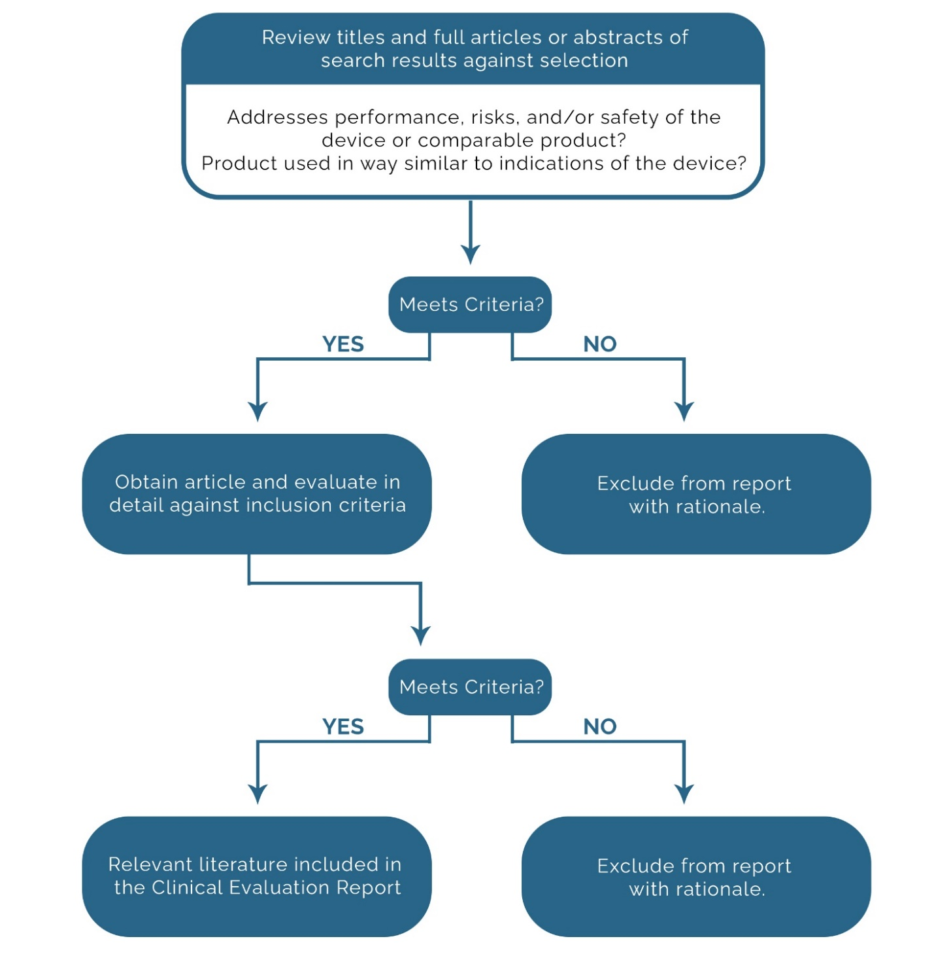

Figure 1 Citation Assessment Flowchart

# Stage 2 – Full Text Review and Data Extraction

## Clinical Literature Appraisal Plan

The following section outlines the criteria for suitability and data contribution used to appraise the literature to be included in this clinical evaluation (adapted from MEDDEV 2.7/1, Rev.4).

## Clinical Literature Analysis Plan

Citations selected for in-depth review are qualitatively summarized to include:

* An overall study evaluation
* A transformation table of evaluation criteria is included in Tables 2 and 3.
* An in-depth analysis of the citation
* Comprehensive Summary to include:
  + Reported Safety Data
  + New identified Risks
  + Performance Benefits/Issues

## Overview of Extraction Process

1. Determine if the article is relevant to the state-of-the-art (SoTA) or the target device
2. Complete Extraction Fields based on either SoTA or target device.

## Suitability Criteria – State of the Art

SoTA Suitability Criteria only applies to articles in the State-of-the-Art Search.

Table 1 Criteria for State of the Art

|  |  |
| --- | --- |
| Criteria | Description |
| CK0 | No SoTA information. |
| CK1 | Establishment of current knowledge/ the state of the art on the medical condition |
| CK2 | Establishment of current knowledge/ the state of the art on alternative therapies/treatments |
| CK3 | Determination and justification of criteria for the evaluation of the risk/benefit relationship |
| CK4 | Determination and justification of criteria for the evaluation of acceptability of undesirable side-effects |
| CK5 | Determination of equivalence |
| CK6 | Justification of the validity of surrogate endpoints |

## Suitability, Contribution, and Acceptability Criteria – Device

Suitability, contribution, and acceptability criteria apply to all articles in the safety/performance search.

Table 2 Criteria for Data Suitability

|  |  |  |
| --- | --- | --- |
| Contribution Criteria | Description | Grading System |
| Appropriate device | Were the data generated from the device in question? | D1 Actual device  D2 Comparable device  D3 Other devices |
| Appropriate device application | Was the device used for the same intended use (e.g., methods of deployment, application, etc.)? | A1 Same use  A2 Minor deviation  A3 Major deviation |
| Appropriate patient group | Were the data generated from a patient group that is representative of the intended treatment population (e.g., age, sex, etc.) and clinical condition (i.e., disease, including state and severity)? | P1 Applicable  P2 Limited  P3 Different |
| Acceptable report/data collation | Do the reports or collations of data contain sufficient information to be able to undertake a rational and objective assessment? | R1 High quality  R2 Minor deficiencies  R3 Insufficient information |

Table 3 Criteria for Data Contribution

|  |  |  |
| --- | --- | --- |
| Accountability Level | Description | Grading |
| Data source type | Was the design of the study appropriate? | T1 Yes  T2 No |
| Outcome measures | Do the outcome measures reported reflect the intended performance of the device? | O1 Yes  O2 No |
| Appropriate follow-up | Is the duration of follow-up long enough to assess treatment effects and identify complications? | F1 Yes  F2 No |
| Statistical significance | Has a statistical analysis of the data been provided and is it appropriate? | S1 Yes  S2 No |
| Clinical significance | Was the magnitude of the treatment effect observed clinically significant? | C1 Yes  C2 No |

## Long-Form Extraction Fields

This section will contain all the relevant information extracted from the articles to support the specific category.

Table 4 Extracted Data from Retained Articles

| S. No | Bibliography | Study design/Objective | Treatment Modality/ Indication/Comparator | Study Result/Conclusion |
| --- | --- | --- | --- | --- |
|  | **Citation**  **Data Suitability**  Dx, Ax, Px, Rx  **Data Contribution**  Tx, Ox, Fx, Sx, Cx  **MDCG Ranking**  Rank x | **Study Design**  **Patients**  **Objective** | **Indication**  **Device:** | **Performance outcomes:**  **Safety outcomes:**  **Conclusion:** |

## Grade MDCG Ranking Table

MDCG ranking is assessed for every retained citation pertaining to the Target Device OR target device and similar devices [modify according to the scope of the project]. The steps for determining the GRADE score are as follows.

Table 5 MDCG Ranking Table

|  |  |  |
| --- | --- | --- |
| Rank | Types of clinical data and evidence | Considerations / comments |
| 1 | Results of high-quality clinical investigations covering all device variants, indications, patient populations, duration of treatment effect, etc. | This may not feasible or necessary for certain well-established devices with broad indications (eg Class IIb legacy sutures, which could be used in every conceivable patient population) |
| 2 | Results of high-quality clinical investigations with some gaps | Gaps must be justified / addressed with other evidence in line with an appropriate risk assessment, and clinical safety, performance, benefit and device claims. Assuming the gaps can be justified, there should be an appropriate PMCF plan to address residual risks. Otherwise, manufacturers shall narrow the intended purpose of the device until sufficient clinical data has also been generated. |
| 3 | Outcomes from high quality clinical data collection systems such as registries | Is there sufficient evidence of the quality of the data collected by the registry? Are the devices adequately represented? Are the data appropriately stratified? Are the endpoints appropriate to the safety, performances and endpoints identified in the clinical evaluation plan? |
| 4 | Outcomes from studies with potential methodological flaws but where data can still be quantified and acceptability justified | Many literature sources fall into this category, due to limitations such as missing information, publication bias, time lag bias, etc. This applies equally to publications in the peer-reviewed scientific literature. However, for legacy devices where no safety or performance concerns have been identified, these sources can be sufficient for confirmation of conformity to the relevant GSPRs if appropriately appraised and the gaps are identified and handled. High quality surveys may also fall into this category. |
| 5 | Equivalence data (reliable / quantifiable) | Equivalence must meet MDR criteria. It is normally expected that manufacturers should gather data on their own devices in the post-market phase, therefore reliance on equivalence should be duly justified, and linked to appropriate PMCF or proactive PMS. |
| 6 | Evaluation of state of the art, including evaluation of clinical data from similar devices as defined in Section 1.2 of 'MDCG 2020-6' | This is not considered clinical data under the MDR, but for well-established technologies only can be considered supportive of confirmation of conformity to the relevant GSPRs. Data from similar devices may be also important to establish whether the device under evaluation and similar devices belong to the group of devices considered as “well established technologies” (WET). See section 1.2 in 'MDCG 2020-6' for the criteria for WET. Data from similar devices may be used, for example, to demonstrate ubiquity of design, lack of novelty, known safety and performance profile of a generic group of devices, etc. |
| 7 | Complaints and vigilance data; curated data | data; curated data This falls within the definition of clinical data under MDR Article 2(48), but is not generally considered a high-quality source of data due to limitations in reporting. It may be useful for identifying safety trends or performance issues. High volume data collected within a robust quality system may provide supportive evidence of device safety. |
| 8 | Proactive PMS data, such as that derived from surveys | This falls within the definition of clinical data under MDR Article 2(48), but is not generally considered a high-quality source of data due limitations associated with sources of bias and quality of data collection. It may be useful for Page 22 of 22 identifying safety concerns or performance issues. |
| 9 | Individual case reports on the subject device | This falls within the definition of clinical data under MDR Article 2(48), but is not considered a high-quality source of data due to limitations in generalizing findings to a wider patient population, reporting bias, etc. It may provide supportive or illustrative information with respect to specific claims. |
| 10 | Compliance to non-clinical elements of common specifications considered relevant to device safety and performance | Common specifications which address clinical investigation or data requirements directly would rank higher in this hierarchy. Common specifications may address clinically relevant endpoints through non-clinical evidence such as mechanical testing for strength and endurance, biological safety, usability, etc. |
| 11 | Simulated use / animal / cadaveric testing involving healthcare professionals or other end users | This is not clinical data, but may be considered evidence of confirmation of conformity to relevant GSPRs, particularly in terms of usability, such as for accessories or instruments. |
| 12 | Pre-clinical and bench testing / compliance to standards | Pre-clinical and bench testing may address clinically relevant endpoints through non-clinical evidence such as mechanical testing for strength and endurance, biological safety, usability, etc. |

# Scientific Databases

{%p for database in lit_search_databases %}

## {{ database.name }}

{{ database.url }}

### Search Strategy

The following filters are to be applied in the search:

* Publication dates: Starting from {{ start_lit_date_of_search }} to {{ lit_date_of_search }}

{%p for item in database.search_strategy %}

* {{ item }}

{%p endfor %}

### Search Terms

{%p for term in database.terms %}

* {{ term }}

{%p endfor %}

{%p endfor %}

# Adverse Event Databases / Recalls

{%p for database in ae_databases %}

## {{ database.name}}

{{ database.url }}

### Date Range

Starting from {{ ae_start_date_of_search }} to {{ae_date_of_search}}.

### Search Strategy

{%p for strategy in database.search_strategy %}

{{ strategy }}

{%p endfor %}

### Search Terms

{%p for term in database.terms %}

* {{ term }}

{%p endfor %}

{%p endfor %}

# Search Verification

All search results shall be exported from each relevant Database and included via Zip file for verification purposes.

An extensive verification process shall be conducted to ensure the validity of all search results. Results shall be validated on an individual search basis and shall be recorded in such a way that any other party could easily duplicate results.

All searches are conducted on 3rd party databases that are subject to change in their literature availability. We are not responsible for future changes/modifications to a public database that could affect previously conducted searches.

Table 6 Summary of Search Verification of Scientific Databases

|  |  |  |  |
| --- | --- | --- | --- |
| Scientific Databases | Searches Verified  Yes / No | Method of Verification | Backup Files |
| {%tr for database in lit_search_databases %} |  |  |  |
| {{ database[‘name’] }} | Yes | Export Files and Exact Search URL | Full Results Attached (Zip File) |
| {%tr endfor %} |  |  |  |

# Acknowledgment and Agreement

SEARCH PERFORMED AND WRITTEN

By:

Name: {{ preparer }}

Title: Medical Writer (CV Attached)

Date:

**CITE MEDICAL, LLC**

By:

Name: {{ preparer }}

Title: Medical Writer (CV Attached)

Date:

**{{ company_name }}**

By: ____________________________________

Name:

Title:

Date: