LITERATURE SEARCH PROTOCOL

**{{ device_name }}**

**Prepared Exclusively For**

**{{ company_name }}**

{{ company_address }}

**Prepared By**

{{ preparer }}

**Date**

{{ prepared_date }}

LITERATURE SEARCH

PROTOCOL

Table of Contents

**Insert Table of Contents Here After Document Is Generated**

# Literature Search Methodology and Selection Criteria

This review of published clinical data further provides support for the clinical evaluation of the {{ device_name }}.

## Scope

The scope of the literature search includes a query of select adverse event report databases as well as scientific databases within the timeframe spanning from {{start_lit_date_of_search}} to {{ lit_date_of_search }}. This period of time is felt to provide sufficient clinical experience with these devices from both a safety and performance perspective. Performance assessments include reports designed to {{ scope }}

## Date of Search

{{ lit_date_of_search }}

## Name of Person(s) Undertaking Search

{{preparer}}

## Period Covered by Search

Starting From {{start_lit_date_of_search}} to {{ lit_date_of_search }}.

## Scientific Databases

{%p for database in lit_search_databases %}

### {{ database.name }}

{{ database.description }}

{%p endfor %}

## Adverse Event Databases

{%p for database in ae_databases %}

* {{ database.name}}

{%p endfor %}

## Database Search Details

Because different databases offer different limiting options and search fields, different approaches were taken appropriate to the database. All unique circumstances are identified in the final report. All searches are performed through online databases.

# Handling of Duplicate Literature References

Duplicate citations found in the search results of the databases are screened and removed prior to any review. The duplicate counts are captured in the final review and summarized in search-term tables.

## How Duplicates Are Identified?

A duplicate citation is identified through electronic signatures based on a match in one of the following fields of information across the databases.

* PubMed Unique Identifier
* PubMed Central Unique Identifier
* Cochrane Library Unique Identifier
* Embase Library Unique Identifier
* Academic Citation (in APA format)

# Stage 1 – Abstract Review

## Selection Criteria

The following criteria is used to assess the suitability of material (articles, reports, etc.) for inclusion/exclusion in the analysis stage of the report.

## Inclusion Criteria

* Citation addresses performance, risks, and/or safety of the {{ device_name }} Device or similar device.
* Products are used in ways like indications for use of the {{ device_name }}Device products.
* Any articles considered relevant to the state of the art/current knowledge as well as similar devices identified during this search will be included in the state-of-the-art section.

## Exclusion Criteria

{%p for item in exclusion_reasons %}

* {{ item }}

{%p endfor %}

## Outputs

All literature citations selected for inclusion are listed as References.

## Data Selection Process

Figure 1 visually outlines the process used in assessing citations retrieved from queries of online databases for suitability for inclusion in the clinical evaluation report.

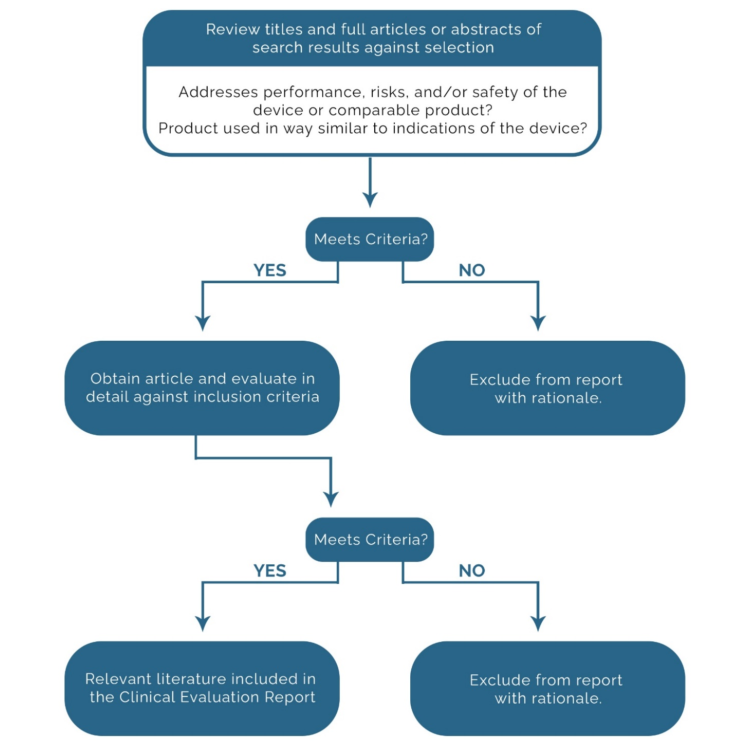

Figure 1 Citation Assessment Flowchart

# Stage 2 – Full Text Review and Data Extraction

## Clinical Literature Appraisal Plan

The following section outlines the criteria for suitability and data contribution used to appraise the literature to be included in this clinical evaluation (adapted from MEDDEV 2.7/1, Rev.4).

## Clinical Literature Analysis Plan

Citations selected for in-depth review are qualitatively summarized to include:

* An overall study evaluation
* A transformation table of evaluation criteria is included in Tables 2 and 3.
* An in-depth analysis of the citation
* Comprehensive Summary to include:
  + Reported Safety Data
  + New identified Risks
  + Performance Benefits/Issues

## Overview of Extraction Process

1. Determine if the article is relevant to the state-of-the-art (SoTA) or the target device
2. Complete Extraction Fields based on either SoTA or target device.

## Suitability Criteria – State of the Art

SoTA Suitability Criteria only applies to articles in the State-of-the-Art Search.

Table 1 Criteria for State of the Art

|  |  |
| --- | --- |
| Criteria | Description |
| CK0 | No SoTA information. |
| CK1 | Establishment of current knowledge/ the state of the art on the medical condition |
| CK2 | Establishment of current knowledge/ the state of the art on alternative therapies/treatments |
| CK3 | Determination and justification of criteria for the evaluation of the risk/benefit relationship |
| CK4 | Determination and justification of criteria for the evaluation of acceptability of undesirable side-effects |
| CK5 | Determination of equivalence |
| CK6 | Justification of the validity of surrogate endpoints |

## Suitability, Contribution, and Acceptability Criteria – Device

Suitability, contribution, and acceptability criteria apply to all articles in the safety/performance search.

Table 2 Criteria for Data Suitability

|  |  |  |
| --- | --- | --- |
| Contribution Criteria | Description | Grading System |
| Appropriate device | Were the data generated from the device in question? | D1 Actual device  D2 Comparable device  D3 Other devices |
| Appropriate device application | Was the device used for the same intended use (e.g., methods of deployment, application, etc.)? | A1 Same use  A2 Minor deviation  A3 Major deviation |
| Appropriate patient group | Were the data generated from a patient group that is representative of the intended treatment population (e.g., age, sex, etc.) and clinical condition (i.e., disease, including state and severity)? | P1 Applicable  P2 Limited  P3 Different |
| Acceptable report/data collation | Do the reports or collations of data contain sufficient information to be able to undertake a rational and objective assessment? | R1 High quality  R2 Minor deficiencies  R3 Insufficient information |

Table 3 Criteria for Data Contribution

|  |  |  |
| --- | --- | --- |
| Accountability Level | Description | Grading |
| Data source type | Was the design of the study appropriate? | T1 Yes  T2 No |
| Outcome measures | Do the outcome measures reported reflect the intended performance of the device? | O1 Yes  O2 No |
| Appropriate follow-up | Is the duration of follow-up long enough to assess treatment effects and identify complications? | F1 Yes  F2 No |
| Statistical significance | Has a statistical analysis of the data been provided and is it appropriate? | S1 Yes  S2 No |
| Clinical significance | Was the magnitude of the treatment effect observed clinically significant? | C1 Yes  C2 No |

## Long-Form Extraction Fields

This section will contain all the relevant information extracted from the articles to support the specific category.

Table 4 Extracted Data from Retained Articles

| S. No | Bibliography | Study design/Objective | Treatment Modality/ Indication/Comparator | Study Result/Conclusion |
| --- | --- | --- | --- | --- |
|  | **Citation**  **Data Suitability**  Dx, Ax, Px, Rx  **Data Contribution**  Tx, Ox, Fx, Sx, Cx  **MDCG Ranking**  Rank x | {%p for field in extraction_fields %}  {%p if field.category == “ST” %}  **{{field.name}}**  {%p endif %}  {%p endfor %} | {%p for field in extraction_fields %}  {%p if field.category == “T” %}  **{{field.name}}**  {%p endif %}  {%p endfor %} | {%p for field in extraction_fields %}  {%p if field.category == “SR” %}  **{{field.name}}**  {%p endif %}  {%p endfor %} |

# Scientific Databases

{%p for database in lit_search_databases %}

## {{ database.name }}

{{ database.url }}

### Search Strategy

The following filters are to be applied in the search:

* Publication dates: Starting from {{ start_lit_date_of_search }} to {{ lit_date_of_search }}

{%p for item in database.search_strategy %}

* {{ item }}

{%p endfor %}

### Search Terms

{%p for term in database.terms %}

* {{ term }}

{%p endfor %}

{%p endfor %}

# Adverse Event Databases / Recalls

{%p for database in ae_databases %}

## {{ database.name}}

{{ database.url }}

### Date Range

Starting from {{ ae_start_date_of_search }} to {{ae_date_of_search}}.

### Search Strategy

{%p for strategy in database.search_strategy %}

{{ strategy }}

{%p endfor %}

### Search Terms

{%p for term in database.terms %}

* {{ term }}

{%p endfor %}

{%p endfor %}

# Search Verification

All search results shall be exported from each relevant Database and included via Zip file for verification purposes.

An extensive verification process shall be conducted to ensure the validity of all search results. Results shall be validated on an individual search basis and shall be recorded in such a way that any other party could easily duplicate results.

All searches are conducted on 3rd party databases that are subject to change in their literature availability. We are not responsible for future changes/modifications to a public database that could affect previously conducted searches.

Table 6 Summary of Search Verification of Scientific Databases

|  |  |  |  |
| --- | --- | --- | --- |
| Scientific Databases | Searches Verified  Yes / No | Method of Verification | Backup Files |
| {%tr for database in lit_search_databases %} |  |  |  |
| {{ database[‘name’] }} | Yes | Export Files and Exact Search URL | Full Results Attached (Zip File) |
| {%tr endfor %} |  |  |  |