**Project Report: Robot Control Interface with Node.js and SQLite**

**Introduction**

This project involves the development of a web-based interface to control a robot. The interface allows users to send directional commands (e.g., forward, backward, left, right) and a "Stop" command to the robot. The commands are stored in an SQLite database using a Node.js backend.

**Step 1: Installing Node.js**

**1.1. Download Node.js**

1. Visit - <https://nodejs.org/en> - the Node.js official website.
2. Download the latest LTS (Long-Term Support) version of Node.js suitable for your operating system.

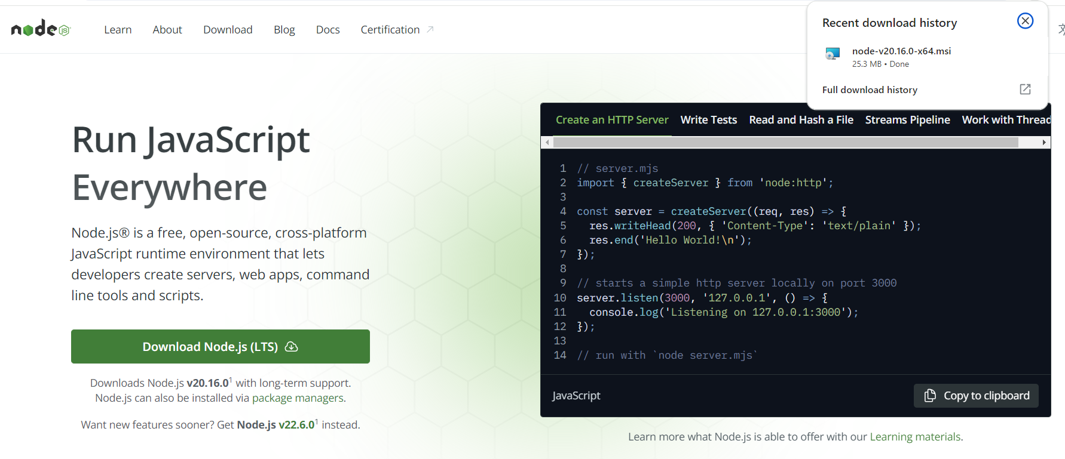

**1.2. Install Node.js**

1. Run the downloaded installer and follow the installation prompts.
2. Accept the license agreement, choose the installation directory, and proceed with the installation.

**1.3. Verify Node.js Installation**

1. Open a command prompt.
2. Type the following commands to verify that Node.js and npm (Node Package Manager) are installed:

**node --version**

**npm --version**

**Step 2: Project Setup**

**2.1. Create the Project Directory**

1. Open the terminal or command prompt.
2. Navigate to the location where you want to create your project.
3. Run the following commands to create a new directory and initialize a Node.js project

**npm init -y**

now you should see this output from package.json file  
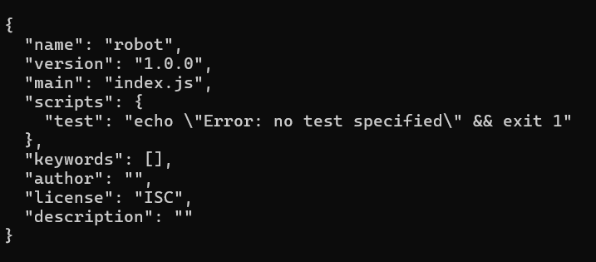

as well, you should see the file in the creation directory  


**2.2. Install Required Packages**

Install the necessary Node.js packages, including Express (for handling HTTP requests) and SQLite3 (for database management).

1. Run the following commands to install the packages

**npm install express sqlite3**

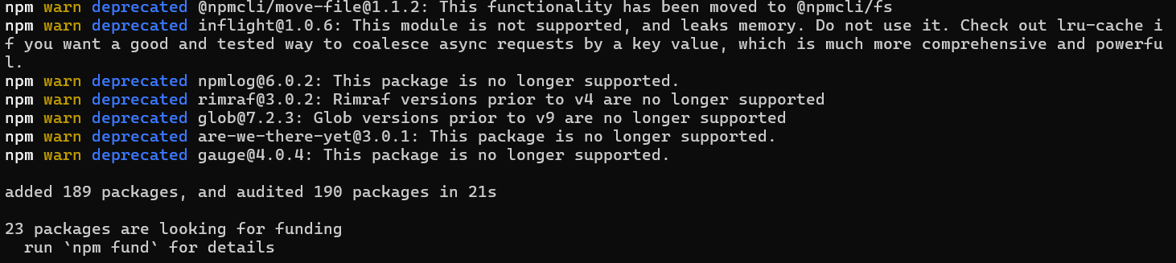

**Step 3: Server Setup**

**3.1. Creating the server.js File**

1. Creating a file named server.js.
2. Creating a code to handle HTTP requests, serve static files, and interact with the SQLite database:

Here is my server.js code

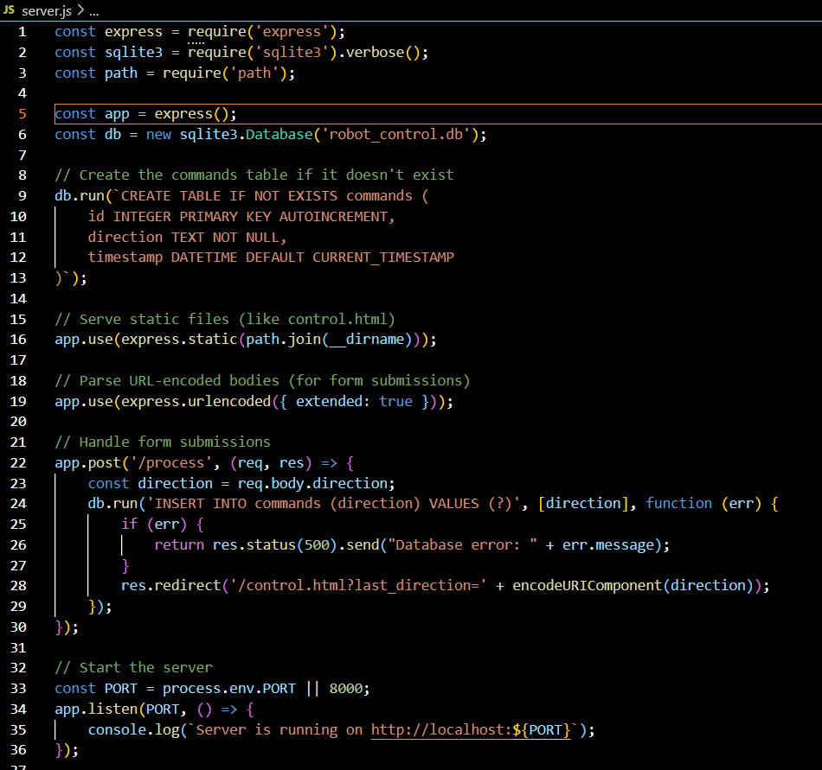

**Step 4: Creating the User Interface**

**4.1. Creating the control.html File**

1. Creating a file named control.html.
2. Creating HTML code to create a web interface for controlling the robot.

Here is my HTML code:

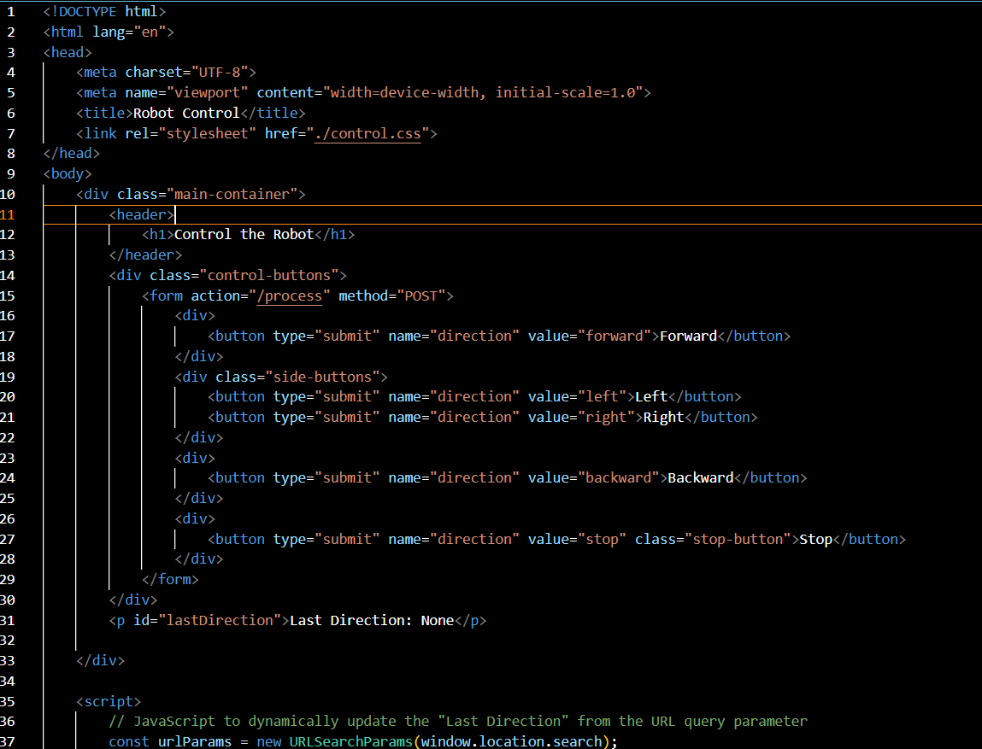

**Step 4: Styling the User Interface**

**4.1. Creating control.css File**

1. Creating a file named control.css.
2. Creating CSS code to Style the web interface for controlling the robot.

Here is my CSS code:

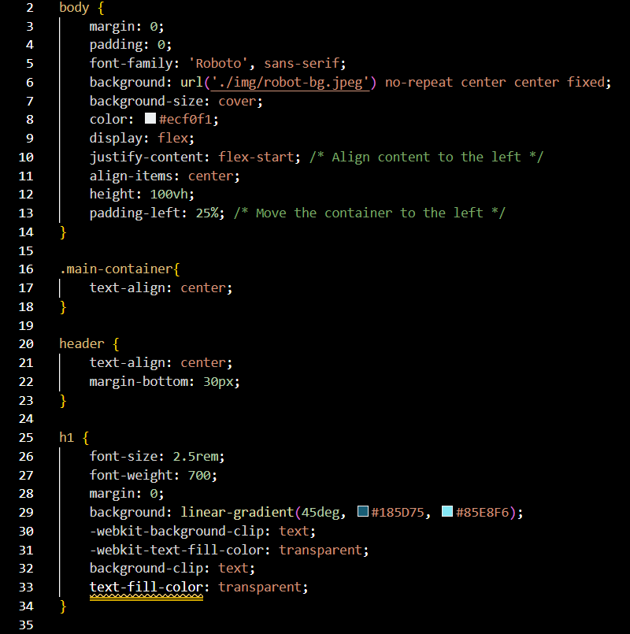

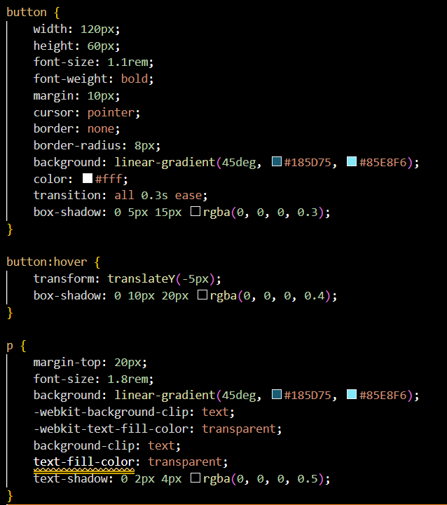

**Step 5: Running the Application**

**5.1. Start the Server**

1. Run the Node.js server by executing the following command

**node server.js**

The server will start and listen on port 8000.



**5.2. Access the Interface**

1. Open your web browser and navigate to http://localhost:8000/control.html.
2. Use the interface to send commands to the robot.

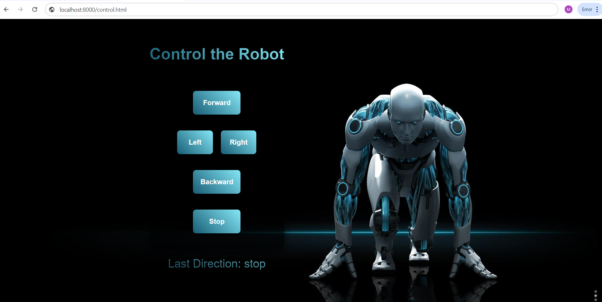

**Step 6: Viewing the Database Content**

**6.1. Using an SQLite Viewer Extension in VS Code**

1. Install the SQLite Viewer extension in VS Code.

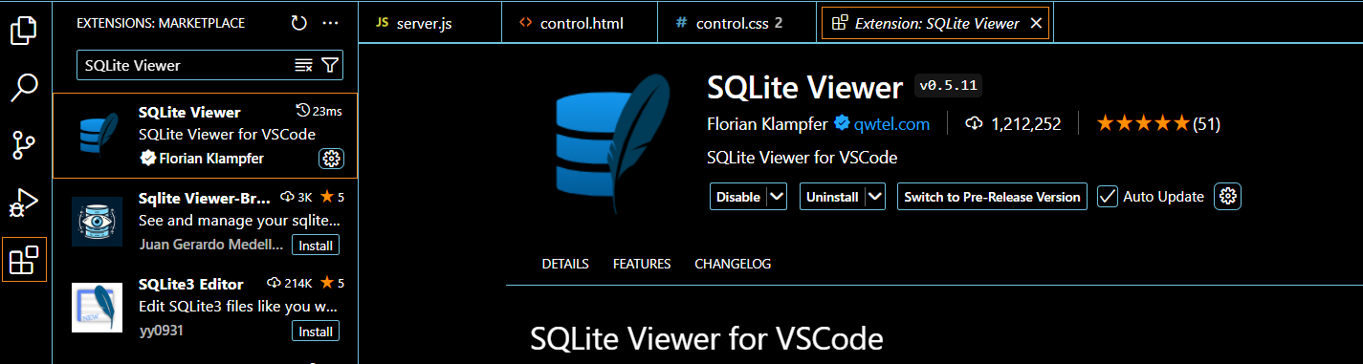

1. Open the robot_control.db file.
2. Browse the commands table to see the logged commands.

