Production SN5600 Fabric Beginner Operations and Handover Guide
Five rack production environment with four active leaves four spines forty clients and routed point to point links
Field | Value
Audience | A new network operator, systems administrator, or on-call engineer with limited prior knowledge of this environment
Purpose | Explain what exists, how traffic moves, how to validate it, how to change it safely, and what work remains
Status date | Operational evidence captured 29 September 2026; guide prepared 30 September 2026
Environment | Real production environment
Credentials | Not included. Obtain access through the approved operational process
Overall state | Forwarding and jumbo reachability are working, but the fabric is degraded because 10 of 128 underlay sessions are missing and one configured client path is down

What the next operator must know. Do not make a broad configuration change to correct a single failed cable or session. Capture both endpoints, repair one pair, and validate the whole fabric before continuing.
Source of truth. Use live applied device state first, followed by the numbered underlay plan, the client mapping workbook, the latest validation logs, and only then older design material. The five-page PDF supplied with this guide is a historical design reference and contains older proposed-state wording.
Prepared for WEKA infrastructure and network operations
Prepared by Chandra Sekhar Gonuguntla with applied-state rollout evidence

Start here
This guide is written so that a person who has never worked on this fabric can understand the physical layout, the addressing pattern, the validation process, and the boundaries of safe work.
The current network carries traffic, and every active switch loopback passed a 9000-byte probe in the saved validation. It is not yet in the desired fully redundant state. Treat every missing link and every deferred host as open work, not as an invitation to recreate the full configuration.

First five actions for a new operator
1. Read the current status and open issues before logging in to a device.
2. Confirm which switch or server you are on by checking hostname and management IP. Several switch names were remapped while their router IDs were intentionally retained.
3. Run read-only checks and save the output before moving a cable or changing a candidate configuration.
4. Change one physical pair or one host at a time. Validate direct reachability, BGP, jumbo MTU, and the whole fabric after each change.
5. Record the result in the issue register and hand it to the next shift, even if the repair was unsuccessful.

How to find information in this guide
Need | Read
Understand the network | Sections 1 through 4
Find a switch or rack | Sections 2 and 5
Understand the IP pattern | Section 3
Check current health | Section 4 and the issue register
Apply a planned change | Sections 6 and 7
Troubleshoot a failure | Sections 8 and 9
Recover or roll back | Section 11
Look up an exact port or IP | Appendices B through D

Change safety rules
- Keep an independent management path. For servers, confirm BMC access before changing Netplan. For switches, use the management VRF or console path.
- Do not paste a generated Netplan file from one server onto another. Interface names and MAC addresses are host-specific.
- Do not stage overlapping NVUE candidates from multiple operator sessions.
- Do not change leaf-05, spine ports swp33 through swp40, or reserved address space during work on the active eight-switch fabric.
- Do not declare RoCE ready from ping tests alone. RoCE acceptance requires lossless configuration checks and sustained RDMA traffic evidence.

1 Network concepts for a beginner
The network is a two-tier leaf-spine fabric. Servers connect to leaf switches. Every active leaf connects to every spine. Spines provide the middle hop between racks.
There are no active leaf-to-leaf data cables and no spine-to-spine data cables in this design. A packet between two different racks normally travels server to leaf to spine to leaf to server.
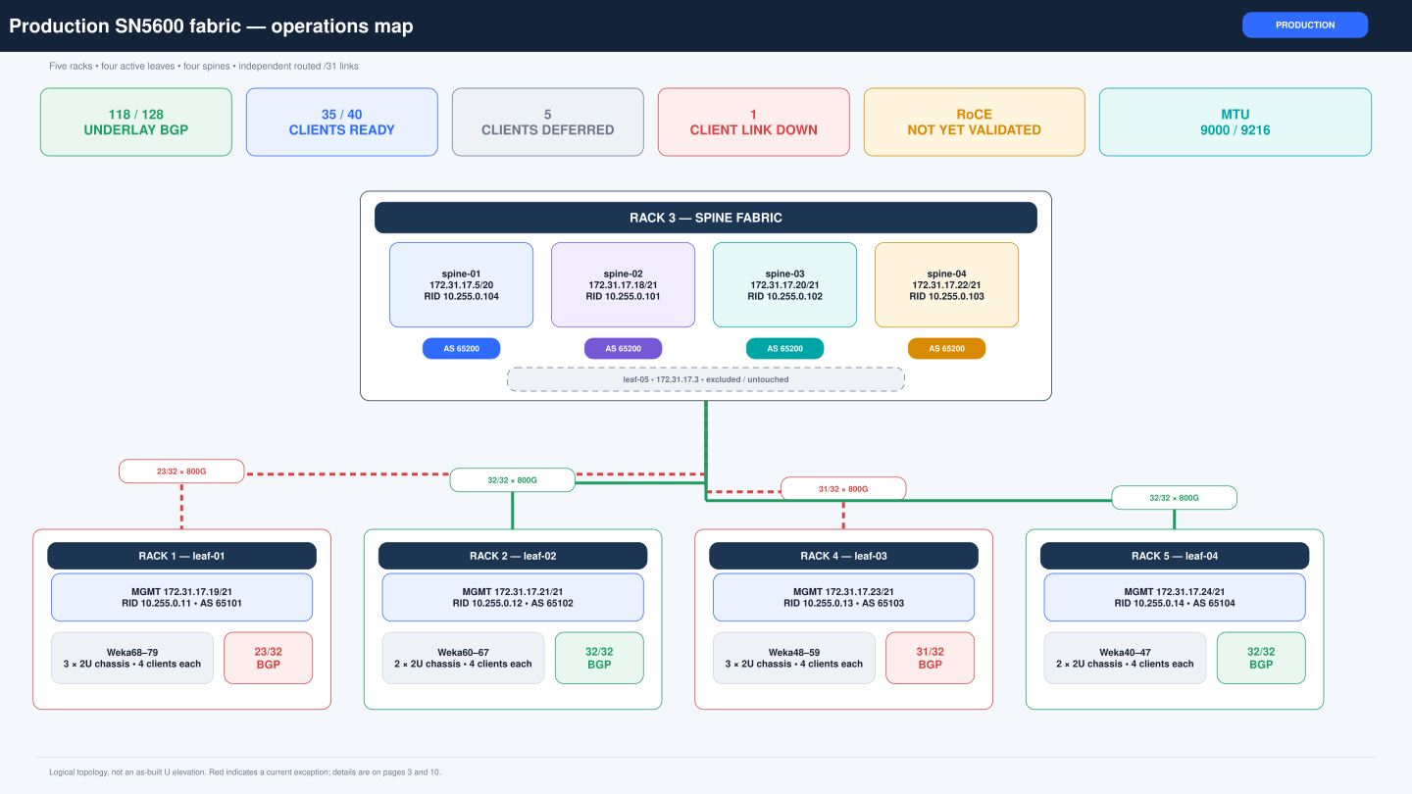
Figure 1 Production fabric operations map showing the four active leaves four spines and current scope

Device roles
Term | Plain language meaning | This environment
Leaf | The switch that directly connects servers in a rack | leaf-01 through leaf-04 are active; leaf-05 is reserved
Spine | A high-capacity transit switch between leaves | spine-01 through spine-04
Client | A server using the routed data network | weka40 through weka79, with five currently deferred
Management network | The network used for SSH and administration | Switches use 172.31.17.x; servers use 172.31.18.x; BMC uses 172.31.16.x
Loopback | A stable IP that identifies a switch in routing | Leaves use 10.255.0.11 through .14; spines retain 10.255.0.101 through .104
Underlay | The routed links between leaves and spines | 10.254.0.0/24 divided into 128 /31 links
Client edge | The routed links between a server and its leaf | Two /31 links per configured client in 10.200.0.0/16
BGP | The routing protocol that tells switches which networks can be reached through which neighbor | eBGP runs over every active leaf-spine /31
ECMP | Using multiple equal-cost paths at the same time | Healthy leaves can use many parallel spine links

Why the design has many parallel links
Each active leaf has eight 800G links to each of four spines. That is 32 fabric links per leaf and 128 links in total. Parallel links provide capacity and resilience. Losing one link should not stop traffic when other routes remain, but it reduces redundancy and can hide a marginal cable problem until more links fail.

What a successful ping proves
A successful ping proves reachability for the path selected by that flow at that moment. It does not prove that every ECMP member is healthy. A complete health decision also needs BGP counts, link speed, FEC state, error counters, and sustained traffic with enough flow variation to exercise multiple paths.

What common status words mean
Status | Beginner interpretation | What to do next
Admin up | The configuration allows the port to operate | Also check operational state; admin up alone does not prove a cable works
Oper up | The physical link trained successfully | Confirm expected speed, RS-FEC, LLDP, counters, and routing
Oper down | The physical link is not carrying traffic | Check both endpoints, cable, module, negotiation, FEC, and port mapping
BGP Established | The two routed endpoints formed a routing session | Confirm learned routes and that the total session count did not regress
BGP Idle | The routing session is not active | First verify link state, /31 addresses, peer address, ASN, and interface route
Degraded | Traffic may work, but redundancy or capacity is reduced | Keep the exception visible and repair one pair at a time
Deferred | Reserved in the plan but not yet configured | Rescan port, MAC, interface name, and Ethernet mode before applying anything

2 Physical topology and inventory
The production environment uses five 48U racks. Client servers are grouped in 2U Supermicro chassis with four clients per chassis. The diagrams show logical placement because exact rack-unit positions have not been confirmed.
Rack 3 contains the spine layer and the reserved leaf-05. The active client racks are Rack 1, Rack 2, Rack 4, and Rack 5.
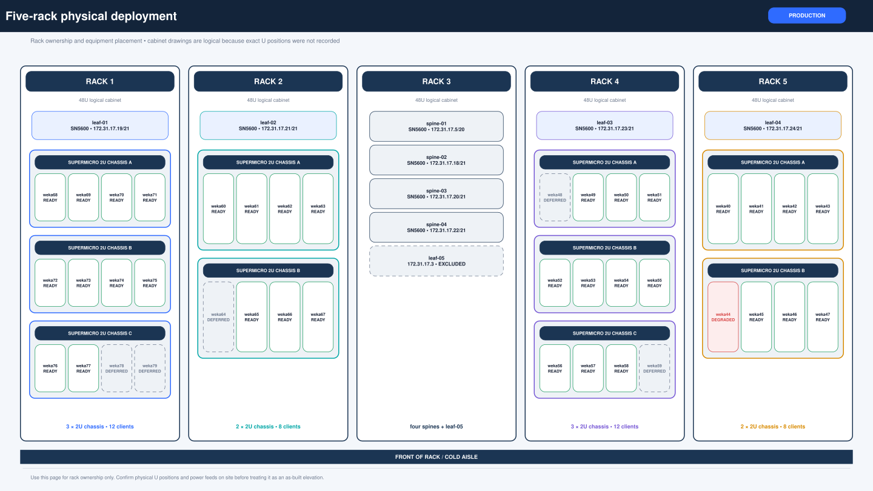
Figure 2 Five rack physical deployment with 2U four-node Supermicro chassis groups

Rack layout
Rack | Network equipment | Server groups | Notes
Rack 1 | leaf-01 | Chassis A weka68-71; B weka72-75; C weka76-79 | 12 clients; weka78 and weka79 deferred
Rack 2 | leaf-02 | Chassis A weka60-63; B weka64-67 | 8 clients; weka64 deferred
Rack 3 | spine-01 through spine-04 and leaf-05 | None in the current client plan | leaf-05 is excluded and reserved
Rack 4 | leaf-03 | Chassis A weka48-51; B weka52-55; C weka56-59 | 12 clients; weka48 and weka59 deferred
Rack 5 | leaf-04 | Chassis A weka40-43; B weka44-47 | 8 clients; weka44 path 1 is down

Rack-unit warning. The rack diagrams are logical layouts. Do not use them as proof of exact U positions until a physical rack audit records those positions.

Active switch inventory
Hostname | Management | Loopback or router ID | ASN | Rack | State
spine-01 | 172.31.17.5/20 | 10.255.0.104 | 65200 | Rack 3 | Active; physical role remap
spine-02 | 172.31.17.18/21 | 10.255.0.101 | 65200 | Rack 3 | Active; physical role remap
spine-03 | 172.31.17.20/21 | 10.255.0.102 | 65200 | Rack 3 | Active; physical role remap
spine-04 | 172.31.17.22/21 | 10.255.0.103 | 65200 | Rack 3 | Active; physical role remap
leaf-01 | 172.31.17.19/21 | 10.255.0.11 | 65101 | Rack 1 | Active
leaf-02 | 172.31.17.21/21 | 10.255.0.12 | 65102 | Rack 2 | Active
leaf-03 | 172.31.17.23/21 | 10.255.0.13 | 65103 | Rack 4 | Active
leaf-04 | 172.31.17.24/21 | 10.255.0.14 | 65104 | Rack 5 | Active; fiber client rack
leaf-05 | 172.31.17.3 | Not assigned in active plan | Not assigned | Rack 3 | Excluded and reserved

Important identity detail. The spine management addresses and router IDs do not follow the same order. This is intentional. Do not rename router IDs to match the last octet of the management IP during unrelated work.

Platform baseline
- NVIDIA SN5600 Spectrum-4 class switches running the Cumulus Linux 5.11.5 baseline used by the saved migration packages.
- Native 800G leaf-spine links. Healthy links negotiate 800G and use RS-FEC.
- Switch data-plane MTU 9216. Server data NIC MTU 9000.
- Management traffic is separate from the data plane and uses the management VRF on the switches.
- Client NICs are NVIDIA ConnectX-7 in Ethernet mode after conversion from InfiniBand where needed.

3 Addressing routing and traffic flow
The design uses numbered IPv4 /31 point-to-point links. A /31 contains exactly two addresses, so both addresses are usable endpoints and there is no separate broadcast address.
Leaf-spine links use 10.254.0.0/24. Server-facing links use 10.200.0.0/16. Management addressing is separate and must not be confused with either routed data-plane pool.
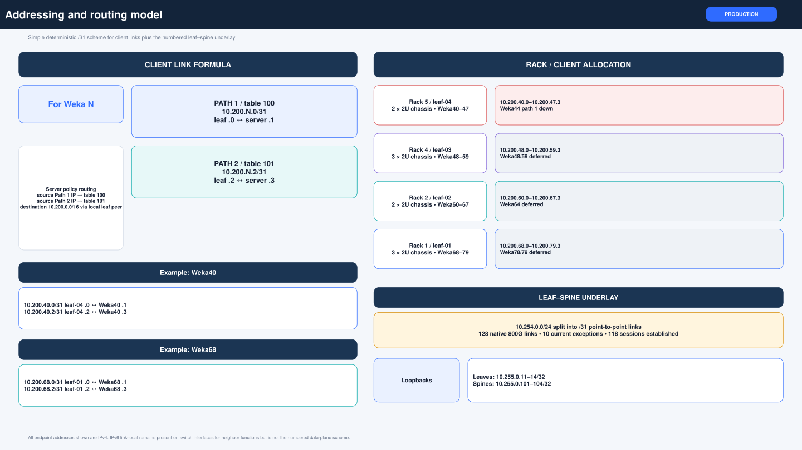
Figure 3 Addressing and routing model for switch underlay and server edge links

The three address types
Address type | Purpose | Example | Used by
Management | SSH, monitoring, file copy, and administration | leaf-02 172.31.17.21 | Operators and management tools
Loopback or router ID | Stable switch routing identity and reachability test target | leaf-02 10.255.0.12 | BGP and validation
Point-to-point /31 | The two endpoints of one physical routed link | 10.200.60.0 and 10.200.60.1 | Switch-to-switch or server-to-leaf traffic

Server /31 example
weka60 has two independent data paths. The first path is one /31 and the second path is another /31. They are adjacent in the address plan, but they are not one shared LAN.
Path | Leaf address | Server address | Server policy table | Source rule
Path 1 | 10.200.60.0/31 | 10.200.60.1/31 | 100 | from 10.200.60.1/32 priority 32764
Path 2 | 10.200.60.2/31 | 10.200.60.3/31 | 101 | from 10.200.60.3/32 priority 32765

Why policy routing is present. A server has two routed NICs. Source-policy rules keep traffic sourced from path 1 in table 100 and traffic sourced from path 2 in table 101. This provides predictable return-path behavior.

Leaf spine underlay rule
- The /31 networks are allocated sequentially from 10.254.0.0/24.
- The spine receives the even address and the leaf receives the odd address.
- Every underlay interface has IPv4 forwarding enabled and MTU 9216.
- Each /31 peer forms an eBGP session. Spines use ASN 65200; leaves use ASN 65101 through 65104.
- A healthy full fabric has 128 established sessions: 4 leaves x 4 spines x 8 links.

How a cross rack packet moves
1. A program on weka68 sends from 10.200.68.1. Linux policy rule 32764 selects routing table 100.
2. The server forwards the packet to leaf-01 at 10.200.68.0.
3. leaf-01 finds the destination /31 in BGP and chooses an available equal-cost spine next hop.
4. The selected spine forwards the packet to the leaf that owns the destination /31.
5. The destination leaf forwards directly to the destination server. The reply may use a different valid ECMP path.

IPv6 behavior
The migrated server data NIC files disable DHCPv6, router advertisements, and IPv6 link-local addressing on those two data NICs. Cumulus interfaces can still show IPv6 link-local addresses. Do not disable IPv6 globally on the switches because historical unnumbered rollback or reserved interfaces can depend on it.

MTU autonegotiation and FEC
Item | Healthy expectation | Why it matters
Server MTU | 9000 | Allows a 9000-byte IP packet including headers when tested with ping payload 8972
Switch MTU | 9216 | Provides headroom for the server jumbo frame and switch encapsulation
Leaf-spine speed | 800G | Confirms all eight lanes trained at the intended rate
Client speed | 200G or 400G as mapped | Depends on the ConnectX-7 and breakout assignment
Autonegotiation | On | Partners agree on supported mode
FEC | RS active on healthy high-speed links | Corrects bit errors and is part of link training

4 Current operational status
The latest saved consolidated evidence is from 29 September 2026. The fabric forwards jumbo traffic across racks, but the underlay is degraded and RoCE has not been accepted.
The correct operational posture is continue service with explicit exceptions, repair one fault domain at a time, and preserve before-and-after evidence.
Area | Observed state | Operational assessment
Leaf-spine underlay | 118 of 128 eBGP sessions established | Degraded; 10 parallel members missing
Switch loopback jumbo probes | All active switch loopback probes passed | Core routed reachability present
Client rollout | 35 of 40 clients configured | Five clients deferred
Configured client links | 69 of 70 links up | weka44 path 1 is down; path 2 works
Cross-rack jumbo | Representative path 1 and path 2 tests passed with 0 percent loss | Routing and MTU proven for tested hashes
RoCE | Preflight compatible; application and sustained RDMA acceptance not confirmed | Not ready for final sign-off

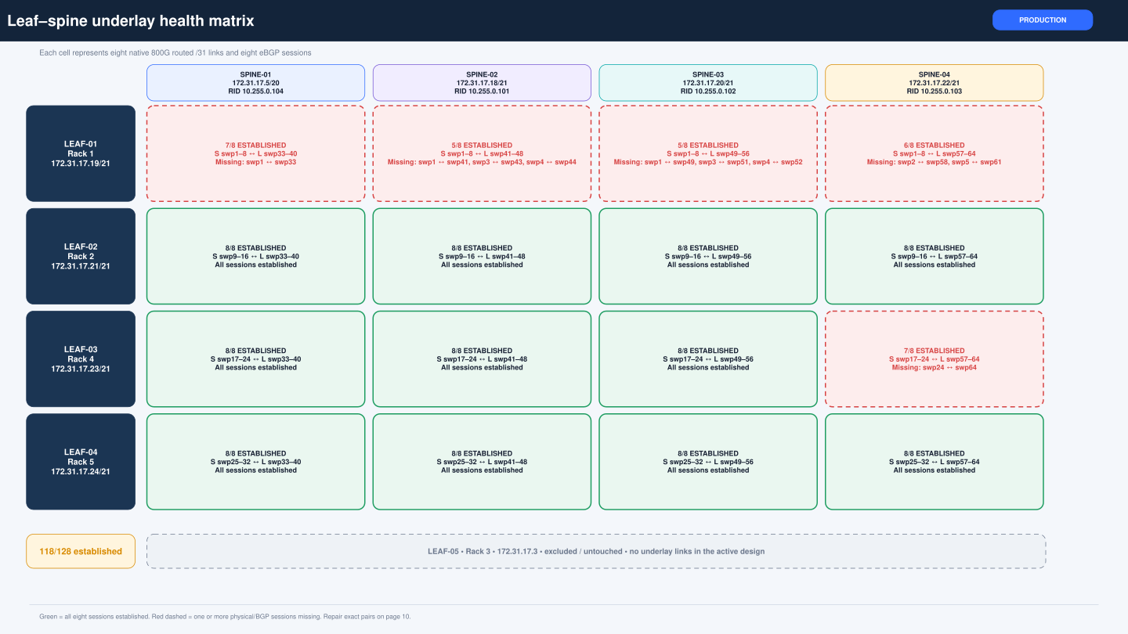
Figure 4 Leaf-spine underlay health matrix based on the saved 29 September validation

Current missing underlay pairs
Priority | Spine endpoint | Leaf endpoint | Network | Status
P2 | spine-01 swp1 | leaf-01 swp33 | 10.254.0.0/31 | Existing physical/session loss
P2 | spine-02 swp1 | leaf-01 swp41 | 10.254.0.16/31 | Existing physical/session loss
P1 | spine-02 swp3 | leaf-01 swp43 | 10.254.0.20/31 | New/intermittent in final run
P2 | spine-02 swp4 | leaf-01 swp44 | 10.254.0.22/31 | Existing physical/session loss
P2 | spine-03 swp1 | leaf-01 swp49 | 10.254.0.32/31 | Existing physical/session loss
P1 | spine-03 swp3 | leaf-01 swp51 | 10.254.0.36/31 | New failure in final run
P2 | spine-03 swp4 | leaf-01 swp52 | 10.254.0.38/31 | Existing physical/session loss
P2 | spine-04 swp2 | leaf-01 swp58 | 10.254.0.50/31 | Existing physical/session loss
P2 | spine-04 swp5 | leaf-01 swp61 | 10.254.0.56/31 | Existing physical/session loss
P2 | spine-04 swp24 | leaf-03 swp64 | 10.254.0.190/31 | Existing physical/session loss

Concentration of risk. Nine of the ten missing underlay pairs involve leaf-01. The missing spine-02 swp3 to leaf-01 swp43 and spine-03 swp3 to leaf-01 swp51 sessions were new in the final run and must be captured before a reseat.

Client edge by leaf
Leaf | Rack | Physical clients | Configured | Links up | Exception
leaf-01 | Rack 1 | weka68-79 | weka68-77 | 20/20 configured | weka78 and weka79 deferred
leaf-02 | Rack 2 | weka60-67 | weka60-63 and weka65-67 | 14/14 configured | weka64 deferred
leaf-03 | Rack 4 | weka48-59 | weka49-58 | 20/20 configured | weka48 and weka59 deferred
leaf-04 | Rack 5 | weka40-47 | weka40-47 | 15/16 configured | weka44 path 1 down

Deferred clients
Host | Rack | Leaf | Tentative parent port | Required action
weka48 | Rack 4 | leaf-03 | swp6 | Deferred: no observed server identity or active link; tentative parent swp6 requires rescan
weka59 | Rack 4 | leaf-03 | swp7 | Deferred: no observed server identity or active link; tentative parent swp7 requires rescan
weka64 | Rack 2 | leaf-02 | swp2 | Deferred by request; both observed leaf ports were down and the RDMA inventory scan was incomplete
weka78 | Rack 1 | leaf-01 | swp2 | Deferred by request; leaf ports were up but LLDP/server reachability did not identify the NICs
weka79 | Rack 1 | leaf-01 | swp1 | Deferred by request; physical LLDP was present but server NIC inventory was not collected

Deferred means not configured. The address pairs are reserved, but a host-specific configuration must not be applied until LLDP, link state, NIC mode, MAC address, and Linux interface name are verified again.

Cross rack validation evidence
Representative 9000-byte client tests passed in both source-policy paths between client racks. Examples include weka68 to weka40, weka68 to weka49 and weka60, weka49 to weka60, and weka60 to weka40. The tests showed 0 percent loss and sub-millisecond response time. These tests verify the selected flows; they do not exercise every ECMP member.
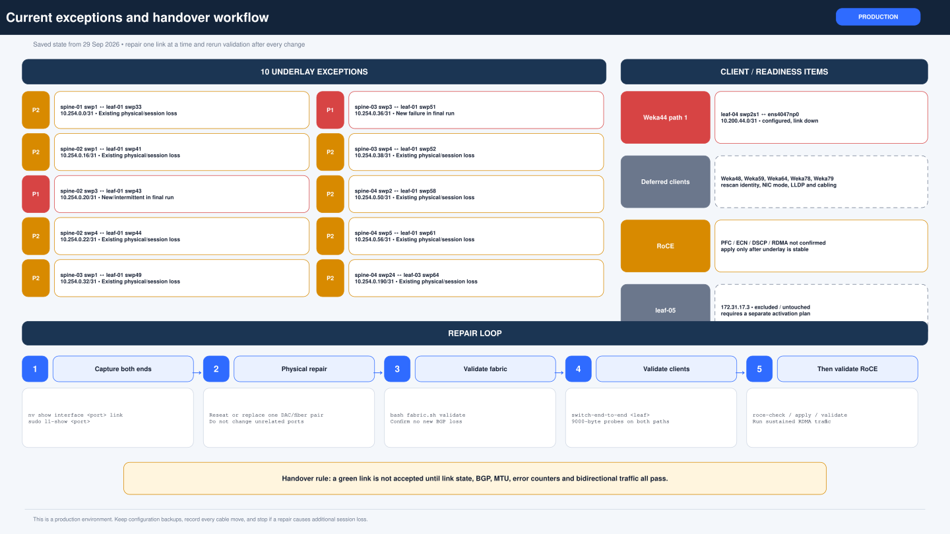
Figure 5 Current exceptions and the safe handover workflow

5 Physical cabling and client placement
Cabling is easiest to understand as repeated blocks. Each spine devotes one eight-port block to each active leaf. Each leaf devotes one eight-port block to each spine.
Server-facing ports are breakout interfaces on the lower-numbered physical ports. The exact client mapping is host-specific and is listed in Appendix C.

Leaf spine port block rule
Remote leaf | Spine port block | Leaf port block to spine-01 | to spine-02 | to spine-03 | to spine-04
leaf-01 | swp1-8 | swp33-40 | swp41-48 | swp49-56 | swp57-64
leaf-02 | swp9-16 | swp33-40 | swp41-48 | swp49-56 | swp57-64
leaf-03 | swp17-24 | swp33-40 | swp41-48 | swp49-56 | swp57-64
leaf-04 | swp25-32 | swp33-40 | swp41-48 | swp49-56 | swp57-64

Position numbers match inside a block. For example, spine-02 swp2 connects to the second port in leaf-01's spine-02 block, leaf-01 swp42. The full 128-link map is in Appendix D.
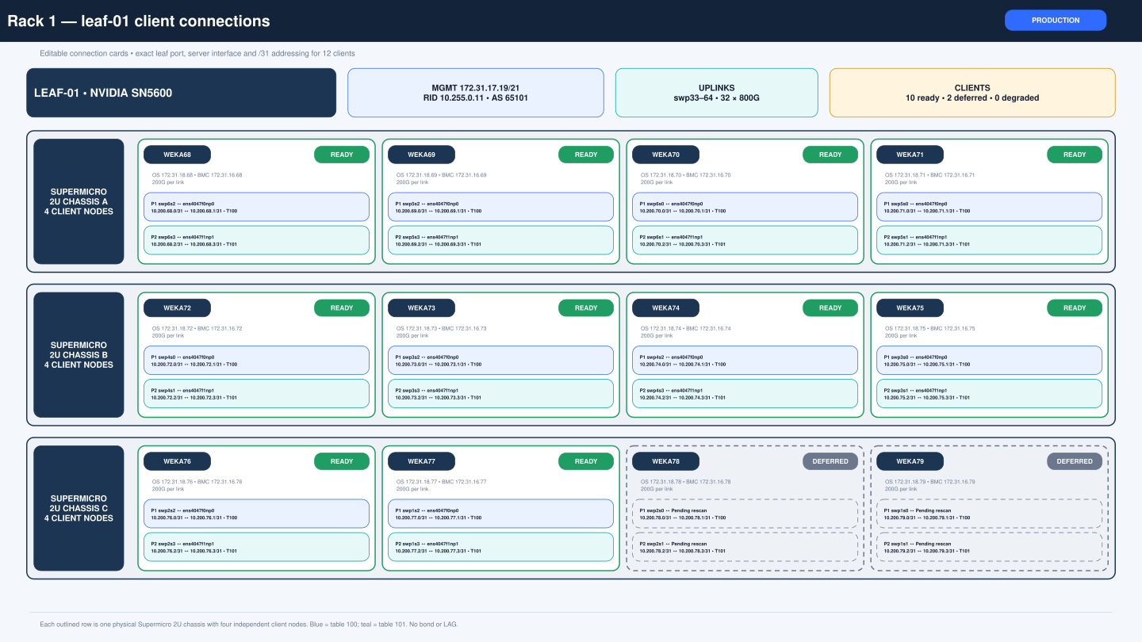
Figure 6 Rack 1 leaf-01 and weka68 through weka79 client connections
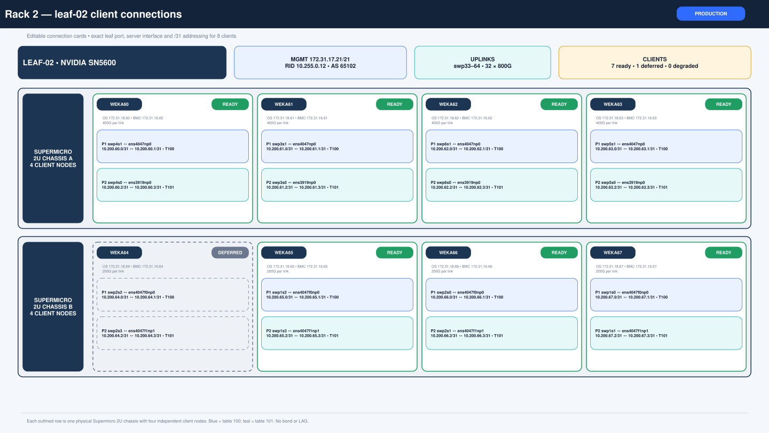
Figure 7 Rack 2 leaf-02 and weka60 through weka67 client connections
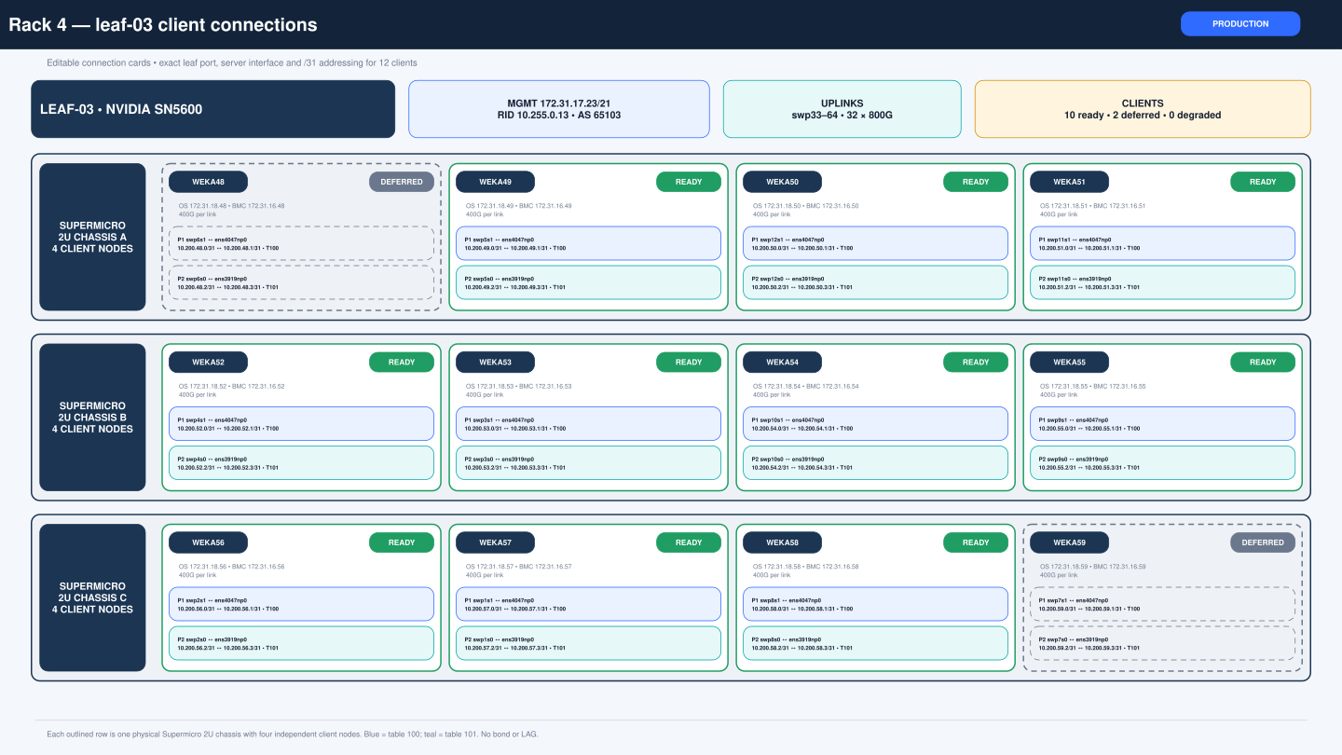
Figure 8 Rack 4 leaf-03 and weka48 through weka59 client connections
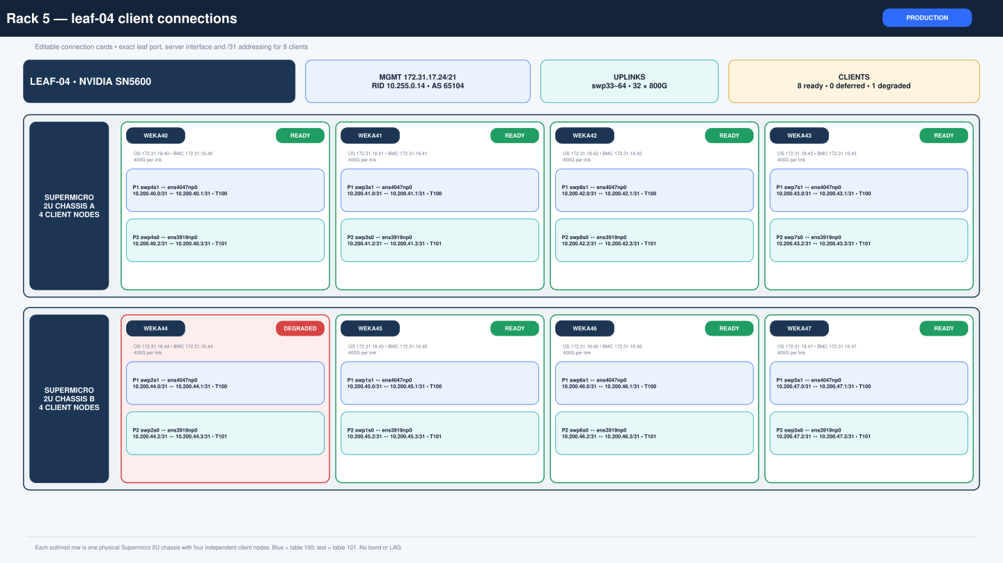
Figure 9 Rack 5 leaf-04 and weka40 through weka47 client connections

Cabling work method
1. Identify the exact pair in the issue register and verify the opposite endpoint from the full port map.
2. Capture link, module, FEC, signal-integrity, and error-counter output at both endpoints.
3. Label the cable serial and both endpoints before moving it.
4. Reseat or substitute only that cable or endpoint. Wait for link training to finish.
5. Confirm speed, lanes, RS-FEC, LLDP neighbor, BGP state, and counter stability.
6. Run full fabric validation and compare the missing set with the saved baseline before moving to the next cable.

6 Safe deployment procedures
The supplied automation follows a check, stage, review, apply, and validate sequence. That sequence is a safety control and should not be shortened.
Commands below use the saved package names from the migration. If a package has been moved, locate it first and verify checksums rather than typing a guessed path.

Before any change
- Open a change or maintenance record and name the exact devices and ports.
- Confirm management reachability and BMC or console access.
- Record hostname, management IP, software version, current time, and current NVUE candidate diff.
- Capture the pre-change BGP summary, interface state, counters, and LLDP neighbor.
- Confirm no second operator is staging a candidate on the same switch.

Numbered underlay validation
cd "$HOME/Downloads/SN5600_Numbered31"
shasum -a 256 -c SHA256SUMS
bash fabric.sh check
bash fabric.sh validate
# Target a single device when isolating a fault
bash fabric.sh validate spine-02
A validation result can be degraded without blocking forwarding. The important safety test is whether a repair creates any additional missing session compared with the saved baseline.

Leaf client configuration workflow
cd "$HOME/Downloads/SN5600_Client31_Rollout_20260929"
bash fabric.sh switch-check leaf-02
bash fabric.sh switch-stage leaf-02
# Log in to the switch and review the candidate
nv config diff
nv config apply --assume-yes
nv config save
# Return to the Mac
bash fabric.sh switch-validate leaf-02
bash fabric.sh switch-end-to-end leaf-02
Stop condition. If a preflight check, staged diff, apply, or validation produces an unexpected result, stop. Do not apply the same change to the remaining leaves until the first device is understood.

Server client configuration workflow
cd "$HOME/Downloads/SN5600_Client31_Rollout_20260929"
bash fabric.sh copy-servers weka60
bash fabric.sh server-check weka60
bash fabric.sh server-stage weka60
# Review the candidate Netplan printed by server-stage
bash fabric.sh server-apply weka60
bash fabric.sh server-validate weka60
The server script checks the host identity, ConnectX-7 mode, interface names, and MAC addresses. It backs up the Netplan directory before applying /etc/netplan/70-datapath.yaml.

InfiniBand to Ethernet conversion
Some ConnectX-7 ports originally operated in InfiniBand mode. Conversion to Ethernet changes firmware link type and requires a reboot before Linux and RDMA tools report the final Ethernet interfaces. A scan that reports no RDMA devices is not sufficient evidence of failure; confirm PCI devices, drivers, and firmware ownership on that host before retrying.
1. Validate management and BMC reachability before the conversion.
2. Record PCI BDF, RDMA device, netdev, MAC, firmware version, and current link layer for every port.
3. Apply only the host-specific firmware change to ports that are confirmed in InfiniBand mode.
4. Reboot once, wait for management SSH to return, and rerun the inventory scan.
5. Proceed to /31 Netplan only when every intended port reports Ethernet and the MACs match the mapping.

Applying to multiple devices
Use a small batch and stop on the first error. A failed password entry, unreachable host, or validation exception must remain visible. Do not use shell logic that hides failures or continues automatically after a failed apply.

7 Validation and acceptance
Validation moves from the local link outward. A passing remote test is not a substitute for checking the local physical state, and a local peer ping is not a substitute for checking BGP or cross-rack forwarding.
Record the time and the source host for every result. A result without its source interface or source IP can be misleading in a dual-path design.

Validation layers
Layer | What to check | Pass condition
Physical | Admin and operational state, speed, lanes, RS-FEC, signal integrity, flaps, errors | Expected speed and stable counters with no new flaps
Direct /31 | Each endpoint can ping the other with a 8972-byte payload | 0 percent loss on both paths
BGP | Expected neighbor is Established and the total count does not regress | 128/128 target or unchanged approved exceptions
Loopback | 9000-byte probes between switch loopbacks | All active switch loopbacks pass
Client local | Server address, policy rule, route table, MTU, and leaf peer | Both configured paths pass
Client cross rack | Both source IPs to both destination source-path IPs | Correct table and 0 percent loss
RoCE | PFC, ECN, classification, RDMA traffic, retransmits, drops and pauses | Sustained test meets the approved acceptance criteria

Switch health commands
hostname
ip -4 address show dev eth0
nv show interface
nv show interface --view lldp
sudo vtysh -c 'show bgp ipv4 unicast summary'
nv show system health
systemctl --failed --no-pager
nv config diff

Physical interface commands
nv show interface <port> link
nv show interface <port> lldp
sudo l1-show <port>
sudo ethtool -m <port> | grep -E 'Vendor name|Vendor PN|Vendor SN|Module State'
sudo ethtool --show-fec <port>
sudo ethtool -S <port> | grep -Ei 'fec|crc|error|err|drop|discard'

Server path checks
ip -4 -o address show dev <interface>
ip rule show
ip -4 route show table 100
ip -4 route show table 101
ip -4 route get <destination> from <source-address>
ping -n -I <source-address> -c 10 -W 2 -M do -s 8972 <destination>
Bind to the source address. During rollout, interface-name binding produced misleading cross-leaf failures. Use the source IP after -I for routed cross-rack tests so the matching policy rule and route table are selected.

Consolidated checks
cd "$HOME/Downloads/SN5600_Numbered31"
bash fabric.sh validate
cd "$HOME/Downloads/SN5600_Client31_Rollout_20260929"
bash fabric.sh switch-end-to-end all

Acceptance targets
- Underlay target: 128 of 128 BGP sessions established, or a formally approved documented exception with capacity assessment.
- Current client target: 80 of 80 physical client paths up after all 40 clients are in scope. Until the five deferred hosts are configured, distinguish configured-link success from total physical population.
- Every active leaf-spine link at 800G with RS-FEC and no growing critical error counters.
- Every configured server path at its expected 200G or 400G speed with MTU 9000 and successful jumbo peer test.
- Cross-rack tests pass in both source-policy paths and the route lookup shows the expected source table.
- RoCE is signed off only after switch and host settings are confirmed and sustained RDMA tests are retained.

8 Troubleshooting procedures
Troubleshooting begins with the lowest layer that can explain the symptom. Fixing routing while a link is physically down adds risk and does not address the cause.
Always compare both endpoints. A switch can report negotiation failure on one end while the other reports no issue, and a marginal cable can train successfully after it is moved.

Symptom guide
Symptom | Likely layer | First checks | Safe action
Admin up and oper down | Cable, module, port, negotiation, or FEC | Both endpoints, EEPROM serial, l1-show, FEC, eye grades, flap count | Capture evidence, reseat once, substitute one component, then validate
Link up but BGP Idle | IP or BGP configuration | /31 address, peer IP, ASN, interface route, FRR summary | Compare live NVUE to plan; change only the incorrect neighbor
Direct peer ping fails | Address, link, or MTU | Link state, addresses, route, neighbor entry, small ping then jumbo | Correct the local mismatch before testing remote paths
Small ping passes but jumbo fails | MTU or PMTU | Server 9000, leaf 9216, underlay 9216 | Correct the lowest MTU and repeat with -M do -s 8972
Leaf reaches remote leaf but server does not | Server policy or return path | ip rule, tables 100 and 101, rp_filter, source-bound route get | Fix host-specific policy routing; do not change the entire fabric
Only one server path fails | Single NIC, cable, breakout port, or policy table | Compare path 1 and path 2, MAC mapping and direct peer | Repair the failing path while preserving the working path
Counters grow under load | Signal integrity, FEC, congestion, or QoS | Before and after counters, lane grades, PFC/ECN when applicable | Stop acceptance test and isolate physical versus congestion counters

Link down procedure
1. Confirm the planned peer from the mapping. Do not assume the cable label is correct.
2. Run nv show interface link, LLDP, l1-show, module EEPROM, FEC, and filtered counters at both endpoints.
3. Record cable part number, serial number, length, switch hostname, and port at both ends.
4. If authorized, shut and no-shut the single port. If the link remains down, reseat one end and retest before moving both ends.
5. If using a known-good path for substitution, record which cable moved where. Test both the suspect cable and the displaced control cable.
6. After link-up, require expected speed, RS-FEC, stable LLDP, established BGP, jumbo peer ping, and no material counter growth.

Axiom DAC and signal integrity lesson
The Axiom MCP4Y10-N003-AX 3 m passive OSFP DAC investigation showed why a simple cable-only conclusion is unsafe. Serial AXMPOSPA01778 failed to train on one path, then trained at 800G with RS-FEC on a known-good path and passed a 1000-packet 9000-byte test. Some lanes still showed low eye values and a bad signal integrity warning. Serial AXMPOSPA01724 also showed path-dependent warnings.
The evidence points to an interaction among cable, seating, port, lane margin, and training conditions. Continue correlating cable serial, endpoints, lane grades, FEC and error growth. A clean ping or a single link-up event is not sufficient to close the case.

weka44 path 1 procedure
- Working path 2 is leaf-04 swp2s0 to weka44 ens3919np0 with 10.200.44.2/31 and 10.200.44.3/31.
- Failed path 1 is leaf-04 swp2s1 to weka44 ens4047np0 with 10.200.44.0/31 and 10.200.44.1/31.
- Confirm the server MAC 9c:63:c0:9b:3a:dc matches the expected path 1 interface before changing configuration.
- Compare the working and failed cable, port, NIC, firmware mode, FEC and counters without disturbing path 2.
- After repair, rerun server-validate weka44 and switch-end-to-end leaf-04.

BGP route exists but traffic fails
Check the route and the actual next hop. A leaf can learn a remote client /31 through many parallel underlay links. Verify the selected next hop exists in the kernel, confirm the destination leaf has the client network directly connected, and check the server return table. Use source-address-bound ping to eliminate ambiguity.

9 RoCE and lossless Ethernet
RoCE carries RDMA over Ethernet. It is more sensitive to congestion and loss than an ordinary ping test, so switch and host settings must agree.
The saved package preflight reported that the standard lossless delta was compatible, but the all-switch apply flow stopped when spine-04 had a new missing BGP session. The enable phase was not confirmed. Treat RoCE as not applied or validated until every device proves otherwise.

RoCE terms
Term | Plain language meaning
RoCEv2 | RDMA carried in routable UDP/IP packets
PFC | Priority flow control that can pause a selected traffic priority instead of the entire link
ECN | Marks congestion before queues overflow so endpoints can slow down
CNP | Congestion notification packet sent to reduce the sender's rate
DSCP | IP header marking used to classify RoCE and congestion traffic
Lossless profile | The coordinated switch buffer, queue, PFC, ECN and classification settings used for RDMA

Planned standard profile
- RoCE traffic priority 3 with PFC on priority 3.
- ECN enabled for the RoCE traffic class.
- DSCP trust with DSCP 26 for RoCE and DSCP 48 for CNP, subject to confirmation against the final applied host and switch policy.
- RoCE traffic class 3 and CNP traffic class 6 in the supplied delta.

Safe RoCE completion plan
Do not apply RoCE while the routing baseline is changing. The orchestration intentionally stopped when a previously established session disappeared. Stabilize the fabric first so a global QoS change is not combined with an unrelated routing regression.
1. Stabilize the physical underlay and obtain an approved exception for anything that cannot be repaired immediately.
2. Run numbered fabric validation and save the exact BGP baseline.
3. Run roce-check on every switch. Review the candidate output and confirm the intended client-facing and fabric port scope.
4. Apply in a maintenance window with counter capture before and after each switch.
5. Validate switch RoCE state, host firmware and driver, Ethernet mode, RoCEv2, DSCP marking, ECN and CNP behavior.
6. Run sustained cross-rack RDMA traffic on both client paths. Retain throughput, latency, retransmits, PFC pause, ECN mark, drop, FEC and flap counters.

10 Day two operations
Day-two operation means keeping the fabric healthy after deployment. The key habit is to preserve a known-good baseline and compare every later result with it.
A daily check can be short. A maintenance check must be detailed enough to prove that a change did not reduce routing, physical-link health, or client reachability.

Daily or pre change check
- Confirm all active switches answer on their management IPs.
- Run the consolidated underlay validation and compare the 118/128 saved baseline until faults are repaired.
- Run client end-to-end validation for all configured leaves.
- Check systemctl failed units, NVUE candidate diff, switch health, and recent link flaps.
- Review P1 and P2 issues and confirm no new exception appeared.

Weekly health review
- Archive BGP summaries and interface state from all eight active switches.
- Review FEC, CRC, symbol, discard, and flap counters for growth rather than only absolute values.
- Confirm LLDP neighbors match the documented port map.
- Run representative cross-rack jumbo tests on both policy paths from each client rack.
- After RoCE approval, review PFC pause, ECN mark, queue drop and RDMA error trends.
- Update the issue register and attach evidence to every closed item.

Change record minimum fields
Field | What to record
Time | Start, apply, validation and completion times with timezone
Scope | Exact switch or host, port, cable serial, and network
Reason | Observed symptom and expected result
Before evidence | Link state, BGP count, counters, LLDP, route and relevant logs
Change | Commands or package action and revision or backup identifiers
After evidence | Direct peer, BGP, jumbo and end-to-end results
Rollback | Whether rollback was needed and the exact restored revision or archive
Owner | Person continuing the work and vendor case if applicable

Vendor evidence package
For an 800G cable or port case, provide a working and failing comparison. Include hostname, port, software version, EEPROM dump, link state, l1-show, FEC state, error counters, cable serial, and a controlled cable move result. If mlxlink or ctb commands are available and supported on the switch, include their output; if a command is unavailable, record the error rather than substituting guessed device parameters.

11 Recovery and rollback
Rollback should restore the smallest affected scope. Do not reset an entire switch or copy another server's configuration to recover one failed interface.
Before rollback, confirm the backup belongs to the same host or switch and record the current state. A rollback that restores reachability can still reintroduce an older routing design, so validate the intended end state afterward.

Server Netplan rollback
Every server apply prints a backup path under /root/sn5600-client31-state/<hostname>/. Use that exact path on that same server.
bash /root/SN5600_Client31_Rollout_20260929/servers/<host>_client31.sh --restore /root/sn5600-client31-state/<host>/netplan-before-<timestamp>.tar.gz
# From console or BMC if manual recovery is required
netplan generate
netplan apply
Management separation check. Management addressing must remain in a separate Netplan file. The rollout replaces only /etc/netplan/70-datapath.yaml.

Switch candidate recovery
- Before apply, use nv config diff. If the candidate is wrong, correct or discard only the pending candidate.
- After apply, identify the saved revision or the package rollback state before reverting.
- Use the package's targeted rollback for the migrated group only during a maintenance window.
- After rollback, confirm hostname, management reachability, BGP summary, routes, interface state, and NVUE diff.
cd "$HOME/Downloads/SN5600_Numbered31"
bash fabric.sh rollback spine-01
bash fabric.sh validate spine-01

Reboot procedure
1. Use an approved maintenance window and reboot one switch at a time.
2. Capture the pre-reboot underlay and client baseline.
3. Verify management or console access and current saved configuration.
4. After reboot, wait for system services, interfaces and BGP to converge.
5. Require no additional missing BGP sessions, no new failed units, correct link speed and FEC, and successful jumbo probes before rebooting another switch.

Emergency management loss
If SSH is lost after a server network change, use BMC or console rather than making blind remote retries. Inspect Netplan syntax, interface names, match-by-MAC entries, addresses, routes and policy rules. Restore the host-specific backup, run netplan generate, then apply. If switch management is lost, use console and verify the management VRF, eth0 address, routing and saved NVUE configuration before rebooting or reverting data-plane changes.

12 Remaining work and handover acceptance
The handover is operationally useful now, but it is not final closure. Chandra will continue working with Matt to repair the physical and session issues, update the evidence, and complete RoCE acceptance.
The receiving operator should track each item to evidence-based closure. A verbal report that a cable was reseated is not closure unless link state, BGP, jumbo reachability and counters are recorded afterward.

Priority work plan
Order | Work | Evidence | Exit condition
1 | Freeze broad changes and rerun read-only validation | Timestamped underlay and client reports | Exact current exception set confirmed
2 | Capture both endpoints of leaf-01 swp43/spine-02 swp3 and leaf-01 swp51/spine-03 swp3 | Link, l1-show, EEPROM, FEC and counters | Probable fault domain identified before reseat
3 | Repair one underlay pair at a time | Before and after counters plus full validation | Pair stable at 800G and RS-FEC with BGP established
4 | Restore weka44 path 1 | Server and leaf validation | Both weka44 /31 paths pass jumbo tests
5 | Rescan and configure deferred hosts | LLDP, MAC, mode, interface and host-specific candidate | Five hosts either validated or formally removed from scope
6 | Complete RoCE change and sustained RDMA acceptance | QoS state and synchronized host/switch counters | Approved lossless and performance criteria met

Handover acceptance checklist
[ ] The successor can access all eight active switches through approved credentials.
[ ] The successor understands that spine management IPs and router IDs intentionally use different numbering.
[ ] The latest underlay missing-pair list has been rerun and attached.
[ ] Repaired links are at 800G with RS-FEC and stable counters.
[ ] weka44 path 1 is restored or accepted as an explicit exception.
[ ] Deferred clients have verified MAC, port, interface and Ethernet-mode inventory before configuration.
[ ] The current client mapping, underlay map, issue register and validation logs are stored with the automation packages.
[ ] RoCE is confirmed on every intended switch and host, and sustained RDMA results are retained.
[ ] Switch and server rollback procedures have been reviewed with console or BMC access available.
[ ] Matt and the receiving operations owner acknowledge the remaining items and ownership.

Scope boundary for future backend expansion
A future 80-server WEKA backend requirement was discussed, but no confirmed rack, port, MAC or /31 as-built mapping for those servers exists in the current evidence set. This guide therefore treats the 40-client deployment as the applied client scope. Create a separate reviewed addressing and cabling plan before adding backend servers or using leaf-05.

Appendix A Switch quick reference
Use this table to verify identity immediately after login. The router-ID mismatch on the spines is intentional.
Hostname | Management | Role | Loopback or router ID | ASN | Rack | Operational note
spine-01 | 172.31.17.5/20 | 10.255.0.104 | 65200 | Rack 3 | Active; physical role remap
spine-02 | 172.31.17.18/21 | 10.255.0.101 | 65200 | Rack 3 | Active; physical role remap
spine-03 | 172.31.17.20/21 | 10.255.0.102 | 65200 | Rack 3 | Active; physical role remap
spine-04 | 172.31.17.22/21 | 10.255.0.103 | 65200 | Rack 3 | Active; physical role remap
leaf-01 | 172.31.17.19/21 | 10.255.0.11 | 65101 | Rack 1 | Active
leaf-02 | 172.31.17.21/21 | 10.255.0.12 | 65102 | Rack 2 | Active
leaf-03 | 172.31.17.23/21 | 10.255.0.13 | 65103 | Rack 4 | Active
leaf-04 | 172.31.17.24/21 | 10.255.0.14 | 65104 | Rack 5 | Active; fiber client rack
leaf-05 | 172.31.17.3 | Not assigned in active plan | Not assigned | Rack 3 | Excluded and reserved

Reserved scope
- leaf-05 at 172.31.17.3 is not part of the active eight-switch deployment.
- Spine ports swp33 through swp40 are reserved for future leaf-05 connectivity.
- The future underlay pool 10.254.1.0/26 remains reserved.

Appendix B Client management and BMC inventory
All 40 client identities use the final-octet pattern shown below. ICMP may be disabled on a BMC even when HTTPS is available, so use both network and service checks when testing reachability.
Host | OS management | BMC | Rack | Leaf | Data-plane state
weka40 | 172.31.18.40 | 172.31.16.40 | Rack 5 | leaf-04 | Configured and validated
weka41 | 172.31.18.41 | 172.31.16.41 | Rack 5 | leaf-04 | Configured and validated
weka42 | 172.31.18.42 | 172.31.16.42 | Rack 5 | leaf-04 | Configured and validated
weka43 | 172.31.18.43 | 172.31.16.43 | Rack 5 | leaf-04 | Configured and validated
weka44 | 172.31.18.44 | 172.31.16.44 | Rack 5 | leaf-04 | Configured with link exception
weka45 | 172.31.18.45 | 172.31.16.45 | Rack 5 | leaf-04 | Configured and validated
weka46 | 172.31.18.46 | 172.31.16.46 | Rack 5 | leaf-04 | Configured and validated
weka47 | 172.31.18.47 | 172.31.16.47 | Rack 5 | leaf-04 | Configured and validated
weka48 | 172.31.18.48 | 172.31.16.48 | Rack 4 | leaf-03 | Deferred
weka49 | 172.31.18.49 | 172.31.16.49 | Rack 4 | leaf-03 | Configured and validated
weka50 | 172.31.18.50 | 172.31.16.50 | Rack 4 | leaf-03 | Configured and validated
weka51 | 172.31.18.51 | 172.31.16.51 | Rack 4 | leaf-03 | Configured and validated
weka52 | 172.31.18.52 | 172.31.16.52 | Rack 4 | leaf-03 | Configured and validated
weka53 | 172.31.18.53 | 172.31.16.53 | Rack 4 | leaf-03 | Configured and validated
weka54 | 172.31.18.54 | 172.31.16.54 | Rack 4 | leaf-03 | Configured and validated
weka55 | 172.31.18.55 | 172.31.16.55 | Rack 4 | leaf-03 | Configured and validated
weka56 | 172.31.18.56 | 172.31.16.56 | Rack 4 | leaf-03 | Configured and validated
weka57 | 172.31.18.57 | 172.31.16.57 | Rack 4 | leaf-03 | Configured and validated
weka58 | 172.31.18.58 | 172.31.16.58 | Rack 4 | leaf-03 | Configured and validated
weka59 | 172.31.18.59 | 172.31.16.59 | Rack 4 | leaf-03 | Deferred
weka60 | 172.31.18.60 | 172.31.16.60 | Rack 2 | leaf-02 | Configured and validated
weka61 | 172.31.18.61 | 172.31.16.61 | Rack 2 | leaf-02 | Configured and validated
weka62 | 172.31.18.62 | 172.31.16.62 | Rack 2 | leaf-02 | Configured and validated
weka63 | 172.31.18.63 | 172.31.16.63 | Rack 2 | leaf-02 | Configured and validated
weka64 | 172.31.18.64 | 172.31.16.64 | Rack 2 | leaf-02 | Deferred
weka65 | 172.31.18.65 | 172.31.16.65 | Rack 2 | leaf-02 | Configured and validated
weka66 | 172.31.18.66 | 172.31.16.66 | Rack 2 | leaf-02 | Configured and validated
weka67 | 172.31.18.67 | 172.31.16.67 | Rack 2 | leaf-02 | Configured and validated
weka68 | 172.31.18.68 | 172.31.16.68 | Rack 1 | leaf-01 | Configured and validated
weka69 | 172.31.18.69 | 172.31.16.69 | Rack 1 | leaf-01 | Configured and validated
weka70 | 172.31.18.70 | 172.31.16.70 | Rack 1 | leaf-01 | Configured and validated
weka71 | 172.31.18.71 | 172.31.16.71 | Rack 1 | leaf-01 | Configured and validated
weka72 | 172.31.18.72 | 172.31.16.72 | Rack 1 | leaf-01 | Configured and validated
weka73 | 172.31.18.73 | 172.31.16.73 | Rack 1 | leaf-01 | Configured and validated
weka74 | 172.31.18.74 | 172.31.16.74 | Rack 1 | leaf-01 | Configured and validated
weka75 | 172.31.18.75 | 172.31.16.75 | Rack 1 | leaf-01 | Configured and validated
weka76 | 172.31.18.76 | 172.31.16.76 | Rack 1 | leaf-01 | Configured and validated
weka77 | 172.31.18.77 | 172.31.16.77 | Rack 1 | leaf-01 | Configured and validated
weka78 | 172.31.18.78 | 172.31.16.78 | Rack 1 | leaf-01 | Deferred
weka79 | 172.31.18.79 | 172.31.16.79 | Rack 1 | leaf-01 | Deferred

Appendix C Detailed client port and IP map
Each row is one physical server-to-leaf path. Rack values below use the final five-rack placement. Deferred rows are reservations and must be rescanned before apply.
Host | Rack | Leaf | Leaf port | Server interface | Server MAC | Leaf IP | Server IP | Table | Speed | State
weka40 | Rack 5 | leaf-04 | swp4s1 | ens4047np0 | d8:94:24:1d:d5:ac | 10.200.40.0/31 | 10.200.40.1/31 | 100 | 400G | Up
weka40 | Rack 5 | leaf-04 | swp4s0 | ens3919np0 | d8:94:24:1d:d5:44 | 10.200.40.2/31 | 10.200.40.3/31 | 101 | 400G | Up
weka41 | Rack 5 | leaf-04 | swp3s1 | ens4047np0 | d8:94:24:1d:d5:d4 | 10.200.41.0/31 | 10.200.41.1/31 | 100 | 400G | Up
weka41 | Rack 5 | leaf-04 | swp3s0 | ens3919np0 | d8:94:24:1d:d5:7c | 10.200.41.2/31 | 10.200.41.3/31 | 101 | 400G | Up
weka42 | Rack 5 | leaf-04 | swp8s1 | ens4047np0 | d8:94:24:1d:d5:5c | 10.200.42.0/31 | 10.200.42.1/31 | 100 | 400G | Up
weka42 | Rack 5 | leaf-04 | swp8s0 | ens3919np0 | d8:94:24:1d:d5:34 | 10.200.42.2/31 | 10.200.42.3/31 | 101 | 400G | Up
weka43 | Rack 5 | leaf-04 | swp7s1 | ens4047np0 | d8:94:24:1d:d5:fc | 10.200.43.0/31 | 10.200.43.1/31 | 100 | 400G | Up
weka43 | Rack 5 | leaf-04 | swp7s0 | ens3919np0 | d8:94:24:1d:d5:a4 | 10.200.43.2/31 | 10.200.43.3/31 | 101 | 400G | Up
weka44 | Rack 5 | leaf-04 | swp2s1 | ens4047np0 | 9c:63:c0:9b:3a:dc | 10.200.44.0/31 | 10.200.44.1/31 | 100 | 400G | Configured down
weka44 | Rack 5 | leaf-04 | swp2s0 | ens3919np0 | d8:94:24:1d:d5:94 | 10.200.44.2/31 | 10.200.44.3/31 | 101 | 400G | Up
weka45 | Rack 5 | leaf-04 | swp1s1 | ens4047np0 | e0:9d:73:02:a5:2e | 10.200.45.0/31 | 10.200.45.1/31 | 100 | 400G | Up
weka45 | Rack 5 | leaf-04 | swp1s0 | ens3919np0 | e0:9d:73:02:a6:5e | 10.200.45.2/31 | 10.200.45.3/31 | 101 | 400G | Up
weka46 | Rack 5 | leaf-04 | swp6s1 | ens4047np0 | d8:94:24:1d:d5:f4 | 10.200.46.0/31 | 10.200.46.1/31 | 100 | 400G | Up
weka46 | Rack 5 | leaf-04 | swp6s0 | ens3919np0 | e0:9d:73:1d:d9:94 | 10.200.46.2/31 | 10.200.46.3/31 | 101 | 400G | Up
weka47 | Rack 5 | leaf-04 | swp5s1 | ens4047np0 | d8:94:24:d5:31:26 | 10.200.47.0/31 | 10.200.47.1/31 | 100 | 400G | Up
weka47 | Rack 5 | leaf-04 | swp5s0 | ens3919np0 | e0:9d:73:02:85:f6 | 10.200.47.2/31 | 10.200.47.3/31 | 101 | 400G | Up
weka48 | Rack 4 | leaf-03 | swp6s1 | ens4047np0 | d8:94:24:1d:d6:0c | 10.200.48.0/31 | 10.200.48.1/31 | 100 | 400G | Deferred
weka48 | Rack 4 | leaf-03 | swp6s0 | ens3919np0 | d8:94:24:1d:d5:bc | 10.200.48.2/31 | 10.200.48.3/31 | 101 | 400G | Deferred
weka49 | Rack 4 | leaf-03 | swp5s1 | ens4047np0 | d8:94:24:1d:d5:e4 | 10.200.49.0/31 | 10.200.49.1/31 | 100 | 400G | Up
weka49 | Rack 4 | leaf-03 | swp5s0 | ens3919np0 | d8:94:24:1d:d5:3c | 10.200.49.2/31 | 10.200.49.3/31 | 101 | 400G | Up
weka50 | Rack 4 | leaf-03 | swp12s1 | ens4047np0 | d8:94:24:1d:d5:cc | 10.200.50.0/31 | 10.200.50.1/31 | 100 | 400G | Up
weka50 | Rack 4 | leaf-03 | swp12s0 | ens3919np0 | d8:94:24:1d:d5:b4 | 10.200.50.2/31 | 10.200.50.3/31 | 101 | 400G | Up
weka51 | Rack 4 | leaf-03 | swp11s1 | ens4047np0 | 9c:63:c0:9b:3b:14 | 10.200.51.0/31 | 10.200.51.1/31 | 100 | 400G | Up
weka51 | Rack 4 | leaf-03 | swp11s0 | ens3919np0 | e0:9d:73:02:85:de | 10.200.51.2/31 | 10.200.51.3/31 | 101 | 400G | Up
weka52 | Rack 4 | leaf-03 | swp4s1 | ens4047np0 | e0:9d:73:02:8b:be | 10.200.52.0/31 | 10.200.52.1/31 | 100 | 400G | Up
weka52 | Rack 4 | leaf-03 | swp4s0 | ens3919np0 | e0:9d:73:02:8a:66 | 10.200.52.2/31 | 10.200.52.3/31 | 101 | 400G | Up
weka53 | Rack 4 | leaf-03 | swp3s1 | ens4047np0 | 9c:63:c0:ba:00:12 | 10.200.53.0/31 | 10.200.53.1/31 | 100 | 400G | Up
weka53 | Rack 4 | leaf-03 | swp3s0 | ens3919np0 | e0:9d:73:02:8b:76 | 10.200.53.2/31 | 10.200.53.3/31 | 101 | 400G | Up
weka54 | Rack 4 | leaf-03 | swp10s1 | ens4047np0 | e0:9d:73:02:8a:ee | 10.200.54.0/31 | 10.200.54.1/31 | 100 | 400G | Up
weka54 | Rack 4 | leaf-03 | swp10s0 | ens3919np0 | e0:9d:73:02:88:a6 | 10.200.54.2/31 | 10.200.54.3/31 | 101 | 400G | Up
weka55 | Rack 4 | leaf-03 | swp9s1 | ens4047np0 | d8:94:24:1d:d5:4c | 10.200.55.0/31 | 10.200.55.1/31 | 100 | 400G | Up
weka55 | Rack 4 | leaf-03 | swp9s0 | ens3919np0 | d8:94:24:1d:d5:dc | 10.200.55.2/31 | 10.200.55.3/31 | 101 | 400G | Up
weka56 | Rack 4 | leaf-03 | swp2s1 | ens4047np0 | d8:94:24:1d:d5:54 | 10.200.56.0/31 | 10.200.56.1/31 | 100 | 400G | Up
weka56 | Rack 4 | leaf-03 | swp2s0 | ens3919np0 | d8:94:24:1d:d6:04 | 10.200.56.2/31 | 10.200.56.3/31 | 101 | 400G | Up
weka57 | Rack 4 | leaf-03 | swp1s1 | ens4047np0 | d8:94:24:1d:d5:24 | 10.200.57.0/31 | 10.200.57.1/31 | 100 | 400G | Up
weka57 | Rack 4 | leaf-03 | swp1s0 | ens3919np0 | d8:94:24:1d:d5:8c | 10.200.57.2/31 | 10.200.57.3/31 | 101 | 400G | Up
weka58 | Rack 4 | leaf-03 | swp8s1 | ens4047np0 | d8:94:24:1d:d5:74 | 10.200.58.0/31 | 10.200.58.1/31 | 100 | 400G | Up
weka58 | Rack 4 | leaf-03 | swp8s0 | ens3919np0 | d8:94:24:1d:d5:ec | 10.200.58.2/31 | 10.200.58.3/31 | 101 | 400G | Up
weka59 | Rack 4 | leaf-03 | swp7s1 | ens4047np0 | d8:94:24:1d:d5:64 | 10.200.59.0/31 | 10.200.59.1/31 | 100 | 400G | Deferred
weka59 | Rack 4 | leaf-03 | swp7s0 | ens3919np0 | d8:94:24:1d:d5:84 | 10.200.59.2/31 | 10.200.59.3/31 | 101 | 400G | Deferred
weka60 | Rack 2 | leaf-02 | swp4s1 | ens4047np0 | d8:94:24:1d:d5:2c | 10.200.60.0/31 | 10.200.60.1/31 | 100 | 400G | Up
weka60 | Rack 2 | leaf-02 | swp4s0 | ens3919np0 | e0:9d:73:1d:d8:34 | 10.200.60.2/31 | 10.200.60.3/31 | 101 | 400G | Up
weka61 | Rack 2 | leaf-02 | swp3s1 | ens4047np0 | e0:9d:73:1d:d2:bc | 10.200.61.0/31 | 10.200.61.1/31 | 100 | 400G | Up
weka61 | Rack 2 | leaf-02 | swp3s0 | ens3919np0 | e0:9d:73:02:a9:96 | 10.200.61.2/31 | 10.200.61.3/31 | 101 | 400G | Up
weka62 | Rack 2 | leaf-02 | swp6s1 | ens4047np0 | d8:94:24:1d:d5:6c | 10.200.62.0/31 | 10.200.62.1/31 | 100 | 400G | Up
weka62 | Rack 2 | leaf-02 | swp6s0 | ens3919np0 | e0:9d:73:02:aa:2e | 10.200.62.2/31 | 10.200.62.3/31 | 101 | 400G | Up
weka63 | Rack 2 | leaf-02 | swp5s1 | ens4047np0 | d8:94:24:1d:d5:9c | 10.200.63.0/31 | 10.200.63.1/31 | 100 | 400G | Up
weka63 | Rack 2 | leaf-02 | swp5s0 | ens3919np0 | e0:9d:73:1d:d7:04 | 10.200.63.2/31 | 10.200.63.3/31 | 101 | 400G | Up
weka64 | Rack 2 | leaf-02 | swp2s2 | ens4047f0np0 | Pending rescan | 10.200.64.0/31 | 10.200.64.1/31 | 100 | 200G | Deferred
weka64 | Rack 2 | leaf-02 | swp2s3 | ens4047f1np1 | Pending rescan | 10.200.64.2/31 | 10.200.64.3/31 | 101 | 200G | Deferred
weka65 | Rack 2 | leaf-02 | swp1s2 | ens4047f0np0 | a0:88:c2:ac:f2:c8 | 10.200.65.0/31 | 10.200.65.1/31 | 100 | 200G | Up
weka65 | Rack 2 | leaf-02 | swp1s3 | ens4047f1np1 | a0:88:c2:ac:f2:c9 | 10.200.65.2/31 | 10.200.65.3/31 | 101 | 200G | Up
weka66 | Rack 2 | leaf-02 | swp2s0 | ens4047f0np0 | a0:88:c2:d5:63:e2 | 10.200.66.0/31 | 10.200.66.1/31 | 100 | 200G | Up
weka66 | Rack 2 | leaf-02 | swp2s1 | ens4047f1np1 | a0:88:c2:d5:63:e3 | 10.200.66.2/31 | 10.200.66.3/31 | 101 | 200G | Up
weka67 | Rack 2 | leaf-02 | swp1s0 | ens4047f0np0 | a0:88:c2:ac:db:e8 | 10.200.67.0/31 | 10.200.67.1/31 | 100 | 200G | Up
weka67 | Rack 2 | leaf-02 | swp1s1 | ens4047f1np1 | a0:88:c2:ac:db:e9 | 10.200.67.2/31 | 10.200.67.3/31 | 101 | 200G | Up
weka68 | Rack 1 | leaf-01 | swp6s2 | ens4047f0np0 | a0:88:c2:a8:5b:40 | 10.200.68.0/31 | 10.200.68.1/31 | 100 | 200G | Up
weka68 | Rack 1 | leaf-01 | swp6s3 | ens4047f1np1 | a0:88:c2:a8:5b:41 | 10.200.68.2/31 | 10.200.68.3/31 | 101 | 200G | Up
weka69 | Rack 1 | leaf-01 | swp5s2 | ens4047f0np0 | a0:88:c2:ad:00:b8 | 10.200.69.0/31 | 10.200.69.1/31 | 100 | 200G | Up
weka69 | Rack 1 | leaf-01 | swp5s3 | ens4047f1np1 | a0:88:c2:ad:00:b9 | 10.200.69.2/31 | 10.200.69.3/31 | 101 | 200G | Up
weka70 | Rack 1 | leaf-01 | swp6s0 | ens4047f0np0 | a0:88:c2:d5:64:22 | 10.200.70.0/31 | 10.200.70.1/31 | 100 | 200G | Up
weka70 | Rack 1 | leaf-01 | swp6s1 | ens4047f1np1 | a0:88:c2:d5:64:23 | 10.200.70.2/31 | 10.200.70.3/31 | 101 | 200G | Up
weka71 | Rack 1 | leaf-01 | swp5s0 | ens4047f0np0 | a0:88:c2:d5:66:72 | 10.200.71.0/31 | 10.200.71.1/31 | 100 | 200G | Up
weka71 | Rack 1 | leaf-01 | swp5s1 | ens4047f1np1 | a0:88:c2:d5:66:73 | 10.200.71.2/31 | 10.200.71.3/31 | 101 | 200G | Up
weka72 | Rack 1 | leaf-01 | swp4s0 | ens4047f0np0 | a0:88:c2:d5:64:02 | 10.200.72.0/31 | 10.200.72.1/31 | 100 | 200G | Up
weka72 | Rack 1 | leaf-01 | swp4s1 | ens4047f1np1 | a0:88:c2:d5:64:03 | 10.200.72.2/31 | 10.200.72.3/31 | 101 | 200G | Up
weka73 | Rack 1 | leaf-01 | swp3s2 | ens4047f0np0 | a0:88:c2:d5:73:82 | 10.200.73.0/31 | 10.200.73.1/31 | 100 | 200G | Up
weka73 | Rack 1 | leaf-01 | swp3s3 | ens4047f1np1 | a0:88:c2:d5:73:83 | 10.200.73.2/31 | 10.200.73.3/31 | 101 | 200G | Up
weka74 | Rack 1 | leaf-01 | swp4s2 | ens4047f0np0 | a0:88:c2:34:b9:36 | 10.200.74.0/31 | 10.200.74.1/31 | 100 | 200G | Up
weka74 | Rack 1 | leaf-01 | swp4s3 | ens4047f1np1 | a0:88:c2:34:b9:37 | 10.200.74.2/31 | 10.200.74.3/31 | 101 | 200G | Up
weka75 | Rack 1 | leaf-01 | swp3s0 | ens4047f0np0 | a0:88:c2:d5:64:12 | 10.200.75.0/31 | 10.200.75.1/31 | 100 | 200G | Up
weka75 | Rack 1 | leaf-01 | swp3s1 | ens4047f1np1 | a0:88:c2:d5:64:13 | 10.200.75.2/31 | 10.200.75.3/31 | 101 | 200G | Up
weka76 | Rack 1 | leaf-01 | swp2s2 | ens4047f0np0 | a0:88:c2:d5:66:92 | 10.200.76.0/31 | 10.200.76.1/31 | 100 | 200G | Up
weka76 | Rack 1 | leaf-01 | swp2s3 | ens4047f1np1 | a0:88:c2:d5:66:93 | 10.200.76.2/31 | 10.200.76.3/31 | 101 | 200G | Up
weka77 | Rack 1 | leaf-01 | swp1s2 | ens4047f0np0 | a0:88:c2:d5:64:42 | 10.200.77.0/31 | 10.200.77.1/31 | 100 | 200G | Up
weka77 | Rack 1 | leaf-01 | swp1s3 | ens4047f1np1 | a0:88:c2:d5:64:43 | 10.200.77.2/31 | 10.200.77.3/31 | 101 | 200G | Up
weka78 | Rack 1 | leaf-01 | swp2s0 | Pending rescan | Pending rescan | 10.200.78.0/31 | 10.200.78.1/31 | 100 | 200G | Deferred
weka78 | Rack 1 | leaf-01 | swp2s1 | Pending rescan | Pending rescan | 10.200.78.2/31 | 10.200.78.3/31 | 101 | 200G | Deferred
weka79 | Rack 1 | leaf-01 | swp1s0 | Pending rescan | Pending rescan | 10.200.79.0/31 | 10.200.79.1/31 | 100 | 200G | Deferred
weka79 | Rack 1 | leaf-01 | swp1s1 | Pending rescan | Pending rescan | 10.200.79.2/31 | 10.200.79.3/31 | 101 | 200G | Deferred

Appendix D Full leaf spine underlay map
The table contains all 128 planned leaf-spine links. Status is based on the saved 29 September 2026 validation. A row marked Established should still be checked live before maintenance.
Link | Leaf | Leaf port | Leaf address | Spine | Spine port | Spine address | Network | Saved status
L1-S1-01 | leaf-01 | swp33 | 10.254.0.1/31 | spine-01 | swp1 | 10.254.0.0/31 | 10.254.0.0/31 | Missing in saved validation
L1-S1-02 | leaf-01 | swp34 | 10.254.0.3/31 | spine-01 | swp2 | 10.254.0.2/31 | 10.254.0.2/31 | Established in saved validation
L1-S1-03 | leaf-01 | swp35 | 10.254.0.5/31 | spine-01 | swp3 | 10.254.0.4/31 | 10.254.0.4/31 | Established in saved validation
L1-S1-04 | leaf-01 | swp36 | 10.254.0.7/31 | spine-01 | swp4 | 10.254.0.6/31 | 10.254.0.6/31 | Established in saved validation
L1-S1-05 | leaf-01 | swp37 | 10.254.0.9/31 | spine-01 | swp5 | 10.254.0.8/31 | 10.254.0.8/31 | Established in saved validation
L1-S1-06 | leaf-01 | swp38 | 10.254.0.11/31 | spine-01 | swp6 | 10.254.0.10/31 | 10.254.0.10/31 | Established in saved validation
L1-S1-07 | leaf-01 | swp39 | 10.254.0.13/31 | spine-01 | swp7 | 10.254.0.12/31 | 10.254.0.12/31 | Established in saved validation
L1-S1-08 | leaf-01 | swp40 | 10.254.0.15/31 | spine-01 | swp8 | 10.254.0.14/31 | 10.254.0.14/31 | Established in saved validation
L1-S2-01 | leaf-01 | swp41 | 10.254.0.17/31 | spine-02 | swp1 | 10.254.0.16/31 | 10.254.0.16/31 | Missing in saved validation
L1-S2-02 | leaf-01 | swp42 | 10.254.0.19/31 | spine-02 | swp2 | 10.254.0.18/31 | 10.254.0.18/31 | Established in saved validation
L1-S2-03 | leaf-01 | swp43 | 10.254.0.21/31 | spine-02 | swp3 | 10.254.0.20/31 | 10.254.0.20/31 | Missing in saved validation
L1-S2-04 | leaf-01 | swp44 | 10.254.0.23/31 | spine-02 | swp4 | 10.254.0.22/31 | 10.254.0.22/31 | Missing in saved validation
L1-S2-05 | leaf-01 | swp45 | 10.254.0.25/31 | spine-02 | swp5 | 10.254.0.24/31 | 10.254.0.24/31 | Established in saved validation
L1-S2-06 | leaf-01 | swp46 | 10.254.0.27/31 | spine-02 | swp6 | 10.254.0.26/31 | 10.254.0.26/31 | Established in saved validation
L1-S2-07 | leaf-01 | swp47 | 10.254.0.29/31 | spine-02 | swp7 | 10.254.0.28/31 | 10.254.0.28/31 | Established in saved validation
L1-S2-08 | leaf-01 | swp48 | 10.254.0.31/31 | spine-02 | swp8 | 10.254.0.30/31 | 10.254.0.30/31 | Established in saved validation
L1-S3-01 | leaf-01 | swp49 | 10.254.0.33/31 | spine-03 | swp1 | 10.254.0.32/31 | 10.254.0.32/31 | Missing in saved validation
L1-S3-02 | leaf-01 | swp50 | 10.254.0.35/31 | spine-03 | swp2 | 10.254.0.34/31 | 10.254.0.34/31 | Established in saved validation
L1-S3-03 | leaf-01 | swp51 | 10.254.0.37/31 | spine-03 | swp3 | 10.254.0.36/31 | 10.254.0.36/31 | Missing in saved validation
L1-S3-04 | leaf-01 | swp52 | 10.254.0.39/31 | spine-03 | swp4 | 10.254.0.38/31 | 10.254.0.38/31 | Missing in saved validation
L1-S3-05 | leaf-01 | swp53 | 10.254.0.41/31 | spine-03 | swp5 | 10.254.0.40/31 | 10.254.0.40/31 | Established in saved validation
L1-S3-06 | leaf-01 | swp54 | 10.254.0.43/31 | spine-03 | swp6 | 10.254.0.42/31 | 10.254.0.42/31 | Established in saved validation
L1-S3-07 | leaf-01 | swp55 | 10.254.0.45/31 | spine-03 | swp7 | 10.254.0.44/31 | 10.254.0.44/31 | Established in saved validation
L1-S3-08 | leaf-01 | swp56 | 10.254.0.47/31 | spine-03 | swp8 | 10.254.0.46/31 | 10.254.0.46/31 | Established in saved validation
L1-S4-01 | leaf-01 | swp57 | 10.254.0.49/31 | spine-04 | swp1 | 10.254.0.48/31 | 10.254.0.48/31 | Established in saved validation
L1-S4-02 | leaf-01 | swp58 | 10.254.0.51/31 | spine-04 | swp2 | 10.254.0.50/31 | 10.254.0.50/31 | Missing in saved validation
L1-S4-03 | leaf-01 | swp59 | 10.254.0.53/31 | spine-04 | swp3 | 10.254.0.52/31 | 10.254.0.52/31 | Established in saved validation
L1-S4-04 | leaf-01 | swp60 | 10.254.0.55/31 | spine-04 | swp4 | 10.254.0.54/31 | 10.254.0.54/31 | Established in saved validation
L1-S4-05 | leaf-01 | swp61 | 10.254.0.57/31 | spine-04 | swp5 | 10.254.0.56/31 | 10.254.0.56/31 | Missing in saved validation
L1-S4-06 | leaf-01 | swp62 | 10.254.0.59/31 | spine-04 | swp6 | 10.254.0.58/31 | 10.254.0.58/31 | Established in saved validation
L1-S4-07 | leaf-01 | swp63 | 10.254.0.61/31 | spine-04 | swp7 | 10.254.0.60/31 | 10.254.0.60/31 | Established in saved validation
L1-S4-08 | leaf-01 | swp64 | 10.254.0.63/31 | spine-04 | swp8 | 10.254.0.62/31 | 10.254.0.62/31 | Established in saved validation
L2-S1-01 | leaf-02 | swp33 | 10.254.0.65/31 | spine-01 | swp9 | 10.254.0.64/31 | 10.254.0.64/31 | Established in saved validation
L2-S1-02 | leaf-02 | swp34 | 10.254.0.67/31 | spine-01 | swp10 | 10.254.0.66/31 | 10.254.0.66/31 | Established in saved validation
L2-S1-03 | leaf-02 | swp35 | 10.254.0.69/31 | spine-01 | swp11 | 10.254.0.68/31 | 10.254.0.68/31 | Established in saved validation
L2-S1-04 | leaf-02 | swp36 | 10.254.0.71/31 | spine-01 | swp12 | 10.254.0.70/31 | 10.254.0.70/31 | Established in saved validation
L2-S1-05 | leaf-02 | swp37 | 10.254.0.73/31 | spine-01 | swp13 | 10.254.0.72/31 | 10.254.0.72/31 | Established in saved validation
L2-S1-06 | leaf-02 | swp38 | 10.254.0.75/31 | spine-01 | swp14 | 10.254.0.74/31 | 10.254.0.74/31 | Established in saved validation
L2-S1-07 | leaf-02 | swp39 | 10.254.0.77/31 | spine-01 | swp15 | 10.254.0.76/31 | 10.254.0.76/31 | Established in saved validation
L2-S1-08 | leaf-02 | swp40 | 10.254.0.79/31 | spine-01 | swp16 | 10.254.0.78/31 | 10.254.0.78/31 | Established in saved validation
L2-S2-01 | leaf-02 | swp41 | 10.254.0.81/31 | spine-02 | swp9 | 10.254.0.80/31 | 10.254.0.80/31 | Established in saved validation
L2-S2-02 | leaf-02 | swp42 | 10.254.0.83/31 | spine-02 | swp10 | 10.254.0.82/31 | 10.254.0.82/31 | Established in saved validation
L2-S2-03 | leaf-02 | swp43 | 10.254.0.85/31 | spine-02 | swp11 | 10.254.0.84/31 | 10.254.0.84/31 | Established in saved validation
L2-S2-04 | leaf-02 | swp44 | 10.254.0.87/31 | spine-02 | swp12 | 10.254.0.86/31 | 10.254.0.86/31 | Established in saved validation
L2-S2-05 | leaf-02 | swp45 | 10.254.0.89/31 | spine-02 | swp13 | 10.254.0.88/31 | 10.254.0.88/31 | Established in saved validation
L2-S2-06 | leaf-02 | swp46 | 10.254.0.91/31 | spine-02 | swp14 | 10.254.0.90/31 | 10.254.0.90/31 | Established in saved validation
L2-S2-07 | leaf-02 | swp47 | 10.254.0.93/31 | spine-02 | swp15 | 10.254.0.92/31 | 10.254.0.92/31 | Established in saved validation
L2-S2-08 | leaf-02 | swp48 | 10.254.0.95/31 | spine-02 | swp16 | 10.254.0.94/31 | 10.254.0.94/31 | Established in saved validation
L2-S3-01 | leaf-02 | swp49 | 10.254.0.97/31 | spine-03 | swp9 | 10.254.0.96/31 | 10.254.0.96/31 | Established in saved validation
L2-S3-02 | leaf-02 | swp50 | 10.254.0.99/31 | spine-03 | swp10 | 10.254.0.98/31 | 10.254.0.98/31 | Established in saved validation
L2-S3-03 | leaf-02 | swp51 | 10.254.0.101/31 | spine-03 | swp11 | 10.254.0.100/31 | 10.254.0.100/31 | Established in saved validation
L2-S3-04 | leaf-02 | swp52 | 10.254.0.103/31 | spine-03 | swp12 | 10.254.0.102/31 | 10.254.0.102/31 | Established in saved validation
L2-S3-05 | leaf-02 | swp53 | 10.254.0.105/31 | spine-03 | swp13 | 10.254.0.104/31 | 10.254.0.104/31 | Established in saved validation
L2-S3-06 | leaf-02 | swp54 | 10.254.0.107/31 | spine-03 | swp14 | 10.254.0.106/31 | 10.254.0.106/31 | Established in saved validation
L2-S3-07 | leaf-02 | swp55 | 10.254.0.109/31 | spine-03 | swp15 | 10.254.0.108/31 | 10.254.0.108/31 | Established in saved validation
L2-S3-08 | leaf-02 | swp56 | 10.254.0.111/31 | spine-03 | swp16 | 10.254.0.110/31 | 10.254.0.110/31 | Established in saved validation
L2-S4-01 | leaf-02 | swp57 | 10.254.0.113/31 | spine-04 | swp9 | 10.254.0.112/31 | 10.254.0.112/31 | Established in saved validation
L2-S4-02 | leaf-02 | swp58 | 10.254.0.115/31 | spine-04 | swp10 | 10.254.0.114/31 | 10.254.0.114/31 | Established in saved validation
L2-S4-03 | leaf-02 | swp59 | 10.254.0.117/31 | spine-04 | swp11 | 10.254.0.116/31 | 10.254.0.116/31 | Established in saved validation
L2-S4-04 | leaf-02 | swp60 | 10.254.0.119/31 | spine-04 | swp12 | 10.254.0.118/31 | 10.254.0.118/31 | Established in saved validation
L2-S4-05 | leaf-02 | swp61 | 10.254.0.121/31 | spine-04 | swp13 | 10.254.0.120/31 | 10.254.0.120/31 | Established in saved validation
L2-S4-06 | leaf-02 | swp62 | 10.254.0.123/31 | spine-04 | swp14 | 10.254.0.122/31 | 10.254.0.122/31 | Established in saved validation
L2-S4-07 | leaf-02 | swp63 | 10.254.0.125/31 | spine-04 | swp15 | 10.254.0.124/31 | 10.254.0.124/31 | Established in saved validation
L2-S4-08 | leaf-02 | swp64 | 10.254.0.127/31 | spine-04 | swp16 | 10.254.0.126/31 | 10.254.0.126/31 | Established in saved validation
L3-S1-01 | leaf-03 | swp33 | 10.254.0.129/31 | spine-01 | swp17 | 10.254.0.128/31 | 10.254.0.128/31 | Established in saved validation
L3-S1-02 | leaf-03 | swp34 | 10.254.0.131/31 | spine-01 | swp18 | 10.254.0.130/31 | 10.254.0.130/31 | Established in saved validation
L3-S1-03 | leaf-03 | swp35 | 10.254.0.133/31 | spine-01 | swp19 | 10.254.0.132/31 | 10.254.0.132/31 | Established in saved validation
L3-S1-04 | leaf-03 | swp36 | 10.254.0.135/31 | spine-01 | swp20 | 10.254.0.134/31 | 10.254.0.134/31 | Established in saved validation
L3-S1-05 | leaf-03 | swp37 | 10.254.0.137/31 | spine-01 | swp21 | 10.254.0.136/31 | 10.254.0.136/31 | Established in saved validation
L3-S1-06 | leaf-03 | swp38 | 10.254.0.139/31 | spine-01 | swp22 | 10.254.0.138/31 | 10.254.0.138/31 | Established in saved validation
L3-S1-07 | leaf-03 | swp39 | 10.254.0.141/31 | spine-01 | swp23 | 10.254.0.140/31 | 10.254.0.140/31 | Established in saved validation
L3-S1-08 | leaf-03 | swp40 | 10.254.0.143/31 | spine-01 | swp24 | 10.254.0.142/31 | 10.254.0.142/31 | Established in saved validation
L3-S2-01 | leaf-03 | swp41 | 10.254.0.145/31 | spine-02 | swp17 | 10.254.0.144/31 | 10.254.0.144/31 | Established in saved validation
L3-S2-02 | leaf-03 | swp42 | 10.254.0.147/31 | spine-02 | swp18 | 10.254.0.146/31 | 10.254.0.146/31 | Established in saved validation
L3-S2-03 | leaf-03 | swp43 | 10.254.0.149/31 | spine-02 | swp19 | 10.254.0.148/31 | 10.254.0.148/31 | Established in saved validation
L3-S2-04 | leaf-03 | swp44 | 10.254.0.151/31 | spine-02 | swp20 | 10.254.0.150/31 | 10.254.0.150/31 | Established in saved validation
L3-S2-05 | leaf-03 | swp45 | 10.254.0.153/31 | spine-02 | swp21 | 10.254.0.152/31 | 10.254.0.152/31 | Established in saved validation
L3-S2-06 | leaf-03 | swp46 | 10.254.0.155/31 | spine-02 | swp22 | 10.254.0.154/31 | 10.254.0.154/31 | Established in saved validation
L3-S2-07 | leaf-03 | swp47 | 10.254.0.157/31 | spine-02 | swp23 | 10.254.0.156/31 | 10.254.0.156/31 | Established in saved validation
L3-S2-08 | leaf-03 | swp48 | 10.254.0.159/31 | spine-02 | swp24 | 10.254.0.158/31 | 10.254.0.158/31 | Established in saved validation
L3-S3-01 | leaf-03 | swp49 | 10.254.0.161/31 | spine-03 | swp17 | 10.254.0.160/31 | 10.254.0.160/31 | Established in saved validation
L3-S3-02 | leaf-03 | swp50 | 10.254.0.163/31 | spine-03 | swp18 | 10.254.0.162/31 | 10.254.0.162/31 | Established in saved validation
L3-S3-03 | leaf-03 | swp51 | 10.254.0.165/31 | spine-03 | swp19 | 10.254.0.164/31 | 10.254.0.164/31 | Established in saved validation
L3-S3-04 | leaf-03 | swp52 | 10.254.0.167/31 | spine-03 | swp20 | 10.254.0.166/31 | 10.254.0.166/31 | Established in saved validation
L3-S3-05 | leaf-03 | swp53 | 10.254.0.169/31 | spine-03 | swp21 | 10.254.0.168/31 | 10.254.0.168/31 | Established in saved validation
L3-S3-06 | leaf-03 | swp54 | 10.254.0.171/31 | spine-03 | swp22 | 10.254.0.170/31 | 10.254.0.170/31 | Established in saved validation
L3-S3-07 | leaf-03 | swp55 | 10.254.0.173/31 | spine-03 | swp23 | 10.254.0.172/31 | 10.254.0.172/31 | Established in saved validation
L3-S3-08 | leaf-03 | swp56 | 10.254.0.175/31 | spine-03 | swp24 | 10.254.0.174/31 | 10.254.0.174/31 | Established in saved validation
L3-S4-01 | leaf-03 | swp57 | 10.254.0.177/31 | spine-04 | swp17 | 10.254.0.176/31 | 10.254.0.176/31 | Established in saved validation
L3-S4-02 | leaf-03 | swp58 | 10.254.0.179/31 | spine-04 | swp18 | 10.254.0.178/31 | 10.254.0.178/31 | Established in saved validation
L3-S4-03 | leaf-03 | swp59 | 10.254.0.181/31 | spine-04 | swp19 | 10.254.0.180/31 | 10.254.0.180/31 | Established in saved validation
L3-S4-04 | leaf-03 | swp60 | 10.254.0.183/31 | spine-04 | swp20 | 10.254.0.182/31 | 10.254.0.182/31 | Established in saved validation
L3-S4-05 | leaf-03 | swp61 | 10.254.0.185/31 | spine-04 | swp21 | 10.254.0.184/31 | 10.254.0.184/31 | Established in saved validation
L3-S4-06 | leaf-03 | swp62 | 10.254.0.187/31 | spine-04 | swp22 | 10.254.0.186/31 | 10.254.0.186/31 | Established in saved validation
L3-S4-07 | leaf-03 | swp63 | 10.254.0.189/31 | spine-04 | swp23 | 10.254.0.188/31 | 10.254.0.188/31 | Established in saved validation
L3-S4-08 | leaf-03 | swp64 | 10.254.0.191/31 | spine-04 | swp24 | 10.254.0.190/31 | 10.254.0.190/31 | Missing in saved validation
L4-S1-01 | leaf-04 | swp33 | 10.254.0.193/31 | spine-01 | swp25 | 10.254.0.192/31 | 10.254.0.192/31 | Established in saved validation
L4-S1-02 | leaf-04 | swp34 | 10.254.0.195/31 | spine-01 | swp26 | 10.254.0.194/31 | 10.254.0.194/31 | Established in saved validation
L4-S1-03 | leaf-04 | swp35 | 10.254.0.197/31 | spine-01 | swp27 | 10.254.0.196/31 | 10.254.0.196/31 | Established in saved validation
L4-S1-04 | leaf-04 | swp36 | 10.254.0.199/31 | spine-01 | swp28 | 10.254.0.198/31 | 10.254.0.198/31 | Established in saved validation
L4-S1-05 | leaf-04 | swp37 | 10.254.0.201/31 | spine-01 | swp29 | 10.254.0.200/31 | 10.254.0.200/31 | Established in saved validation
L4-S1-06 | leaf-04 | swp38 | 10.254.0.203/31 | spine-01 | swp30 | 10.254.0.202/31 | 10.254.0.202/31 | Established in saved validation
L4-S1-07 | leaf-04 | swp39 | 10.254.0.205/31 | spine-01 | swp31 | 10.254.0.204/31 | 10.254.0.204/31 | Established in saved validation
L4-S1-08 | leaf-04 | swp40 | 10.254.0.207/31 | spine-01 | swp32 | 10.254.0.206/31 | 10.254.0.206/31 | Established in saved validation
L4-S2-01 | leaf-04 | swp41 | 10.254.0.209/31 | spine-02 | swp25 | 10.254.0.208/31 | 10.254.0.208/31 | Established in saved validation
L4-S2-02 | leaf-04 | swp42 | 10.254.0.211/31 | spine-02 | swp26 | 10.254.0.210/31 | 10.254.0.210/31 | Established in saved validation
L4-S2-03 | leaf-04 | swp43 | 10.254.0.213/31 | spine-02 | swp27 | 10.254.0.212/31 | 10.254.0.212/31 | Established in saved validation
L4-S2-04 | leaf-04 | swp44 | 10.254.0.215/31 | spine-02 | swp28 | 10.254.0.214/31 | 10.254.0.214/31 | Established in saved validation
L4-S2-05 | leaf-04 | swp45 | 10.254.0.217/31 | spine-02 | swp29 | 10.254.0.216/31 | 10.254.0.216/31 | Established in saved validation
L4-S2-06 | leaf-04 | swp46 | 10.254.0.219/31 | spine-02 | swp30 | 10.254.0.218/31 | 10.254.0.218/31 | Established in saved validation
L4-S2-07 | leaf-04 | swp47 | 10.254.0.221/31 | spine-02 | swp31 | 10.254.0.220/31 | 10.254.0.220/31 | Established in saved validation
L4-S2-08 | leaf-04 | swp48 | 10.254.0.223/31 | spine-02 | swp32 | 10.254.0.222/31 | 10.254.0.222/31 | Established in saved validation
L4-S3-01 | leaf-04 | swp49 | 10.254.0.225/31 | spine-03 | swp25 | 10.254.0.224/31 | 10.254.0.224/31 | Established in saved validation
L4-S3-02 | leaf-04 | swp50 | 10.254.0.227/31 | spine-03 | swp26 | 10.254.0.226/31 | 10.254.0.226/31 | Established in saved validation
L4-S3-03 | leaf-04 | swp51 | 10.254.0.229/31 | spine-03 | swp27 | 10.254.0.228/31 | 10.254.0.228/31 | Established in saved validation
L4-S3-04 | leaf-04 | swp52 | 10.254.0.231/31 | spine-03 | swp28 | 10.254.0.230/31 | 10.254.0.230/31 | Established in saved validation
L4-S3-05 | leaf-04 | swp53 | 10.254.0.233/31 | spine-03 | swp29 | 10.254.0.232/31 | 10.254.0.232/31 | Established in saved validation
L4-S3-06 | leaf-04 | swp54 | 10.254.0.235/31 | spine-03 | swp30 | 10.254.0.234/31 | 10.254.0.234/31 | Established in saved validation
L4-S3-07 | leaf-04 | swp55 | 10.254.0.237/31 | spine-03 | swp31 | 10.254.0.236/31 | 10.254.0.236/31 | Established in saved validation
L4-S3-08 | leaf-04 | swp56 | 10.254.0.239/31 | spine-03 | swp32 | 10.254.0.238/31 | 10.254.0.238/31 | Established in saved validation
L4-S4-01 | leaf-04 | swp57 | 10.254.0.241/31 | spine-04 | swp25 | 10.254.0.240/31 | 10.254.0.240/31 | Established in saved validation
L4-S4-02 | leaf-04 | swp58 | 10.254.0.243/31 | spine-04 | swp26 | 10.254.0.242/31 | 10.254.0.242/31 | Established in saved validation
L4-S4-03 | leaf-04 | swp59 | 10.254.0.245/31 | spine-04 | swp27 | 10.254.0.244/31 | 10.254.0.244/31 | Established in saved validation
L4-S4-04 | leaf-04 | swp60 | 10.254.0.247/31 | spine-04 | swp28 | 10.254.0.246/31 | 10.254.0.246/31 | Established in saved validation
L4-S4-05 | leaf-04 | swp61 | 10.254.0.249/31 | spine-04 | swp29 | 10.254.0.248/31 | 10.254.0.248/31 | Established in saved validation
L4-S4-06 | leaf-04 | swp62 | 10.254.0.251/31 | spine-04 | swp30 | 10.254.0.250/31 | 10.254.0.250/31 | Established in saved validation
L4-S4-07 | leaf-04 | swp63 | 10.254.0.253/31 | spine-04 | swp31 | 10.254.0.252/31 | 10.254.0.252/31 | Established in saved validation
L4-S4-08 | leaf-04 | swp64 | 10.254.0.255/31 | spine-04 | swp32 | 10.254.0.254/31 | 10.254.0.254/31 | Established in saved validation

Appendix E Command and file reference

Combined operations bundle
The complete companion download is Production_SN5600_Operations_Bundle_2026-09-30.zip. It combines the underlay package, client package, handover files, mappings, saved evidence, checksums, and a read-only command wrapper. The wrapper deliberately does not expose apply, migrate, rollback, or RoCE-enable actions.
cd "$HOME/Downloads"
unzip Production_SN5600_Operations_Bundle_2026-09-30.zip
cd Production_SN5600_Operations_Bundle_2026-09-30
bash run_checks.sh verify
bash run_checks.sh help
Read-only command | Purpose
bash run_checks.sh underlay-check | Preflight all eight active switches without changing configuration
bash run_checks.sh underlay-validate | Validate the numbered /31 BGP underlay and jumbo loopback reachability
bash run_checks.sh underlay-validate spine-02 | Validate one selected spine group and its four leaf-side blocks
bash run_checks.sh roce-check | Run RoCE compatibility and routing-baseline checks without enabling RoCE
bash run_checks.sh leaf-check all | Run client-facing preflight on all four active leaves
bash run_checks.sh leaf-validate all | Validate configured client-facing ports, addresses, and advertised networks
bash run_checks.sh leaf-end-to-end all | Run switch-to-client 9000-byte probes for every configured path
bash run_checks.sh server-check weka60 | Check one server's expected ConnectX-7 mode, interface names, and MAC addresses
bash run_checks.sh server-validate weka60 | Validate one server's /31 addresses, policy routes, MTU, Ethernet mode, and peer probes
bash run_checks.sh all-switches | Run the consolidated read-only underlay and client switch-side checks

Current expected exceptions. Until repairs are complete, compare results with the saved 118 of 128 underlay baseline, the weka44 path 1 failure, and the five deferred clients. A new failure is a stop condition even when traffic still forwards.

Automation locations
Location | Purpose
Mac ~/Downloads/SN5600_Numbered31 | Numbered /31 underlay check, validation, rollback and RoCE workflows
Switch /home/cumulus/SN5600_Numbered31 | Per-switch wrappers, plan, saved migration state and commands
Mac ~/Downloads/SN5600_Client31_Rollout_20260929 | Client leaf and server orchestration, mappings and checksums
Switch /home/cumulus/SN5600_Client31_Rollout_20260929 | Leaf-side client /31 scripts
Server /root/SN5600_Client31_Rollout_20260929 | Host-specific server script and Netplan input
Server /root/sn5600-client31-state/<host> | Candidate files and pre-apply Netplan backups

Companion handover files
File | Purpose
Production_SN5600_Operations_Bundle_2026-09-30.zip | Complete handover, validation packages, read-only wrapper, mappings, and evidence
Production_SN5600_Reference_Style_48U_Handover_Lucid.xml | Editable 15-page Lucid-importable topology and port diagrams
Production_SN5600_Reference_Style_48U_Handover.drawio | Editable Draw.io copy of the same topology
SN5600_Client31_Port_IP_Mapping.xlsx | Exact client MAC, port, IP, route table and status map
SN5600_Underlay_Port_IP_Map.csv | Exact 128-link leaf-spine /31 plan
SN5600_Current_Issue_Register.csv | Open underlay, client and RoCE issues
SN5600_Fabric_31_Lucid_Import(1).pdf | Historical five-page /31 design reference; older status labels are not authoritative

Known evidence collection correction
The consolidated collector contained an incorrect local path for the leaf-02 client section: Downloads0 was typed instead of Downloads. Leaf-02 was rerun separately and passed 14 of 14 configured links and endpoint tests. Keep the original log and the corrective run together so the history is transparent.

Quick command list
# Confirm identity
hostname
ip -4 address show dev eth0
# Switch routing and health
nv show interface
nv show interface --view lldp
sudo vtysh -c 'show bgp ipv4 unicast summary'
systemctl --failed --no-pager
nv config diff
# Server path
ip -4 -o address show
ip rule show
ip -4 route show table 100
ip -4 route show table 101
# Controlled RoCE workflow after the routing baseline is stable
cd "$HOME/Downloads/SN5600_Numbered31"
bash fabric.sh validate
bash fabric.sh roce-check
bash fabric.sh roce-apply
bash fabric.sh roce-validate

Appendix F Glossary
Term | Meaning
/31 | An IPv4 prefix containing two usable addresses, suited to a point-to-point link.
AN | Autonegotiation. The process used by both ends to agree on link mode.
ASN | Autonomous system number. The identity used by a BGP routing domain.
BGP | Border Gateway Protocol. It exchanges reachability between switches.
BMC | Baseboard management controller. Independent server management used when the operating system or data NICs are unavailable.
Breakout | One physical high-speed switch port divided into multiple logical ports such as swp4s0 and swp4s1.
CNP | Congestion notification packet used by RoCE congestion control.
DAC | Direct attach copper cable used for short high-speed connections.
DSCP | A packet marking used for QoS classification.
ECMP | Equal-cost multipath. Multiple routing next hops are installed for the same destination.
ECN | Explicit congestion notification. Marks packets instead of waiting for a queue to overflow.
EEPROM | Module memory containing vendor, part number, serial number and capability information.
FEC | Forward error correction. RS-FEC is the expected active mode on healthy high-speed links.
IB | InfiniBand. A ConnectX-7 link mode that was converted to Ethernet where required.
LLDP | Link Layer Discovery Protocol. Shows the device and port seen on the other end of a link.
MTU | Maximum transmission unit. The server uses 9000 and the switch data plane uses 9216.
NVUE | NVIDIA switch configuration and operational interface used through nv commands.
PFC | Priority flow control. Pauses a selected priority and is used in a lossless RoCE design.
Policy routing | Linux rules that select a routing table according to source address.
RDMA | Remote direct memory access. High-performance data transfer that bypasses much of the normal host networking path.
RoCE | RDMA over Converged Ethernet.
Router ID | A stable identifier used by the routing process. It is not necessarily the management IP.
VRF | Virtual routing and forwarding instance. Cumulus uses a separate management VRF.

