**BOAME MOBILE APP SYSTEM REQUIREMENTS AND USER FLOW**

**September 8, 2020.**

*By WekiWork Creative Lab.*

**Introduction**

This document contains the system requirements, which outlines the list of functionalities agreed upon for the development of the BOAME mobile app. Any Addition would incur additional fee, billed per hour, signed, and documented.

To begin, we would run through the user flow and then proceed to the system requirements.

**User flow**

1. **Victim/Reporter**

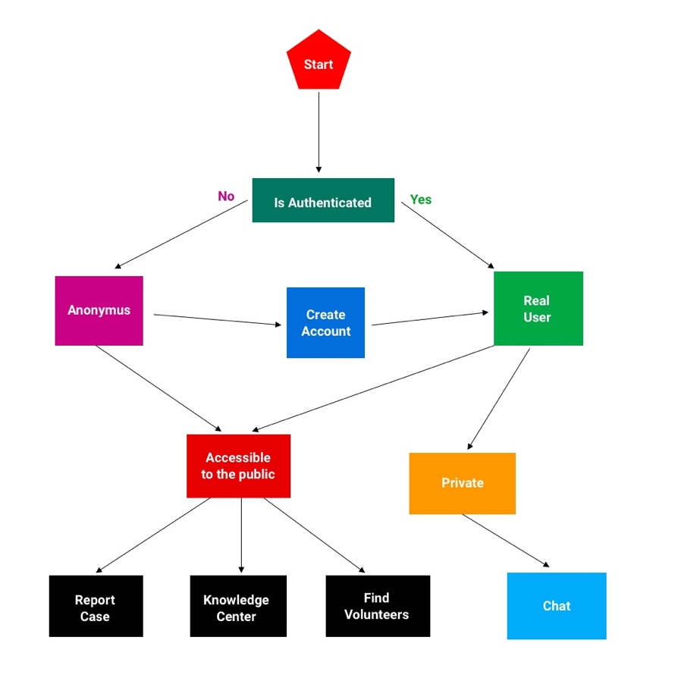

1. **Volunteers**

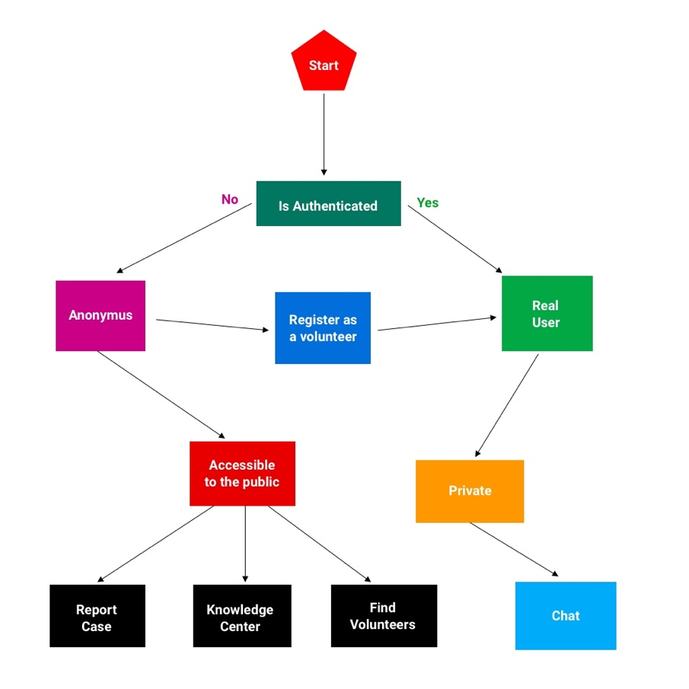

1. **Counselors**

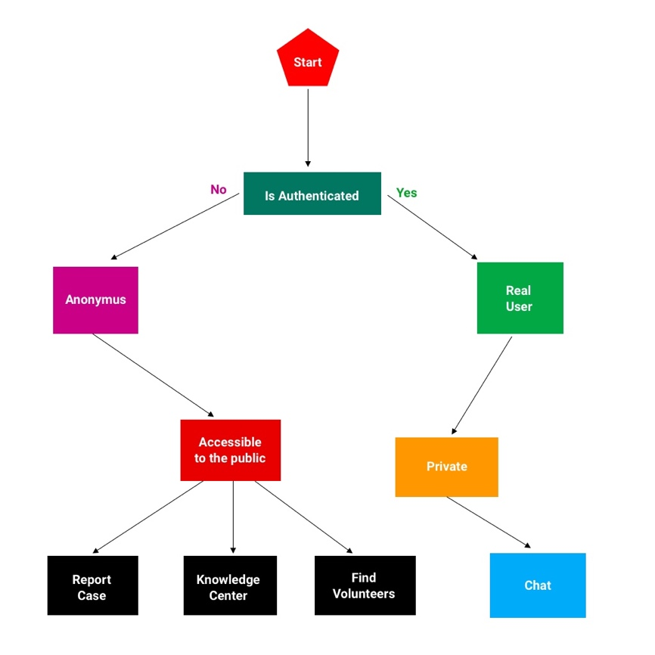

**System Requirements**

The following features shall be satisfied from the point of delivery.

|  |  |  |
| --- | --- | --- |
| **Feature** | **Objective** | **Status** |
| Login and registration for reporters | The system shall successfully onboard new users, authenticate existing users in a secure environment. |  |
| Login for counselors | The system shall successfully authenticate existing counselors for counseling through chats |  |
| Login and registration for volunteers | The system shall successfully onboard new volunteers, authenticate existing volunteers.  Their application process would be approved from the backend before gaining full access to the app. |  |
| Report a case (Call) | The system shall successfully allow users call the hotline |  |
| Report a case (Send a video) | The system shall successfully allow sending of videos from the phone library. |  |
| Report a case (Capture a video) | The system shall successfully allow capturing of a video with the device camera. |  |
| Report a case (Send audio) | The system shall successfully allow sending of audio files from the phone library. |  |
| Report a case (Record an audio) | The system shall successfully allow recording of audio through the app. |  |
| Chat | The system shall successfully allow users to chat with counselors, volunteers through the app. |  |
| Articles | The system shall successfully allow listing of articles for public awareness and consumption. |  |
| Videos | The system shall successfully allow listing of videos for public awareness and consumption. |  |
| Feedback | The system shall successfully allow feedback from the general public to be submitted. |  |
| 3rd party authentication | The system shall successfully allow login via Facebook. |  |
| Report a case (Text) | The system shall successfully allow reporting a case via text. |  |
| Tracking | The system shall successfully send signals to the web app for analysis.  Such as;   1. Services often requested 2. App usage 3. Article views 4. Video views |  |
| Password reset | The system shall successfully allow a user to reset forgotten passwords. |  |

**Conclusion**

We want to be sure that we covered all the builds for this version. Additions to this would incur additional fee with an extension to the agreed delivery date.

Please your acknowledgement is required before we begin development.

_______________ ______________

Signature Date

Acknowledged by

WekiWork Creative Lab

Issued by

08-Sep-2020

____________

Date Issued