Formula Reports Lib

List of reports (ReportType)
Sales_CreditCardTrans,
Sales_OverShortByBusinessDay,
Sales_SalesBySrvcType,
Sales_SalesSummary,
Sales_Voids,
History_CardPaymentsByType,
History_PaymentsBySrvcType,
History_SalesBySrvcType,
History_SalesOverview,
History_SalesUnitQty,
History_Voids,
History_EndOfDaySalesNumbers,
History_SalesByDay,
Employee_PayrollReport,
Employee_ActivityLog,
Employee_CashDrawerActivity,
Employee_DriverReimbursement,
Employee_LaborReport,
Customer_306090DaysSinceLastOrder,
Customer_CustomerCredits,
Customer_Customers,
Customer_NewCustomers,
Items_ItemSalesSummary,
Items_SalesByGroup,
AllSalesReport

Using the ReportsControl control
Reports Control Properties
ShowPrintButton | Show the Print button of the control
ParamDate | Can use to set a multiple date parameter  rptcontrol.ParamDate.Add(new ParamDate(dtpFrom.Value, ParameterCondition.AND));
Sales_CreditCardTrans | Credit Card Transaction report (see Report Methods)
Sales_OverShortByBusinessDay | Over Short By Business Day (see Report Methods)
Sales_SalesBySrvcType | Sales By Service Type (see Report Methods)
Sales_SalesSummary | Sales Summary (see Report Methods)
Sales_Voids | Voids (see Report Methods)
History_CardPaymentsByType | Card Payments By Type (see Report Methods)
History_PaymentsBySrvcType | Payments By Service Type (see Report Methods)
History_SalesBySrvcType | Sales By Service Type (see Report Methods)
History_SalesOverview | Sales Overview (see Report Methods)
History_SalesUnitQty | Sales Unit Qty (see Report Methods)
History_Voids | Voids (see Report Methods)
History_SalesByDay | Sales By Day (see Report Methods)
Employee_ActivityLog | Activity Log (see Report Methods)
Employee_LaborReport | Labor Report (see Report Methods)
Employee_CashDrawerActivity | Cash Drawer Activity (see Report Methods)
AllSalesReport | All Sales Report (see Report Methods)
MyReports | Array list collection of all reports

Report Control Methods
ShowPreview (Index) | Show preview report by index (see List of reports (ReportType))
ShowPreview (ReportType) | Show preview report by ReportType (see List of reports (ReportType))
Print (ReportType) | Print report by ReportType (see List of reports (ReportType))

Report Methods
ShowReport | Show report to the ReportsControl control
ShowReportDesigner | Show report to a separate window generated by DevExpress with ability to redesign the report
ShowPreviewReport | Show preview report to a separate window generated by DevExpress (view only)
ShowPreviewReportDialog | Show preview report in modal mode to a separate window generated by DevExpress (view only)
Print | Prints the report

ParamDate(DateTime, ParameterCondition) Parameters
Name | Data Type | Description
Date | DateTime | The value of the criteris
Parameter Condition | ParameterCondition | Query criteria condition (AND, OR)

Reference
using FormulaReportsLib;

Connection String Setup
Individual property
DatabaseConnectionSettings.User = "root";
DatabaseConnectionSettings.Password = "root";
DatabaseConnectionSettings.Database = comboBox3.SelectedItem.ToString();
DatabaseConnectionSettings.Port = "3306";
Or importing the whole connection string
DatabaseConnectionSettings.SetConnectionString = "server=Localhost;User Id=root;password=root;Persist Security Info=True;database=purepos";

Usage
//instantiate ReportsControl
ReportsControl rptcontrol = new ReportsControl();

//add control to the form
//you can add the control (report viewer) to any container
this.Controls.Add(rptcontrol);
rptcontrol.Dock = DockStyle.Fill;
//if you have a custom print button, set this to false
rptcontrol.ShowPrintButton = true;

//clear ParamDate first before adding new dates
rptcontrol.ParamDate.Clear();
rptcontrol.ParamDate.Add(new ParamDate(datepickerFrom.Value, ParameterCondition.AND));
rptcontrol.ParamDate.Add(new ParamDate(datepickerTo.Value, ParameterCondition.AND));

//generate report
rptcontrol.ShowPreview(ReportType.Employee_LaborReport);

Printing the report
//print report, if you have a custom print button
rptcontrol.Print(ReportType.Employee_LaborReport);

Prerequisites
These are the DLLs by DevExpress

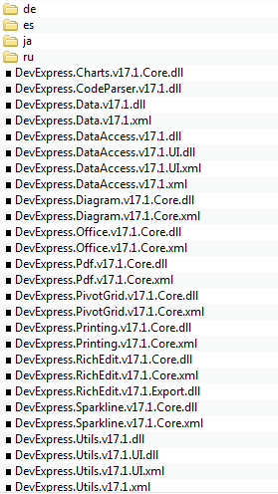
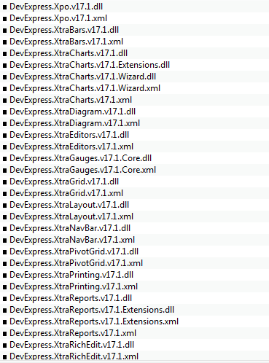
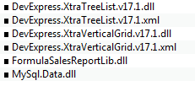

Required MySql database function (FormatDate)
This function is used by all queries to reformat the date from (m/d/yyyy, m-d-yyyy, etc) to yyyy/mm/dd general format.

DELIMITER $$

USE `purepos`$$

DROP FUNCTION IF EXISTS `FormatDate`$$

CREATE DEFINER=`root`@`localhost` FUNCTION `FormatDate`(StrDate TEXT, IncludeTime INT) RETURNS TEXT CHARSET utf8
BEGIN
DECLARE val TEXT;
IF LOCATE('.',StrDate) THEN
SET StrDate = SUBSTRING(StrDate,1,LOCATE('.',StrDate)-1);
END IF;
IF LOCATE('/',SUBSTRING(StrDate,1,5)) = 5 THEN
IF LOCATE(':',StrDate) > 1 THEN
IF LOCATE('AM',StrDate) > 1 OR LOCATE('PM',StrDate) > 1 THEN
SET val = STR_TO_DATE(StrDate, '%Y/%m/%d %h:%i:%s %p');
ELSE
SET val = STR_TO_DATE(StrDate, '%Y/%m/%d %H:%i:%s');
END IF;
ELSE
SET val = STR_TO_DATE(StrDate, '%Y/%m/%d');
END IF;
ELSEIF LOCATE('/',SUBSTRING(StrDate,1,5)) > 1 AND LOCATE('/',SUBSTRING(StrDate,1,5)) < 5 THEN
IF LOCATE(':',StrDate) > 1 THEN
IF LOCATE('AM',StrDate) > 1 OR LOCATE('PM',StrDate) > 1 THEN
SET val = STR_TO_DATE(StrDate, '%m/%d/%Y %h:%i:%s %p');
ELSE
SET val = STR_TO_DATE(StrDate, '%m/%d/%Y %H:%i:%s');
END IF;
ELSE
SET val = STR_TO_DATE(StrDate, '%m/%d/%Y');
END IF;
ELSE
IF LOCATE('-',SUBSTRING(StrDate,1,5)) = 5 THEN
IF LOCATE(':',StrDate) > 1 THEN
IF LOCATE('AM',StrDate) > 1 OR LOCATE('PM',StrDate) > 1 THEN
SET val = STR_TO_DATE(StrDate, '%Y-%m-%d %h:%i:%s %p');
ELSE
SET val = STR_TO_DATE(StrDate, '%Y-%m-%d %H:%i:%s');
END IF;
ELSE
SET val = STR_TO_DATE(StrDate, '%Y-%m-%d');
END IF;
ELSEIF LOCATE('-',SUBSTRING(StrDate,1,5)) > 1 AND LOCATE('-',SUBSTRING(StrDate,1,5)) < 5 THEN
IF LOCATE(':',StrDate) > 1 THEN
IF LOCATE('AM',StrDate) > 1 OR LOCATE('PM',StrDate) > 1 THEN
SET val = STR_TO_DATE(StrDate, '%m-%d-%Y %h:%i:%s %p');
ELSE
SET val = STR_TO_DATE(StrDate, '%m-%d-%Y %H:%i:%s');
END IF;
ELSE
SET val = STR_TO_DATE(StrDate, '%m-%d-%Y');
END IF;
ELSE
SET val = NULL;
END IF;
END IF;
IF IncludeTime = 1 THEN
RETURN DATE_FORMAT(val, '%Y/%m/%d %H:%i:%s');
ELSE
RETURN DATE_FORMAT(val, '%Y/%m/%d');
END IF;
END$$

DELIMITER ;

