DraftFirst
ER&SQL Report
Author: <Author name>
Revision: 1.0

<Your Company Name>
205 InTheMiddleOfNowhere, Denver,CO | Date: June 10, 2014

Revision History
Revision | Date | Reason For Changes | Author
0.1 | Jan 01, 1990 | <Initial draft> | <Author Name>
1.0 | Jan 02, 1990 | <Release> | <Author Name>
Table of Contents
Microsoft Word users please click here and press F9 to create Table of Contents.
OpenOffice.org users please remove this text and select Insert Table of Content from menu.
Table of Figures
Microsoft Word users please click here and press F9 to create Table of Contents.
OpenOffice.org users please remove this text and select Insert Table of Content from menu.
Executive Summary
This section previews the main points of a report. The executive summary contains enough information for a reader to get familiarized with what is discussed in the full report without having to read it.

Introduction

Purpose
<This document lists the ER and SQL model elements in the project - entities, their attributes and relationships (for ER); tables and their columns, keys, views, sequences, global operations, user-defined types, permissions (for SQL).>

Scope
<Provide a short description of the system being specified and its purpose, including relevant benefits, objectives, and goals.>

Overview
<Describe what the document contains and explain how the document is organized>

Tables

Table VISCLINVA.CLINVARSETID

Columns:
- fk_BMK:NA
- CLINVARSETID:NA
- IsRefernceID:NA
- CLINVARID:NA
- Active:boolean NOT NULL

Keys/Constraints/Indexes/Triggers:
- Foreign (anonymous): to table TRACKING, fk_BMK=TRACKING.BMK

Table VISCLINVA.DateCreated

Columns:
- fk_BMK:NA
- DATECREATED:date
- Active:boolean NOT NULL
- IsReferenceID:boolean NOT NULL
- fk_CLINVARID:varchar(255)

Keys/Constraints/Indexes/Triggers:
- Foreign (anonymous): to table TRACKING, fk_BMK=TRACKING.BMK

Table VISCLINVA.EVIDENCE

Columns:
- fk_BMK:NA
- EVI_CLINVARID:NA
- Active:boolean NOT NULL
- CLINVARREFID:NA

Keys/Constraints/Indexes/Triggers:
- Primary (anonymous): fk_BMK
- Foreign (anonymous): to table TRACKING, fk_BMK=TRACKING.BMK

Table VISCLINVA.GENENAME

Columns:
- fk_BMK:NA
- HUGO:varchar(255) NULL
- SYNONYMS:varchar(255) NULL
- CLINVARname:varchar(255) NOT NULL
- Active:boolean NOT NULL
- IsReferneceID:boolean NOT NULL

Keys/Constraints/Indexes/Triggers:
- Primary (anonymous): fk_BMK
- Foreign (anonymous): to table TRACKING, fk_BMK=TRACKING.BMK

Table VISCLINVA.LOCATION

Columns:
- fk_BMK:NA
- LOCATION:varchar(255)
- REFGENOME:varchar(255)
- ACCESSION:varchar(255)
- CHROMOSOME:varchar(255)
- START:varchar(255)
- STOP:varchar(255)
- Active:boolean NOT NULL
- IsReferenceID:boolean NOT NULL

Keys/Constraints/Indexes/Triggers:
- Primary (anonymous): fk_BMK
- Foreign (anonymous): to table TRACKING, fk_BMK=TRACKING.BMK

Table VISCLINVA.PHENOTYPES

Columns:
- fk_BMK:NA
- PHENOTYPETEXT:NA
- INTERPRETATION:NA
- DISEASENAME:NA NULL
- SIGNIFICANCE:varchar(255)
- STARNUM:varchar(255)
- Active:boolean NOT NULL
- IsReferenceID:boolean NOT NULL
- NA:NA

Keys/Constraints/Indexes/Triggers:
- Primary (anonymous): fk_BMK, NA
- Foreign (BMKs): to table TRACKING, fk_BMK=TRACKING.BMK

Table VISCLINVA.SUBMISSION

Columns:
- fk_BMK:NA
- SUBMITTER:NA
- DATE:date
- Active:NA NOT NULL

Keys/Constraints/Indexes/Triggers:
- Foreign (anonymous): to table TRACKING, fk_BMK=TRACKING.BMK

Table VISCLINVA.TABLENAMEMAP

Columns:
- TableName:NA
- DateAdded:NA
- MapName:NA
- MapNameRemapped:NA
- TableMeaning:NA

Keys/Constraints/Indexes/Triggers:

Table VISCLINVA.TRACKING

Columns:
- BMK:NA
- CLINVARID:varchar(255) NOT NULL
- BATCHID:bigint
- UPDATEDATE:date
- Active:boolean NOT NULL
- IsReferenceID:boolean NOT NULL
- CLINVARSETID:NA

Keys/Constraints/Indexes/Triggers:
- Primary (anonymous): BMK

Table VISCLINVA.TYPE

Columns:
- fk_BMK:NA
- TYPE:NA
- SEQCHANGE:NA
- SEQ_NONVARIENT:NA
- SEQ_VARIENT:NA
- Active:boolean NOT NULL
- IsReferenceID:boolean NOT NULL

Keys/Constraints/Indexes/Triggers:
- Foreign (anonymous): to table TRACKING, fk_BMK=TRACKING.BMK

Sequences

Sequence VISCLINVA.BMKNUM
increment=1

Appendix A: Diagram

VISCLINVA
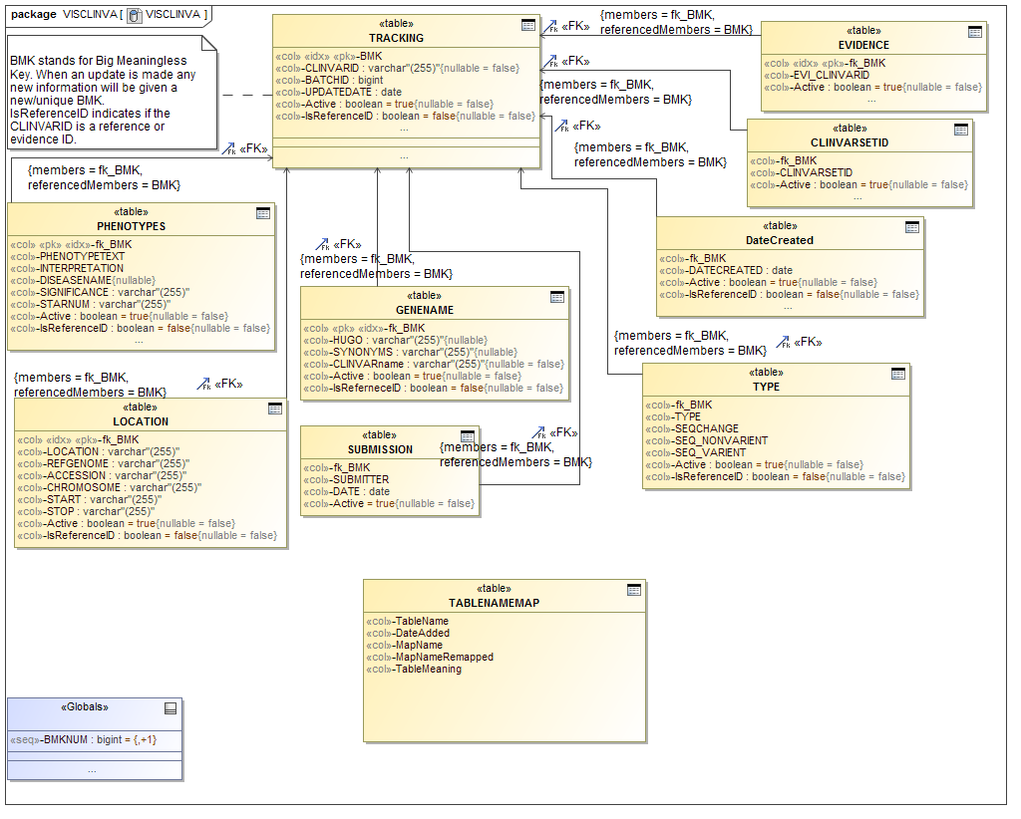
- VISCLINVA

