1. Download the package from Baidu Cloud and unzip it:

*Link：<https://pan.baidu.com/s/1-FISC8f2qd7EaaY_1TuhiQ?pwd=nx1t>*

*Code：nx1t*

*Multi.rar ---ADHD*

*Deep WSANTF.rar---Abide*

1. Before running the program, please make sure the following software is installed(requirement.txt):
2. CUDA Compilation Tools: Release 11.1, V11.1.74  
   Build: cuda_11.1.relgpu_drvr455TC455_06.29069683_0
3. JDK: 1.8.0_202
4. Python Version: 3.8.7
5. TensorFlow Version: 2.4.3
6. tkinter
7. pandas Version: 1.2.1
8. matplotlib Version: 3.5.2
9. Keras Version: 2.4.3
10. nibabel Version: 3.2.1
11. PIL (Pillow) Version: 8.4.0
12. SimpleITK Version: 2.1.1
13. scipy Version: 1.7.1
14. numpy Version: 1.19.5
15. scikit-learn Version: 1.0.1
16. hyperopt Version: 0.2.5
17. scikit-multilearn (skmultilearn)
18. Please place the MRI data in the ***dist/rawdata/data*** directory, and the corresponding diagnostic information in the ***dist/participants.tsv*** file.  
    **Note:**
19. The ***participant_id*** must be in the second column, and
20. The ***dx_group*** (diagnostic group) must be in the fourth column.  
    All other columns are irrelevant and will not be used.
21. Double click **Deep_WSANTF.exe** and **wait** to finish (about several hours)

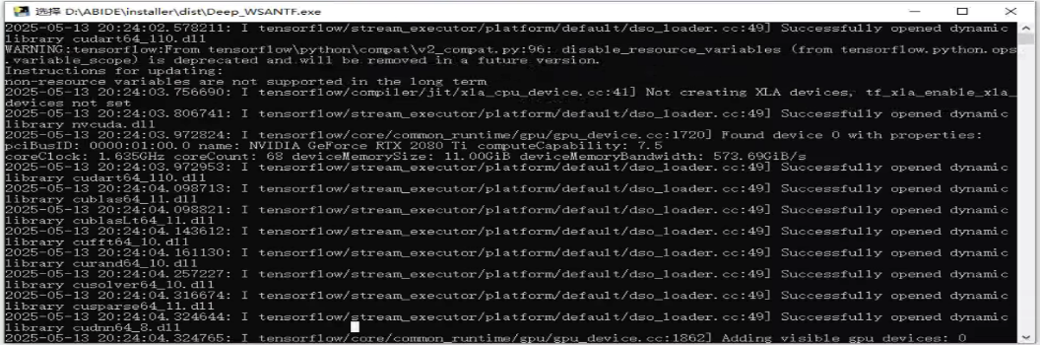

Go into the path: “**dist\processed_Deep_WSANTF**”, which contains the extracted factor matrices.

1. Open the **CMD,** go into the folder which contains the **Deep_WSANTF.jar** file, and run the following java command:

C:\Users\PC\Documents\Tencent Files\112174113\FileRecv\MobileFile\Image\]AG)$QI)9[OGHKXGP0%0TBH.png

java -jar Deep_WSANTF.jar com.alcol.BuildDataset

Go into the path: “**dist\processed_Deep_WSANTF**”, you can find the four files: rows.csv, columns.csv, zs.csv and ncs.csv

Note: the version of jar file for multi-class-labels should be “Deep_WSANTF_mult.jar” and “**dist/multi**”. The executing way follows the same way with “single”. Please place the ADHD data in this directory and ensure that the file naming is consistent with that of "Abide".

1. Copy the file “kerasmulti_final_5fold.py” to the folder: “**dist\processed_Deep_WSANTF**”, and run it:

Python kerasmulti_final_5fold.py

Note: you can run this test script for ABIDE (BNI: in “dist\processed_Deep_WSANTF”) and ADHD (NeuroImage: processed_Deep_WSANTF(NeuroImage))

Note: **After processing a dataset, ensure to move/rename the processed dataset data (including processed, rawdata, and diagnostic files) to another directory.**

Have fun and Enjoy it! Any issues please could you kindly contact me at *hengjin.ke@whu.edu.cn*