**Ctm部署文档**

**1.**版本(推荐): apache-tomcat-8.5.45

下载tomcat8.5,配置环境变量,环境变量配置如下**：**

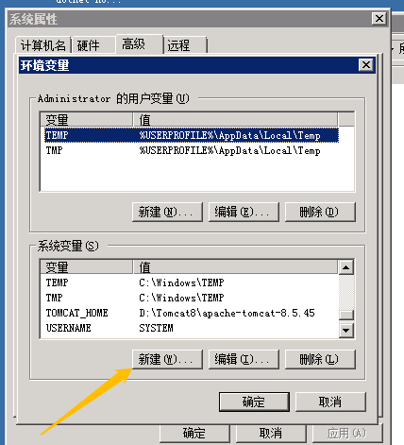

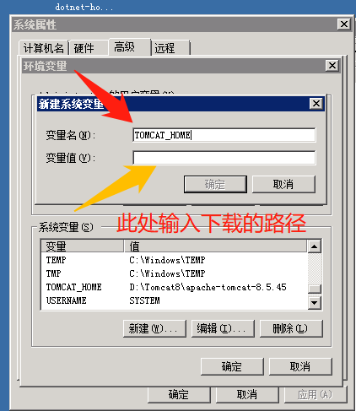

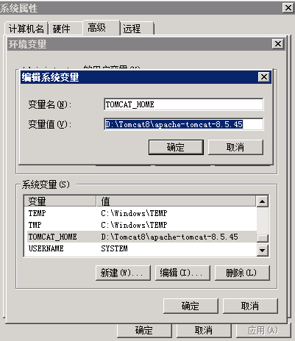

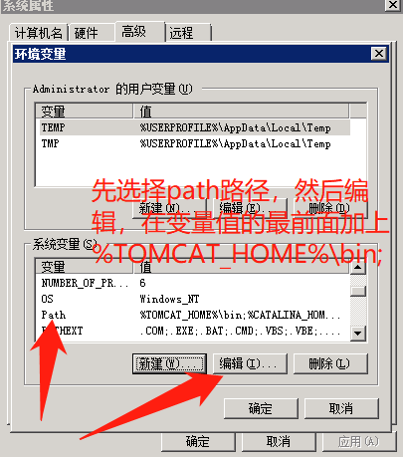

将已经打好的Java war包保存(有多个war包)

点开tomcat进入如下图界面

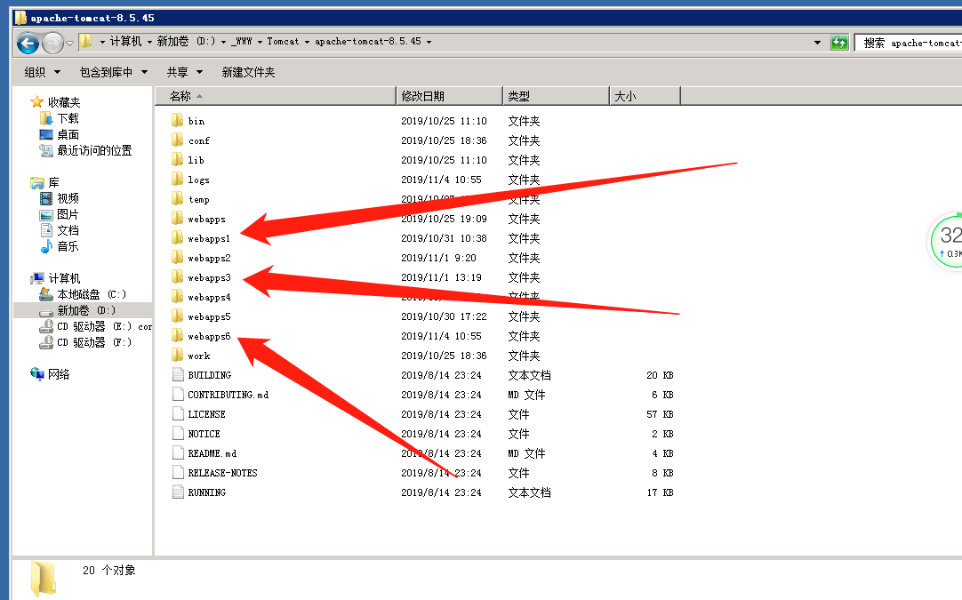

如图，将webapps复制6份，分别命名webapps1...webapps6,

然后将webapps删除

然后点击conf，如图

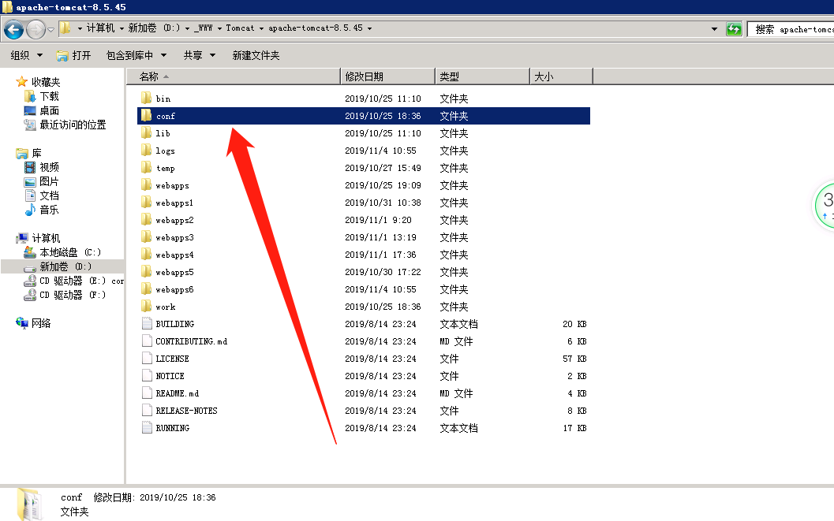

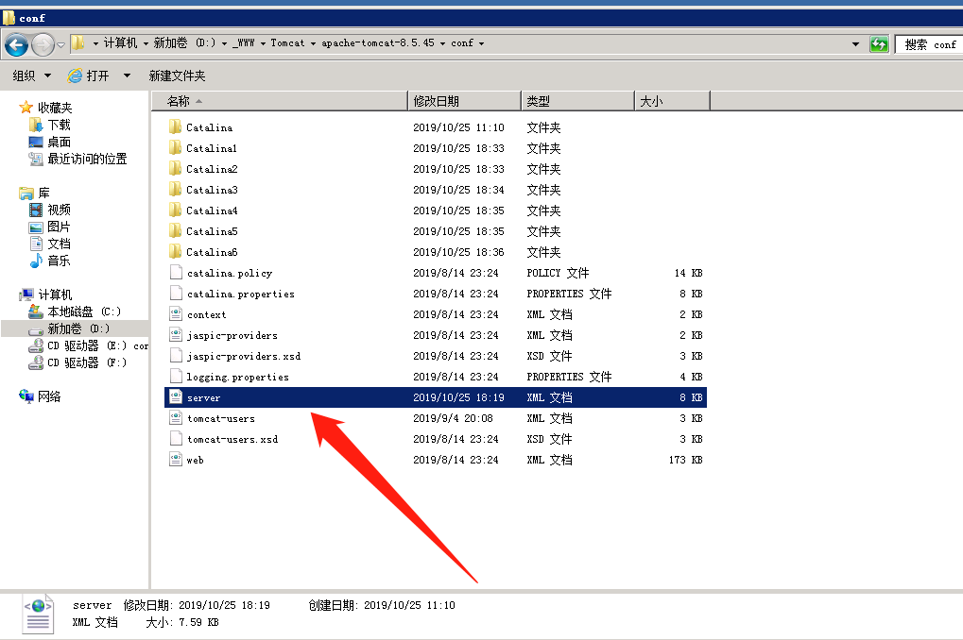

点击server.xml编辑

将以下的覆盖保存

<?xml version="1.0" encoding="UTF-8"?>

<Server port="8005" shutdown="SHUTDOWN">

<Listener className="org.apache.catalina.startup.VersionLoggerListener" />

<Listener className="org.apache.catalina.core.AprLifecycleListener" SSLEngine="on" />

<!-- Prevent memory leaks due to use of particular java/javax APIs-->

<Listener className="org.apache.catalina.core.JreMemoryLeakPreventionListener" />

<Listener className="org.apache.catalina.mbeans.GlobalResourcesLifecycleListener" />

<Listener className="org.apache.catalina.core.ThreadLocalLeakPreventionListener" />

<GlobalNamingResources>

<Resource name="UserDatabase" auth="Container"

type="org.apache.catalina.UserDatabase"

description="User database that can be updated and saved"

factory="org.apache.catalina.users.MemoryUserDatabaseFactory"

pathname="conf/tomcat-users.xml" />

</GlobalNamingResources>

<Service name="Catalina1">

<Connector port="9091" protocol="HTTP/1.1"

connectionTimeout="20000" URIEncoding="UTF-8"

redirectPort="8444" />

<Connector port="8010" protocol="AJP/1.3" redirectPort="8444" />

<Engine name="Catalina1" defaultHost="localhost">

<Realm className="org.apache.catalina.realm.LockOutRealm">

<Realm className="org.apache.catalina.realm.UserDatabaseRealm"

resourceName="UserDatabase"/>

</Realm>

<Host name="localhost" appBase="webapps1"

unpackWARs="true" autoDeploy="true">

<Valve className="org.apache.catalina.valves.AccessLogValve" directory="logs"

prefix="localhost_access_log" suffix=".txt"

pattern="%h %l %u %t &quot;%r&quot; %s %b" />

<Context path="" docBase="ctm_main" reloadable="true" ></Context>

</Host>

</Engine>

</Service>

<Service name="Catalina2">

<Connector port="9092" protocol="HTTP/1.1"

connectionTimeout="20000" URIEncoding="UTF-8"

redirectPort="8445" />

<Connector port="8011" protocol="AJP/1.3" redirectPort="8445" />

<Engine name="Catalina2" defaultHost="localhost">

<Realm className="org.apache.catalina.realm.LockOutRealm">

<Realm className="org.apache.catalina.realm.UserDatabaseRealm"

resourceName="UserDatabase"/>

</Realm>

<Host name="localhost" appBase="webapps2"

unpackWARs="true" autoDeploy="true">

<Valve className="org.apache.catalina.valves.AccessLogValve" directory="logs"

prefix="localhost_access_log" suffix=".txt"

pattern="%h %l %u %t &quot;%r&quot; %s %b" />

<Context path="" docBase="ctm_user" reloadable="true" ></Context>

</Host>

</Engine>

</Service>

<Service name="Catalina3">

<Connector port="9093" protocol="HTTP/1.1"

connectionTimeout="20000" URIEncoding="UTF-8"

redirectPort="8446" />

<Connector port="8012" protocol="AJP/1.3" redirectPort="8446" />

<Engine name="Catalina3" defaultHost="localhost">

<Realm className="org.apache.catalina.realm.LockOutRealm">

<Realm className="org.apache.catalina.realm.UserDatabaseRealm"

resourceName="UserDatabase"/>

</Realm>

<Host name="localhost" appBase="webapps3"

unpackWARs="true" autoDeploy="true">

<Valve className="org.apache.catalina.valves.AccessLogValve" directory="logs"

prefix="localhost_access_log" suffix=".txt"

pattern="%h %l %u %t &quot;%r&quot; %s %b" />

<Context path="" docBase="ctm_api" reloadable="true" ></Context>

</Host>

</Engine>

</Service>

<Service name="Catalina4">

<Connector port="9094" protocol="HTTP/1.1"

connectionTimeout="20000" URIEncoding="UTF-8"

redirectPort="8447" />

<Connector port="8013" protocol="AJP/1.3" redirectPort="8447" />

<Engine name="Catalina4" defaultHost="localhost">

<Realm className="org.apache.catalina.realm.LockOutRealm">

<Realm className="org.apache.catalina.realm.UserDatabaseRealm"

resourceName="UserDatabase"/>

</Realm>

<Host name="localhost" appBase="webapps4"

unpackWARs="true" autoDeploy="true">

<Valve className="org.apache.catalina.valves.AccessLogValve" directory="logs"

prefix="localhost_access_log" suffix=".txt"

pattern="%h %l %u %t &quot;%r&quot; %s %b" />

<Context path="" docBase="ctm_finance" reloadable="true" ></Context>

</Host>

</Engine>

</Service>

<Service name="Catalina5">

<Connector port="9095" protocol="HTTP/1.1"

connectionTimeout="20000" URIEncoding="UTF-8"

redirectPort="8448" />

<Connector port="8014" protocol="AJP/1.3" redirectPort="8448" />

<Engine name="Catalina5" defaultHost="localhost">

<Realm className="org.apache.catalina.realm.LockOutRealm">

<Realm className="org.apache.catalina.realm.UserDatabaseRealm"

resourceName="UserDatabase"/>

</Realm>

<Host name="localhost" appBase="webapps5"

unpackWARs="true" autoDeploy="true">

<Valve className="org.apache.catalina.valves.AccessLogValve" directory="logs"

prefix="localhost_access_log" suffix=".txt"

pattern="%h %l %u %t &quot;%r&quot; %s %b" />

<Context path="" docBase="ctm_report" reloadable="true" ></Context>

</Host>

</Engine>

</Service>

<Service name="Catalina6">

<Connector port="9090" protocol="HTTP/1.1"

connectionTimeout="20000" URIEncoding="UTF-8"

redirectPort="8449" />

<Connector port="8015" protocol="AJP/1.3" redirectPort="8449" />

<Engine name="Catalina6" defaultHost="localhost">

<Realm className="org.apache.catalina.realm.LockOutRealm">

<Realm className="org.apache.catalina.realm.UserDatabaseRealm"

resourceName="UserDatabase"/>

</Realm>

<Host name="localhost" appBase="webapps6"

unpackWARs="true" autoDeploy="true">

<Valve className="org.apache.catalina.valves.AccessLogValve" directory="logs"

prefix="localhost_access_log" suffix=".txt"

pattern="%h %l %u %t &quot;%r&quot; %s %b" />

<Context path="" docBase="ctm_apply" reloadable="true" ></Context>

</Host>

</Engine>

</Service>

</Server>

保存server.xml，

然后在webapps1-webapps6依次按顺序保存各自的war包

ctm_main.war, ctm_user.war,ctm_api,ctm_finance.war,ctm_report,ctm_apply依次放入webapps1-webapps6下如图

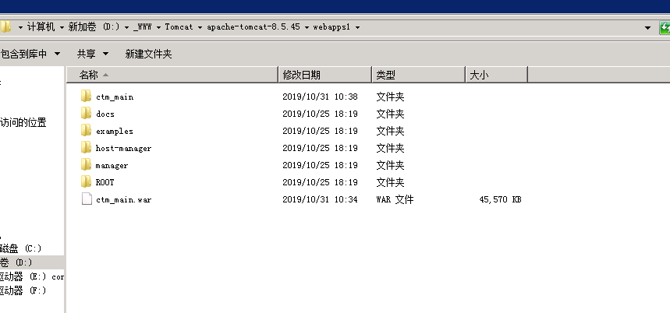

如果没有配置环境变量,在bin目录下点击startup的文件运行.

如果已经配置环境变量了,在桌面创建一个.bat的文件，然后编辑内容为：startup 双击该文件会启动项目.

可以将此文件加载在服务器开机自启中~…

也可以将这个进程加载成服务。