BCG Matrix:

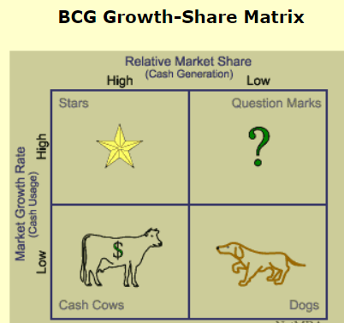

Also referred to as the product portfolio matrix, is a business planning tool used to evaluate the strategic position of a firm’s brand portfolio.

Each quadrant is classified as low or high performance, depending on the relative market share and market growth rate.

The horizontal axis of the BCG Matrix represents the amount of market share of a product and its strength in the particular market.

The vertical axis of the BCG Matrix represents the growth rate of a product and its potential to grow in a particular market.

Question marks: Products with high market growth but a low market share.

Question marks are the most managerially intensive products and require extensive investment and resources to increase their market share. Investments in question marks are typically funded by cash flows from the cash cow quadrant.

Stars: Products with high market growth and a high market share.

Products in the stars quadrant are market-leading products and require significant investment to retain their market position, boost growth, and maintain a competitive advantage.

Cash cows: Products with low market growth but a high market share.

Products in the cash cows quadrant are thought of as products that are leaders in the marketplace. The products already have a significant amount of investments in them and do not require significant further investments to maintain their position. Cash flows generated by cash cows are high and are generally used to finance stars and question marks.

Dogs: Products with low market growth and a low market share.

It is considered a dog and should be sold, liquidated, or repositioned. Dogs, found in the lower right quadrant of the grid, don't generate much cash for the company since they have a low market share and little to no growth. Because of this, dogs can turn out to be cash traps, tying up company funds for long periods of time.

Market Competition:  
It consists of four types: perfect competition, oligopoly markets, monopoly markets, and monopolistic competition.

Market structure refers to the way that various industries are classified and differentiated in accordance with their degree and nature of competition for products and services.

When a market is competitive, businesses will have greater incentives to lower prices, to improve the quality of their products and services, and to provide buyers with more options.

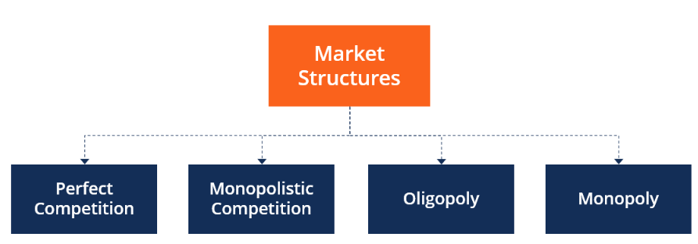

* It is common to differentiate these markets across the following seven distinct features:

1. The industry’s buyer structure
2. The turnover of customers
3. The extent of product differentiation
4. The nature of costs of inputs
5. The number of players in the market
6. The largest player’s market share

Types of Market Structures

1. Perfect Competition:

In a marketplace with perfect competition, suppliers are price takers rather than price makers. The necessary characteristics for a market condition of perfect competition are as follows:

Prices in the marketplace are essentially controlled by the basic economic forces of supply and demand. In particular, sellers do not have any significant ability to control the prices of their goods or services.

Many different companies sell identical, or nearly identical, products or services. It means that buyers have several choices when making purchases; **having many suppliers of identical products is key to perfect competition**.

They sell similar products (homogeneous), lack price influence over the commodities, and are free to enter or exit the market.

Consumers in this type of market have full knowledge of the goods being sold. They are aware of the prices charged on them and the product branding. In the real world, the pure form of this type of market structure rarely exists. However, it is useful when comparing companies with similar features.

This market is unrealistic as it faces some significant criticisms described below:

• No incentive for innovation: In the real world, if competition exists and a company holds a dominant market share, there is a tendency to increase innovation to beat the competitors and maintain the status quo. However, in a perfectly competitive market, the profit margin is fixed, and sellers cannot increase prices, or they will lose their customers.

* There are very few barriers to entry: Any company can enter the market and start selling the product. Therefore, incumbents must stay proactive to maintain market share

1. Imperfect Competition Market Structures

Imperfect competition often results from a marketplace where there are many sellers. Still, they are all selling unique goods or goods that are substantially dissimilar to any goods sold by their competitors.

Several companies have roughly equal market shares, which is another factor that prevents a single supplier from being able to control market prices.

Market information is readily available and transparent – buyers have easy access to complete information about the products or services they wish to purchase.

The industry that provides goods or services to the marketplace has relatively little or no barriers to entry for potential new suppliers. It helps to ensure that the market has many suppliers, thus making it more competitive.

------

Market structures that effectively render competition imperfect are most often characterized by a lack of competitive suppliers. Imperfect competition often exists as a result of extremely high barriers to entry for new suppliers. For example, the airline industry has high barriers to entry due to the extremely high cost of aircraft.

The most extreme condition of imperfect competition exists when the market for a particular good or service is a **monopoly**, one in which there is a sole supplier. A supplier that has a monopoly on the provision of a good or service essentially has complete control over prices. Because it has no competition from other suppliers, the sole supplier can essentially set the price of its goods or services at any level it desires. Monopolies often charge prices that provide them with significantly higher profit margins than most companies operate with.

A **duopoly** is a market structure in which there are only two suppliers. Although duopolies are somewhat more competitive than monopolies, the level of competition is still far from perfect, as the two suppliers still have significant control of marketplace prices. An example of a duopoly exists in the United Kingdom’s detergent market, where Procter & Gamble (NYSE: PG) and Unilever (NYSE: UL) are virtually the only suppliers. The two suppliers in a duopoly often collude in price setting.

**Oligopolies** are much more common than either monopolies or duopolies. In an oligopoly, there are several – but a small, limited number – of suppliers. The market for cell phone service in the United States is an example of an oligopoly, as it is essentially controlled by just a handful of suppliers. The small number of suppliers, which limits buying choices for consumers, provides the suppliers with substantial, although not complete, control over pricing.

A rare form of imperfect competition is **a monopsony**. A monopsony is a single buyer, rather than any supplier, who has great control over market prices. Government entities often enjoy a monopsony position.

For example, the central government in any country is usually the sole buyer of certain military equipment. There may be multiple manufacturers selling such goods, but all the sellers are basically at the mercy of whatever price the government is willing to pay for the goods.

1. Monopolistic Competition:

Monopolistic competition exists when many companies offer competing products or services that are similar, but not perfect, substitutes.

The barriers to entry in a monopolistic competitive industry are low, and the decisions of any one firm do not directly affect its competitors.

The competing companies differentiate themselves based on pricing and marketing decisions.

Monopolistic competition exists between a monopoly and perfect competition, combines elements of each, and includes companies with similar, but not identical, product offerings.

Examples:

Restaurants, hair salons, household items, and clothing are examples of industries with monopolistic competition. Items like dish soap or hamburgers are sold, marketed, and priced by many competing companies.

What Is the Difference Between Monopolistic Competition and Perfect Competition?

In perfect competition, the product offered by competitors is the same item. If one competitor increases its price, it will lose all of its market share to the other companies based on market supply and demand forces, where prices are not set by companies and sellers accept the pricing determined by market activity.

In monopolistic competition, supply and demand forces do not dictate pricing. Firms are selling similar, yet distinct products, so firms determine the pricing. Product differentiation is the key feature of monopolistic competition, where products are marketed by quality or brand. Demand is highly elastic, and any change in pricing can cause demand to shift from one competitor to another.

