Chapter 3

3.1. Define the following terms as they apply to the relational model of data: domain, attribute, n-tuple, relation schema, relation state, degree of a relation, relational database schema, and relational database state.

3.3. Why are duplicate tuples not allowed in a relation?

3.4. What is the difference between a key and a superkey?

3.6. Discuss the characteristics of relations that make them different from ordinary tables and files.

3.8. Discuss the entity integrity and referential integrity constraints. Why is each considered important?

3.9. Define foreign key. What is this concept used for?

3.11. Suppose that each of the following Update operations is applied directly to the database state shown in Figure 3.6. Discuss all integrity constraints violated by each operation, if any, and the different ways of enforcing these constraints.

b. Insert <‘ProductA’, 4, ‘Bellaire’, 2> into PROJECT.

c. Insert <‘Production’, 4, ‘943775543’, ‘2007-10-01’> into DEPARTMENT.

e. Insert <‘453453453’, ‘John’, ‘M’, ‘1990-12-12’, ‘spouse’> into DEPENDENT.

f. Delete the WORKS_ON tuples with Essn= ‘333445555’.

h. Delete the PROJECT tuple with Pname= ‘ProductX’.

i. Modify the Mgr_ssn and Mgr_start_date of the DEPARTMENT tuple with Dnumber= 5 to ‘123456789’ and ‘2007-10-01’, respectively.

k. Modify the Hours attribute of the WORKS_ON tuple with Essn= ’999887777’ and Pno= 10 to ‘5.0’.

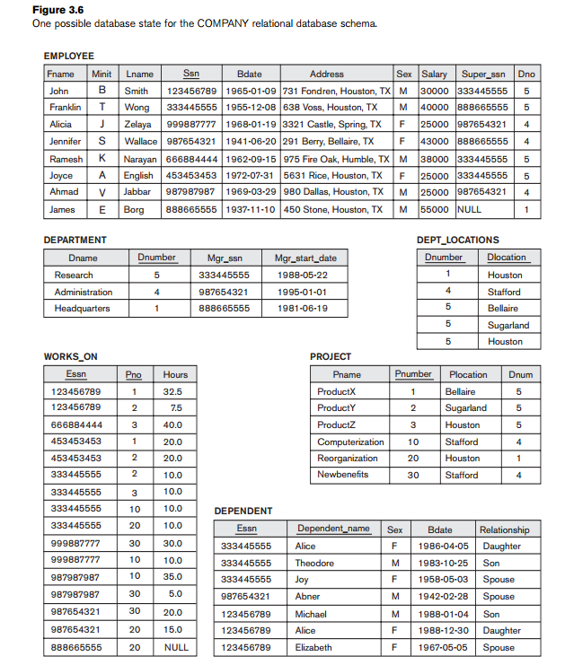

3.12. Consider the AIRLINE relational database schema shown in Figure 3.8, which describes a database for airline flight information. Each FLIGHT is identified by a Flight_number, and consists of one or more FLIGHT_LEGs with Leg_numbers 1, 2, 3, and so on. Each FLIGHT_LEG has scheduled arrival and departure times, airports, and one or more LEG_INSTANCEs—one for each Date on which the flight travels. FAREs are kept for each FLIGHT. For each FLIGHT_LEG instance, SEAT_RESERVATIONs are kept, as are the AIRPLANE used on the leg and the actual arrival and departure times and airports. An AIRPLANE is identified by an Airplane_id and is of a particular AIRPLANE_TYPE. CAN_LAND relates AIRPLANE_TYPEs to the AIRPORTs at which they can land. An AIRPORT is identified by an Airport_code. Consider an update for the AIRLINE database to enter a reservation on a particular flight or flight leg on a given date.

a. Give the operations for this update.

b. What types of constraints would you expect to check?

c. Which of these constraints are key, entity integrity, and referential integrity constraints, and which are not?

d. Specify all the referential integrity constraints that hold on the schema shown in Figure 3.8.

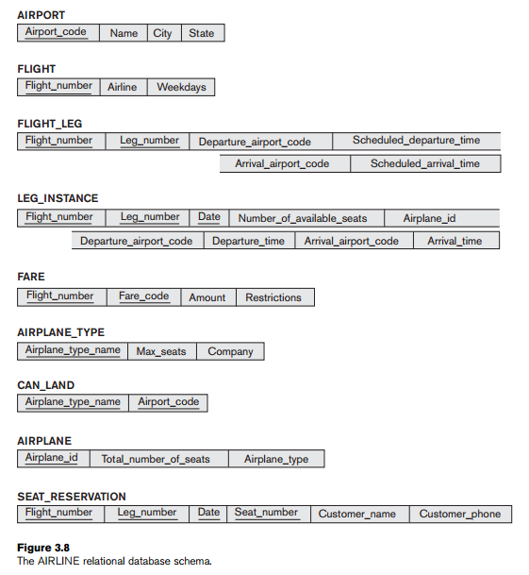

3.17. Consider the following relations for a database that keeps track of automobile sales in a car dealership (OPTION refers to some optional equipment installed on an automobile):

CAR (Serial_no, Model, Manufacturer, Price)

OPTION (Serial_no, Option_name, Price)

SALE (Salesperson_id, Serial_no, Date, Sale_price)

SALESPERSON (Salesperson_id, Name, Phone)

First, specify the foreign keys for this schema, stating any assumptions you make. Next, populate the relations with a few sample tuples, and then give an example of an insertion in the SALE and SALESPERSON relations that violates the referential integrity constraints and of another insertion that does not.

3.19. Consider a STUDENT relation in a UNIVERSITY database with the following attributes (Name, Ssn, Local_phone, Address, Cell_phone, Age, Gpa). Note that the cell phone may be from a different city and state (or province) from the local phone. A possible tuple of the relation is shown below:

Name Ssn Local_phone Address Cell_phone Age Gpa

George Shaw 123-45-6789 555-1234 123 Main St., 555-4321 19 3.75

William Edwards Anytown,

CA 94539

a. Identify the critical missing information from the Local_phone and Cell_phone attributes. (Hint: How do you call someone who lives in a different state or province?)

b. Would you store this additional information in the Local_phone and Cell_phone attributes or add new attributes to the schema for STUDENT?

c. Consider the Name attribute. What are the advantages and disadvantages of splitting this field from one attribute into three attributes (first name, middle name, and last name)?

d. What general guideline would you recommend for deciding when to store information in a single attribute and when to split the information?

e. Suppose the student can have between 0 and 5 phones. Suggest two different designs that allow this type of information.

Chapter 9

Map the EER schema in Figure 8.12 (P278) and Figure 8.7 (P255) into a Relational Data Model. Clearly state the mapping rules and steps.

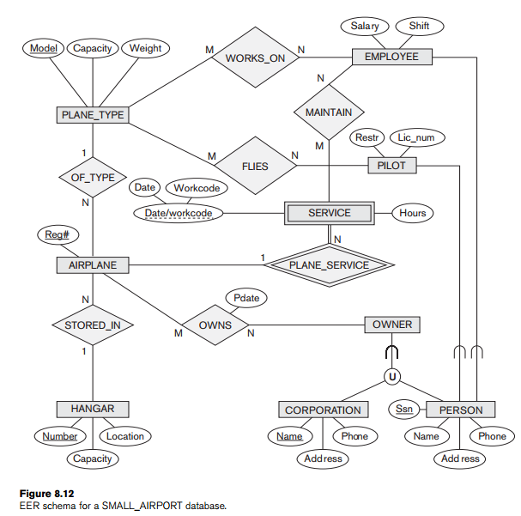

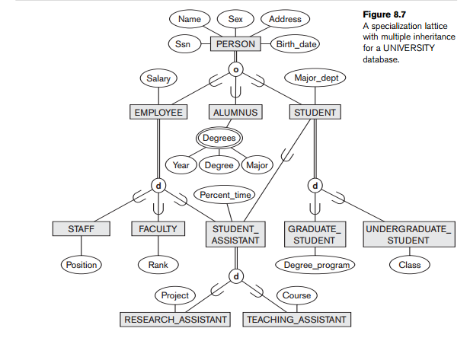

Chapter 6

6.2. What is union compatibility? Why do the UNION, INTERSECTION, and DIFFERENCE operations require that the relations on which they are applied be union compatible?

6.16. Specify the following queries on the COMPANY relational database schema shown in Figure 5.5, using the relational operators discussed in this chapter. Also show the result of each query as it would apply to the database state in Figure 3.6.

a. Retrieve the names of all employees in department 5 who work more than

10 hours per week on the ProductX project.

b. List the names of all employees who have a dependent with the same first name as themselves.

d. For each project, list the project name and the total hours per week (by all employees) spent on that project.

e. Retrieve the names of all employees who work on every project.

f. Retrieve the names of all employees who do not work on any project.

g. For each department, retrieve the department name and the average salary of all employees working in that department.

i. Find the names and addresses of all employees who work on at least one project located in Houston but whose department has no location in Houston.

j. List the last names of all department managers who have no dependents.

