Project for Database Design

Phase I. EER Design

Cong Wang cxw133030@utdallas.edu
Chulei Wu cxw132530@utdallas.edu
Ruili Yao rxy121130@utdallas.edu

(Week 1-6: Jan.13-Feb.17)

0. Pre-Illumination
For clearly describing the EER design, we separate this report into three parts. In Part 1, we specify the assumptions, explanations and limitations of the whole project, in Part 2 we draw the EER diagram in details, and in Part 3 we give the explanation of (min, max) notation for all the relationship appearing in EER diagram. Finally, a short summary will be given at the end of this report.

1. Assumptions, Explanations and Limitations
In this part we discuss all the assumptions, explanations and limitations in this project to illuminate our EER diagram, based on both the project description and real life experiences.
1.1 Assumption
- A lab must have at least a person
- If a person join in one lab or a lab have a people, then he/she is a people of lab , we create a entity PEOPLE
- A people can be a faculty, a student or a employee
- A faculty has his unique faculty id
- A student has his unique student id
- employee has his unique employee id
- Faculty id, student id and employee id are different with each other
- Users can be faculties or students and have unique USER_ID which equals to the ID of faculties or students
- Event holders can only be faculties or employees and have unique HOLDER_ID which equals to the ID of faculties or employees
- An equipment can only be possessed by a lab
- Every sponsor need to support at least one lab
- A lab can have multiple sponsors or no sponsor
- These events may be held in different rooms, we add an attribute room number
- A student’s friend who is not in the university is presented as a weak entity
- A corresponding friend can only be taken by one student
- Experiment should be conducted or analyzed by at lease one user
- Experiment result is presented as a weak entity, because it can not exist without experiments
- An employee can manage several financial transaction or not
- A financial transaction can only be managed by one employee
- Each funding is given by a specific sponsor

  - Explanation (This is to explain all subclass/union you made for your EER)
- Union of User:
We think that User should be the union of faculties and students. According to the statement: “Users can be faculties or students”. So User could be either of them, which means user is a subset of the union of faculties and students.
- Union of people:
We think that lab member should be the union of entity student, faculty and employee.According to the statement: “ Three kinds of person are allowed to access the laboratory: Faculty, Student and Employee”. So lab member could be any of them, which means lab member is a subset of the union of faculties ,students and employees.
- Union of Event holder :
We think that event holder should be the union of employees and faculties .According to the statement: “ Event Holders can be faculties or employees”. So event holder could be either of them, which means event holder is a subset of the union of faculties and employees.
- Subclasses of financial transaction:
According to the statement:”There are three kinds of financial transaction in the lab. The first part is Experiment Cost.The second part is Fine. The third part is Funding.” So financial transaction is the superclass and the three entity are the subclasses .We use an entity named Financial Transaction to represent the superclass, and three entities named Experiment Cost , Fine and Funding to represent the subclasses.

1.3 Limitations (list all limitations you made for your EER)
There are some limitations both from title statement and from daily life. We list them as follows:
- The unique Lab_ID from “L000” to “L999”.
- The name of person includes First Name, Mid Name and Last Name.
- A person can have more than one phone number.
- A person can have multiple Emails.
- The degree program can only be “B.S.”, “M.S.” or “Ph.D.”.
- The unique equipment ID is from “EQ00000” to “EQ99999”.
- The type of an equipment can be “computer”, “projector”, “server” or “router”.
- The status of an equipment is only “Available” or “In use”.
- The evaluation score varies from 1 to 10.
- The unique experiment ID is from “EXP00000” to “EXP99999”.
- Serial number of experiment result from 00 to 99.
- Score of experiment result from 0 to 100.
- Transaction ID from T00000 to T99999.

2. EER Design Diagram
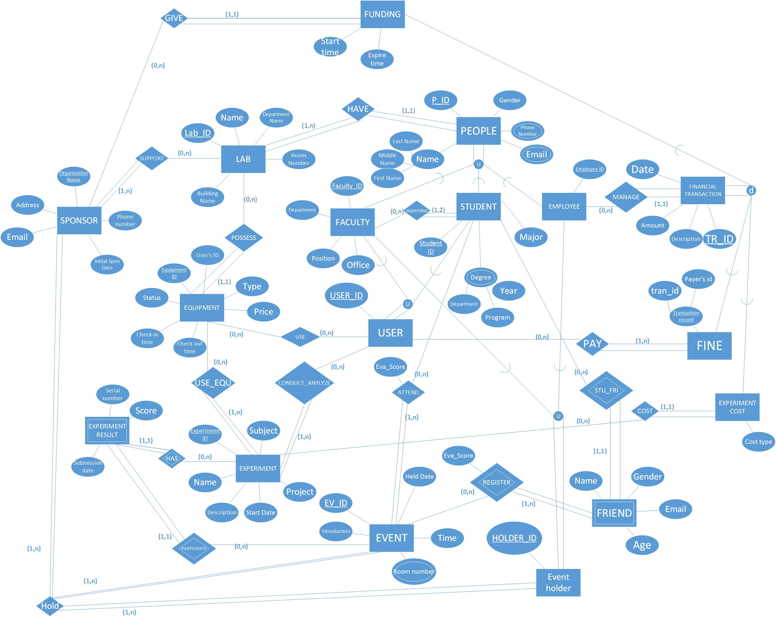
In this part we draw an EER design diagram with common notation introduced from textbook. Figure 1 exhibits the whole design as follows:

Figure 1

3. (Min, Max) Notation for Relationship
In this part we discuss the (min, max) notation for several relationships exist in our EER design diagram. Table 1 clearly specifies how the numerical expression corresponds to the relationship between two entities.

Table 1. Explanation for (Min, Max) Notation
Numerical Expression | Discussion
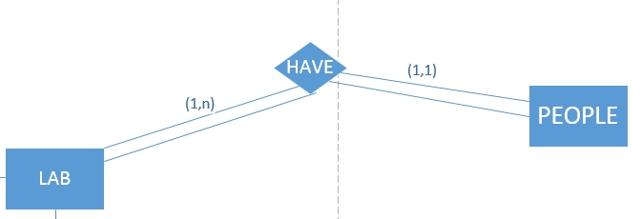 | - A lab can have more than one people, so on LAB side the number is (1, n).  - A person can only join one lab, so on PEOPLE side the numerical expression is (1, 1).
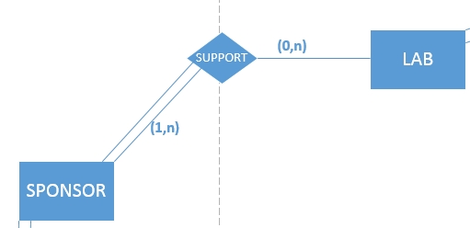 | - A sponsor must support at least one lab, so on SPONSOR side the number is (1, n).  - A lab can have several sponsors or not, so on LAB side the number is (0, n).
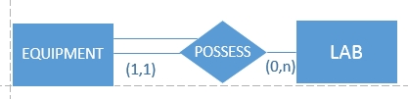 | - One equipment can only be possessed by a specific lab, so on EQUIPMENT side the number is (1,1)  - A lab can have several equipments or not, so on LAB side the number is (0,n)
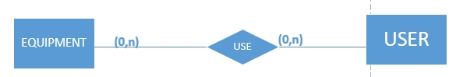 | - One equipment can be used by several users or not, so on EQUIPMENT side the number is (0,n)  - A user can use several equipments or not, so on USER side the number is (0,n)
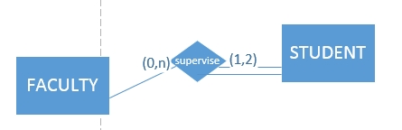 | - One faculty can supervise several students or not, so on FACULTY side the number is (0,n)  - A student can be supervised by at least one faculty or at most two faculties, so on STUDENT side the number is (1,2)
 | - A sponsor can give several funds or not, so on SPONSOR side the number is (0, n).  - A funding can only be given by a specific sponsor, so on FUNDING side the numerical expression is (1, 1).
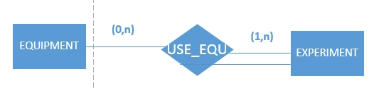 | - One equipment can be used for several experiments or not, so on EQUIPMENT side the number is (0,n)  - A experiment can use at least one equipment, so on EXPERIMENT side the number is (1,n)
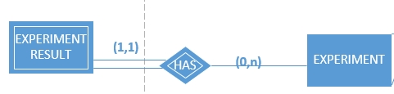 | - One equipment result can only be generated by a specific experiment, so on EXPERIMENT RESULT side the number is (1,1)  - A experiment can have several experiment results or not, so on EXPERIMENT side the number is (0,n)
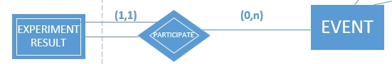 | - One equipment result can only be used by a specific event, so on EXPERIMENT RESULT side the number is (1,1)  - A event can use several experiment results or not, so on EVENT side the number is (0,n)
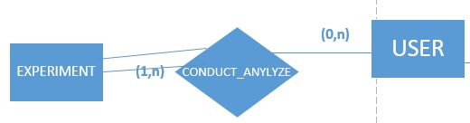 | - One experiment can be conducted or analyzed by at least one user, so on EXPERIMENT side the number is (1,n)  - A user can conduct and analyze several experiment or not, so on USER side the number is (0,n)
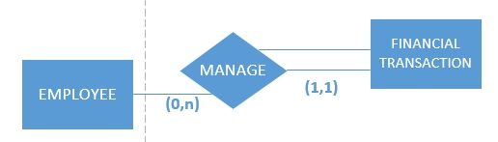 | - A financial transaction can only be managed by one employee, so on FINANCIAL TRANSACTION side the number is (1,1)  - An employee can manage several financial transaction or not, so on EMPLOYEE side the number is (0,n)
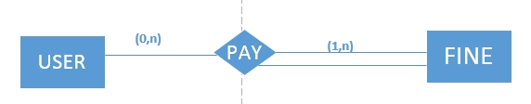 | - A user may pay several fines or not, so on USER side the number is (0,n)  - A fine can be paid by more than one user, so on FINE side the number is (1,n)
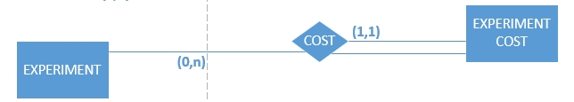 | - A experiment may cost several experiment cost or not, so on EXPERIMENT side the number is (0,n)  - A experiment cost must be cost by one specific experiment, so on EXPERIMENT COST side the number is (1,1)
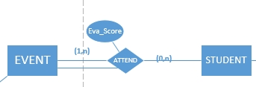 | - An event must have more than one attendee, so on EVENT side the number is (1,n)  - A student may attend several events or not, so on STUDENT side the number is (0,n)
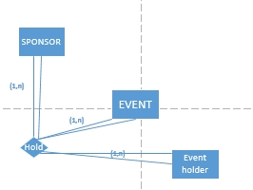 | - An event must have at least one sponsor, so on SPONSOR side the number is (1,n)  - In this triple entity relationship there must exist at least one event, so on EVENT side the number is (1,n)  - An event must have at least one event holder, so on EVENT HOLDER side the number is (1,n)

4. Conclusion
In this report we discussed and drew the EER diagram for Database of ABC Laboratory Management System. In the first part we made our assumptions and explanations, and then we gave the diagram for our EER model. The last part is mainly focused on all relationships existed in the EER diagram.

This report analyzed the conceptual model of ABC Laboratory Management System Database. The next step is to build physical models and other details. In the future, we may change some mappings of this conceptual model when facing practical difficulties and other requests. In addition, Figure 1 includes all the details which we may omit in our descriptions.

