Project for Database Design

Phase IV. Documentation

Cong Wang cxw133030@utdallas.edu
Chulei Wu cxw132530@utdallas.edu
Ruili Yao rxy121130@utdallas.edu

(Week 15-16: Apr. 29-May.5)

0. Pre-Illumination
In this project report we will follow the requirement of Phase IV directly. In Section 1 we gave problem description copied from Web site; in Section 2 we answered 3 questions listed in the project and justified our solution; in Section 3 we exhibited EER diagram with all assumptions; in Section 4 we showed our relational schema after normalization; in Section 5 we gave all requested SQL statements for both views and queries; and in Section 6 we gave dependency diagram induced from relational schemas. Finally, a short summary is given at the end of this report.

1. Problem Description

Design, develop, and test ABC Laboratory Management System that supports people to do experiments, workshops and financial transaction based on combined database. The project is in four parts: conceptual design and requirements analysis (Phase I), database design requirements (Phase II), normalization (Phase III), and final report &demo (Phase IV).

1) The lab has its unique Lab_ID (from “L000” to “L999”), Name, Department Name that belongs to, Building name and room number (like “ECSS2102”). Three kinds of person are allowed to access the laboratory: Faculty, Student and Employee. A lab can have many people, but a person can only join in one lab. All the people share some common attributes: P_ID (like “qwe123456”, unique), Name (includes First Name, Mid Name and Last Name), Gender, Phone Number (one or more phone numbers), and Email (can be multiple values). Faculties have their own Position, Office and Department information. Students have information about Major and Degree. One student may pursuit multiple degrees, which include Department, Program (“B.S.”, “M.S.” or “Ph.D.”) and Year. One faculty may supervise several students or not. One student has at least one, at most two supervisors.

2) The lab offers equipment to users. Users can be faculties or students. Equipment has its unique Equipment ID (from “EQ00000” to“EQ99999”), Type (“computer”, “projector”, “server” or “router”), Status (“Available ” or “In use”), Price, User’s ID, Check-in time (such as 4-Feb-14) and Check out time.

3) There are some Sponsor supports the lab. Each sponsor has it unique Organization Name (such as NSF, companies, etc.), Address, Phone number, Email and Initial Sponsor Date.

4) The lab often has special events for students, like experiment result presentation, tutor, workshop etc. The event id EV_ID is unique. Held Date, Time and rough Introduction of each event will be recorded. Usually holding one event must need sponsors and event holders. The Event Holders can be employees or faculties. These events may be held in different rooms. Every student can attend every event alone or with a friend who is not in the university. The corresponding friend’ name, gender, email, age information need to be registered for the event. And attendees need to evaluate the events they attend. The
evaluation score varies from 1 to 10.

5) Users conduct and analyze experiments. Experiments has information about unique Experiment ID (from “EXP00000” to “EXP99999”), Subject, Project that belongs to, Name, experiment Description and Start Date. Each experiment uses at least one piece of equipment in the lab. Experiment may contain several Experiment Results or not. Experiment Result has its Serial number (NOT UNIQUE, from 00 to 99), Submission Date and Score (from 0 to 100). Some experiment results participate in events that the lab held. One experiment result can only be presented in one specific event.

6) Employees need to manage financial Transaction in the lab. There are three kinds of financial transaction in the lab. The first part is Experiment Cost. The second part is Fine. The third part is Funding. All transactions have unique transaction ID (TR_ID from T00000 to T99999), amount, transaction Date and brief Description. Sponsors give funding. Each funding has its Start time and Expire time. Some experiments create experiment cost. Transactions about experiment cost also contain Cost Type information (Buying equipment, expert Evaluation, etc.). Users who broke the equipment need to pay fine to the lab. Since there may be several users pay the fine, one unique Fine record needs transaction id and payer’s id to confirm it.

2. Three Questions
2.1 1. Is the ability to model super-class / subclass relationships likely to be important in such environment? Why or why not?
The EER model includes all the modeling concepts of the ER model. In addition, it includes the concepts of subclass and superclass and the related concepts of specialization and generalization. Another concept included in the EER model is that of a category or union type, which is used to represent a collection of objects (entities) that is the union of objects of different entity types. Associated with these concepts is the important mechanism of attribute and relationship inheritance. Unfortunately, no standard terminology exists for these concepts, so we use the most common terminology. Alternative terminology is given in footnotes.We also describe a diagrammatic technique for displaying these concepts when they arise in an EER schema. We call the resulting schema diagrams enhanced ER or EER diagrams.
The first Enhanced ER (EER) model concept we take up is that of a subtype or
subclass of an entity type. An entity type is used to represent both a type of entity and the entity set or collection of entities of that type that exist in the database. In many cases an entity type has numerous subgroupings or subtypes of its entities that are meaningful and need to be represented explicitly because of their significance to the database application. We call the relationship between a superclass and any one of its subclasses a superclass/subclass or supertype/subtype or simply class/subclass relationship. Notice that a member entity of the subclass represents the same real-world entity as some member of the superclass; Hence, the subclass member is the same as the entity in the superclass, but in a distinct specific role.When we implement a superclass/subclass relationship in the database system, however, we may represent a member of the subclass as a distinct database object—say, a distinct record that is related via the key attribute to its superclass entity. We discuss various options for representing superclass/subclass relationships in relational databases.
An entity cannot exist in the database merely by being a member of a subclass; it
must also be a member of the superclass. Such an entity can be included optionally as a member of any number of subclasses. However, it is not necessary that every entity in a superclass is a member of some subclass.An important concept associated with subclasses (subtypes) is that of type inheritance.
Recall that the type of an entity is defined by the attributes it possesses and
the relationship types in which it participates. Because an entity in the subclass represents the same real-world entity from the superclass, it should possess values for its specific attributes as well as values of its attributes as a member of the superclass.
We say that an entity that is a member of a subclass inherits all the attributes of the entity as a member of the superclass. The entity also inherits all the relationships in which the superclass participates. Notice that a subclass, with its own specific (or local) attributes and relationships together with all the attributes and relationships it inherits from the superclass, can be considered an entity type in its own right.

2.2 2. Can you think of 5 more rules (other than the one explicitly described above) that are likely to be used in a school environment? Add your rules to the above requirement to be implemented.
- every lab have one lab manager, lab manager can be a faculty or a employee
- Every lab manager can employ some student to clean up lab
- Student who clean lab can get some pay, which should be recorded as a transaction with data.
- Same supervisor may supervise several students. They can do one project together.
- Supplier can supply equipment for school. We should record where every equipment from.

2.3 Justify using a Relational DBMS like Oracle for this project.
A database management system (DBMS) is a collection of programs that enables
users to create and maintain a database. The DBMS is a general-purpose software system that facilitates the processes of defining, constructing, manipulating, and sharing databases among various users and applications. Defining a database involves specifying the data types, structures, and constraints of the data to be stored in the database.
The database definition or descriptive information is also stored by the DBMS in the form of a database catalog or dictionary; it is called meta-data. Constructing the database is the process of storing the data on some storage medium that is controlled by the DBMS.Manipulating a database includes functions such as querying the database to retrieve specific data, updating the database to reflect changes in the miniworld, and generating reports from the data. Sharing a database allows multiple users and programs to access the database simultaneously.
An application program accesses the database by sending queries or requests for data to the DBMS. A transaction may cause some data to be read and some data to be written into the database.
Other important functions provided by the DBMS include protecting the database and maintaining it over a long period of time. Protection includes system protection against hardware or software malfunction (or crashes) and security protection against unauthorized or malicious access. A typical large database may have a life cycle of many years, so the DBMS must be able to maintain the database system by allowing the system to evolve as requirements change over time. It is not absolutely necessary to use general-purpose DBMS software to implement a computerized database. We could write our own set of programs to create and maintain the database, in effect creating our own special-purpose DBMS software. In either case—whether we use a general-purpose DBMS or not—we usually have to deploy a considerable amount of complex software. In fact, most DBMSs are very complex software systems.
3. EER diagram with all assumptions
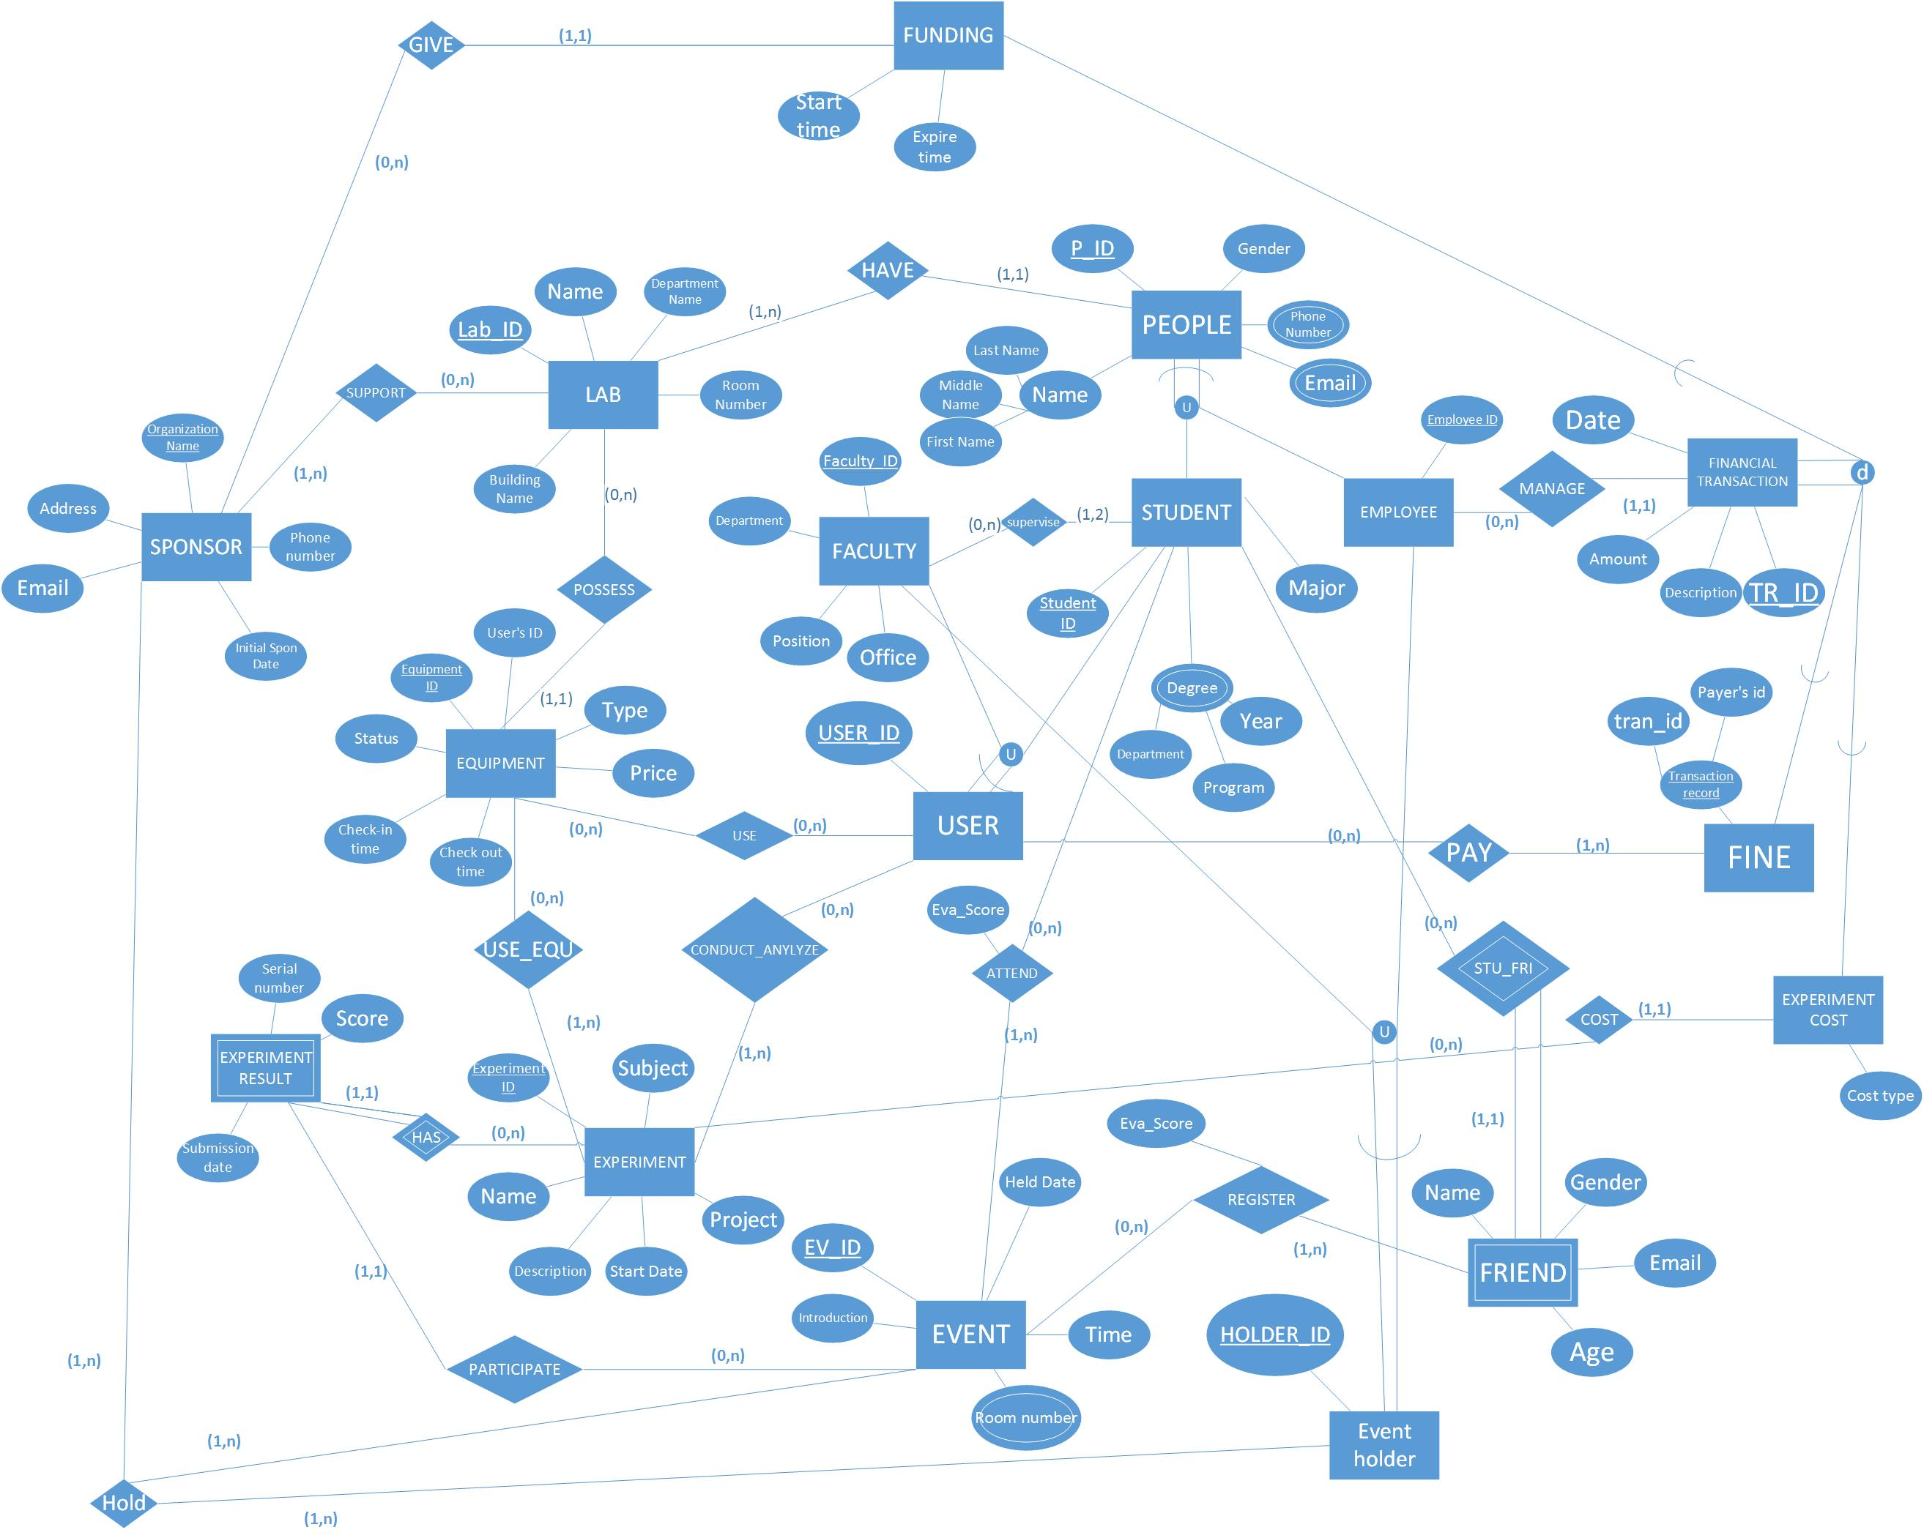

Assumption
- A lab must have at least a person
- If a person join in one lab or a lab have a people, then he/she is a people of lab , we create a entity PEOPLE
- A people can be a faculty, a student or a employee
- A faculty has his unique faculty id
- A student has his unique student id
- employee has his unique employee id
- Faculty id, student id and employee id are different with each other
- Users can be faculties or students and have unique USER_ID which equals to the ID of faculties or students
- Event holders can only be faculties or employees and have unique HOLDER_ID which equals to the ID of faculties or employees
- An equipment can only be possessed by a lab
- Every sponsor need to support at least one lab
- A lab can have multiple sponsors or no sponsor
- These events may be held in different rooms, we add an attribute room number
- A student’s friend who is not in the university is presented as a weak entity
- A corresponding friend can only be taken by one student
- Experiment should be conducted or analyzed by at lease one user
- Experiment result is presented as a weak entity, because it can not exist without experiments
- An employee can manage several financial transaction or not
- A financial transaction can only be managed by one employee
- Each funding is given by a specific sponsor

4. Relational Schema in Third Normal Form
4.1 Relational Schema
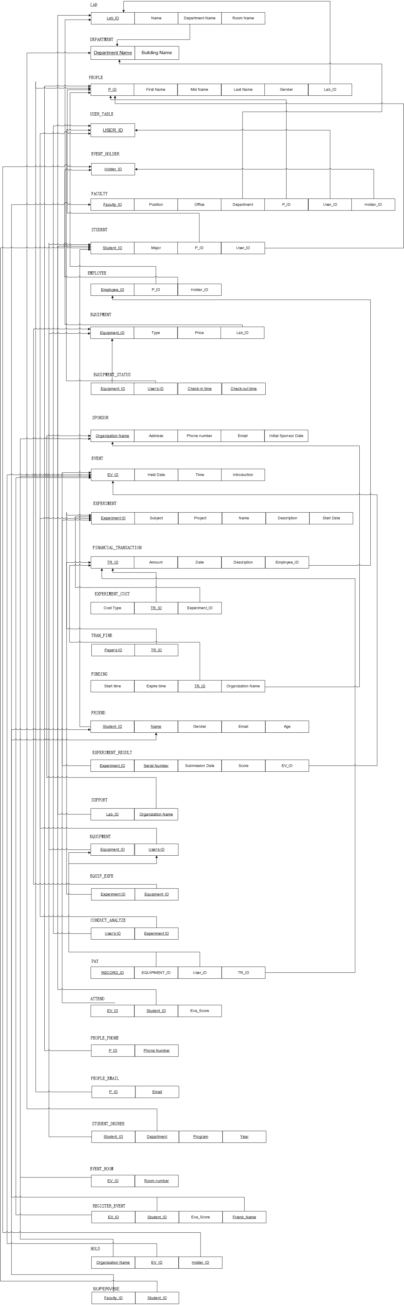

4.2 Format for Every Relation
Explanation for format design
The rules are shown as follows:

- Data format for Lab_ID is LXXX ,from “L000” to “L999”, have an “L” and 3 characters.
- Lab name shall less than 20 characters.
- Department name shall less than 20 characters.
- Building name shall less than 20 characters.
- Data format for room_number is XXXX-XXXX, composite of department name and 4 characters.
- Data format for P_ID is XXX-XXXXXX.P_ID shall have 9 characters.
- Data format for person Name is XXX-XXX-XXX,which is composited of First Name , Mid Name and Last Name. Person Name shall less than 20 characters.
- Data format for Gender is X. Gender shall be “F” or “M”.
- Data format for phone number is XXX-XXX-XXXX. Phone number shall have 10 characters.
- Data format for email is XXXXXXXXXXX@XXXXX. Email shall have less than 20 characters.
- Data format for Faculty ID is FXXXXX, from F00000 to F99999, composited of “F” and 5 characters.
- Data format for Student ID is SXXXXX, from S00000 to S99999, composited of “S” and 5 characters.
- Data format for Employee ID is EMXXXXX, from EM00000 to EM99999, composited of “EM” and 5 characters.
- Faculty Position shall less than 20 characters.
- Data format for faculty Office is XXXX-XXXX. Faculty office shall have 8 characters.
- Faculty Department shall have less than 4 characters.
- Student major shall have less than 4 characters.
- Student degree department shall have less than 4 characters.
- Data format for Student Degree Year is XXXX. Student Degree Year shall have 4 characters.
- Department Program should be “B.S”,”M.S”, or “Ph.D”.
- Data format for User ID is UXXXXX, from U00000 to U99999, composited of “U” and 5 characters.
- Data format for Equipment ID is EQXXXXX, from EQ00000 to EQ99999, composited of “EQ” and 5 characters.
- Equipment type shall be “computer”, “projector”, “server” or “router”.
- Equipment status shall be “ available” or “in use” .
- Data format for Equipment Check-in time is XX-XXX-XX, which is date, month and year. Check-in time shall have 7 characters.
- Data format for Equipment Check-out time is XX-XXX-XX, which is date, month and year. Check-out time shall have 7 characters.
- Data format for sponsor organization name is a string . Organization name shall have no more than 20 characters.
- Organization address shall have less than 30 characters.
- Data format for Initial Sponsor Data is XX-XXX-XX, which is date, month and year. Initial Sponsor Data shall have 7 characters.
- Data format for Event ID is EVXXXXX, from EV00000 to EV99999, composited of “EV” and 5 characters.
- Data format for Held Data is XX-XXX-XX, which is date, month and year. Held Data shall have 7 characters.
- Data format for Held Time is XX-XX, which is hour and minute . Held Data shall have 4 characters.
- Data format for age is XX . Age shall have 2 characters.
- Data format for Holder ID is HXXXXX, from H00000 to H99999, composited of “H” and 5 characters.
- Data format for evaluation score is X. Evaluation score shall have 1 character.
- Data format for Experiment ID is EXPXXXXX, from “EXP00000” to “EXP99999”, which composited of “EXP” and 5characters.
- Experiment name shall have less than 20 characters.
- Experiment subject shall have less than 4 characters.
- Data format for Experiment Start Data is XX-XXX-XX, which is date, month and year. Experiment Start Data shall have 7 characters.
- Data format for Experiment Result is XX. Experiment Result shall have 2 characters.
- Data format for Experiment Submission Data is XX-XXX-XX, which is date, month and year. Experiment Submission Data shall have 7 characters.
- Data format for Experiment Score is XXX, from 0 to 100. Experiment Score shall less than 3 characters.
- Data format for TR_ID is “TXXXXX”, from T00000 to T99999,which is composited of “T” and 5 characters.
- Cost type shall less than 30 characters.
- Data format for Transaction Data is XX-XXX-XX, which is date, month and year. Transaction Data shall have 7 characters.
- Data format for Funding Start Data is XX-XXX-XX, which is date, month and year. Transaction Data shall have 7 characters.
- Data format for Funding Expire Data is XX-XXX-XX, which is date, month and year. Transaction Data shall have 7 characters.
- Description or Introduction shall have less than 120 characters.
- Data format for Payer’s ID is “PAXXXXX”, from PA00000 to PA99999,which is composited of “PA” and 5 characters.
Table 3 gives data type and format for each attribute in each relational schema.

Relation Names | Attributes | Date Type
HAVE | P_ID | PXXXXX, string = 6 chars
HAVE | First_Name | string <= 20 chars
HAVE | Middle_Name | string <= 20 chars
HAVE | Last_Name | string <= 20 chars
HAVE | Gender | F or M
HAVE | Phone | XXX-XXX-XXXX, int = 10
HAVE | Email | XXXXXXX@XXXXXX , string <=20 chars
HAVE | Lab_ID | LXXX ,string = 4 chars
HAVE | Name | String <=20 chars
HAVE | Department Name | string <= 20 chars
HAVE | Building Name | string <= 20 chars
HAVE | Room Number | XXXX-XXXX,String <= 8 chars

Relation Names | Attributes | Date Type
SUPPORT | Email | XXXXXXX@XXXXXX , string <=20 chars
SUPPORT | Address | string <= 20 chars
SUPPORT | Organization Name | string <= 20 chars
SUPPORT | Phone number | XXX-XXX-XXXX, int = 10
SUPPORT | Initial Sponsor Date | XX-XXX-XX, string = 7 chars
SUPPORT | Lab_ID | LXXX ,string = 4 chars
SUPPORT | Name | String <=20 chars
SUPPORT | Department Name | string <= 20 chars
SUPPORT | Building Name | string <= 20 chars
SUPPORT | Room Number | XXXX-XXXX,String <= 8 chars

Relation Names | Attributes | Date Type
POSSESS | Lab_ID | LXXX ,string = 4 chars
POSSESS | Name | String <=20 chars
POSSESS | Department Name | string <= 20 chars
POSSESS | Building Name | string <= 20 chars
POSSESS | Room Number | XXXX-XXXX,String <= 8 chars
POSSESS | User ID | UXXXXX, string = 6 chars
POSSESS | Equipment ID | EQXXXXX, string = 7 chars
POSSESS | Status | string <= 20 chars
POSSESS | Type | string <= 20 chars
POSSESS | Price | int <= 20 chars
POSSESS | Check-in time | XX-XXX-XX, string = 7 chars
POSSESS | Check-out time | XX-XXX-XX, string = 7 chars

Relation Names | Attributes | Date Type
USE | User ID | UXXXXX, string = 6 chars
USE | Equipment ID | EQXXXXX, string = 7 chars
USE | Status | string <= 20 chars
USE | Type | string <= 20 chars
USE | Price | int <= 20 chars
USE | Check-in time | XX-XXX-XX, string = 7 chars
USE | Check-out time | XX-XXX-XX, string = 7 chars

Relation Names | Attributes | Date Type
USE_EQU | User ID | UXXXXX, string = 6 chars
USE_EQU | Equipment ID | EQXXXXX, string = 7 chars
USE_EQU | Status | string <= 20 chars
USE_EQU | Type | string <= 20 chars
USE_EQU | Price | int <= 20 chars
USE_EQU | Check-in time | XX-XXX-XX, string = 7 chars
USE_EQU | Check-out time | XX-XXX-XX, string = 7 chars
USE_EQU | Subject | string <= 20 chars
USE_EQU | Experiment ID | EXPXXXXX, string =8 chars
USE_EQU | Name | string <= 20 chars
USE_EQU | Description | string <= 20 chars
USE_EQU | Start Date | XX-XXX-XX, string = 7 chars
 | Project | string <= 20 chars

Relation Names | Attributes | Date Type
HAS | Subject | string <= 20 chars
HAS | Experiment ID | EXPXXXXXX, string =8 chars
HAS | Name | string <= 20 chars
HAS | Description | string <= 20 chars
HAS | Start Date | XX-XXX-XX, string = 7 chars
HAS | Project | string <= 20 chars
HAS | Serial number | XX, int = 2
HAS | Score | Int <=3
HAS | Submission date | XX-XXX-XX, string = 7 chars

Relation Names | Attributes | Date Type
PARTICIPATE | Serial number | XX, int = 2
PARTICIPATE | Score | Int <=3
PARTICIPATE | Submission date | XX-XXX-XX, string = 7 chars
PARTICIPATE | EV_ID | EVXXXXX, string = 7 chars
PARTICIPATE | Held Date | XX-XXX-XX, string = 7 chars
PARTICIPATE | Time | XX-XX, int = 4 chars
PARTICIPATE | Room number | XXXX-XXXX, string = 8 chars
PARTICIPATE | introduction | string <= 120 chars

Relation Names | Attributes | Date Type
HOLD | EV_ID | EVXXXXX, string = 7 chars
HOLD | Held Date | XX-XXX-XX, string = 7 chars
HOLD | Time | XX-XX, int = 4 chars
HOLD | Room number | XXXX-XXXX, string = 8 chars
HOLD | introduction | string <= 120 chars
HOLD | Holder ID | HXXXXX, string = 6 chars
HOLD | Email | XXXXXXX@XXXXXX , string <=20 chars
HOLD | Address | string <= 20 chars
HOLD | Organization Name | string <= 20 chars
HOLD | Phone number | XXX-XXX-XXXX, int = 10
HOLD | Initial Sponsor Date | XX-XXX-XX, string = 7 chars

Relation Names | Attributes | Date Type
GIVE | Email | XXXXXXX@XXXXXX , string <=20 chars
GIVE | Address | string <= 20 chars
GIVE | Organization Name | string <= 20 chars
GIVE | Phone number | XXX-XXX-XXXX, int = 10
GIVE | Initial Sponsor Date | XX-XXX-XX, string = 7 chars
GIVE | Start Time | XX-XXX-XX, string = 7 chars
GIVE | Expire Time | XX-XXX-XX, string = 7 chars

Relation Names | Attributes | Date Type
PAY | User ID | UXXXXX, string = 6 chars
PAY | Tran_ID | TXXXXX, string = 6 chars
PAY | Payer’s ID | PXXXXX, string = 6 chars

Relation Names | Attributes | Date Type
COST | Cost type | string <= 20 chars
COST | Subject | string <= 20 chars
COST | Experiment ID | EXPXXXXXX, string =8 chars
COST | Name | string <= 20 chars
COST | Description | string <= 20 chars
COST | Start Date | XX-XXX-XX, string = 7 chars
COST | Project | string <= 20 chars

Relation Names | Attributes | Date Type
CONDUCT_ANYLYZE | Subject | string <= 20 chars
CONDUCT_ANYLYZE | Experiment ID | EXPXXXXX, string =8 chars
CONDUCT_ANYLYZE | Name | string <= 20 chars
CONDUCT_ANYLYZE | Description | string <= 20 chars
CONDUCT_ANYLYZE | Start Date | XX-XXX-XX, string = 7 chars
CONDUCT_ANYLYZE | Project | string <= 20 chars
CONDUCT_ANYLYZE | User ID | UXXXXX, string =6 chars

Relation Names | Attributes | Date Type
SUPERVISE | Faculty ID | FXXXXX, string =6 chars
SUPERVISE | Department | string <= 4 chars
SUPERVISE | Position | string <= 20 chars
SUPERVISE | Office | XXXX-XXXX, string <=8 chars
SUPERVISE | Student ID | SXXXXX, string =6 chars
SUPERVISE | Major | string <= 4 chars
SUPERVISE | Program | stromg <= 4 chars
SUPERVISE | Year | XXXX, int = 4

Table 3. Format for Each Attribute (example)
Relation Names | Attributes | Date Type
MANAGE | Employee ID | EMXXXXX, string =7 chars
MANAGE | Date | XX-XXX-XX, string = 7 chars
MANAGE | Amout | int <= 20 chars
MANAGE | Description | string <= 120 chars
MANAGE | TR_ID | TXXXXX, string =6 chars

Relation Names | Attributes | Date Type
STU_FRI | Gender | F or M
STU_FRI | Name | XXX-XXX-XXX, string <=20 chars
STU_FRI | Email | XXXXXXX@XXXXXX , string <=20 chars
STU_FRI | Age | XX, int = 4
STU_FRI | Student ID | SXXXXX, string =6 chars
STU_FRI | Major | string <= 4 chars
STU_FRI | Program | stromg <= 4 chars
STU_FRI | Year | XXXX, int = 4
STU_FRI | Department | string <= 4 chars

Relation Names | Attributes | Date Type
ATTEND | Student ID | SXXXXX, string =6 chars
ATTEND | Major | string <= 4 chars
ATTEND | Program | stromg <= 4 chars
ATTEND | Year | XXXX, int = 4
ATTEND | Department | string <= 4 chars
ATTEND | Eva_score | Int
ATTEND | EV_ID | EVXXXXX, string = 7 chars
ATTEND | Held Date | XX-XXX-XX, string = 7 chars
ATTEND | Time | XX-XX, int = 4 chars
ATTEND | Room number | XXXX-XXXX, string = 8 chars
ATTEND | introduction | string <= 120 chars

Relation Names | Attributes | Date Type
REGISTER | EV_ID | EVXXXXX, string = 7 chars
REGISTER | Held Date | XX-XXX-XX, string = 7 chars
REGISTER | Time | XX-XX, int = 4 chars
REGISTER | Room number | XXXX-XXXX, string = 8 chars
REGISTER | introduction | string <= 120 chars
REGISTER | Eva_score | Int
REGISTER | Gender | F or M
REGISTER | Name | XXX-XXX-XXX, string <=20 chars
REGISTER | Email | XXXXXXX@XXXXXX , string <=20 chars
REGISTER | Age | XX, int = 4

5. All Requested SQL Statements
5.1 Creation of Database with SQL Statements
5.1.1 Table Creation
Using SQL statement, we created 32 tables as follows:
CREATE TABLE LAB
( Lab_ID char(4) NOT NULL,
Lab_Name varchar(20) NOT NULL,
Department_Name varchar(20),
Room_Number char(8) NOT NULL,
PRIMARY KEY (Lab_ID),
UNIQUE (Lab_Name,Room_Number),
FOREIGN KEY (Department_Name) REFERENCES DEPARTMENT(Department_Name));

CREATE TABLE DEPARTMENT
( Department_Name varchar(20),
Building_Name varchar(20),
PRIMARY KEY (Department_Name),
UNIQUE (Building_Name));

CREATE TABLE PEOPLE
( P_ID char(9) not null,
first_name varchar(10) not null,
mid_name varchar(10),
last_name varchar(10) not null,
gender char(1),
lab_id char(4),
PRIMARY KEY (P_ID),
FOREIGN KEY (lab_id) REFERENCES LAB(lab_id));

CREATE TABLE USER_TABLE
( USER_ID char(6) not null,
PRIMARY KEY (USER_ID));

CREATE TABLE EVENT_HOLDER
( HOLDER_ID char(6) not null,
PRIMARY KEY (HOLDER_ID));

CREATE TABLE FACULTY
( FACULTY_ID char(6) not null,
POSITION VARCHAR(20) NOT NULL,
OFFICE CHAR(8) NOT NULL,
DEPARTMENT VARCHAR(4) NOT NULL,
P_ID CHAR(9) NOT NULL,
USER_ID CHAR(6),
HOLDER_ID CHAR(6),
PRIMARY KEY (FACULTY_ID),
UNIQUE (P_ID),
FOREIGN KEY (P_id) REFERENCES PEOPLE(P_id),
FOREIGN KEY (DEPARTMENT) REFERENCES DEPARTMENT(DEPARTMENT_NAME),
FOREIGN KEY (USER_id) REFERENCES USER_TABLE(USER_id),
FOREIGN KEY (HOLDER_id) REFERENCES EVENT_HOLDER(HOLDER_id));

CREATE TABLE STUDENT
( STUDENT_ID char(6) not null,
MAJOR VARCHAR(4) NOT NULL,
P_ID CHAR(9) NOT NULL,
USER_ID CHAR(6),
PRIMARY KEY (STUDENT_ID),
UNIQUE (P_ID),
FOREIGN KEY (P_id) REFERENCES PEOPLE(P_id),
FOREIGN KEY (USER_id) REFERENCES USER_TABLE(USER_id));

CREATE TABLE EMPLOYEE
( EMPLOYEE_ID CHAR(7) NOT NULL,
P_ID CHAR(9) NOT NULL,
HOLDER_ID CHAR(6),
PRIMARY KEY (EMPLOYEE_ID),
UNIQUE (P_ID),
FOREIGN KEY (P_id) REFERENCES PEOPLE(P_id),
FOREIGN KEY (HOLDER_id) REFERENCES EVENT_HOLDER(HOLDER_id));

CREATE TABLE EQUIPMENT
( EQUIPMENT_ID CHAR(7) NOT NULL,
EQUIPMENT_TYPE VARCHAR(9),
PRICE INTEGER,
LAB_ID CHAR(4),
PRIMARY KEY (EQUIPMENT_ID),
CHECK (EQUIPMENT_TYPE IN ('computer','projector','server','router')),
FOREIGN KEY (LAB_ID) REFERENCES LAB(LAB_ID));

CREATE TABLE EQUIPMENT_STATUS
( EQUIPMENT_ID CHAR(7) NOT NULL,
USER_ID CHAR(6) NOT NULL,
CHECKIN_TIME DATE NOT NULL,
CHECKOUT_TIME DATE,
PRIMARY KEY (EQUIPMENT_ID,USER_ID,CHECKIN_TIME),
FOREIGN KEY (USER_ID) REFERENCES USER_TABLE(USER_ID),
FOREIGN KEY (EQUIPMENT_ID) REFERENCES EQUIPMENT(EQUIPMENT_ID));

CREATE TABLE SPONSOR
( ORGANIZATION_NAME VARCHAR(20) NOT NULL,
ADDRESS VARCHAR(30),
PHONE_NUMBER CHAR(10),
EMAIL VARCHAR(30),
INITIAL_SPONSOR_DATE DATE,
PRIMARY KEY (ORGANIZATION_NAME));

CREATE TABLE EVENT
( EV_ID CHAR(7) NOT NULL,
HELD_DATE DATE NOT NULL,
HELD_TIME TIMESTAMP NOT NULL,
INTRODUCTION VARCHAR(40),
PRIMARY KEY (EV_ID));

CREATE TABLE EXPERIMENT
( EXPERIMENT_ID CHAR(8) NOT NULL,
SUBJECT VARCHAR(4) NOT NULL,
PROJECT_NAME VARCHAR(20) NOT NULL,
EXPERIMENT_NAME VARCHAR(20) NOT NULL,
DESCRIPTION VARCHAR(40),
START_DATE DATE NOT NULL,
PRIMARY KEY (EXPERIMENT_ID));

CREATE TABLE FINANCIAL_TRANSACTION
( TR_ID CHAR(6) NOT NULL,
AMOUNT INTEGER NOT NULL,
TRANSACTION_DATE DATE NOT NULL,
TRANSACTION_DESCRIPTION VARCHAR(40),
EMPLOYEE_ID CHAR(7) NOT NULL,
PRIMARY KEY (TR_ID)
FOREIGN KEY (EMPLOYEE_ID) REFERENCES EMPLOYEE (EMPLOYEE_ID));

CREATE TABLE EXPERIMENT_COST
( TR_ID CHAR(6) NOT NULL,
COST_TYPE VARCHAR(30) NOT NULL,
EXPERIMENT_ID CHAR(8) NOT NULL,
PRIMARY KEY (TR_ID),
FOREIGN KEY (TR_ID) REFERENCES FINANCIAL_TRANSACTION(TR_ID),
FOREIGN KEY (EXPERIMENT_ID) REFERENCES EXPERIMENT(EXPERIMENT_ID));

CREATE TABLE TRAN_FINE
( TR_ID CHAR(6) NOT NULL,
PAYER_ID CHAR(7) NOT NULL,
PRIMARY KEY (TR_ID,PAYER_ID),
CHECK (REGEXP_LIKE(PAYER_ID, 'PA[0-9][0-9][0-9][0-9][0-9]')),
FOREIGN KEY (TR_ID) REFERENCES FINANCIAL_TRANSACTION(TR_ID));

CREATE TABLE FUNDING
( TR_ID CHAR(6) NOT NULL,
START_DATE DATE NOT NULL,
EXPIRE_DATE DATE NOT NULL,
ORGANIZATION_NAME VARCHAR(20) NOT NULL,
PRIMARY KEY (TR_ID),
FOREIGN KEY (TR_ID) REFERENCES FINANCIAL_TRANSACTION(TR_ID),
FOREIGN KEY (ORGANIZATION_NAME) REFERENCES SPONSOR(ORGANIZATION_NAME));

CREATE TABLE FRIEND
( STUDENT_ID CHAR(6) NOT NULL,
FRIEND_NAME VARCHAR(30) NOT NULL,
GENDER CHAR(1),
EMAIL VARCHAR(20),
AGE INTEGER,
PRIMARY KEY (STUDENT_ID,FRIEND_NAME),
FOREIGN KEY (STUDENT_ID) REFERENCES STUDENT(STUDENT_ID));

CREATE TABLE EXPERIMENT_RESULT
( EXPERIMENT_ID CHAR(8) NOT NULL,
SERIAL_NUMBER INTEGER NOT NULL,
SUBMISSION_DATE DATE NOT NULL,
SCORE INTEGER NOT NULL,
EV_ID CHAR(7),
PRIMARY KEY (EXPERIMENT_ID,SERIAL_NUMBER),
CHECK (SCORE <= 100 AND SCORE >= 0),
FOREIGN KEY (EXPERIMENT_ID) REFERENCES EXPERIMENT(EXPERIMENT_ID),
FOREIGN KEY (EV_ID) REFERENCES EVENT(EV_ID));

CREATE TABLE SUPPORT
( LAB_ID CHAR(4) NOT NULL,
ORGANIZATION_NAME VARCHAR(20) NOT NULL,
PRIMARY KEY (LAB_ID,ORGANIZATION_NAME),
FOREIGN KEY (LAB_ID) REFERENCES LAB(LAB_ID),
FOREIGN KEY (ORGANIZATION_NAME) REFERENCES SPONSOR(ORGANIZATION_NAME));

CREATE TABLE USER_EQUIPMENT
( EQUIPMENT_ID CHAR(7) NOT NULL,
USER_ID CHAR(6) NOT NULL,
PRIMARY KEY (EQUIPMENT_ID,USER_ID),
FOREIGN KEY (EQUIPMENT_ID) REFERENCES EQUIPMENT(EQUIPMENT_ID),
FOREIGN KEY (USER_ID) REFERENCES USER_TABLE(USER_ID));

CREATE TABLE EQUIP_EXPE
( EQUIPMENT_ID CHAR(7) NOT NULL,
EXPERIMENT_ID CHAR(8) NOT NULL,
PRIMARY KEY (EQUIPMENT_ID,EXPERIMENT_ID),
FOREIGN KEY (EQUIPMENT_ID) REFERENCES EQUIPMENT(EQUIPMENT_ID),
FOREIGN KEY (EXPERIMENT_ID) REFERENCES EXPERIMENT(EXPERIMENT_ID));

CREATE TABLE CONDUCT_ANALYZE
( USER_ID CHAR(6) NOT NULL,
EXPERIMENT_ID CHAR(8) NOT NULL,
PRIMARY KEY (USER_ID,EXPERIMENT_ID),
FOREIGN KEY (USER_ID) REFERENCES USER_TABLE(USER_ID),
FOREIGN KEY (EXPERIMENT_ID) REFERENCES EXPERIMENT(EXPERIMENT_ID));

CREATE TABLE PAY
( RECORD_ID CHAR(6) NOT NULL,
USER_ID CHAR(6) NOT NULL,
EQUIPMENT_ID CHAR(7) NOT NULL,
TR_ID CHAR(6) NOT NULL,
PRIMARY KEY (RECORD_ID),
CHECK (REGEXP_LIKE(RECORD_ID, 'QA[0-9][0-9][0-9][0-9]')),
FOREIGN KEY (USER_ID,EQUIPMENT_ID) REFERENCES USER_EQUIPMENT(USER_ID,EQUIPMENT_ID),
FOREIGN KEY (TR_ID) REFERENCES FINANCIAL_TRANSACTION(TR_ID));

CREATE TABLE ATTEND
( EV_ID CHAR(7) NOT NULL,
STUDENT_ID CHAR(6) NOT NULL,
EVA_SCORE INTEGER NOT NULL,
PRIMARY KEY (EV_ID,STUDENT_ID),
CHECK (EVA_SCORE >= 0 AND EVA_SCORE <= 10),
FOREIGN KEY (EV_ID) REFERENCES EVENT(EV_ID),
FOREIGN KEY (STUDENT_ID) REFERENCES STUDENT(STUDENT_ID));

CREATE TABLE PEOPLE_PHONE
( P_ID CHAR(9) NOT NULL,
PHONE_NUMBER CHAR(10) NOT NULL,
PRIMARY KEY (P_ID,PHONE_NUMBER),
FOREIGN KEY (P_ID) REFERENCES PEOPLE(P_ID));

CREATE TABLE PEOPLE_EMAIL
( P_ID CHAR(9) NOT NULL,
EMAIL VARCHAR(20) NOT NULL,
PRIMARY KEY (P_ID,EMAIL),
FOREIGN KEY (P_ID) REFERENCES PEOPLE(P_ID));

CREATE TABLE STUDENT_DEGREE
( STUDENT_ID CHAR(6) NOT NULL,
DEPARTMENT_NAME VARCHAR(20) NOT NULL,
STUDY_PROGRAM VARCHAR(5) NOT NULL,
STUDY_YEAR INTEGER NOT NULL,
PRIMARY KEY (STUDENT_ID,DEPARTMENT_NAME,STUDY_PROGRAM,STUDY_YEAR),
CHECK (STUDY_PROGRAM IN ('B.S.','M.S.','Ph.D.')),
FOREIGN KEY (DEPARTMENT_NAME) REFERENCES DEPARTMENT(DEPARTMENT_NAME),
FOREIGN KEY (STUDENT_ID) REFERENCES STUDENT(STUDENT_ID));

CREATE TABLE EVENT_ROOM
( EV_ID CHAR(7) NOT NULL,
ROOM_NUMBER VARCHAR(20) NOT NULL,
PRIMARY KEY (EV_ID,ROOM_NUMBER),
FOREIGN KEY (EV_ID) REFERENCES EVENT(EV_ID));

CREATE TABLE REGISTER_EVENT
( EV_ID CHAR(7) NOT NULL,
STUDENT_ID CHAR(6) NOT NULL,
FRIEND_NAME VARCHAR(30) NOT NULL,
EVA_SCORE INTEGER NOT NULL,
PRIMARY KEY (EV_ID,STUDENT_ID,FRIEND_NAME),
CHECK (EVA_SCORE <= 10 AND EVA_SCORE >= 0),
FOREIGN KEY (STUDENT_ID,FRIEND_NAME) REFERENCES FRIEND(STUDENT_ID,FRIEND_NAME),
FOREIGN KEY (EV_ID) REFERENCES EVENT(EV_ID));

CREATE TABLE HOLD
( EV_ID CHAR(7) NOT NULL,
HOLDER_ID CHAR(6) NOT NULL,
ORGANIZATION_NAME VARCHAR(20) NOT NULL,
PRIMARY KEY (EV_ID,HOLDER_ID,ORGANIZATION_NAME),
FOREIGN KEY (EV_ID) REFERENCES EVENT(EV_ID),
FOREIGN KEY (HOLDER_ID) REFERENCES EVENT_HOLDER(HOLDER_ID),
FOREIGN KEY (ORGANIZATION_NAME) REFERENCES SPONSOR(ORGANIZATION_NAME));

CREATE TABLE SUPERVISE
( FACULTY_ID CHAR(6) NOT NULL,
STUDENT_ID CHAR(6) NOT NULL,
PRIMARY KEY (FACULTY_ID,STUDENT_ID),
FOREIGN KEY (FACULTY_ID) REFERENCES FACULTY(FACULTY_ID),
FOREIGN KEY (STUDENT_ID) REFERENCES STUDENT(STUDENT_ID));

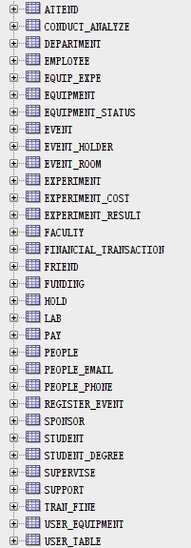

5.1.2 A Database State
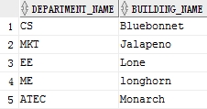

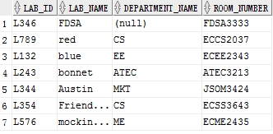

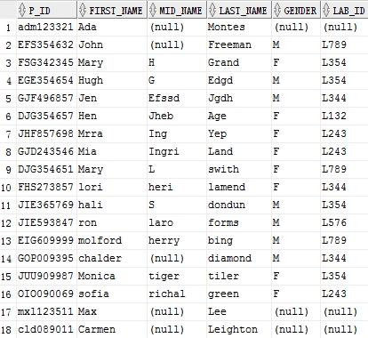

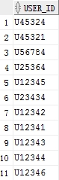

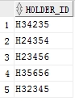

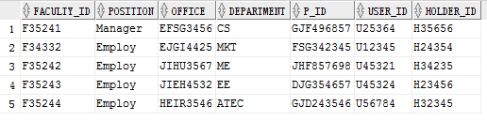

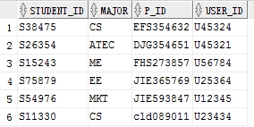

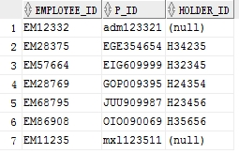

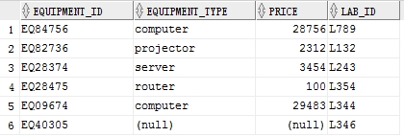

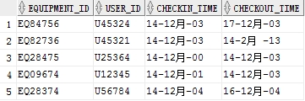

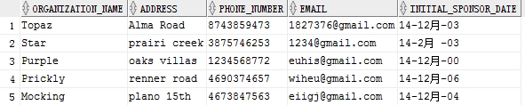

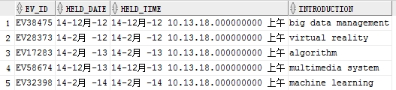

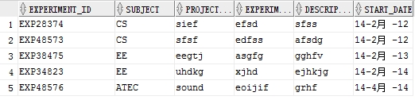

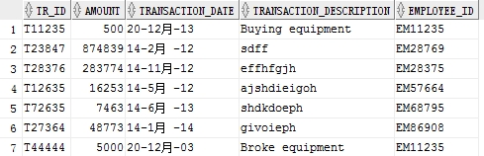

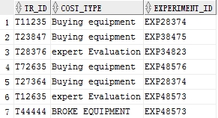

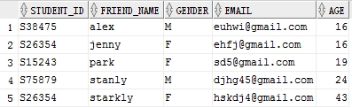

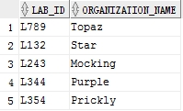

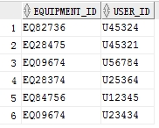

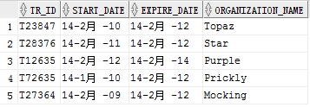

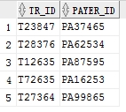

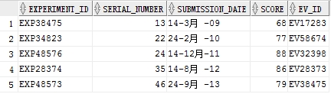

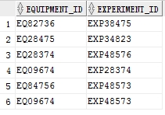

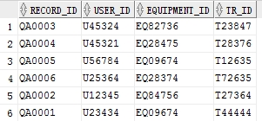

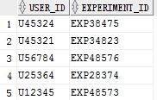

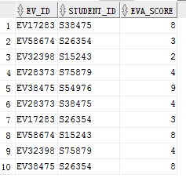

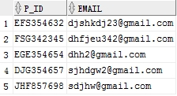

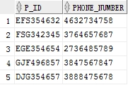

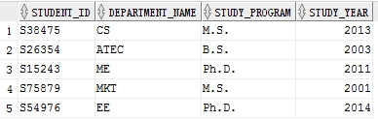

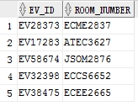

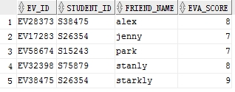

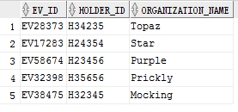

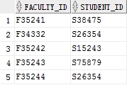

5.2 Creation of Views (Answer for Question d/Phase III)
5.2.1 USE_QUIP
This view returns all Equipment ID be used by each person’s id, no matter used by faculties or students:
CREATE VIEW USE_QUIP(EQUIPMENT_ID, USER_ID) AS
(SELECT DISTINCT ES.EQUIPMENT_ID, F.P_ID
FROM EQUIPMENT_STATUS ES,FACULTY F
WHERE ES.USER_ID=F.USER_ID)
UNION
(SELECT DISTINCT ES.EQUIPMENT_ID, S.P_ID
FROM EQUIPMENT_STATUS ES,STUDENT S
WHERE ES.USER_ID=S.USER_ID)

5.2.2 EQUIP_FINE
This view returns all Equipment ID and report date associated with any fine transaction with at least $50 fine cost:
CREATE VIEW EQUIP_FINE(EQUIPMENT_ID, TRANSACTION_DATE) AS
SELECT DISTINCT P.EQUIPMENT_ID, F.TRANSACTION_DATE
FROM PAY P, FINANCIAL_TRANSACTION F
WHERE P.TR_ID=F.TR_ID AND F.AMOUNT >= '50';

5.2.3 SELECTED_EVENT
This view returns the id and the theme of the event that has more grades above or equal to 5 than those below 5:
CREATE VIEW T1(EV_ID,EVA_SCORE) AS
((SELECT ATT.EV_ID,ATT.EVA_SCORE
FROM ATTEND ATT)
UNION
(SELECT RGE.EV_ID,RGE.EVA_SCORE
FROM REGISTER_EVENT RGE));

CREATE VIEW T2(EV_ID,SCORE_NUM) AS
SELECT T1.EV_ID, COUNT(T1.EVA_SCORE)
FROM T1
WHERE T1.EVA_SCORE>='5'
GROUP BY T1.EV_ID;

CREATE VIEW T3(EV_ID,SCORE_NUM) AS
SELECT T1.EV_ID, COUNT(T1.EVA_SCORE)
FROM T1
WHERE T1.EVA_SCORE<'5'
GROUP BY T1.EV_ID;

CREATE VIEW SELECTED_EVENT(EV_ID, INTRODUCTION) AS
SELECT DISTINCT EV.EV_ID, EV.INTRODUCTION
FROM EVENT EV
WHERE EV.EV_ID IN
(SELECT T2.EV_ID
FROM T2,T3
WHERE T2.SCORE_NUM>T3.SCORE_NUM AND T2.EV_ID=T3.EV_ID);

5.2.4 STUDENT_EQUIP
This view returns the equipment used by each student id on 4-Feb-14:
CREATE VIEW STUDENT_EQUIP(EQUIPMENT_ID) AS
SELECT DISTINCT EST.EQUIPMENT_ID
FROM EQUIPMENT_STATUS EST, STUDENT S
WHERE EST.USER_ID=S.USER_ID AND CHECKIN_TIME<=TO_DATE('04-FEB-14', 'DD-MON-RR') AND (CHECKOUT_TIME>TO_DATE('04-FEB-14', 'DD-MON-RR') OR (CHECKOUT_TIME IS NULL));

5.3 Creation of SQL Queries (Answer for Question e/Phase III)
Now we give out the SQL Queries for each of 16 questions listed in Question e as follows:

5.3.1 Add Ada Montes as an employee to the system.

BEGIN
INSERT INTO PEOPLE(P_ID,FIRST_NAME,LAST_NAME) VALUES ('adm123321','Ada','Montes');
INSERT INTO EMPLOYEE(EMPLOYEE_ID,P_ID) VALUES ('EM12332','adm123321');
END;

5.3.2 Return the equipment id that have more than 10 checking out history records.

SELECT EQUIPMENT_ID
FROM EQUIPMENT_STATUS
WHERE CHECKOUT_TIME IS NOT NULL
GROUP BY EQUIPMENT_ID
HAVING COUNT(CHECKOUT_TIME)> '10';

5.3.3 Return the experiments’ names that need to use more than 5 pieces of equipment.

SELECT E.EXPERIMENT_NAME
FROM EXPERIMENT E
WHERE E.EXPERIMENT_ID IN
(SELECT E1.EXPERIMENT_ID
FROM EQUIP_EXPE E1
GROUP BY E1.EXPERIMENT_ID
HAVING COUNT(E1.EQUIPMENT_ID)> '5');

5.3.4 Retrieve the equipment id and the id of person who uses the equipment before 29-Jan-14.

SELECT DISTINCT ES.EQUIPMENT_ID,S.P_ID
FROM EQUIPMENT_STATUS ES,STUDENT S
WHERE CHECKIN_TIME<TO_DATE('2014/01/29', 'YYYY/MM/DD') AND ES.USER_ID=S.USER_ID
UNION
SELECT DISTINCT ES.EQUIPMENT_ID,F.P_ID
FROM EQUIPMENT_STATUS ES,FACULTY F
WHERE CHECKIN_TIME<TO_DATE('2014/01/29', 'YYYY/MM/DD') AND ES.USER_ID=F.USER_ID

5.3.5 Retrieve the Experiment Ids whose experiment result having the most “satisfying” feedback in the show events, where “a satisfying feedback” means the event has more grades above or equal to 6 than those below 6.

CREATE VIEW T1(EV_ID,EVA_SCORE) AS
((SELECT ATT.EV_ID,ATT.EVA_SCORE
FROM ATTEND ATT)
UNION
(SELECT RGE.EV_ID,RGE.EVA_SCORE
FROM REGISTER_EVENT RGE));

CREATE VIEW ABOVE6(EV_ID,SCORE_NUM) AS
SELECT T1.EV_ID, COUNT(T1.EVA_SCORE)
FROM T1
WHERE T1.EVA_SCORE>='6'
GROUP BY T1.EV_ID;

CREATE VIEW BELOW6(EV_ID,SCORE_NUM) AS
SELECT T1.EV_ID, COUNT(T1.EVA_SCORE)
FROM T1
WHERE T1.EVA_SCORE<'6'
GROUP BY T1.EV_ID;

SELECT DISTINCT ER.EXPERIMENT_ID
FROM EVENT EV,EXPERIMENT_RESULT ER
WHERE ER.EV_ID=EV.EV_ID AND EV.EV_ID IN
(SELECT ABOVE6.EV_ID
FROM ABOVE6,BELOW6
WHERE ABOVE6.SCORE_NUM>BELOW6.SCORE_NUM AND ABOVE6.EV_ID=BELOW6.EV_ID);

5.3.6 Retrieve the id and name of the FACULTY(employee) who takes charge of 3 pieces of equipment.

SELECT P.P_ID, P.FIRST_NAME, P.MID_NAME, P.LAST_NAME
FROM FACULTY F, PEOPLE P
WHERE F.P_ID=P.P_ID AND F.USER_ID IN
(SELECT ES.USER_ID
FROM EQUIPMENT_STATUS ES
WHERE ES.CHECKOUT_TIME IS NULL
GROUP BY ES.USER_ID
HAVING COUNT(ES.EQUIPMENT_ID)='3');

5.3.7 Show all experiments’ ID in order of their cost effectives. Cost effectives refer to AVG(Experiment Result Score) / (Experiment Cost+1).

CREATE VIEW AVE_SCORE(EXPERIMENT_ID, AVG_SCORE) AS
SELECT EXPERIMENT_ID, AVG(SCORE)
FROM EXPERIMENT_RESULT
GROUP BY EXPERIMENT_ID;

SELECT E.EXPERIMENT_ID, (A1.AVG_SCORE/(FT.AMOUNT+'1')) AS COST_EFF
FROM EXPERIMENT_COST E,FINANCIAL_TRANSACTION FT,AVE_SCORE A1
WHERE E.TR_ID=FT.TR_ID AND A1.EXPERIMENT_ID=E.EXPERIMENT_ID
ORDER BY COST_EFF DESC NULLS LAST;

5.3.8 Retrieve the name of employee who holds most events.

SELECT P.FIRST_NAME,P.MID_NAME,P.LAST_NAME
FROM PEOPLE P,EMPLOYEE E
WHERE P.P_ID=E.P_ID AND E.HOLDER_ID IN
(SELECT H.HOLDER_ID
FROM HOLD H
GROUP BY H.HOLDER_ID
HAVING COUNT(EV_ID)=
(SELECT MAX(EVID)
FROM (SELECT COUNT(EV_ID) AS EVID
FROM HOLD H1
GROUP BY H1.HOLDER_ID
)
)
);

5.3.9 Add a buying transaction for equipment “EQ40305” record to employee “mxl123555” on 20-Dec-13.

BEGIN
INSERT INTO PEOPLE(P_ID,FIRST_NAME,LAST_NAME) VALUES ('mxl123511','Max','Lee');
INSERT INTO EMPLOYEE(EMPLOYEE_ID,P_ID) VALUES ('EM11235','mxl123511');
INSERT INTO FINANCIAL_TRANSACTION VALUES ('T11235','500',TO_DATE('2013/12/20', 'YYYY/MM/DD'),'Buying equipment','EM11235');
INSERT INTO EQUIPMENT(EQUIPMENT_ID,LAB_ID) VALUES ('EQ40305','L346');
INSERT INTO EXPERIMENT_COST VALUES ('T11235','Buying equipment','EXP28374');
END;

5.3.10 Retrieve the faculties who supervise least students in experiments.

SELECT SV.FACULTY_ID
FROM SUPERVISE SV,STUDENT S,CONDUCT_ANALYZE CA
WHERE SV.STUDENT_ID=S.STUDENT_ID AND S.USER_ID= CA.USER_ID
GROUP BY SV.FACULTY_ID
HAVING COUNT(DISTINCT CA.USER_ID)=
(SELECT MIN(USID)
FROM (SELECT COUNT(DISTINCT CA1.USER_ID) AS USID
FROM SUPERVISE SV1,STUDENT S1,CONDUCT_ANALYZE CA1
WHERE SV1.STUDENT_ID=S1.STUDENT_ID AND S1.USER_ID= CA1.USER_ID
GROUP BY SV1.FACULTY_ID
HAVING COUNT(DISTINCT CA1.USER_ID) IS NOT NULL));

5.3.11 Add a broken equipment record (QA0001) by a person id “cld089011”.

BEGIN
Insert into PEOPLE(P_ID,FIRST_NAME,LAST_NAME) Values('cld089011','Carmen','Leighton');
INSERT INTO USER_TABLE VALUES ('U23434');
Insert into STUDENT Values('S11330','CS','cld089011','U23434');
INSERT INTO FINANCIAL_TRANSACTION VALUES ('T44444','5000',TO_DATE('2003/12/20', 'YYYY/MM/DD'),'Broke equipment','EM11235');
INSERT INTO EXPERIMENT_COST values ('T44444','BROKE EQUIPMENT','EXP48573');
INSERT INTO EQUIP_EXPE VALUES ('EQ09674','EXP48573');
INSERT INTO USER_EQUIPMENT VALUES ('EQ09674','U23434');
INSERT INTO PAY VALUES('QA0001','U23434','EQ09674','T44444');
END;

5.3.12 Find the average and variance score of experiments’ result to determine gender factors (group by users’ gender).

CREATE VIEW F_FACTOR(EXPERIMENT_ID) AS
((SELECT DISTINCT CA.EXPERIMENT_ID
FROM PEOPLE P,STUDENT S,CONDUCT_ANALYZE CA
WHERE P.P_ID=S.P_ID AND S.USER_ID=CA.USER_ID AND P.GENDER='F')
UNION
(SELECT DISTINCT CA1.EXPERIMENT_ID
FROM PEOPLE P1,FACULTY F,CONDUCT_ANALYZE CA1
WHERE P1.P_ID=F.P_ID AND F.USER_ID=CA1.USER_ID AND P1.GENDER='F'));

CREATE VIEW M_FACTOR(EXPERIMENT_ID) AS
((SELECT DISTINCT CA.EXPERIMENT_ID
FROM PEOPLE P,STUDENT S,CONDUCT_ANALYZE CA
WHERE P.P_ID=S.P_ID AND S.USER_ID=CA.USER_ID AND P.GENDER='M')
UNION
(SELECT DISTINCT CA1.EXPERIMENT_ID
FROM PEOPLE P1,FACULTY F,CONDUCT_ANALYZE CA1
WHERE P1.P_ID=F.P_ID AND F.USER_ID=CA1.USER_ID AND P1.GENDER='M'));

CREATE VIEW F_VARIANCE(EXPERIMENT_ID,F_VARI) AS
(SELECT ER.EXPERIMENT_ID, VARIANCE(ER.SCORE)
FROM EXPERIMENT_RESULT ER,F_FACTOR F
WHERE ER.EXPERIMENT_ID=F.EXPERIMENT_ID
GROUP BY ER.EXPERIMENT_ID);

CREATE VIEW M_VARIANCE(EXPERIMENT_ID,M_VARI) AS
(SELECT ER.EXPERIMENT_ID, VARIANCE(ER.SCORE)
FROM EXPERIMENT_RESULT ER,M_FACTOR M
WHERE ER.EXPERIMENT_ID=M.EXPERIMENT_ID
GROUP BY ER.EXPERIMENT_ID);

CREATE VIEW EXPE_AVR(EXPERIMENT_ID,AVERAGE) AS
(SELECT ER.EXPERIMENT_ID, AVG(ER.SCORE)
FROM EXPERIMENT_RESULT ER
GROUP BY ER.EXPERIMENT_ID);

SELECT EA.EXPERIMENT_ID,EA.AVERAGE,F.F_VARI,M.M_VARI
FROM EXPE_AVR EA,F_VARIANCE F,M_VARIANCE M
WHERE EA.EXPERIMENT_ID=F.EXPERIMENT_ID OR EA.EXPERIMENT_ID=M.EXPERIMENT_ID;

5.3.13 Retrieve the id of the event, the id of the holders hosting the events and the id of the attendees participating the events on 10-Oct-13.

SELECT E.EV_ID,ATT.STUDENT_ID,H.HOLDER_ID
FROM ATTEND ATT,EVENT E,HOLD H
WHERE H.EV_ID=E.EV_ID AND ATT.EV_ID=E.EV_ID AND E.HELD_DATE=TO_DATE('2013/10/10', 'YYYY/MM/DD');

5.3.14 Retrieve the id and the last name of the person who does not invite any friends to any events.

SELECT P.P_ID,P.LAST_NAME
FROM PEOPLE P,STUDENT S
WHERE P.P_ID=S.P_ID AND S.STUDENT_ID NOT IN
(SELECT DISTINCT STUDENT_ID
FROM FRIEND);

5.3.15 Retrieve the person’s id that only attends the events with his/her friend, that is, the persons never attend any events alone.

SELECT S.P_ID
FROM STUDENT S,REGISTER_EVENT RE
WHERE S.STUDENT_ID=RE.STUDENT_ID AND S.STUDENT_ID NOT IN
(SELECT DISTINCT ATT.STUDENT_ID
FROM ATTEND ATT
MINUS
SELECT DISTINCT RE1.STUDENT_ID
FROM REGISTER_EVENT RE1,ATTEND ATT1
WHERE RE1.EV_ID=ATT1.EV_ID AND RE1.STUDENT_ID=ATT1.STUDENT_ID);

5.3.16 Retrieve the attendees’ first name and last name that participate events of all events.

SELECT P.FIRST_NAME,P.LAST_NAME
FROM PEOPLE P,STUDENT S
WHERE P.P_ID=S.P_ID AND NOT EXISTS
(SELECT EV.EV_ID
FROM EVENT EV
MINUS
SELECT ATT.EV_ID
FROM ATTEND ATT
WHERE ATT.STUDENT_ID=S.STUDENT_ID);

6. Dependency Diagram
We now draw a dependency diagram for each table from Figure 2 as follows:
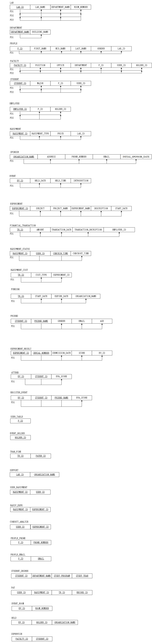

7. Conclusion
In this final report we summarized all the necessary descriptions and solutions for ABC Laboratory Management System database, including process and result of EER diagrams, relational schemas in third normal form, SQL statements to create database, create view and solve corresponding queries, as well as dependency diagram. We also implement the whole database in Oracle and using a database state to test every query. In section 2 we also explained why we use superclass/subclass relationship to build relational schema, why we choose a Relational DBMS to implement our database, and the additional five business rules shown from implementation.

