Método Matlab – Fitmethis

Vídeo Distribuição LogLikelihood Parâmetros

Boron *Gama 1.039e+06 a = 39.8647, b = 0.0041

Normal 1.019e+06 mu = 0.1634, sigma = 0.0268

GaAs Gama 4.123e+05 a = 266.2090, b = 0.0013

*Normal 4.134e+05 mu = 0.3482, sigma = 0.0212

PbCu *Gama 8.4000e+04 a = 22.1459, b = 0.0074

Normal 7.9296e+04 mu = 0.1643, sigma = 0.0384

Moview Gama 3.9097e+04 a = 767.5907, b = 5.2483e-04

*Normal 3.9129e+04 mu = 0.4029, sigma = 0.0145

Método Matlab – Allfitdist

Vídeo Distribuição Negative LogLikelihood Parâmetros

Boron *Gama -1.0394e+06 a = 39.8647, b = 0.004

Normal -1.0186e+06 mu = 0.1634, sigma = 0.0268

GaAs Gama 5.2816e+05 a = 266.2090, b = 0.0013

*Normal 5.2709e+05 mu = 0.3482, sigma = 0.0212

PbCu *Gama -8.4000e+04 a = 22.1459, b = 0.0074

Normal -7.9296e+04 mu = 0.1643, sigma = 0.0384

Moview Gama -3.9097e+04 a = 767.5907, b = 5.2483e-04

*Normal -3.9129e+04 mu = 0.4029, sigma = 0.0145

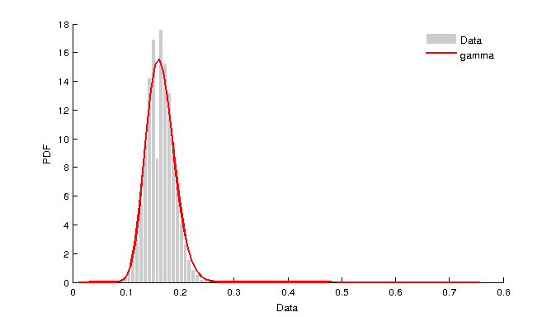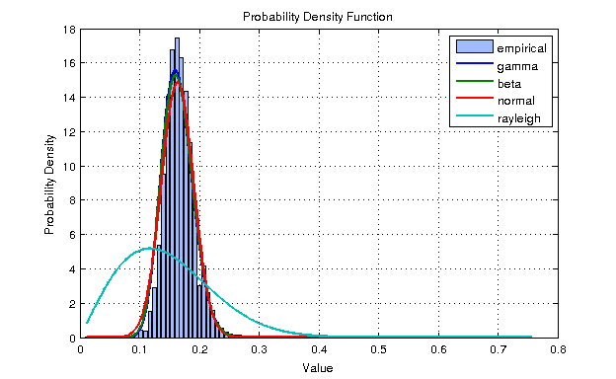Boron_Si

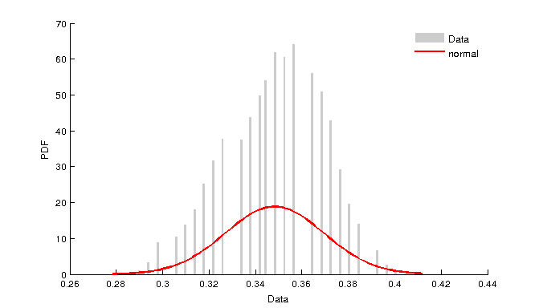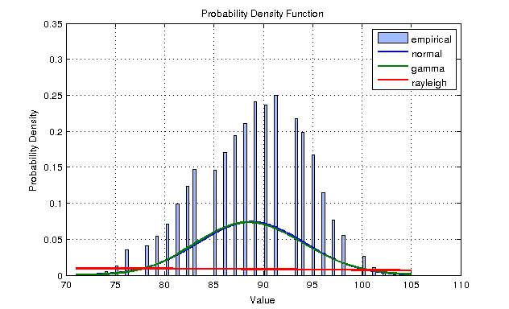GaAs

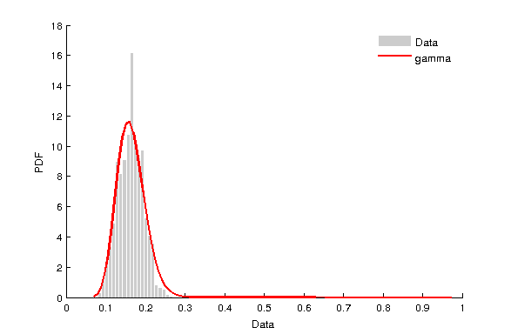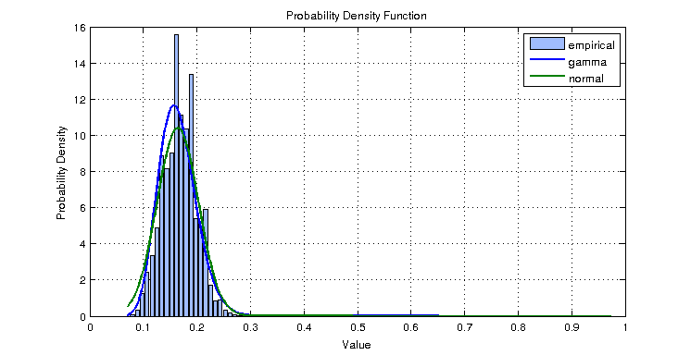PbCu

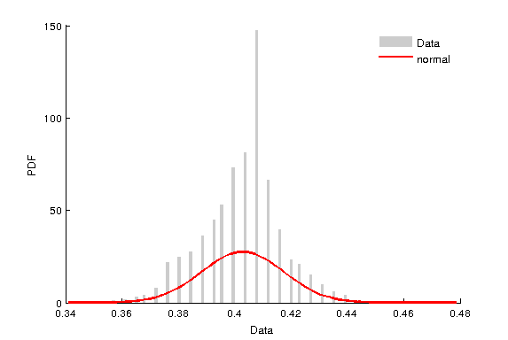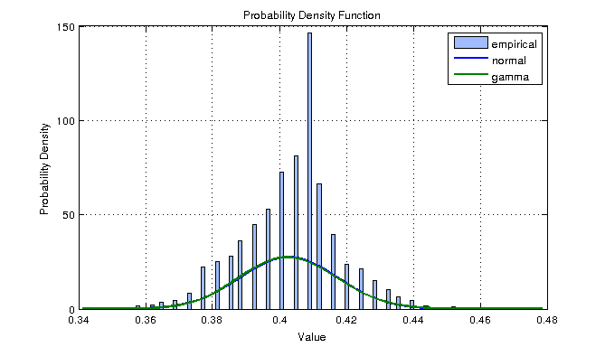Moview